ARK-5 Human Detector Robot
Simple System Design Document

1. Overview
ARK-5 is a small autonomous robot that searches for humans in a disaster/rescue-style environment. It combines three ways of sensing a person: a camera with AI-based detection, WiFi signal sensing (to detect someone behind a wall), and ultrasonic distance sensing for obstacle avoidance.

2. Architecture Diagram
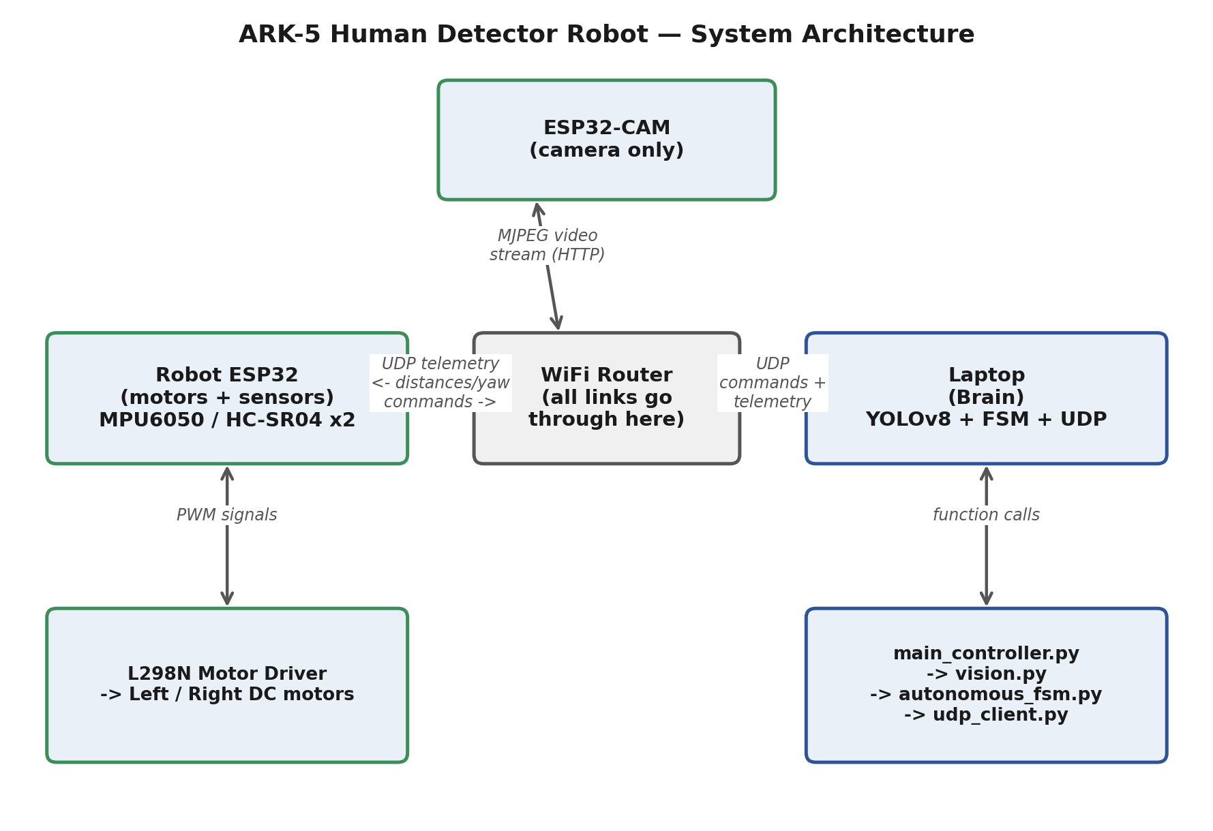
All communication between the three devices (ESP32-CAM, Robot ESP32, and Laptop) goes through a shared WiFi router — there is no direct wired link between them.

3. Hardware Components
Component | Role
ESP32-CAM | Streams live video over WiFi. Does nothing else — no AI, no motors.
Robot ESP32 | Reads sensors (MPU6050 gyro/tilt, 2x HC-SR04 ultrasonic) and drives the L298N motor driver based on commands from the laptop.
WiFi Router | Connects all three devices — every message between laptop, camera, and robot passes through it.
Laptop (Brain) | Runs YOLOv8 to detect humans in the video, runs the decision-making logic (FSM), and sends drive commands to the robot over UDP.

4. Software Modules (Laptop Side)
File | Responsibility
main_controller.py | Entry point. Runs the main loop: read frame -> detect -> decide -> send command.
utils/vision.py | Camera connection (threaded, auto-reconnect) + YOLOv8 human detection.
utils/autonomous_fsm.py | Finite State Machine — decides the robot's next action (go straight / stop / turn / scan).
utils/udp_client.py | Sends motor commands and receives sensor telemetry over UDP.
utils/wifi_sensing.py | Watches WiFi signal strength (RSSI) to sense a person behind a wall.
utils/tentative_map.py | Builds a simple text-based map of where the robot has been and what it found.
utils/config_validation.py | Checks that config/project.yaml has all required settings before the robot starts.
config/project.yaml | All tunable settings in one place (IP addresses, thresholds, speeds, timeouts).

5. How a Decision Gets Made (Data Flow)
- ESP32-CAM captures video and streams it to the laptop over WiFi.
- The Robot ESP32 reads its sensors and sends telemetry (distances, tilt/yaw) to the laptop over UDP.
- On the laptop, vision.py runs YOLOv8 on the video to detect humans (standing / fallen / person).
- wifi_sensing.py checks WiFi signal strength for signs of a person behind a wall.
- autonomous_fsm.py combines all of this information and decides the next action: move forward, stop, turn, or scan.
- udp_client.py sends the resulting motor command back to the Robot ESP32, which drives the motors.
- tentative_map.py records the robot's path and any humans found, saving a simple map file.

6. Design Principles Followed in the Recent Fixes
- Safety first: if sensor data goes stale (WiFi link lost), the robot stops automatically rather than acting on old data.
- Single source of truth: tunable values (thresholds, timeouts, IPs) live only in config/project.yaml, not scattered across code.
- Resilience: camera and network issues are recovered from automatically instead of crashing the whole program.
- Observability: every important event is logged with a timestamp, both to the screen and to a log file, for easier debugging.

