
SCIENTIA SPECTRUM MAGAZINE PROJECT PROPOSAL
ResQ-Swarm: Autonomous Multi-Robot Search and Rescue System
1. Problem Statement
After natural disasters such as earthquakes and building collapses, search-and-rescue operations are dangerous and time-consuming. Sending human rescuers into unstable structures can put their lives at risk, while a single robot may have limited coverage and can become disabled. There is a need for a low-cost robotic system that can explore dangerous and unknown environments, locate potential survivors, and coordinate search efforts efficiently.
2. Background / Introduction
Search-and-rescue robots are increasingly being explored for disaster response and emergency operations. However, many existing robotic systems are expensive and rely on a single sophisticated robot. Swarm robotics offers an alternative approach in which multiple low-cost robots cooperate to accomplish a common task. This project aims to develop a small-scale swarm of autonomous robots capable of exploring an unknown environment, sharing information, dividing search areas, and detecting potential survivors.
3. Project Aim
To develop a low-cost swarm of autonomous robots that can collaboratively explore an unknown environment and assist in locating potential survivors during search-and-rescue operations.
4. Objectives
- Design and build a swarm of two autonomous mobile robots.
- Enable robots to navigate and explore an unknown environment.
- Implement wireless communication between robots and the central system.
- Develop a task allocation mechanism to divide unexplored areas among robots.
- Detect and report potential survivors using onboard sensors.
- Maintain information about explored and unexplored areas.
- Demonstrate swarm cooperation and adaptability when one or more robots become unavailable.
5. Proposed Solution
The proposed project is a multi-robot swarm system for search-and-rescue operations in dangerous and unknown environments, such as areas affected by earthquakes, building collapses, or other disasters. The system consists of two small autonomous mobile robots that work collaboratively to explore a simulated disaster environment and locate potential survivors.
Each robot will be equipped with sensors for obstacle detection and target identification, along with a microcontroller for autonomous movement and wireless communication. Instead of relying on a single large and complex robot, the proposed system uses multiple low-cost robots that cooperate to accomplish the search mission.
On laptop side, a model will be trained specifically for humans in falling position to distinguish between normal, dead or unconscious person. The model that we will use is YOLO v5 or YOLO v8.
At the beginning of a mission, the robots are deployed into the search environment. They navigate through different areas while avoiding obstacles and sharing information about their locations and explored regions. A coordination system maintains information about the overall search progress and assigns unexplored areas to available robots. This reduces unnecessary duplication, allowing the robots to cover a larger area efficiently.
When a robot detects a potential survivor, it records the detected location and communicates this information to the monitoring system. The location is then marked as a priority area, and other robots can be assigned to assist or investigate the location further. The system also monitors the status of each robot. If a robot becomes unavailable or fails during the mission, its unfinished search area can be reassigned to other available robots.
Survivor detection across a wall is achieved primarily through WiFi signal disruption sensing. Each robot’s ESP32 is configured to operate in a dual Access Point + Station (AP+STA) mode: the AP interface emits a localized WiFi field that acts as the sensing signal, while the STA interface keeps the robot connected to the base router for continuous data relay to the monitoring laptop. Since a human body causes significantly greater signal attenuation and multipath disturbance because human body contains 60 percent of water and WiFi doesn't pass through water than thin obstructions such as debris or partition walls, fluctuations in the received signal strength are used as a first-pass indicator of a person’s presence in the robot’s vicinity, even when partially obstructed from direct line of sight. This disturbance data is streamed to the monitoring laptop for processing, where it is combined with the robot’s onboard camera feed to confirm and localize potential survivors.
Ultrasonic sensors are used because the model YOLO will be trained to detect humans in some positions and WiFi signals are used to detect humans beyond a wall. So to detect wall Infront of robot ultrasonic sensors are used.
Compared with a conventional single-robot approach, the proposed swarm-based solution provides greater coverage, redundancy, and fault tolerance. A failure of one robot does not necessarily stop the entire mission, as the remaining robots can continue searching and take over unfinished tasks. Furthermore, using several relatively simple and low-cost robots can potentially be more affordable and scalable than developing one highly sophisticated robot capable of performing every task independently.
For localization, we have two possible approaches: (1) wheel-encoder-based odometry, where we add two wheel encoders (one for each drive wheel) and use their measured rotations to calculate wheel displacement and the robot’s approximate (x, y, θ) position; or (2) motor-command-based dead reckoning, where no encoders are added and the ESP32 estimates wheel displacement from the PWM signals sent to the motors, using experimentally measured motor speeds at different PWM levels. The encoder approach provides significantly better accuracy because it measures actual wheel movement, while the PWM approach is cheaper and simpler but is affected by battery voltage, friction, motor variations, and wheel slip.
The project will be demonstrated using a simulated disaster environment designed to represent a collapsed or obstructed structure. The prototype will demonstrate autonomous exploration, obstacle avoidance, communication, collaborative task allocation, potential survivor detection, and failure recovery.
Proposed System Flow:
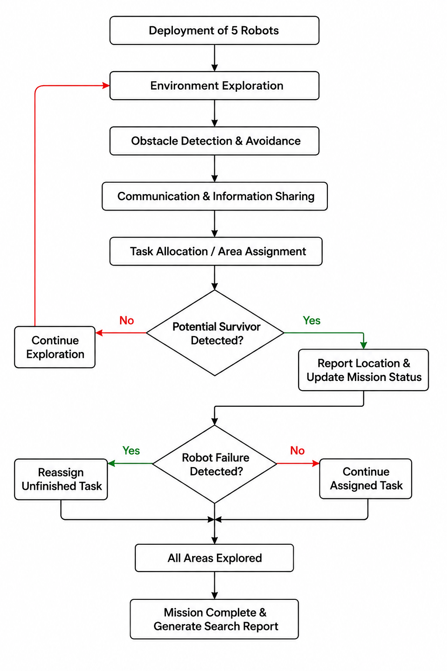
6. Innovation / Novelty
The main innovation of the project is the use of swarm intelligence and collaborative task allocation rather than relying on a single complex robot. The robots will be designed to be relatively simple and low-cost while achieving complex behavior through cooperation.
The system will demonstrate:
- Decentralized or distributed decision-making.
- Dynamic task allocation.
- Collaborative exploration.
- Failure tolerance.
- Information sharing between multiple robots.
7. SDGs Addressed
SDG 9 – Industry, Innovation and Infrastructure: Promotes innovation in robotics, automation, and intelligent systems.
SDG 11 – Sustainable Cities and Communities: Supports safer and more resilient communities through technology for disaster response.
SDG 13 – Climate Action: The technology can potentially support response operations following climate-related disasters.
SDG 3 – Good Health and Well-being: Reduces the risk faced by human rescuers during dangerous search-and-rescue operations.
8. Scope of the Project
The prototype will consist of approximately five small autonomous mobile robots designed for simulated indoor disaster environments.
The prototype will include:
- Autonomous movement.
- Obstacle detection and avoidance.
- Wireless communication.
- Collaborative area exploration.
- Task allocation.
- Target/survivor detection.
- Central monitoring.
The prototype will not include:
- Real-world deployment in collapsed buildings.
- Advanced robotic arms for victim extraction.
- Long-range outdoor navigation.
- Professional-grade rescue equipment.
Future expansion:
- Thermal cameras.
- LiDAR-based mapping.
- GPS integration.
- Advanced AI-based survivor detection.
- Larger robot swarms.
- Real-world disaster deployment.
9. System Features
- Autonomous Navigation: Robots move through the environment without continuous manual control.
- Obstacle Avoidance: Robots detect and avoid obstacles.
- Swarm Communication: Robots share relevant information with one another.
- Collaborative Exploration: Robots divide the environment and explore different areas.
- Task Allocation: New tasks are assigned based on robot status and unexplored areas.
- Survivor Detection: Robots identify potential survivors using sensors.
- Location Reporting: Detected survivors are reported to the monitoring system.
- Failure Recovery: If a robot stops functioning, its unfinished task can be reassigned.
- Central Monitoring: A monitoring interface displays robot status and detected targets.
10. Working Methodology
Overall system flow:
Robot Initialization
↓
Deployment of 2 Robots
↓
Assignment of Search Areas
↓
Autonomous Exploration
↓
Obstacle Detection & Avoidance
↓
Communication & Information Sharing
↓
Task Progress Monitoring
↓
Potential Survivor Detected?
→ Yes: Report Location & Mark Priority Area
→ No: Continue Exploration
↓
Robot Failure Detected?
→ Yes: Reassign Unfinished Task
→ No: Continue Assigned Task
↓
All Search Areas Completed?
→ No: Continue Exploration
→ Yes: Generate Mission Report
↓
Mission Complete
11. Hardware Components
Components for 1 robot:
Hardware Component | Purpose | Qty.
ESP32 | Main controller | 1
DC Geared Motors | Drive the robot | 2
Wheels | Robot movement | 2
Caster Wheel | Balance/support | 1
L298N Motor Driver | Controls motors | 1
Ultrasonic Sensors (HC-SR04) | Obstacle detection | 2
MPU 6050 | Inertial measurement unit | 1
Battery | Power supply | 1
Battery Holder + Power Modules as  2s BMS + tp5100 | Power management and charging | 1
Robot Chassis | Robot body | 1
Buzzer + LEDs | Alerts/status | 1 set
Jumper Wires & Connectors | Wiring | —
Screws, Nuts & Misc. | Assembly | —

12. Software Requirements
- Arduino IDE (if it doesn't works then Vs code with platform io extension)
- C/C++
- Python
- OpenCV (if computer vision is included)
- FastAPI or Node.js (for the monitoring backend, if needed)
- React (for monitoring dashboard, if needed)
- Database system
- Git/GitHub
- CAD software for robot chassis design
13. Technologies Used
- Robotics
- Swarm Intelligence
- Embedded Systems
- Automation
- Wireless Communication
- Internet of Things (IoT)
- Artificial Intelligence
- Computer Vision (optional)
- Path Planning
- Distributed Systems
- Real-Time Data Processing
14. Challenges and Limitations
- Limited battery capacity of small robots.
- Wireless communication range and reliability.
- Limited processing power of microcontrollers.
- Accurate localization of robots in unknown environments.
- Ensuring reliable task allocation and information sharing.
- Limited sensor accuracy.
- Prototype testing will be conducted in a controlled simulated environment rather than a real disaster site.
15. Estimated Budget
Required budget for 1 robot (we’ll most probably make 5)
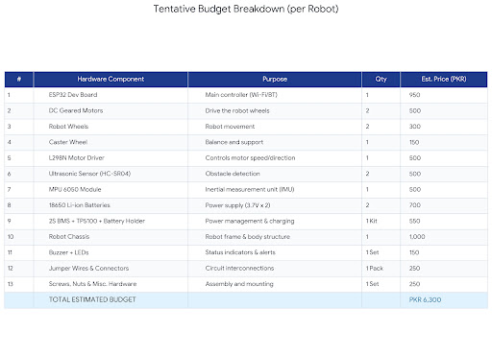

As we already have some materials, the cost can e reduced to a great extent.
16. Timeline
Week | Tasks

Week 1 | Finalize design, acquire components, build robot chassis, and assemble hardware.

Week 2 | Program individual robots for movement, obstacle detection, and basic autonomous navigation.

Week 3 | Implement wireless communication, task allocation, and collaborative swarm behavior.

Week 4 | Integrate survivor detection and failure recovery, conduct final testing, fix issues, and prepare the demonstration.

17. Conclusion & References
This project proposes a low-cost swarm robotic system designed to assist in search-and-rescue operations. By combining autonomous navigation, wireless communication, collaborative exploration, and dynamic task allocation, the system aims to demonstrate how multiple simple robots can cooperate to perform a complex mission. The prototype will provide a foundation for future development of more advanced disaster-response robotic systems.

