University Institute of Information Technology PMAS-Arid Agriculture University, Rawalpindi
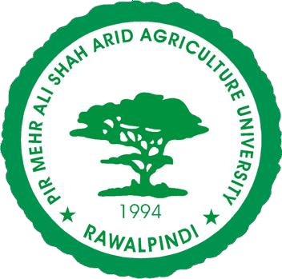

Project Proposal For

(VertiNutrient System)

Submitted By:
Syeda Muzna Hashmi 22-ARID-1059
Dania Batool 22-ARID-1000
Rafia Jahangir Abbasi 22-ARID-3184

Supervised By:
Mr Ashan Arshad

Submission Date (24-sep-2025) (Original version 1.0)

- Please select the appropriate category of your project (Select multiple if required)

A-Desktop Application/Information System | □ B-Problem Solving and AI
C-Web Application/Web Application based Information System. | □ D-Simulation & Modeling | □
E-Smartphone Application | F-Smartphone Game | □
G-Image Processing | H-Networks | □
I- Other: | □

Group Members

  - Student Name: Syeda Muzna Hashmi Registration No: 22-ARID-1059 Class: BSSE
Section: A Shift: Evening
Email: muzna.hashmi@yahoo.com WhatsApp No: 03130510818
  - Student Name: Dania Batool Registration No: 22-ARID-1000 Class: BSSE
Section: A Shift: Evening
Email: daniabatool017@gmail.com WhatsApp No: 03145678918
  - Student Name: Rafia Jahangir Abbasi Registration No: 22-ARID-3184 Class: BSSE
Section: A Shift: Evening
Email: rafiaabbasi0001@gmail.com WhatsApp No: 03325898524

TABLE OF CONTENTS
- Introduction 4
- Literature Review 4
- Problem Statement 5
- Problem Solution 6
- Advantages/Benefits of proposed system 6
- Scope 6
- Software Methodology 7
- Tools and Technologies 8
- Concepts 9
- Intended Users 9
- Mockups 10
- Conclusion 10

Introduction
Agriculture is the backbone of Pakistan’s economy, yet farmers face persistent challenges such as nutrient deficiencies, excessive fertilizer use, and inconsistent crop quality, all of which directly affect yield and profitability. Traditional farming practices often rely on guesswork and blanket spraying, leading to high input costs, soil degradation, and reduced crop quality. To overcome these limitations, modern techniques like vertical farming and aeroponics provide controlled environments with optimized resource utilization and year-round production.
This project introduces an AI-powered Nutrient Detection and Precision Spraying System designed for crops such as tomato, capsicum, lettuce, and coriander. Using a combination of IoT sensors, ESP32-CAM modules, and real-time data collection, the system monitors both plant health and environmental conditions. An integrated AI model analyzes leaf images and sensor data to accurately detect nutrient deficiencies and recommend or automatically deliver targeted nutrient sprays.
By adopting a vertical farming framework combined with aeroponic techniques, the system minimizes soil dependency, reduces water usage by up to 90%, and ensures efficient nutrient delivery directly to plant roots. For Pakistani farmers, this solution provides a cost-effective alternative by preventing fertilizer misuse, improving crop consistency, and ensuring sustainable production. Ultimately, the project combines IoT, AI, aeroponics, and Precision Agriculture practices to enhance productivity, sustainability, and profitability in Pakistan’s agricultural sector

Literature Review

IoT-Based Smart Irrigation Systems (2018, NARC Pakistan)
Several IoT-enabled irrigation systems have been developed to monitor soil moisture and automate water delivery. These systems reduce water wastage and improve efficiency compared to traditional flood irrigation.
Shortcoming: They primarily focus on water management only and do not address nutrient deficiency detection or targeted nutrient spraying, which is critical for crop health.
  - AI-Powered Leaf Disease Detection (2020, International Conference on Smart Agriculture) Research has shown success in using machine learning and image processing to detect plant diseases like blight, rust, and leaf spot through smartphone images. Such solutions improve early detection and reduce crop loss.
Shortcoming: These systems are limited to disease classification only, lacking integration with IoT sensors or automated nutrient delivery mechanisms, which makes them less practical for real-time farm management.

  - Aeroponic Vertical Farming Systems (2021, Urban Agriculture Studies – USA & UAE) Aeroponic farming setups use nutrient-rich mist to grow crops without soil, ensuring water efficiency, faster growth, and improved yields. These systems are considered sustainable and suitable for urban agriculture.
Shortcoming: Aeroponic systems are expensive, require high technical expertise, and lack affordable AI-powered nutrient detection, making them difficult for adoption by small-scale farmers in Pakista

Benchmarking

Feature / Project | IoT-Based Smart Irrigation (NARC, 2018) | AI-Powered Leaf Disease Detection (2020) | Aeroponic Vertical Farming (2021) | Proposed AI-Powered Nutrient Detection & Precision Spraying
Water Management | Yes | No | Yes | ⬛ Yes (Optimized  with sensors + aeroponics)
Nutrient Deficiency  Detection | No | No | No | ⬛ Yes (AI model + sensors + camera)
Automated Nutrient Spraying | No | No | No | ⬛ Yes (Precision spraying system)
Disease Detection (AI-based) | No | Yes | No | ⬛ Planned integration for basic leaf analysis
Vertical Farming / Aeroponics | No | No | Yes | ⬛ Yes (low-cost aeroponic prototype)
Real-Time Data & Cloud  Monitoring | Limited | Limited | Limited | ⬛ Yes (Firebase + mobile/web app)
Cost- Effectiveness for Small Farmers | Moderate | Moderate | Expensive | ⬛ Affordable (low- cost sensors + ESP32- CAM)

- Problem Statement
Table 1 Benchmarking

In Pakistan, agriculture continues to rely on traditional practices that are highly inefficient and resource intensive. Farmers often apply excessive fertilizers and pesticides without proper measurement, leading to nutrient wastage, soil degradation, and long-term decline in fertility. Outdated irrigation methods such as flood irrigation consume large volumes of water, which is a critical concern in a country already facing water scarcity. Despite using significant amounts of land, the yield per acre remains low due to poor monitoring and lack of precision in resource application. The imbalance between high input costs and low productivity causes financial strain on farmers, making agriculture less sustainable. Nutrient deficiencies often remain undetected until it is too late, further reducing crop health and growth. In many cases, resources such as water, nutrients, and labor are consumed disproportionately compared to the output received. The lack of real-time monitoring systems prevents timely interventions and forces farmers to rely on guesswork. As a result, both economic losses and environmental damage are increasing steadily.

There is a critical need for a smart, efficient, and precise solution that minimizes resource wastage while maximizing crop output in limited land.

Problem Solution
The proposed solution is an AI-powered Nutrient Detection and Precision Spraying System integrated with aeroponic vertical farming. The system will use ESP32-CAM modules and IoT sensors to capture real-time data on plant health, environmental conditions, and nutrient levels. An AI model will analyze this data to detect deficiencies and recommend or automatically apply only the required nutrients, ensuring precise usage. By adopting aeroponic vertical farming, the system drastically reduces water consumption, eliminates dependency on soil, and ensures that nutrients are delivered directly to plant roots via mist, addressing resource wastage issues efficiently. Real-time monitoring allows farmers to track crop conditions and receive instant alerts for corrective actions, minimizing guesswork. The spraying mechanism is automated, saving time and reducing excessive labor costs. Vertical farming racks optimize space utilization, allowing higher yields per unit area of land. The integration of a mobile and web-based app provides farmers with a simple interface to view data, recommendations, and growth tracking, ensuring that each user manages their farm data securely through cloud integration. The system is designed to be affordable, scalable, and practical for farmers in Pakistan. Ultimately, it combines AI, IoT, and precision agriculture techniques to minimize resource wastage and maximize sustainable crop production using aeroponics.

Advantages/Benefits of proposed system
  - Reduced Resource Wastage – Precise spraying ensures minimum use of water and fertilizers.
  - Improved Crop Health – AI detects nutrient deficiencies early, preventing plant stress and damage.
  - Higher Yield in Less Space – Vertical farming and aeroponics maximize production on limited land.
  - Cost-Effective for Farmers – Eliminates unnecessary input costs and reduces labor requirements.
  - Real-Time Monitoring – Farmers can track plant health and environment data instantly via the app.
  - Sustainable & Scalable – Supports eco-friendly farming practices and can be expanded for larger setups

Scope
The scope of this project is to design and implement an AI-powered Nutrient Detection and Precision Spraying System integrated with vertical farming. The system will use IoT sensors and ESP32-CAM modules to collect real-time data on plant health, nutrient levels, and environmental conditions. An AI model will analyze this data to detect nutrient deficiencies and control an automated spraying mechanism for accurate nutrient delivery. A mobile and web-based application will be developed to visualize data, provide recommendations, and monitor crop growth. Firebase cloud will be used to store and manage user-specific data, ensuring that each farmer can securely access their own records. The system will be tested on selected crops such as tomato, capsicum, lettuce, and coriander, which are widely cultivated in Pakistan. Vertical farming racks will be implemented to maximize yield within limited space, while

aeroponics will improve water efficiency and crop quality. Camera-based monitoring will be introduced for detailed image analysis of plants, supporting the AI model in deficiency detection. A small-scale prototype with multiple racks will be developed to demonstrate feasibility and accuracy. The project will be divided into three main areas: hardware integration, AI model development, and application/cloud management, allowing equal contribution from all team members. This scope ensures that the project remains practical, innovative, and aligned with the needs of Pakistani farmers.

Modules of the project:
  - IoT-Based Monitoring Module – Collects real-time data on environmental conditions and plant growth using IoT sensors and ESP32-CAM.
  - AI Nutrient Deficiency Detection Module – Uses machine learning and image processing to detect nutrient deficiencies from captured plant images. (Special feature: AI-driven detection customized for local crops in Pakistan)
  - Precision Spraying Automation Module – Controls pumps and sprinklers to deliver the exact amount of nutrients required.
  - Cloud & Database Module – Stores sensor readings, images, and user data securely using Firebase for real-time synchronization.
  - Mobile & Web Application Module – Provides a dashboard for farmers to monitor crops, view AI analysis, and receive recommendations. (New feature: Simple Urdu/English interface for easy farmer adoption)
  - Vertical Farming Integration Module – Implements rack-based aeroponic/vertical farming setup to maximize yield in limited space.

Software Methodology
For this project, we will use the Agile Software Development Methodology. Agile is suitable because our system involves multiple modules like AI model, IoT integration, and mobile app, which can be developed and tested in iterative cycles. It allows us to get continuous feedback from supervisors and make improvements at each stage. This flexibility is essential as sensor integration and AI accuracy may require adjustments. Agile ensures faster prototyping, teamwork, and adaptability throughout the project.
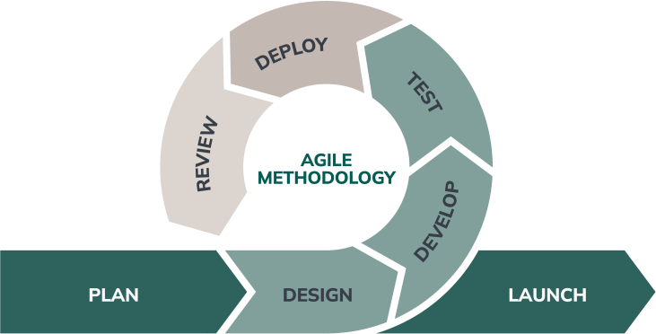
Fig 1 Agile Model

Tools and Technologies
Category | Tool/Sof  tware | Version | Purpose

IDE &  Development | Visual Studio  Code | 1.93 (latest) | Code editing for backend, app, and AI
Mobile  Development | Android  Studio | Hedgehog  2023.1.1 | Mobile app development &  testing
Database | Firebase  Firestor e | Cloud-  based (Latest) | Real-time data storage & sync
Image Processing & AI | TensorF low /  TensorF  low Lite | 2.15 / Lite  2.12 | AI model training & deployment
Computer  Vision | OpenC  V | 4.8.1 | Image preprocessing & analysis
API Testing | Postman | 11.x | Testing backend APIs
Design | Figma | Latest  (Web) | UI/UX design mockups
Documentation | MS  Word | 2019 | Report writing
Presentation | MS  PowerP oint | 2019 | Project presentation
Simulation | Proteus | 8.13 | Microcontroller/sensor  simulation
Circuit Design | Arduino  IDE | 2.3.2 | ESP32 & sensor programming
Table 2 tools

1.1 Technologies

Technology | Version | Usage
Programming  Languages | Python 3.11, (Android SDK  33), C++ | AI model training, mobile app, and ESP32  firmware
Frameworks | Flutter | Cross-platform mobile app

Database | Firebase Firestore (Cloud) | Real-time DB for user/sensor data
Protocols | MQTT, HTTPS | Sensor-to-cloud & app communication
SDKs | Firebase SDK, Android SDK 33 | App development & cloud integration
Cloud Services | Firebase Hosting, Google Cloud  AI APIs | Data hosting, authentication, AI model  deployment
APIs | REST API (custom-built) | Data flow between ESP32, Cloud, and  App
Table 3 technology

Concepts

IoT and Sensor Integration
This project enables learning of how to connect and program IoT devices like ESP32-CAM and sensors to collect real-time environmental and plant data. It also covers communication protocols such as MQTT and data transmission to the cloud.

Artificial Intelligence and Image Processing
Practical experience will be gained in training machine learning models to detect nutrient deficiencies from plant images. Key concepts include feature extraction, classification, and AI- based decision-making.

Database and Cloud Computing
The project provides exposure to designing, managing, and deploying a real-time database using Firebase or similar platforms. Core areas include data synchronization, image storage, and user access management.

Mobile and Web Application Development
Hands-on skills will be developed in building farmer-friendly dashboards using modern frameworks. Focus areas include UI/UX design, real-time data visualization, and bilingual support (Urdu/English)

Intended Users

Pakistani Farmers
The primary users are local farmers who will directly benefit from real-time monitoring of crop health, automated nutrient spraying, and improved yield. They can reduce costs, avoid guesswork, and ensure better quality crops for local markets and exports.

Agricultural Experts & Researchers
Experts can use the system to analyze crop growth data, validate AI predictions, and provide recommendations to farmers. This helps in improving research on precision agriculture and smart farming techniques in Pakistan.

Government & Policy Makers
Agri-departments can use the system for monitoring regional crop health trends, promoting sustainable agriculture, and encouraging vertical farming adoption to strengthen food security.

Mockups
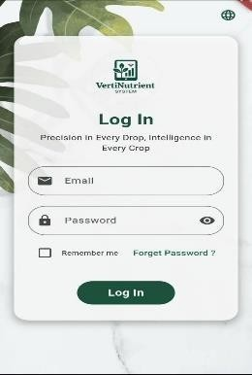
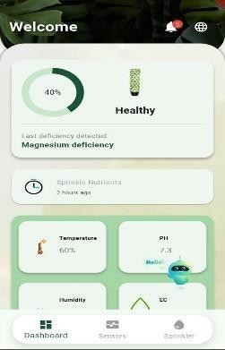
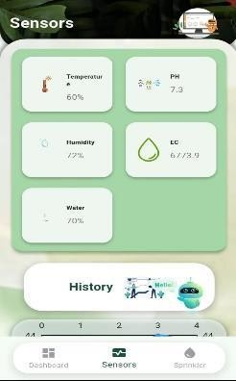
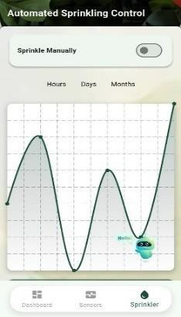
Fig 2 Log in Fig 3 Dashboard Fig 4 Sensor Out put Fig 4 Sprinkler

Timeline
.
Task / Sprint | Start Date | End Date | Duration
Sprint 0: Setup & Planning | 15-Sep-2025 | 25-Sep-2025 | 10 days
Sprint 1: Requirement Analysis & Design | 26-Sep-2025 | 10-Oct-2025 | 15 days
Sprint 2: Sensor & Data Module | 11-Oct-2025 | 25-Oct-2025 | 15 days
Sprint 3: AI Model Preparation | 26-Oct-2025 | 10-Nov-2025 | 16 days
Sprint 4: Application Module | 11-Nov-  2025 | 30-Nov-2025 | 20 days
Sprint 5: Cloud & Database Integration | 01-Dec-2025 | 20-Dec-2025 | 20 days
Sprint 6: Hardware Integration (ESP32  + Sensors + Aeroponics) | 01-Jan-2026 | 20-Jan-2026 | 20 days
Sprint 7: Testing & Validation | 21-Jan-2026 | 01-Feb-2026 | 12 days

Conclusion
The proposed project VertiNutrient System presents a sustainable and innovative approach to address the major challenges faced by Pakistani farmers, including nutrient mismanagement, high production costs, and inconsistent crop quality. By integrating AI-driven deficiency detection, IoT- based monitoring, and precision nutrient spraying in a vertical farming setup, the system ensures optimized resource usage, year-round production, and healthy crop growth. This project not only reduces unnecessary fertilizer use but also enhances profitability and productivity, making modern farming accessible and affordable for local farmers. Ultimately, it bridges the gap between traditional practices and smart agriculture, contributing to food security, economic growth, and sustainable farming in Pakistan

References
- R. Khosla and D. Mulla, Handbook of Precision Agriculture: Principles and Applications. New York, USA: Routledge, 2020.

- M. B. Kirkham, Principles of Soil and Plant Water Relations. Cambridge, MA: Academic Press, 2014.
- A. Ahmad, M. A. Khan, and A. Rehman, “IoT-based smart irrigation system for sustainable
agriculture,” in Proc. Int. Conf. Emerging Technologies (ICET), Islamabad, Pakistan, 2018, pp. 1–6.
- S. Hameed, T. Hussain, and R. Jalil, “AI-driven plant disease detection and smart agriculture
solutions,” IEEE Access, vol. 8, pp. 180110–180120, 2020.
- Food and Agriculture Organization of the United Nations (FAO), “Water use in agriculture,” 2021.
[Online]. Available: https://www.fao.org/water
- National Aeronautics and Space Administration (NASA), “Precision agriculture and remote sensing,” 2022. [Online]. Available: https://earthdata.nasa.gov
- Pakistan Council of Research in Water Resources (PCRWR), Annual Report on Irrigation and Water Use in Pakistan. Islamabad, Pakistan: PCRWR, 2021.
- National Agricultural Research Centre (NARC), Smart Agriculture and IoT-based Farming Practices in Pakistan. Islamabad, Pakistan: NARC, 2019.

