**Kumar Anuj**

**AM.EN.P2WNA22007**

**IoT – assignment 1**

Create a generic architecture and a 3 layer IoT architecture based on your term project.

Use google draw or similar software to create these architectures.

Add these architecture in a document and describe the functionalities. Make sure you include the data flow between each module/block also.

Submit the files to your github repository on WNA organisation account and share the link when you submit the assignment.

**IoT BASED SMART MIRROR**

The project explains about the development and design of a smart mirror that represents an elegant and interface about the smart mirrors. It also gives the information about the thief detection in an environment using IoT. It is a system that works on the functions of additional capability of displaying date, time, current temperature, weather details. Actually, a smart mirror may be a two-way mirror with an inbuilt display behind the glass. The system is based on the IoT based intelligence to facilitate and enhance the user’s awareness.

The concept of IoT based smart mirror allows users to access all of this  
information on a mirror, which is automatically updated from time to time. In addition,  
when a camera is put behind the mirror, smart mirrors are employed for security purposes. An  
AI-based facial identification mechanism is implemented, which detects unknown people and  
sends a notification to the user's mobile phone. It includes google voice assistant which is used for live interaction with the mirror which can play YouTube videos, music, etc. on giving the voice command. The voice command is given through the microphone and speakers are connected for the output audio. Pulse sensor and temperature sensor are interfaced with the mirror which measures heart rate and temperature of the user and alerts the user if it is not in the normal range. Google voice assistant is used to activate the mirror display from sleeping mode when a user appears in front of the mirror.

**Here is the 3-layer architecture of this project:**

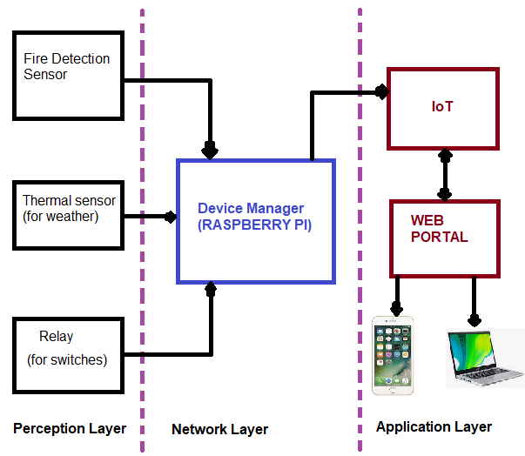

**The perception layer** contains different types of sensors. These sensors capture different types of data and forwards to the network layer for processing. Some of the methodologies are as follows:

Sensors as information system: These sensors are used to get the humidity and temperature details.

Sensors as security system: Ex – PIR sensors can detect the movements and capture the image, and update the owner by sending this picture.

Sensors as relay – to switch on/off lights, fan, AC etc.

**The network layer** classifies and process these data and pass on to the application layer.

**The application layer** has a web portal, which keeps record of these data. These web portals can be connected to end-user devices. These devices are equipped with apps, which allows them to access the smart mirror in real-time to track the activity at home.

**Sensors which can be used for smart Mirror:**

1. Temperature sensor GY-906
2. Heat sensor max30100
3. Web camera
4. USB microphone
5. Speaker

**Microcontroller:** Raspberry Pi 3b+

**Block diagram:**

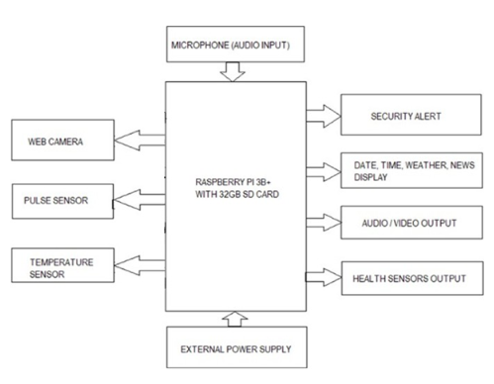

**Flow diagram**

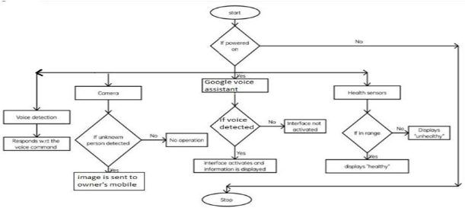

The smart mirror shows basic information such as date, time, news and current weather condition. The google assistant is activated on receiving the command “ok google”. once activated it responds according to user commands. The screen is activated using google voice assistant. The camera is used for face recognition and sends images to owner’s mail when an unknown face is detected. The health sensors help to keep track on user's heath.

**Future scope:**

This smart mirror can be further developed for home automation such as turning on  
lights, fans etc. and other home appliances can be controlled, also various other parameters  
can be included according to the user's requirement. The mirror with a larger display in length  
can be used as a virtual trial room where the dresses can be tried out virtually when person  
stands in front of the mirror. On basis of the location commands, google maps can be activated  
and directions can be shown.