Assignment 1: **Deploy multiple sites using apache2 server. Both sites must be accessible concurrently using IP address or site name.**

***Note : before following the below steps we need to install Apache2.***

Step 1 : Create directories inside /var/www/ to deploy your websites.

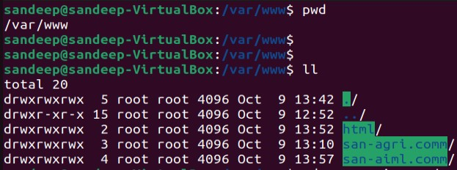

Note : *Inside these directory I have created sub directory to deploy the static webpages*

Step 2 : Navigate to /etc/apache2/sites-available

Step 3: copy the default config files to the map to your websites

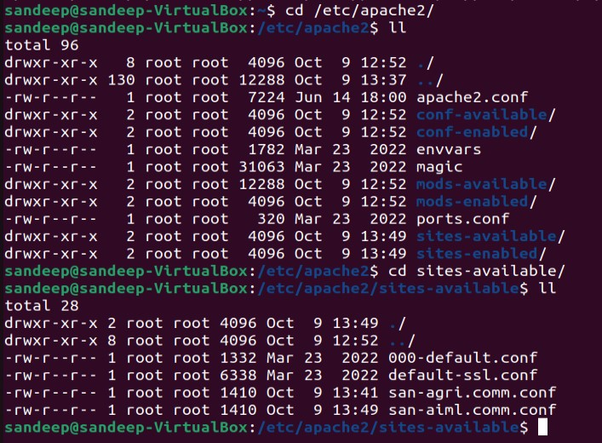

Step 4 : Edit the copied config files.



Step 5: Edit the files to map the deployed website directory to Server address. Below are the files edited with lines **ServerName** and **ServerAlias**. Also update the **DocumentRoot** to point to the website deployed directory.

Step 6 : Disable the default website and enable the newly deployed websites

a2dissite 000-default.conf

a2ensite san-agri.comm.conf

a2ensite san-aiml.comm.conf

***Note*** *: We can check which website is enable to for routing.*

Step 7: Edit the hosts file on the system to locate the route of the website.

Below is the output of the websites hosted on Apache2.

<http://www.san-agri.comm>



<http://www.san-aiml.comm>

