Assignment 2:

Implement versioning in S3 bucket and attach bucket policies, ACL on objects of bucket to implement user access permissions.

**Step 1**: Log in to your Amazon Web Services Account 🡪 In your console search bar, search S3 🡪 then select the S3.

**Step 2**: On the Amazon S3 page click on create a bucket.

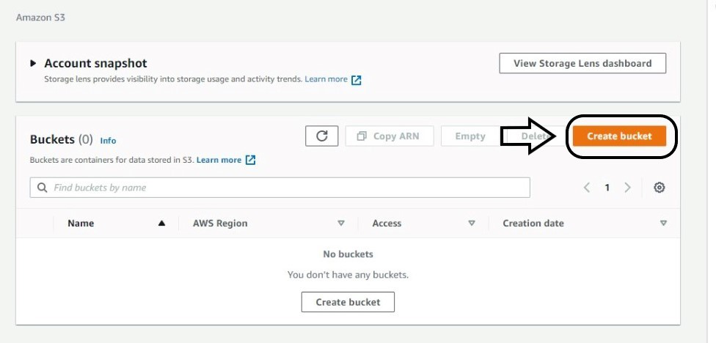

**Step 3:** In create bucket page, Give the bucket a Name



NOTE:

1. **Name must be unique and should not contain any space or uppercase letter**
2. Select any region
3. Enable ACL (Access Control List basically helps to manage access to created buckets and it’s a different version of object)
4. Un-tick Block all public access option (If you want to give it public access)
5. Click on “I acknowledge”
6. Keep default encryption disabled
7. Click on Create Bucket

**To enable versioning, we will follow below mentioned steps.**

1. In the Buckets list, choose the **name of the bucket** that you want to enable versioning for.
2. Choose Properties.
3. Under Bucket Versioning, choose Edit.
4. Choose **Enable**, and then choose Save changes.



Note: While creating bucket, select encryption enable/disable based on the requirement.

**Step 4**: Click on your created bucket 🡪 Click on upload 🡪Upload any file

Select objects uploaded and go to object action 🡪 Click on the public using ACL.

By default, the static website hosting will be **disabled**. To get S3 object as website, **enable** the static website hosting.

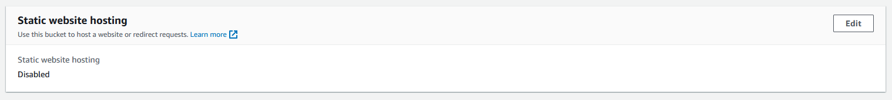



Using the website endpoint, we will access the web hosted S3.

**Below is the output of the website.**

For this output I have added .CSS and image file. Which not available in the screenshot.

Finally, we can see the **number of versions** for the file **index.html**. We have uploaded the file multiple times and its available with version ID’s. So that we can restore if it is required for later use or if we want to revert the content.

