1. Run a sample static web app on EC2 and save an AMI

For example, use folder from teams “High_Availabality_Scalabality_Elastic_App”

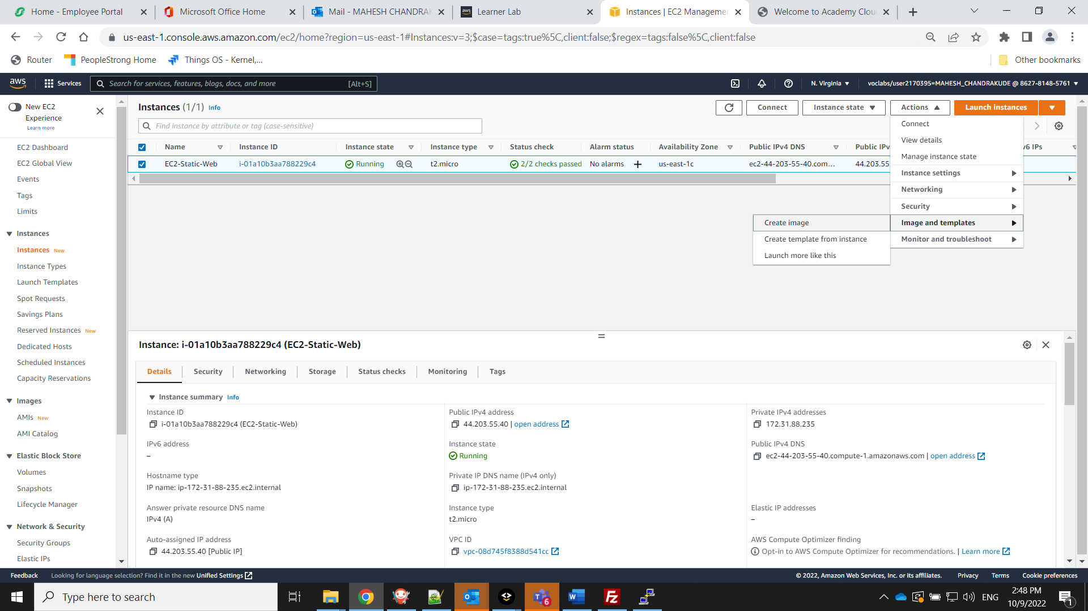

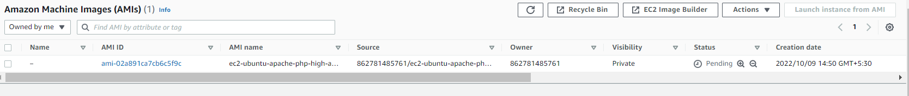



1. Create an instance from the saved AMI and confirm if its fine in browser

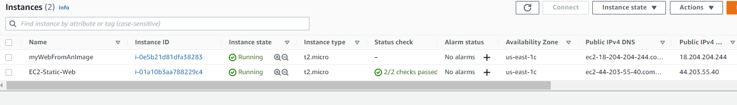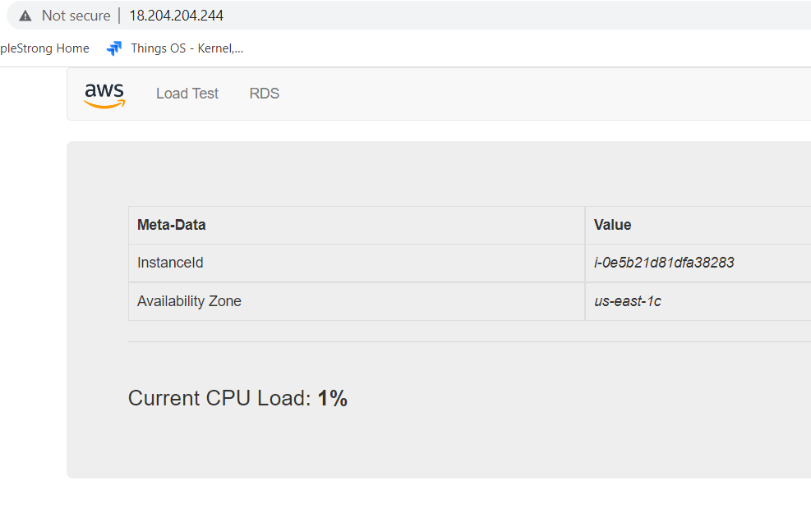

**Now we use the AMI and start with creation of target group, ELB, Launch config and finally ASG**

1. Create a VPC spanning across 2 AZs and should be divided into 2 public and 2 private subnets

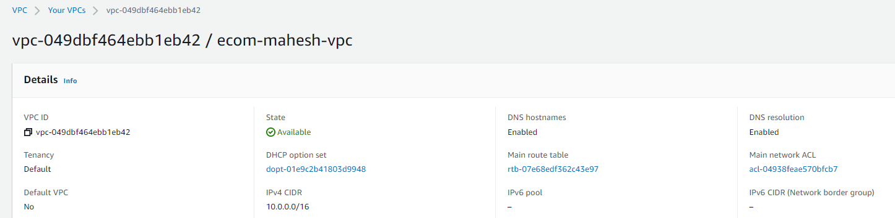

1. Create a Target group for the ELB

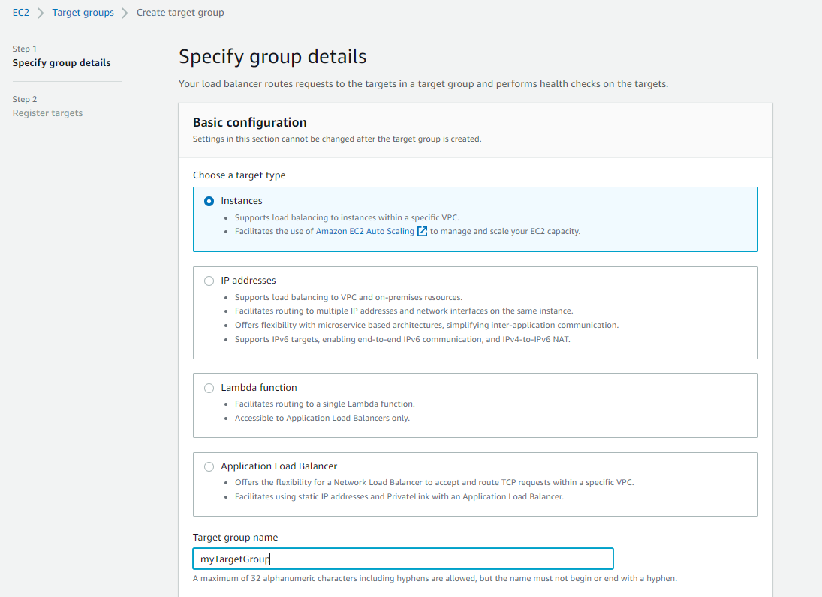

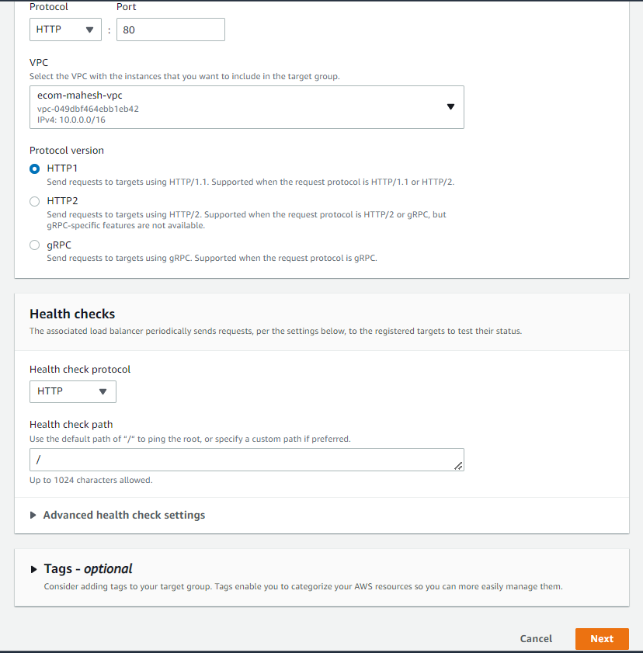

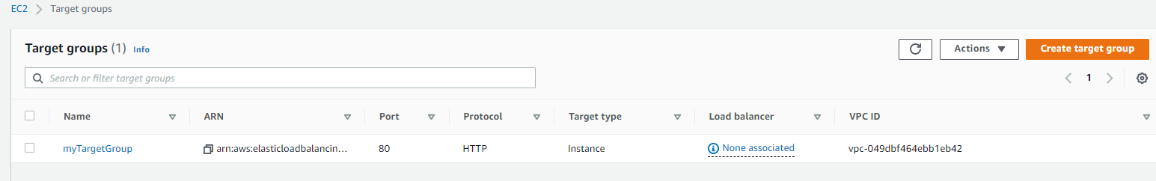

1. Create Load Balancer ELB, associate with TargetGroup

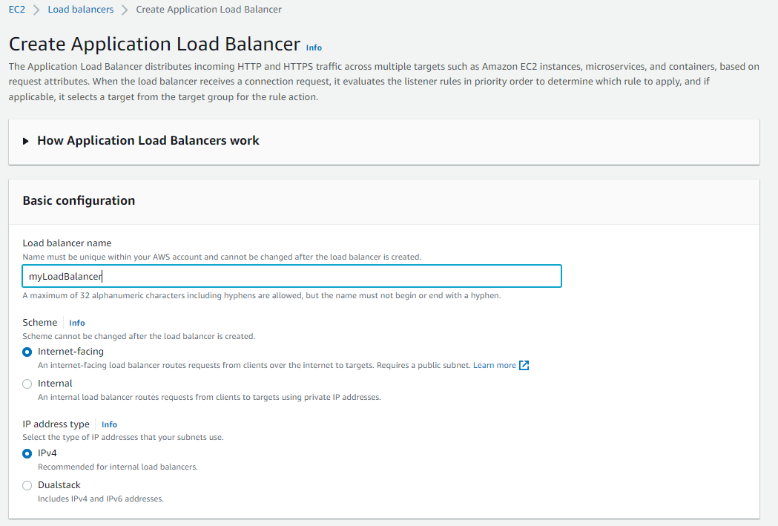

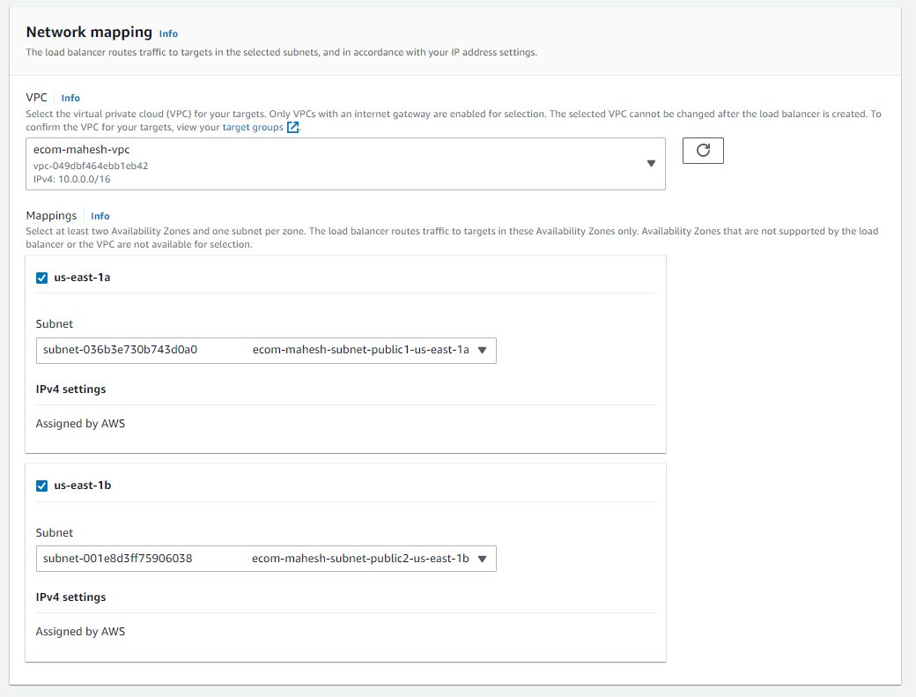

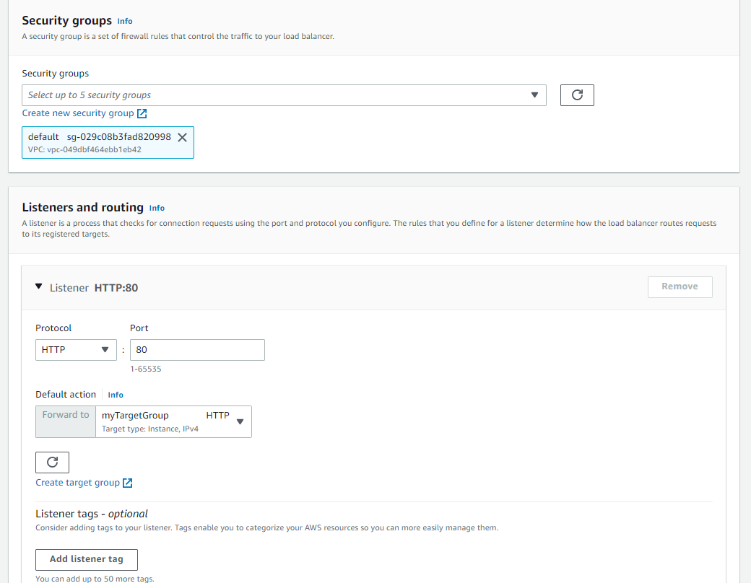

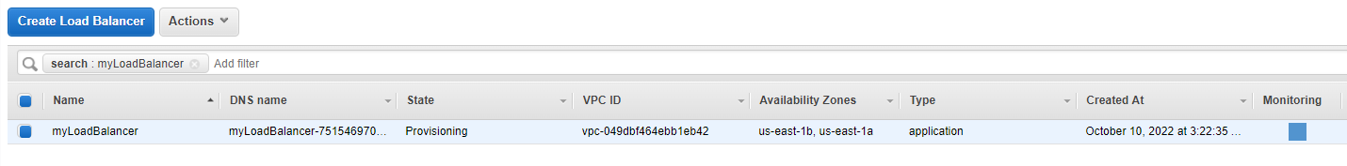

1. Create Launch config

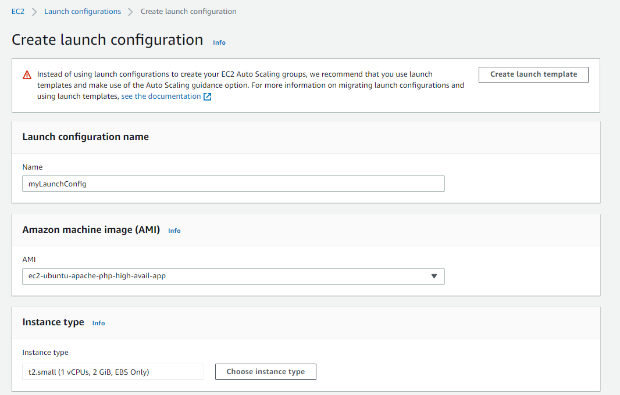

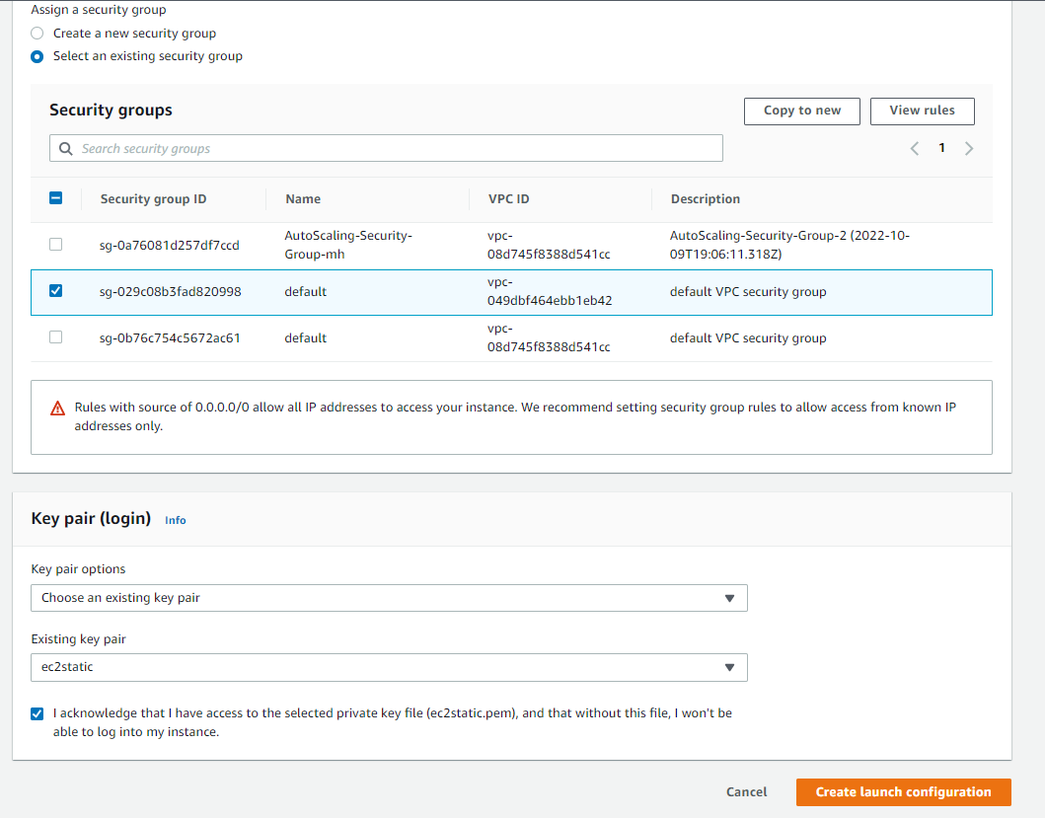

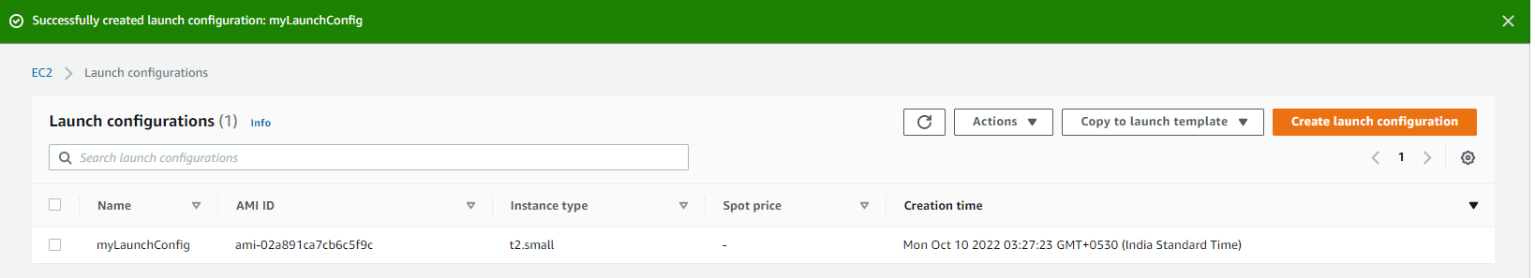

1. Create Autoscaling Group (ASG) using Launch config

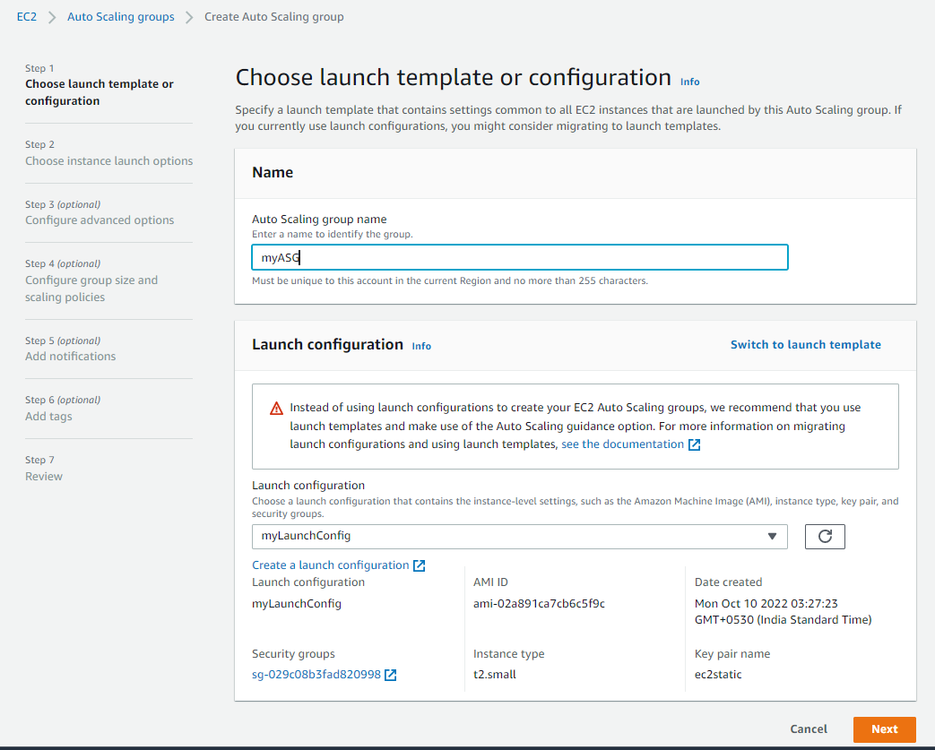

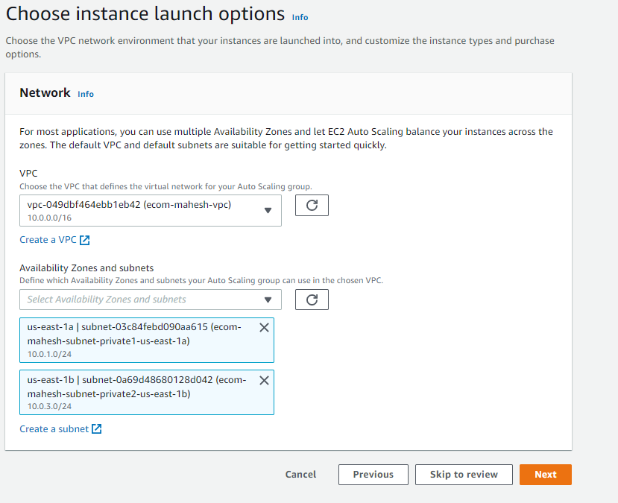

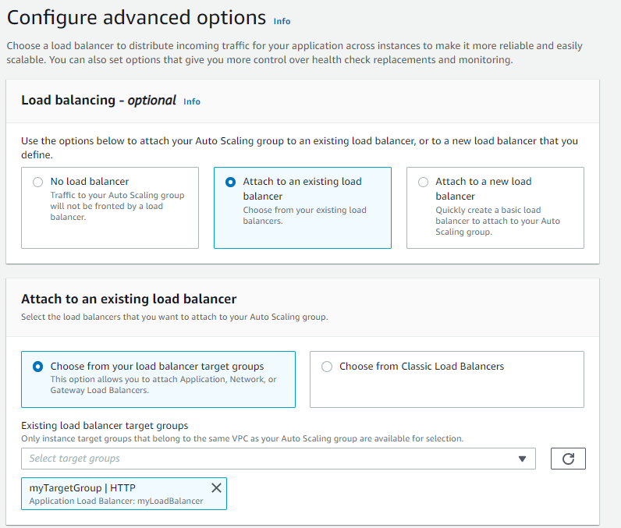

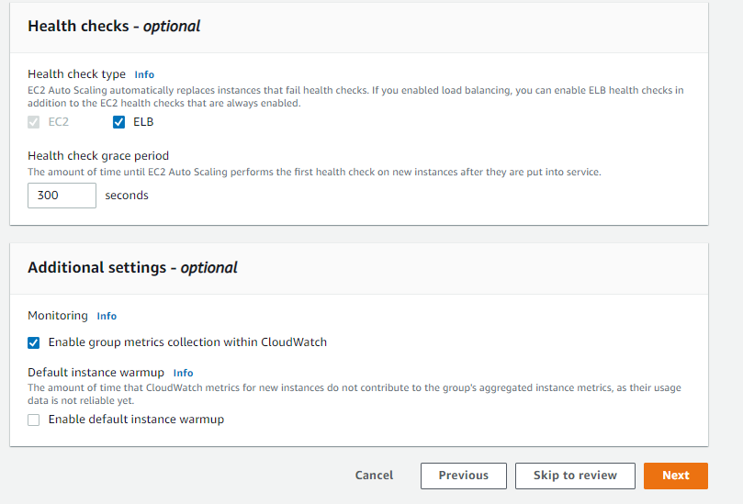

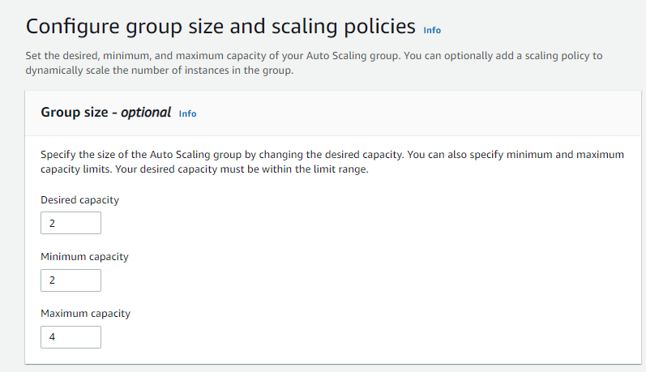

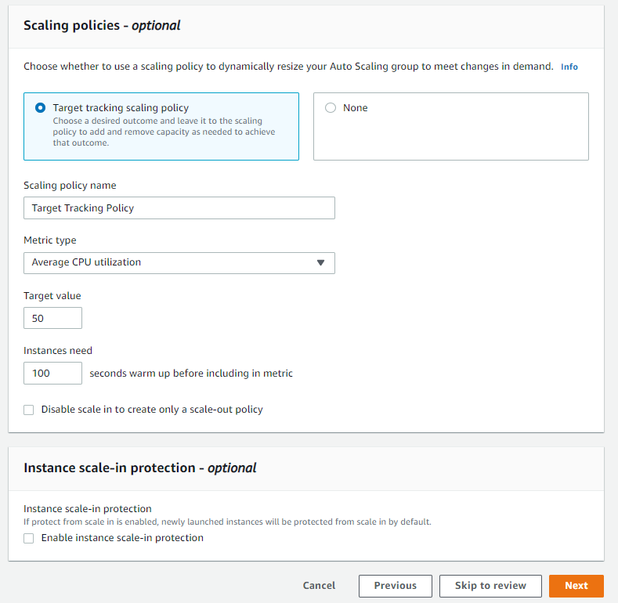

Click next and review and finally create ASG

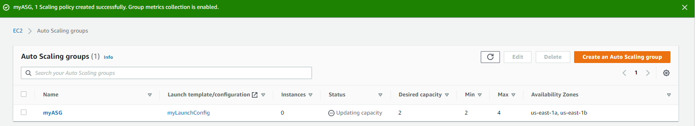

1. Find the DNS in the Load Balancer tab and Open it in web browser

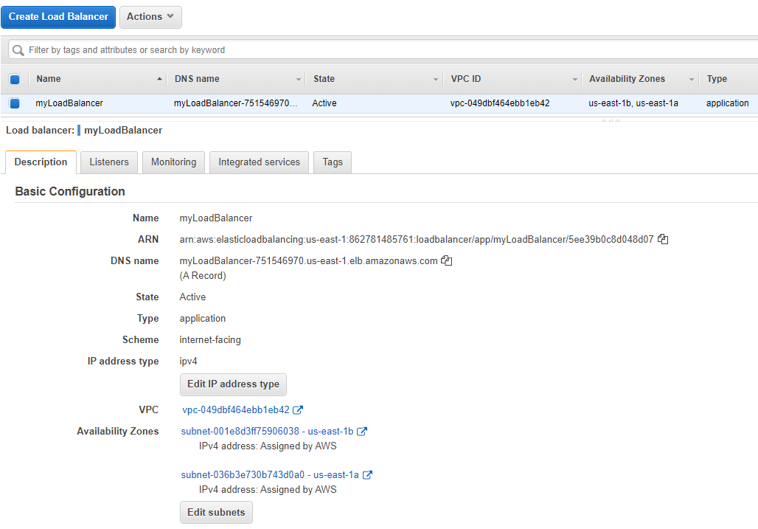

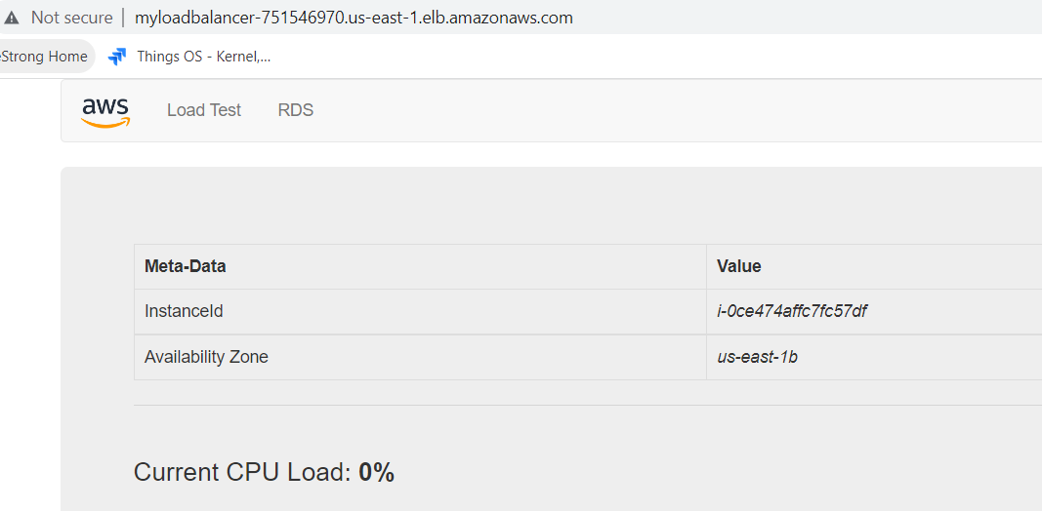

1. Now Load test and observe the page indicating we are hitting different instances of webserver

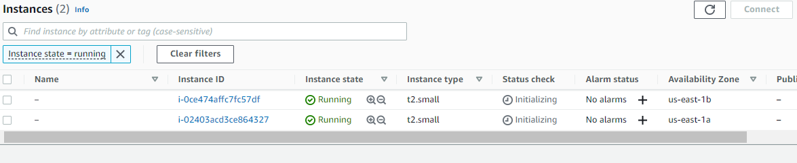

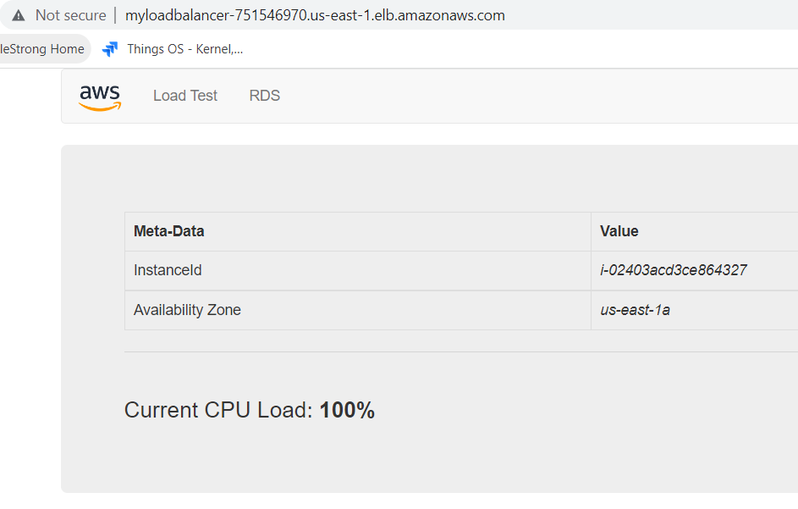

1. After load testing instances will increase to serve high load

