Assignment 1:

**Deploy multiple sites using apache2 server. Both sites must be accessible concurrently using IP address or site name.**

***Note:***

* ***Before following the below steps, we need to install Apache2. I am installing on ubuntu.***
* ***I have downloaded free web templates for this implementation.***

Step 1 :

Create directories inside /var/www/ to deploy your websites.

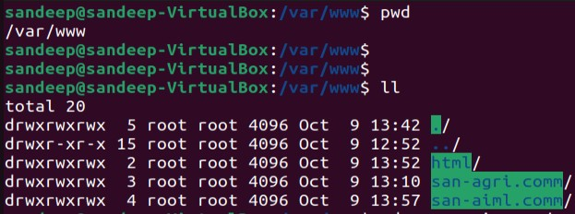

Note: *Inside this directory I have created sub directory to deploy the static webpages*

Step 2 :

Navigate to **/etc/apache2/sites-available**



Step 3:

copy the default config files to the map to your websites

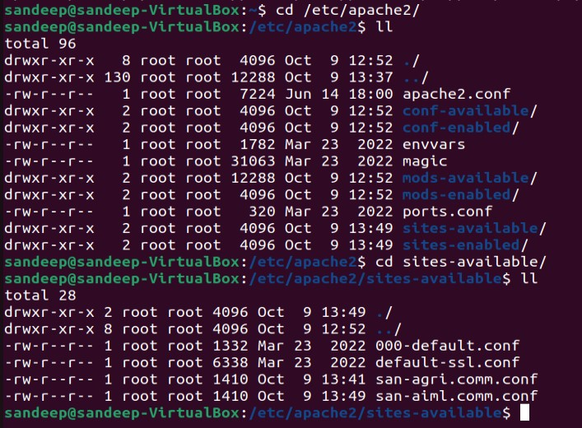

Step 4 :

Edit the copied config files.



Step 5:

Edit the files to map the deployed website directory to Server address.

Below are the files edited with lines **ServerName** and **ServerAlias**.

Also update the **DocumentRoot** to point to the website deployed directory.

Step 6 :

Disable the default website and enable the newly deployed websites. Run the below commands to disable and enable sites.

**/a2dissite 000-default.conf**

**/a2ensite san-agri.comm.conf**

**/a2ensite san-aiml.comm.conf**

***Note*** *: We can check which website is enable to for routing.*

Step 7:

Edit the hosts file on the system to locate the route of the website.

This is from the system where we are trying to access the website.

**Below is the output of the websites hosted on Apache2.**

<http://www.san-agri.comm>



<http://www.san-aiml.comm>

