Assignment 3:

Provision VPC in us-east-1 region with 2 public and private subnets on two availability zones. Deploy Dynamic website presentation layer on ec2 instance on one of the public subnet. Spin up RDS (Managed Database) on private subnet and connect web layer to database layer using connection string. Finally deploy dynamic website.

**Below is the summary of all steps for this assignment.**

1. Create EC2 with all the required software to be installed. Check if the webserver is working with web page access.
2. Create new AMI with this instance.
3. Create VPC
   1. With Public subnet - web server associated with this 🡪 website is deployed here
   2. With Private subnet – Database server associated with this 🡪 DB server running
   3. Default route table
4. Create target group - To route traffic to the targets in a target group, specify the target group in an action when you create a listener
5. Create load balancer – public zone
6. Create a launch configuration and Auto scaling
   1. Create an Auto Scaling group using a launch configuration
   2. **Note** : Enable cloud watch, monitor health check

Once we finish all the above steps, we can access the website to see the load balance is working or not.

Also we can stop instance to see the request is going to available to webserver.

**Below is the example image for the VPC with private and public subnet.**


    Diagram for scenario: VPC with public and private subnets
   

1. Create VPC

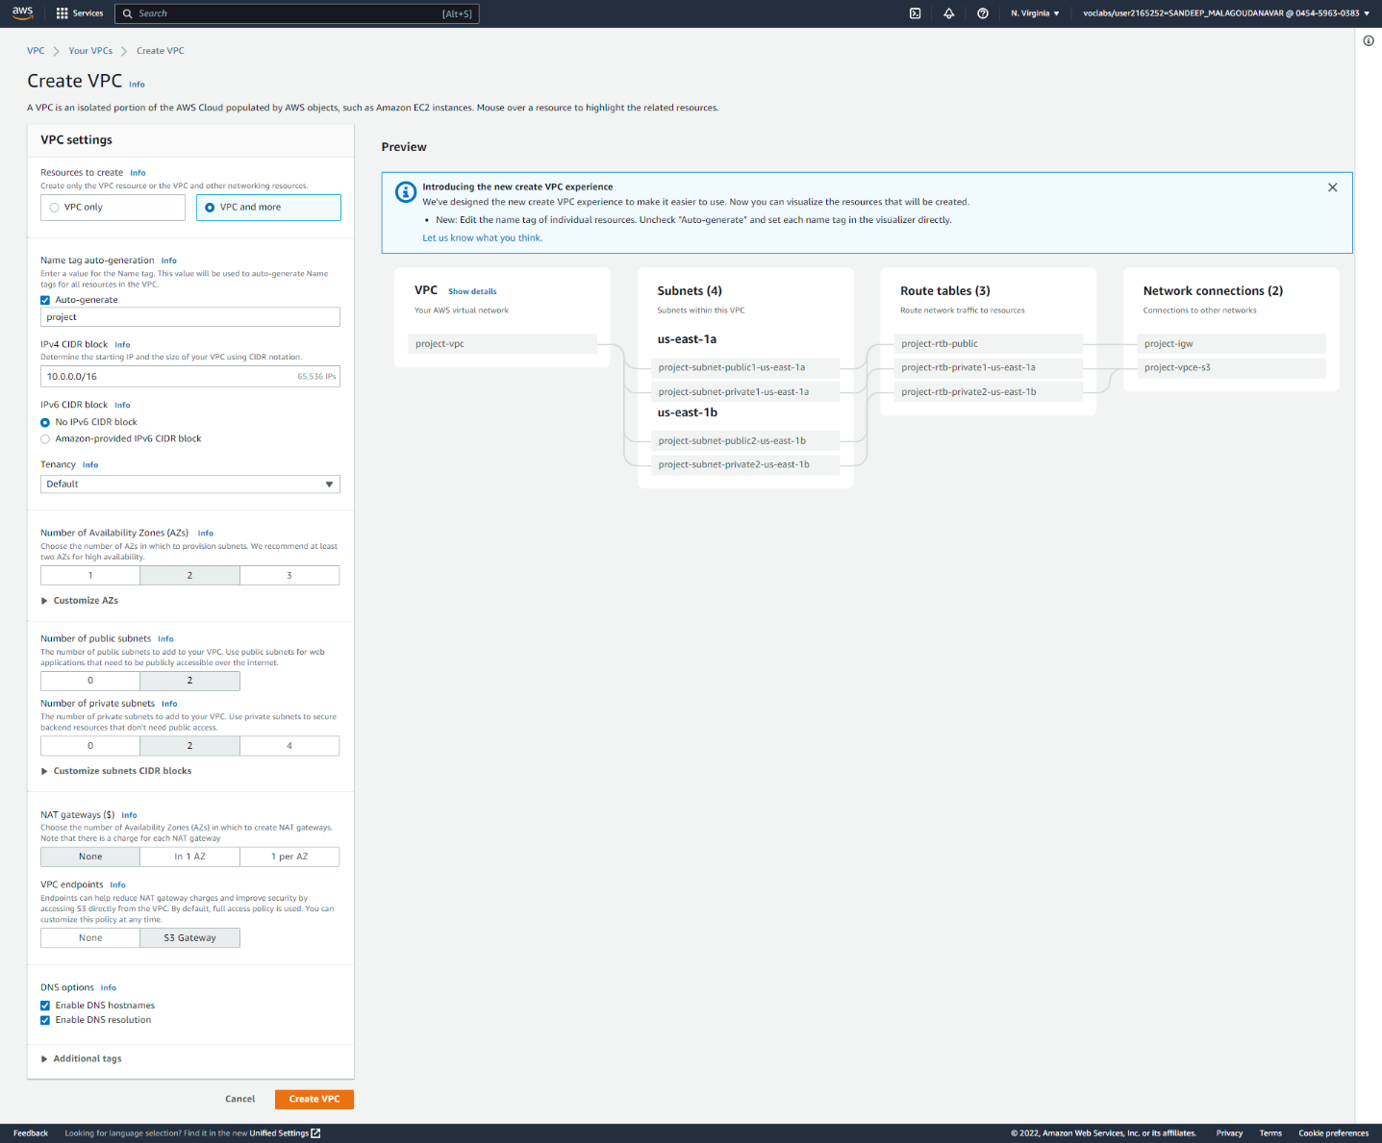

# Create a target group

By default, the load balancer sends requests to registered targets using the port and protocol that you specified for the target group. To route traffic to the targets in a target group, specify the target group in an action when you create a listener or create a rule for your listener. Add or remove targets from your target group at any time.

1. **create a DB instance in a VPC:**

*Assuming already we have created VPC*

1. We will create a DB subnet group
2. Create a VPC security group
3. Create a DB instance in the VPC

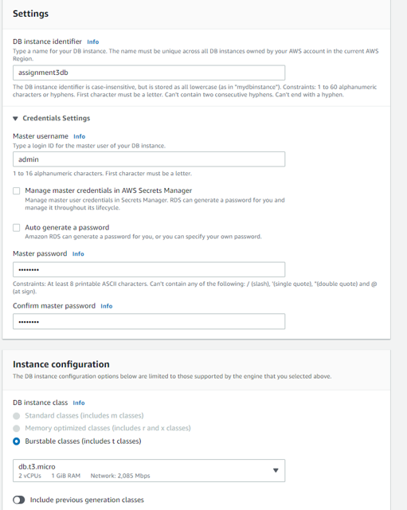

Note : Public access is set to NO. So that we can hide the DB instance from the public access.

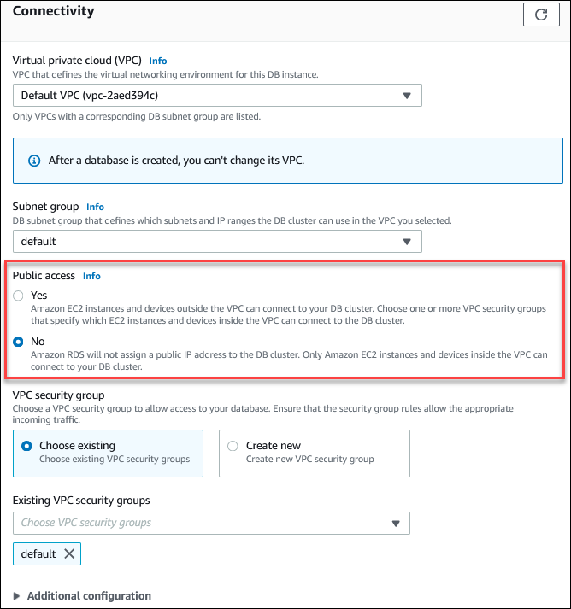

1. **create a DB subnet group**
2. Open the Amazon RDS console at <https://us-east-1.console.aws.amazon.com/rds/home?region=us-east-1>
3. choose **Subnet groups**.
4. Choose **Create DB Subnet Group**.
5. **Name**, type the name of your DB subnet group.
6. **Description**, type a description for your DB subnet group.
7. **VPC**, choose the default VPC or the VPC that you created.
8. **Add subnets** section, choose the Availability Zones that include the subnets from **Availability Zones**, and then choose the subnets from **Subnets - private**.

1. **Create a load balancer using the AWS Management Console, complete the following tasks.**

***Configure a target group - Already we create target group.***

1. Register targets
2. Configure a load balancer and a listener
3. Test the load balancer

Under **Application Load Balancer**, choose **Create**.

In next steps

* choose **Internet-facing** or **Internal**. An internet-facing load balancer routes requests from clients to targets over the internet. An internal load balancer routes requests to targets using private IP addresses.
* Select an existing security group
* For **Listeners and routing**, the default listener accepts HTTP traffic on port 80. You can keep the default protocol and port, or choose different ones. For **Default action**, choose the target group that you created.

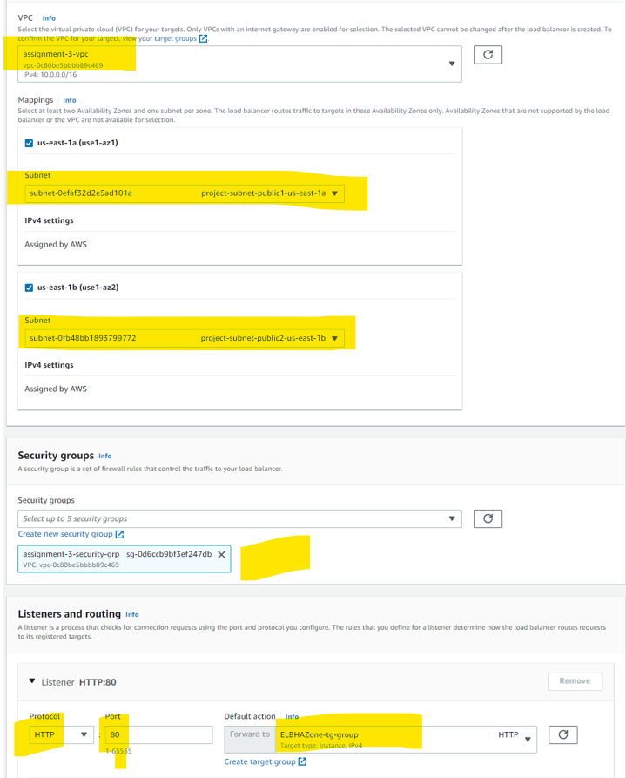

# 6. Launch configurations

A launch configuration is an instance configuration template that an Auto Scaling group uses to launch EC2 instances. When you create a launch configuration, you specify information for the instances. Include the ID of the Amazon Machine Image (AMI), the instance type, a key pair, one or more security groups. You can specify your launch configuration with multiple Auto Scaling groups

* Under Auto Scaling, choose Launch Configurations.
* In the navigation bar, select your AWS Region.
* Choose Create launch configuration and enter a name for your launch configuration.
* For Amazon machine image (AMI), choose an AMI – may be our custom AMI create with webservers.

