**Exercise 9**

Marc Teixeira

Grand Canyon University: CST - 117

Date: 03/31/2021

Exercise 9

Github Link: <https://github.com/MTeixeiraGCU/CST-117.git>

Description:

In the code I found to sections with errors. The first being inside the containsElement method. On the first iteration of the for loop, the algorithm will always exit. It needs to check all the elements and upon finding no matches, only then exit with false. The second section with errors is in the union method. Initially the method was looping through the right-hand side Set and adding it to the left-hand side, thereby changing the original lhs. It needs to create a new set from the union of the two.

Screenshots of breakpoints:

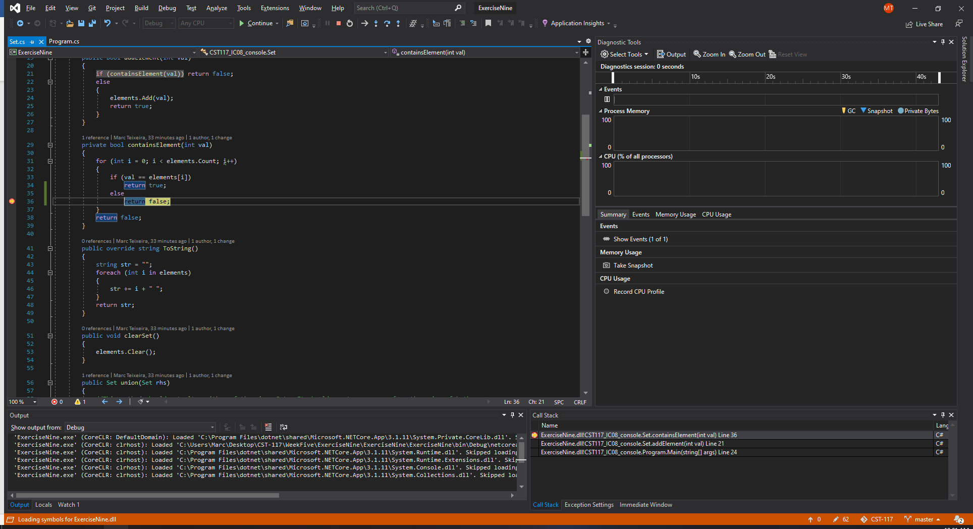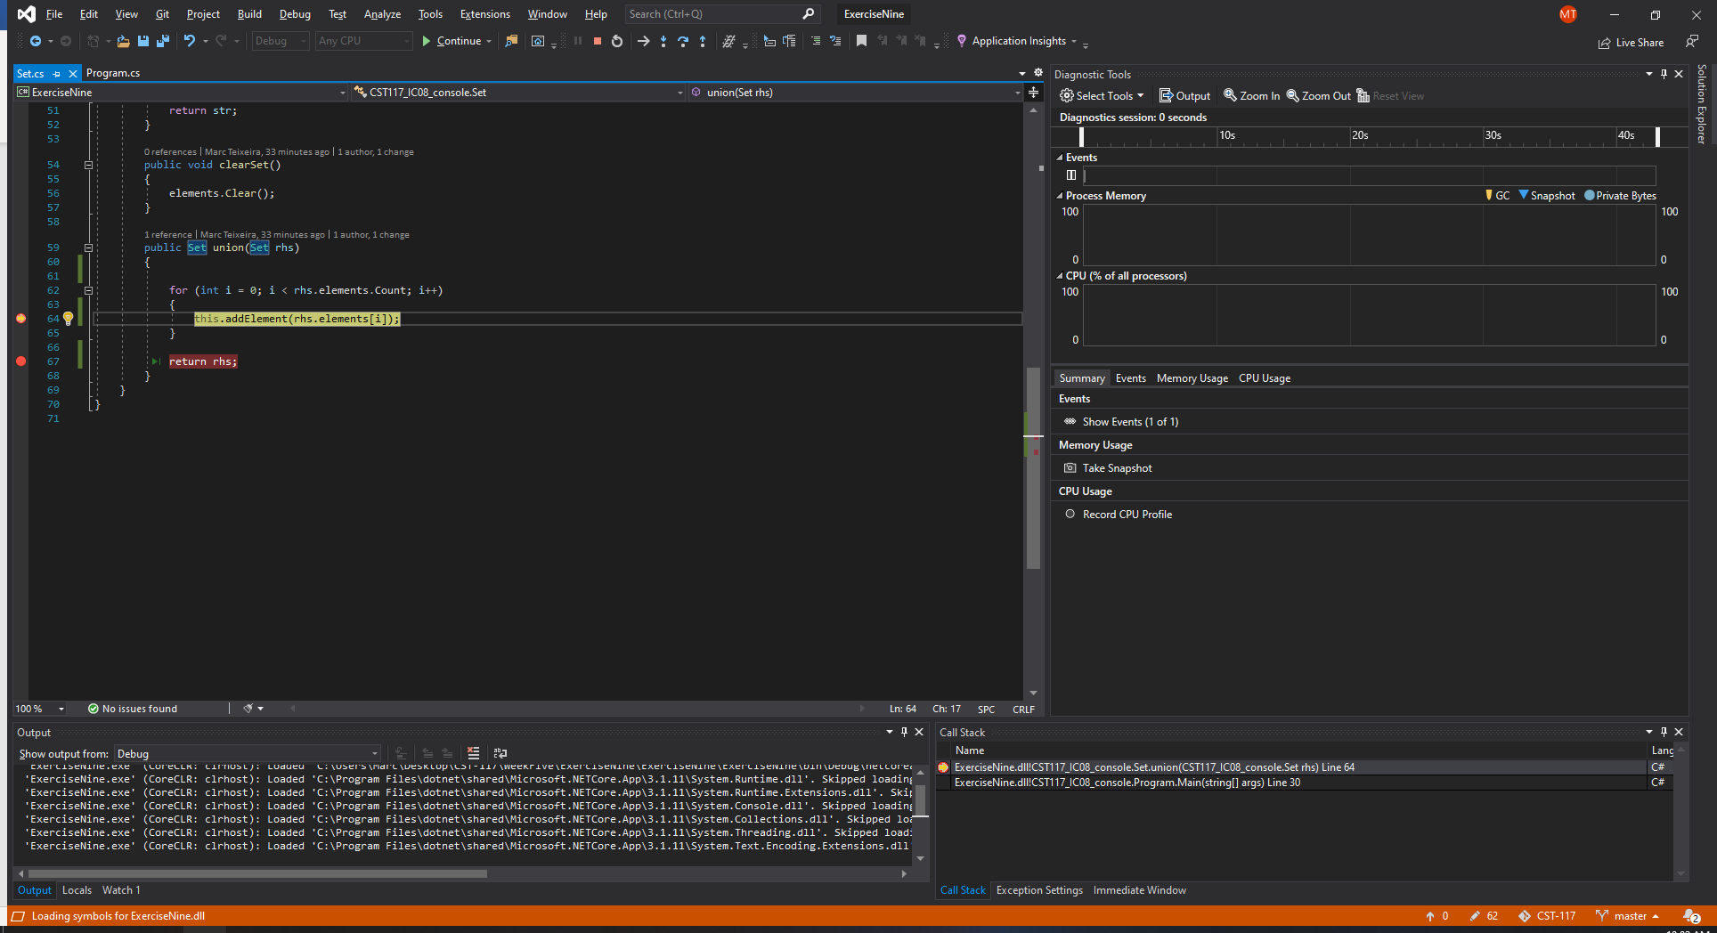

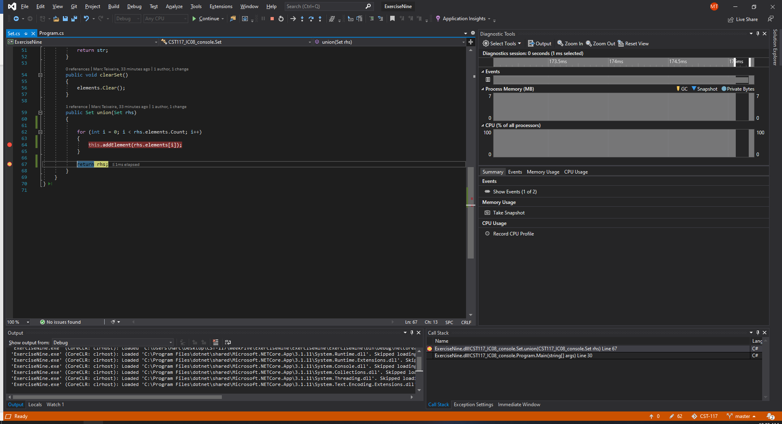

Screenshots after of fixes:

