**Milestone 2**

Marc Teixeira

Grand Canyon University: CST - 117

Date: 03/28/2021

Milestone 2

**Summary**

Github link: <https://github.com/MTeixeiraGCU/CST-117.git>

For this milestone I implemented the Employee class. Each employee object has and ID, Name, Wage amount, Position, and Department. To test the classes functionality, I placed it into the high-fidelity prototype. Within the application you can view, remove, add, and edit employees from the mock list.

**UML Diagram**

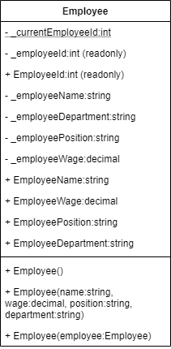

**Implementation of Employee Class**

Screenshots of Employee Class:

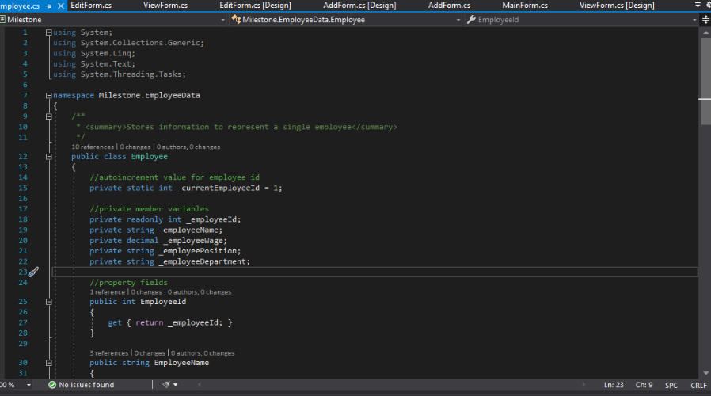

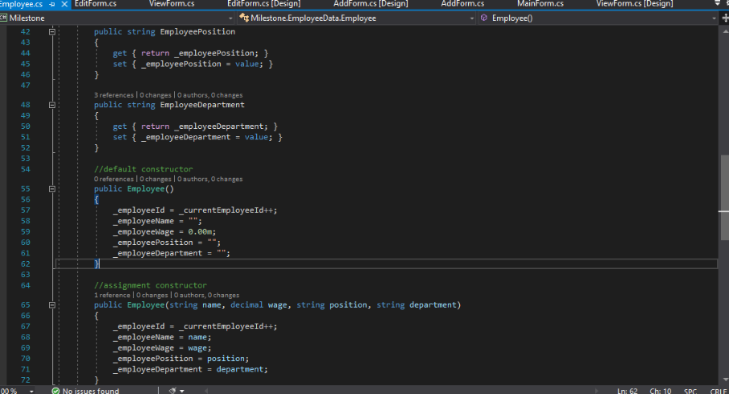

**Test of the Employee Class**

Screenshots in the high-fidelity prototype:

