**Milestone 1**

Marc Teixeira

Grand Canyon University: CST - 117

Date: 03/06/2021

Milestone 1

Github Link: <https://github.com/MTeixeiraGCU/CST-117.git>

**Part 1**

The design that I am choosing to develop for the Milestone project will be a system to track employee information. Employees can be added, removed, edited, filtered, and searched for from the list. Each employee will also have several properties tied to them:

employeeId as an int, used to identify each employee with a unique number

employeeName as a string, each employee’s full name, first and last

employeeWage as a decimal, the employee’s hourly wages

employeePosition as a string, which position the employee has in the company

employeeDepartment as a string, the department that the employee belongs to.

**Part 2**

Screenshots of wireframes:

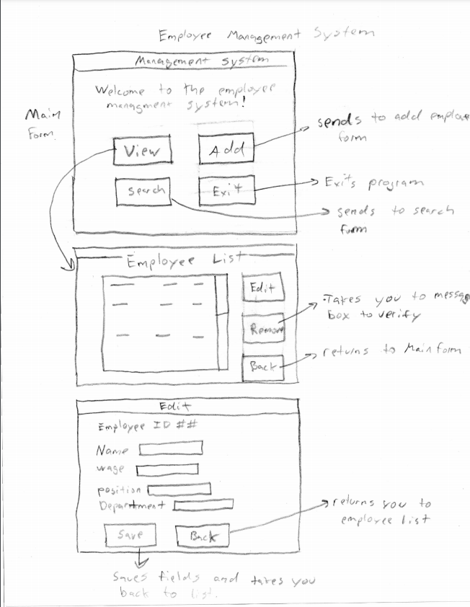

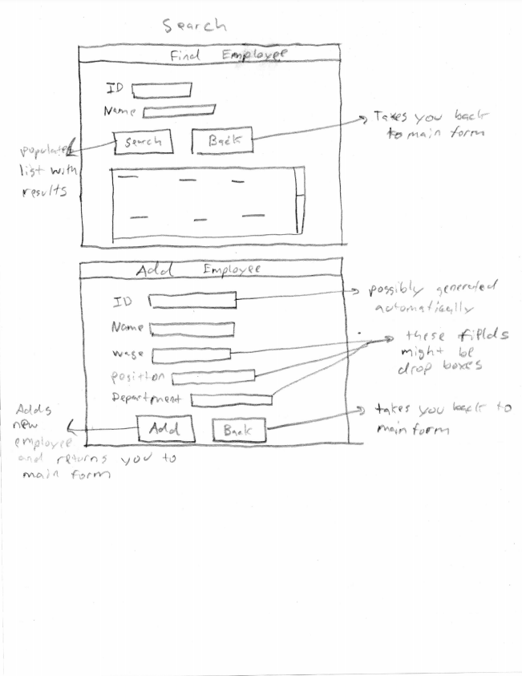

**Part 3**

Screenshot of mock forms for application:

