**Milstone 5**

Marc Teixeira

Grand Canyon University: CST - 117

Date: 04/15/2021

Milestone 5

**Description**: In this version of the application, a few of the forms were rearranged and cleaned up. This was to support the addition of saving and loading the list of employees. The user is now prompted to load a list from file before they use the application. If they decide not to, the mock list will be loaded, otherwise the file they chose will be parsed into the list. Additionally, upon exiting the application the user is asked whether they would like to save their work to file before they leave.

**Github Link**: <https://github.com/MTeixeiraGCU/CST-117.git>

**Video Presentation Link**: <https://youtu.be/PqzdmWe6-c8>

**UML Diagram**:

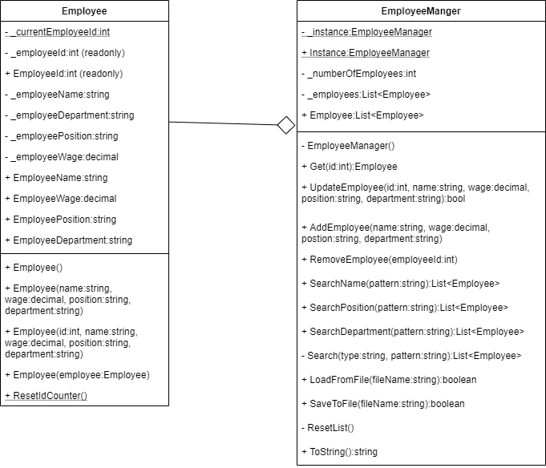

**Screenshots**:

