**Milestone 4**

Marc Teixeira

Grand Canyon University: CST - 117

Date: 04/15/2021

Milestone 4

**Description/Brief Walkthrough**: The application starts by presenting the user with options to view, add, or search for employees in the list. The view section will allow editing and removing employees. The add form lets the user type in the new employees’ information, minus the auto generated ID, to create and append them to the list. Searching for employees gives the user the option to search by Name, employee Position, or the department they are in. All of these can be used separate or together to filter employees.

The main change for this milestone was that instead of an array being used to back the collection of employees, EmployeeManager uses a List now. This required several changes to the add and remove methods within the class. Removing an employee from the View menu was also broken due to the way the List is passed and error checking was needed on that form.

**Techniques Learned**: Managing multiple forms was a key technique that I used for this project. The main form branches off to several focused forms and keeping the flow of the interface was very important. Commenting throughout the project also helped a great deal. It made it easier to keep track of what each of the button event methods was doing as well as tracking the Employee and EmployeeManager classes usage.

**Problems Encountered**: One of the main issues that came up was how to display the entire list of Employees to the user. It was given as an open-ended part of the project and finding the right fit in all the controls was a little difficult. I started off with a ListView, but that did not have the correct structure with selectable elements and headers. I ended on the DataGridView to store the list and it gave a lot of customization with respect to column management.

**Github Link**: <https://github.com/MTeixeiraGCU/CST-117.git>

**Screenshots**:

New employee List structure with changed Add and Remove Methods.

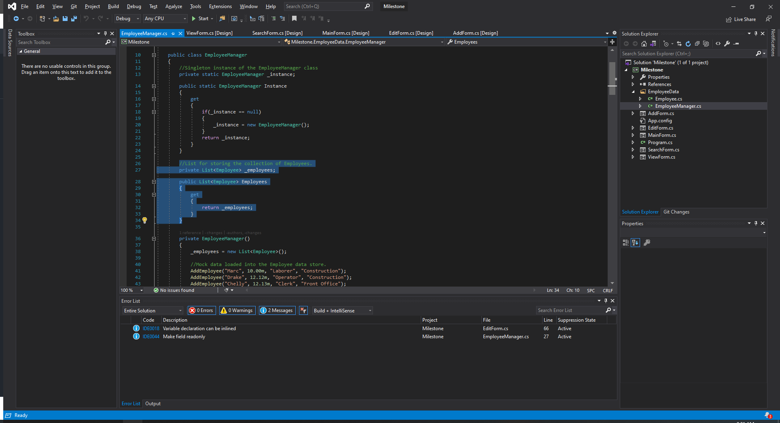

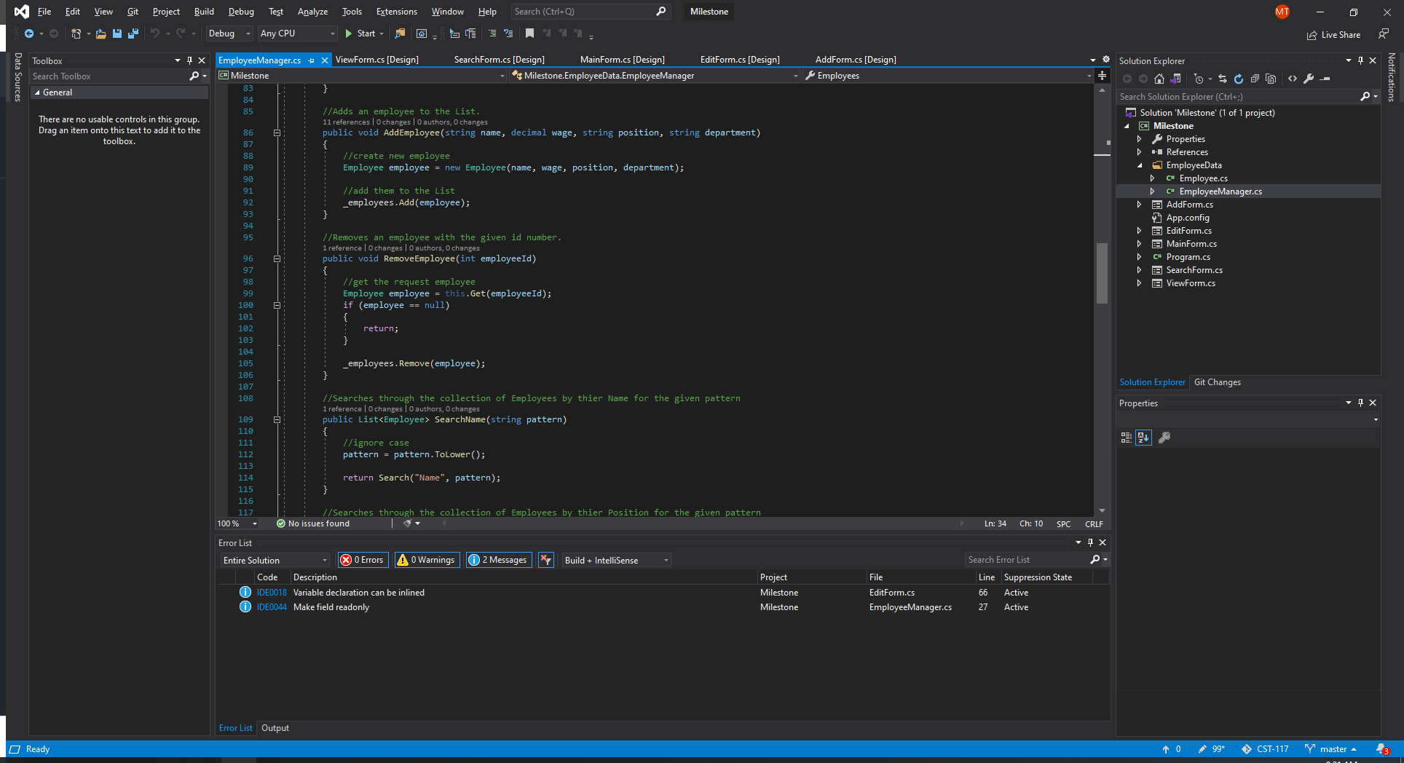

Program running as before

