**Milestone 3**

Marc Teixeira

Grand Canyon University: CST - 117

Date: 04/10/2021

Milestone 3

**Description**: In this milestone, we were asked to implement an Inventory Manager class. I decided to keep the initial Employee Object as the item to be managed and created an EmployeeManager class to track an array of Employees. To test its functionality, I placed it into the high-fidelity model. The class was designed as a singleton to give access to it from all the forms in the program. In the model, I added support for all the CRUD operations required, such as adding and removing an Employee, editing existing entries, getting a single Employee, and printing an Employee. It also allows for searching by either employee name, position, or department.

**Github Link**: <https://github.com/MTeixeiraGCU/CST-117.git>

**UML Diagram**: 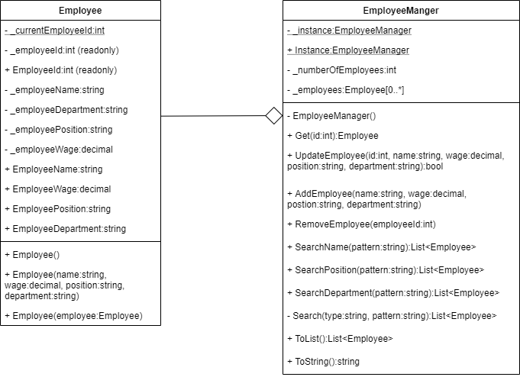

**Screenshots**:

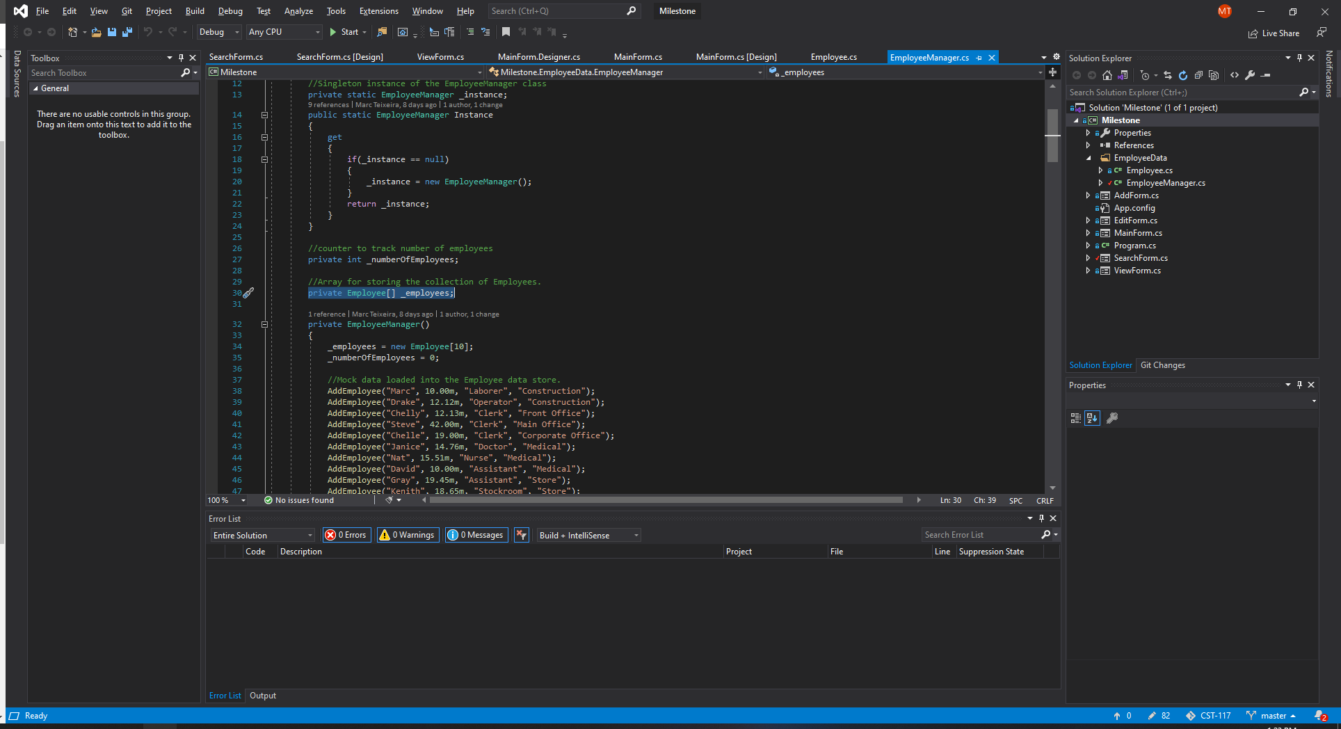

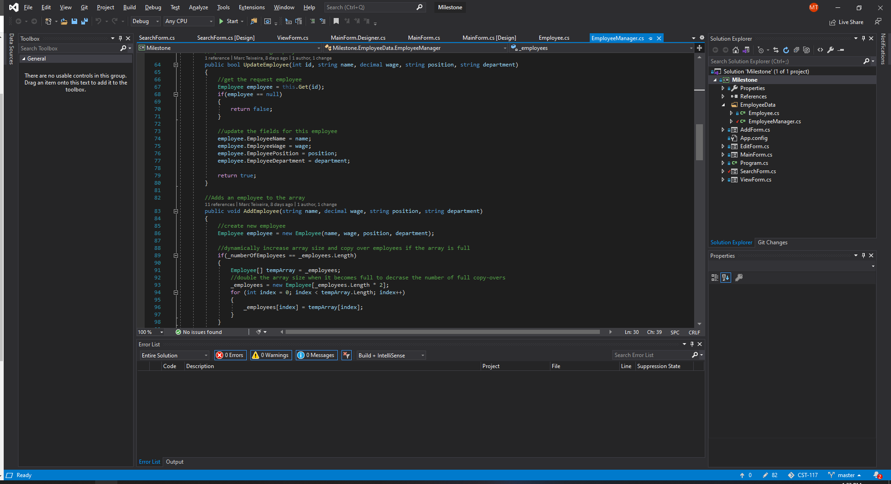

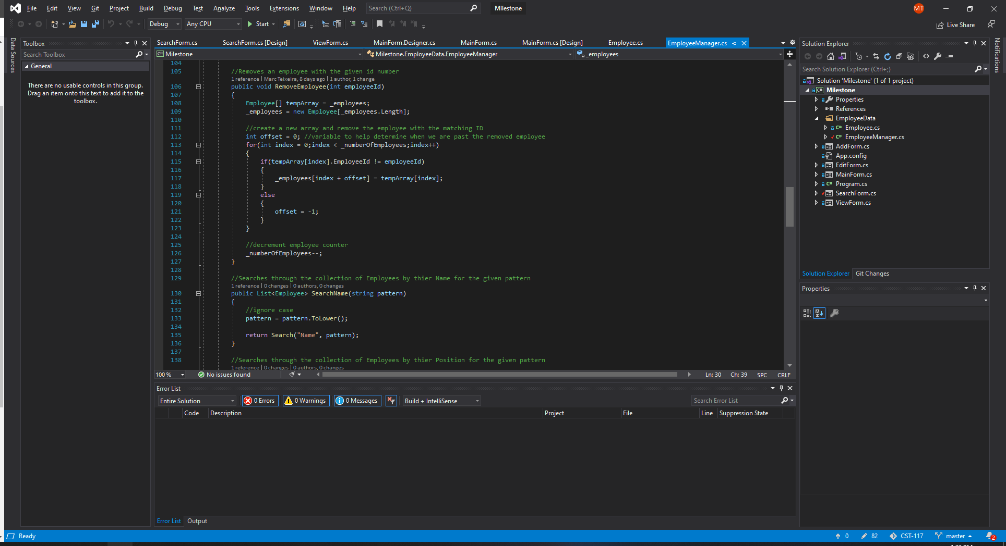

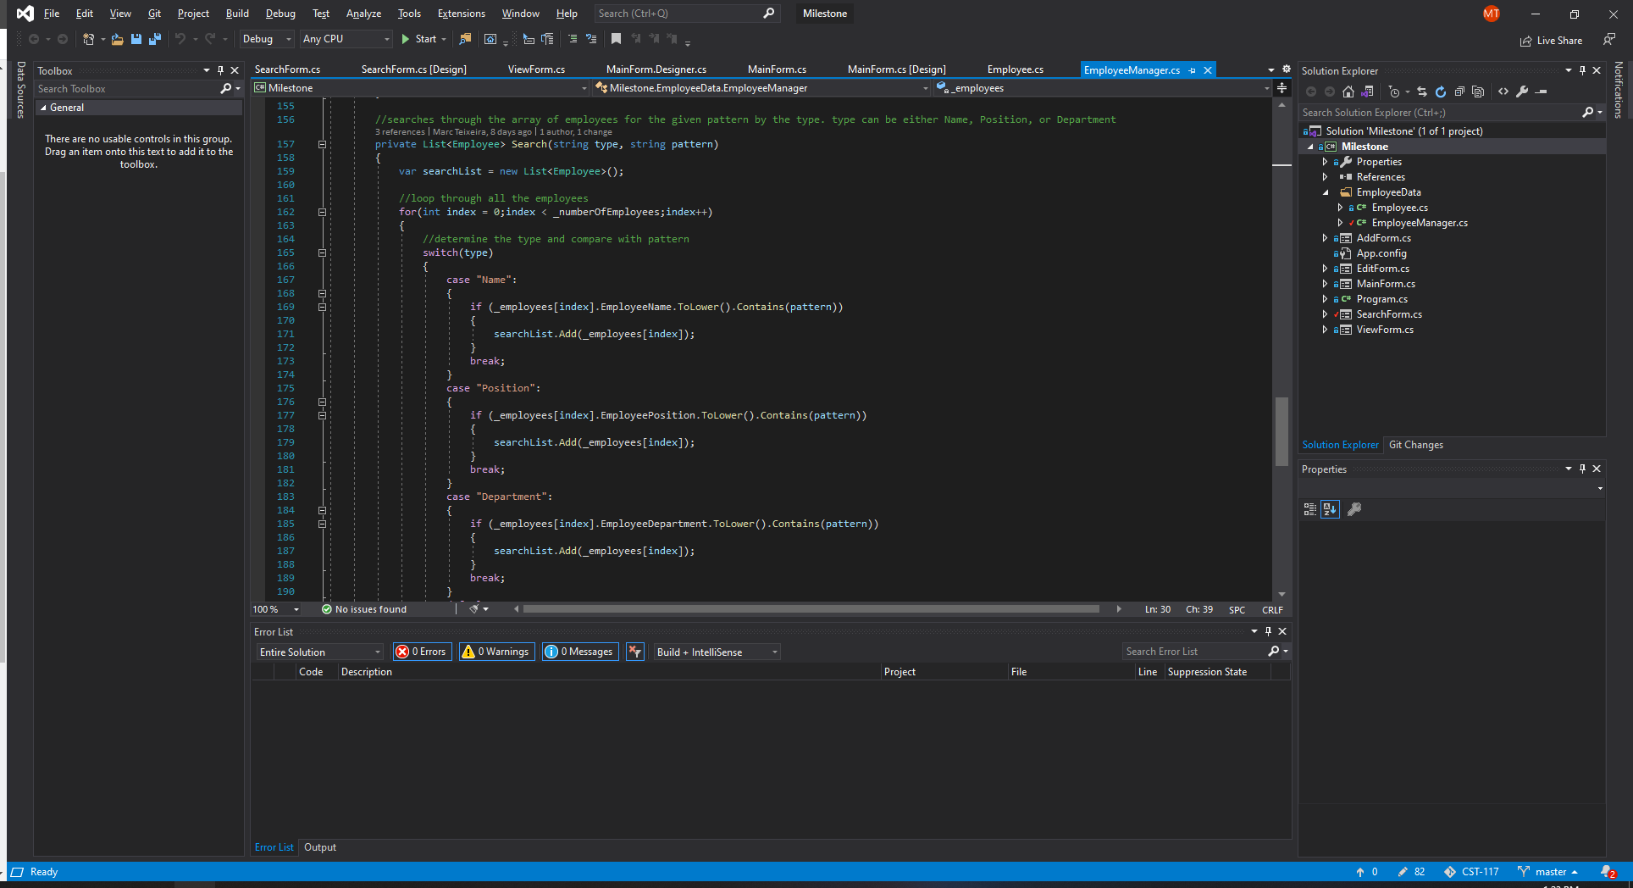

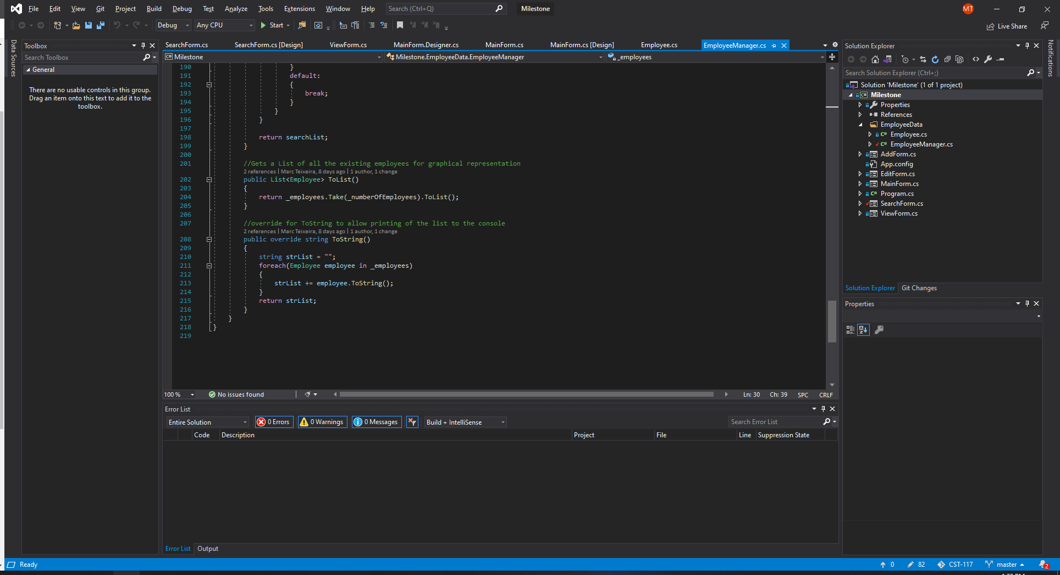

Search Functionality:

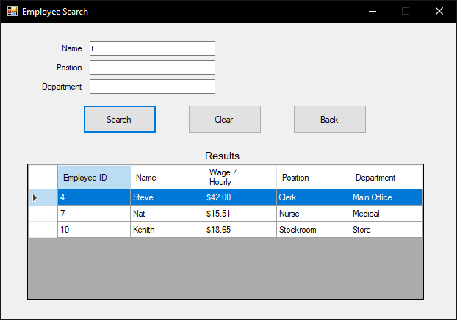

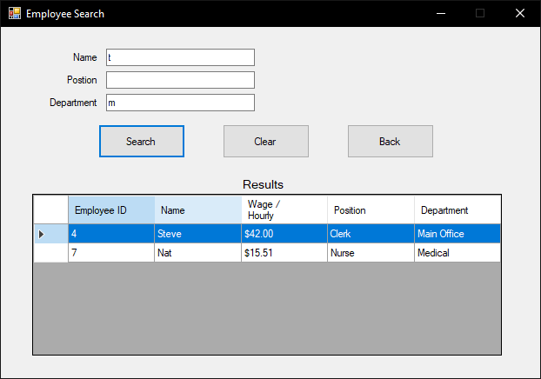

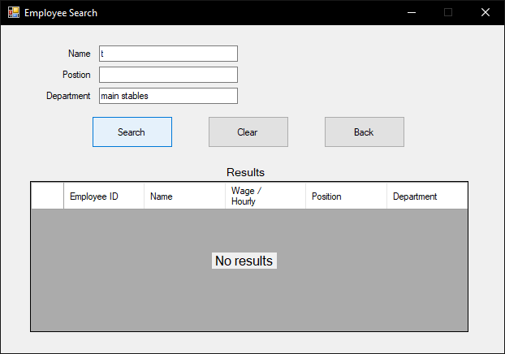

Adding and removing:

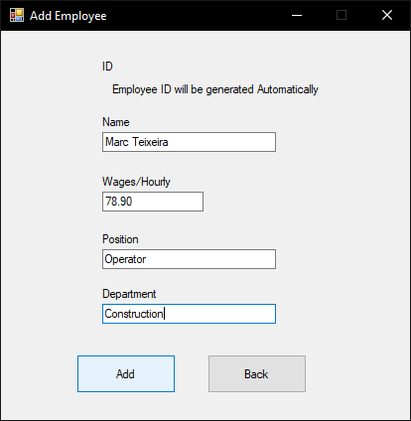

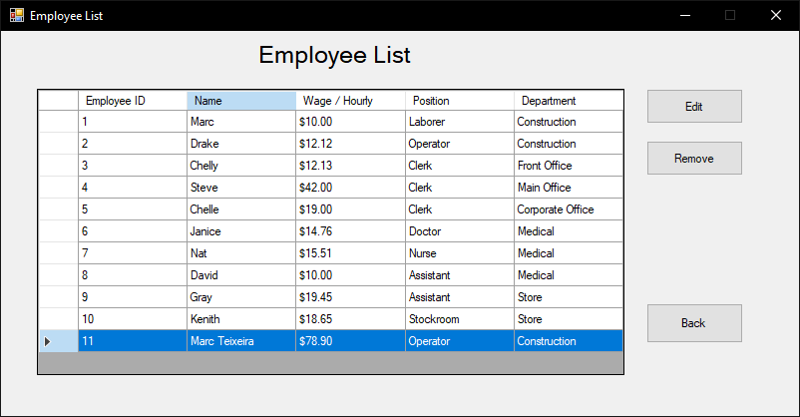

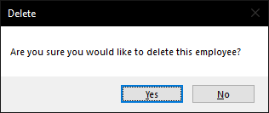

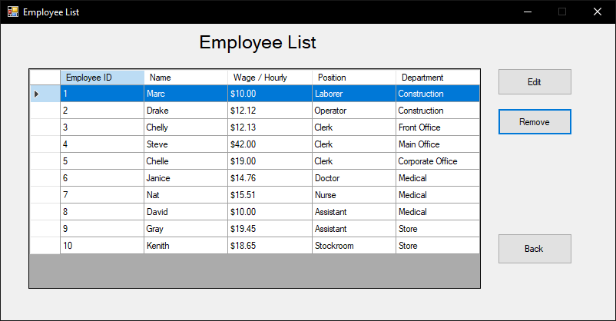

Editing an existing employee:

