Name: Marc Teixeira

Date: 07/29/2020

Course: CST-235

Instructor: Charbel Elkhoury

Git Link:

Databases

Part 1:

Screenshot from pgAdmin_4 of SELECT statement showing ten entries in the testapp.Orders table:

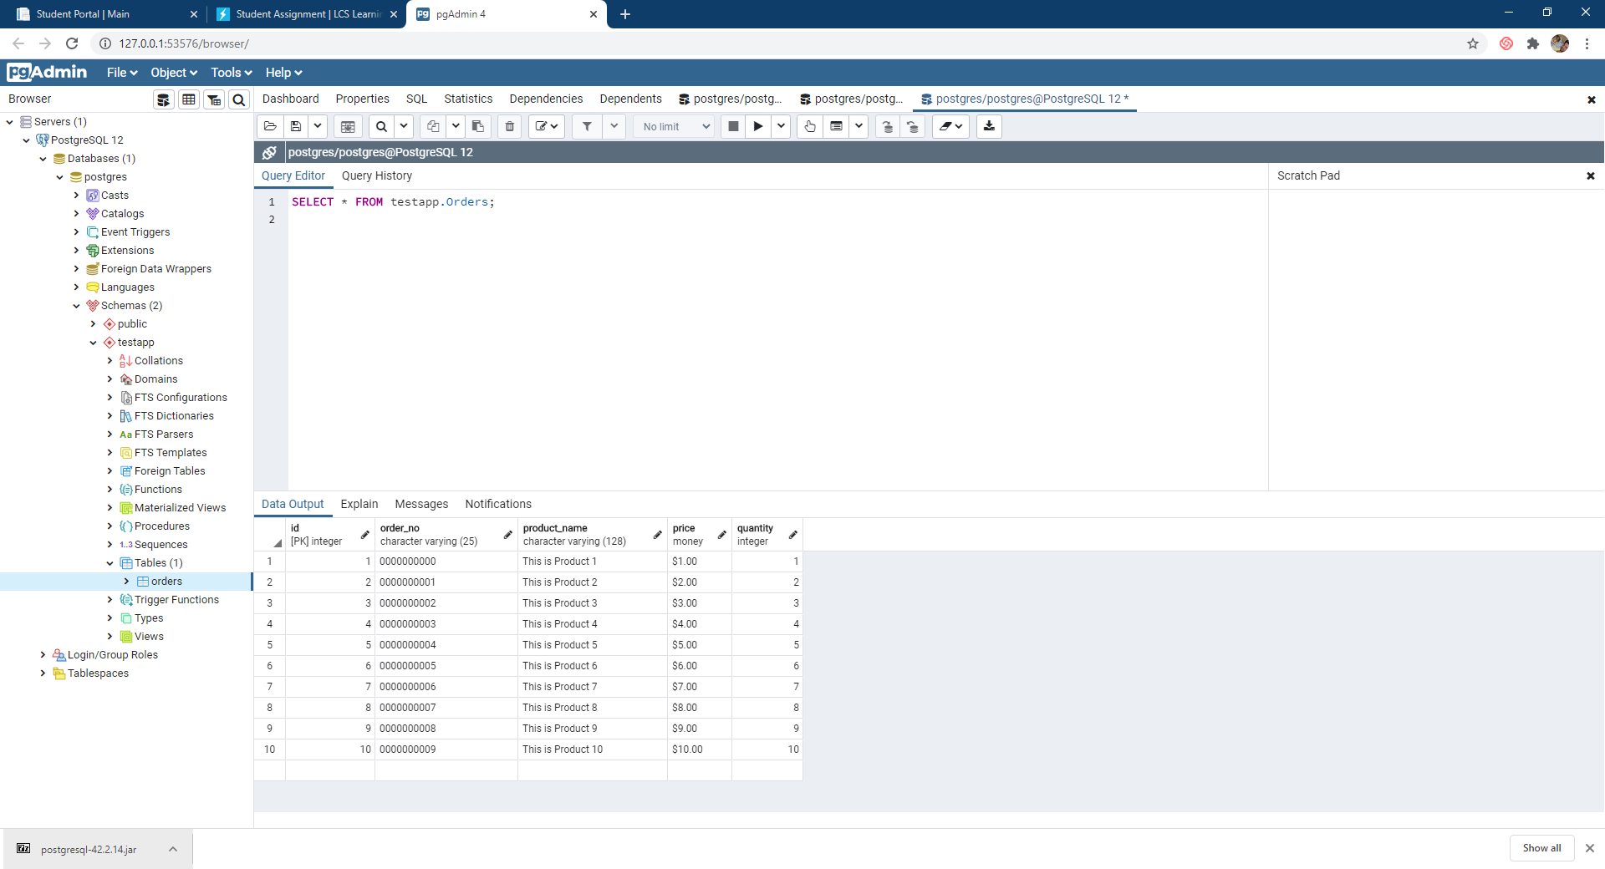

Part 4:

Screenshot from successful connection open and close to PostgreSQL database:

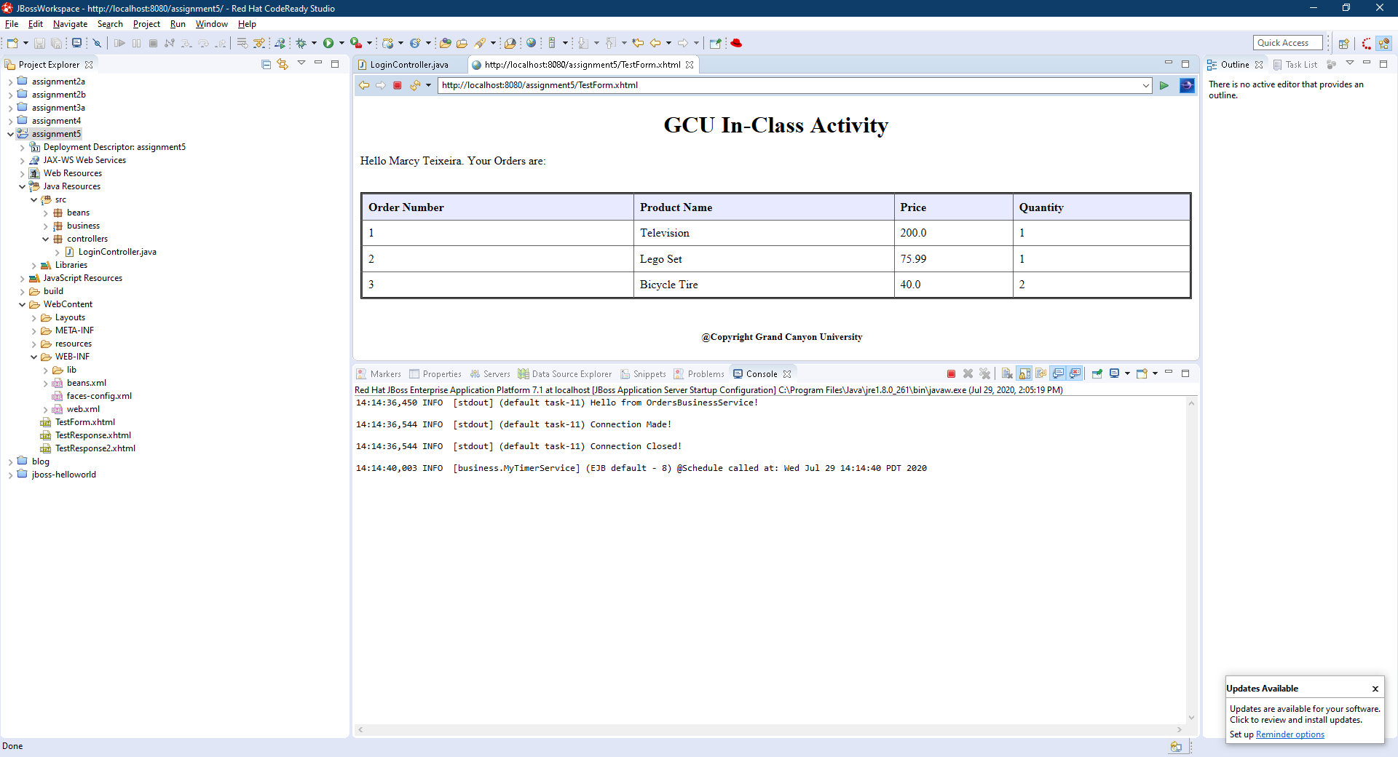

Screenshot from console printing the contents of the testapp.Orders table:

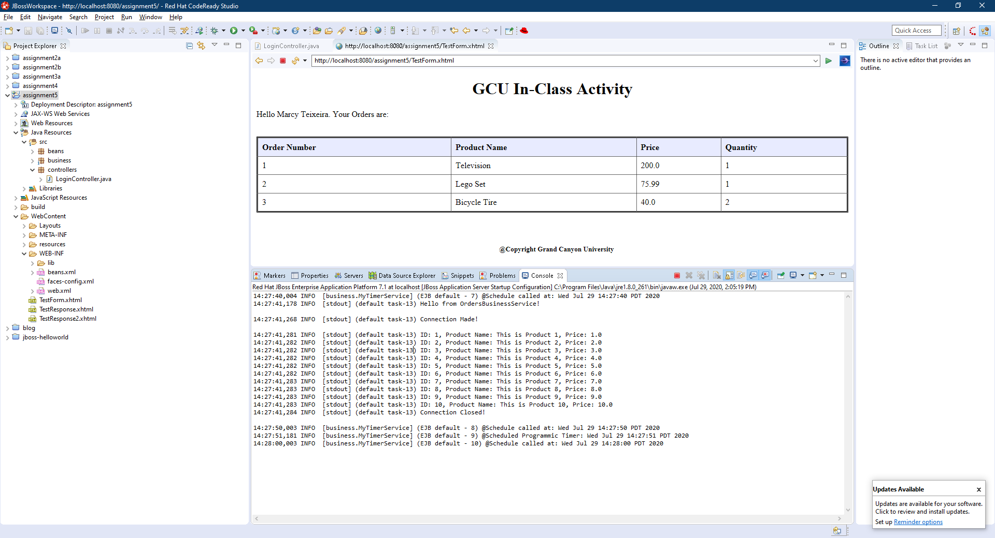

Part 5:

Screenshot from successful insert into the database:

