Name: Marc Teixeira

Date: 07/21/2020

Course: CST-235

Instructor: Charbel Elkhoury

Git Link: <https://github.com/MTeixeiraGCU/CST-235/tree/master/WeekFour>

Design and Implement an Enterprise Java Bean

Part 1:

Screenshot of OrdersBusinessService as the alternative:

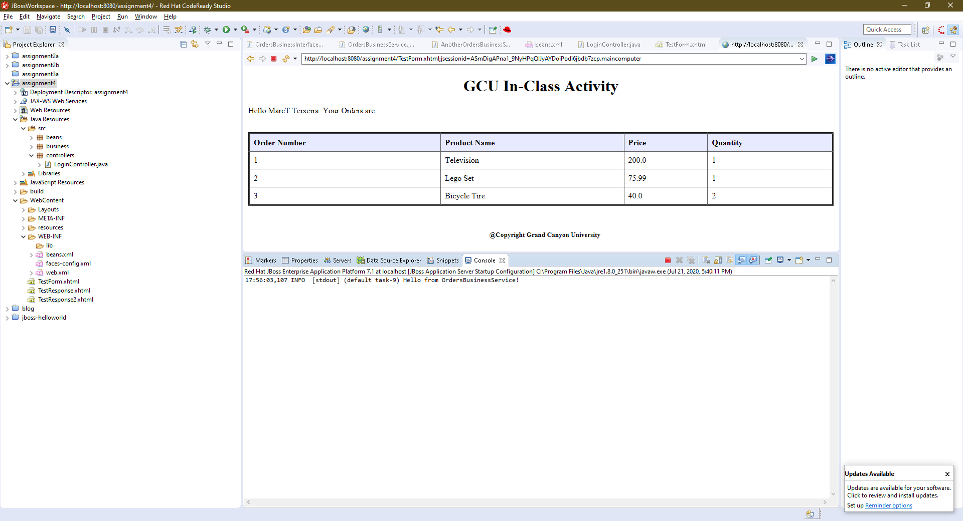

Screenshot of AnotherOrdersBusinessService as the alternative:

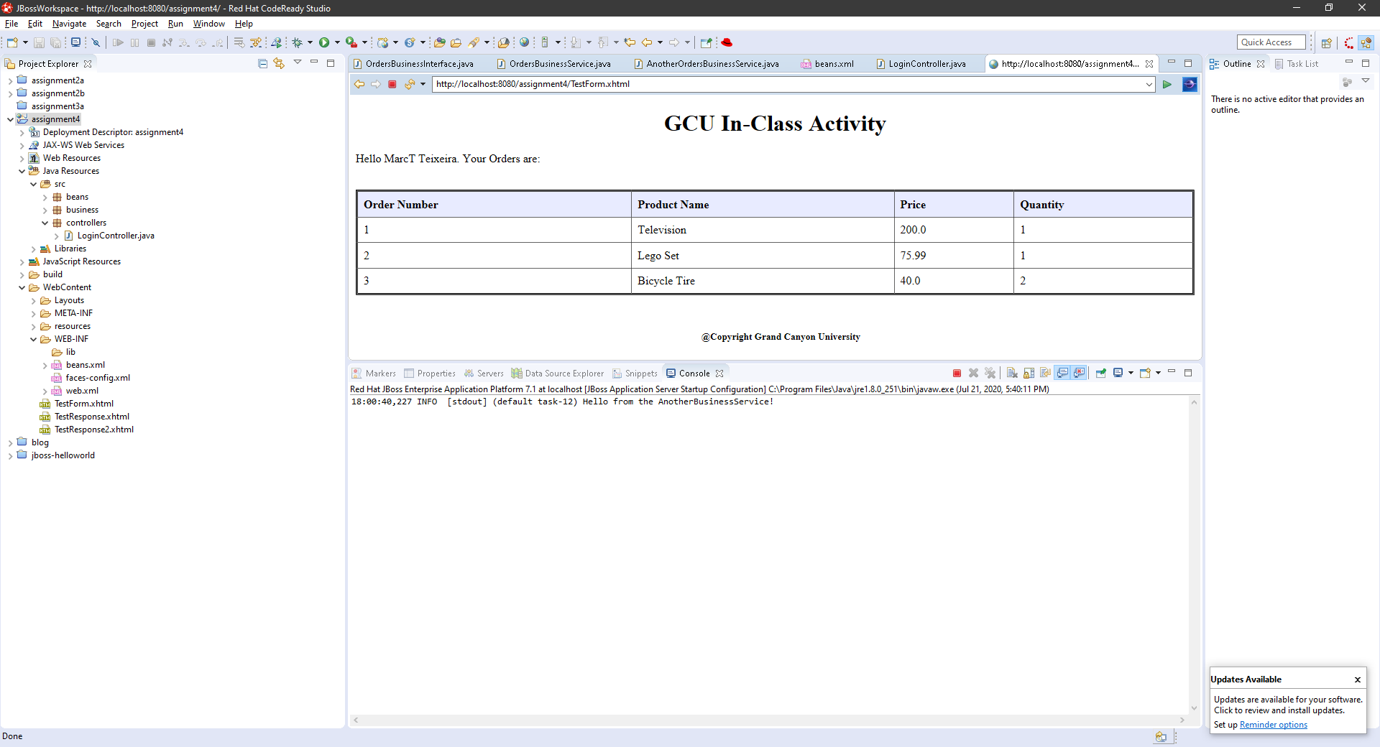

Part 2:

Screenshot from AnotherBusinessService with an added orders list:

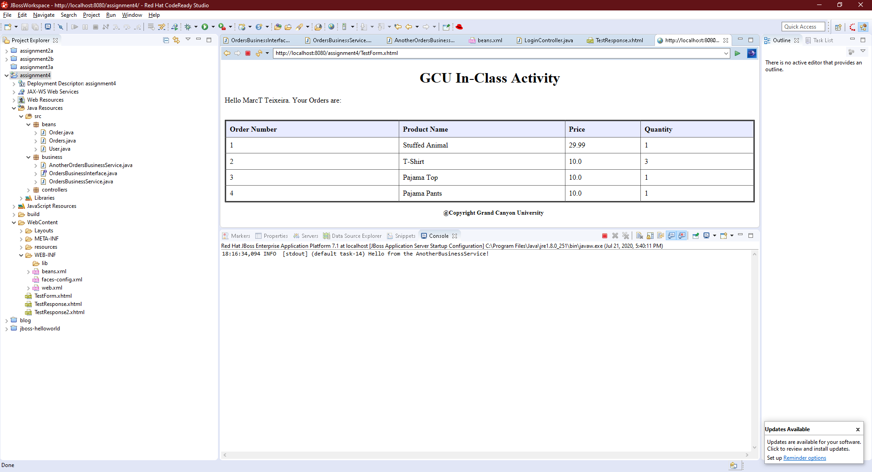

Screenshot from OrdersBusinessService with an added orders list:

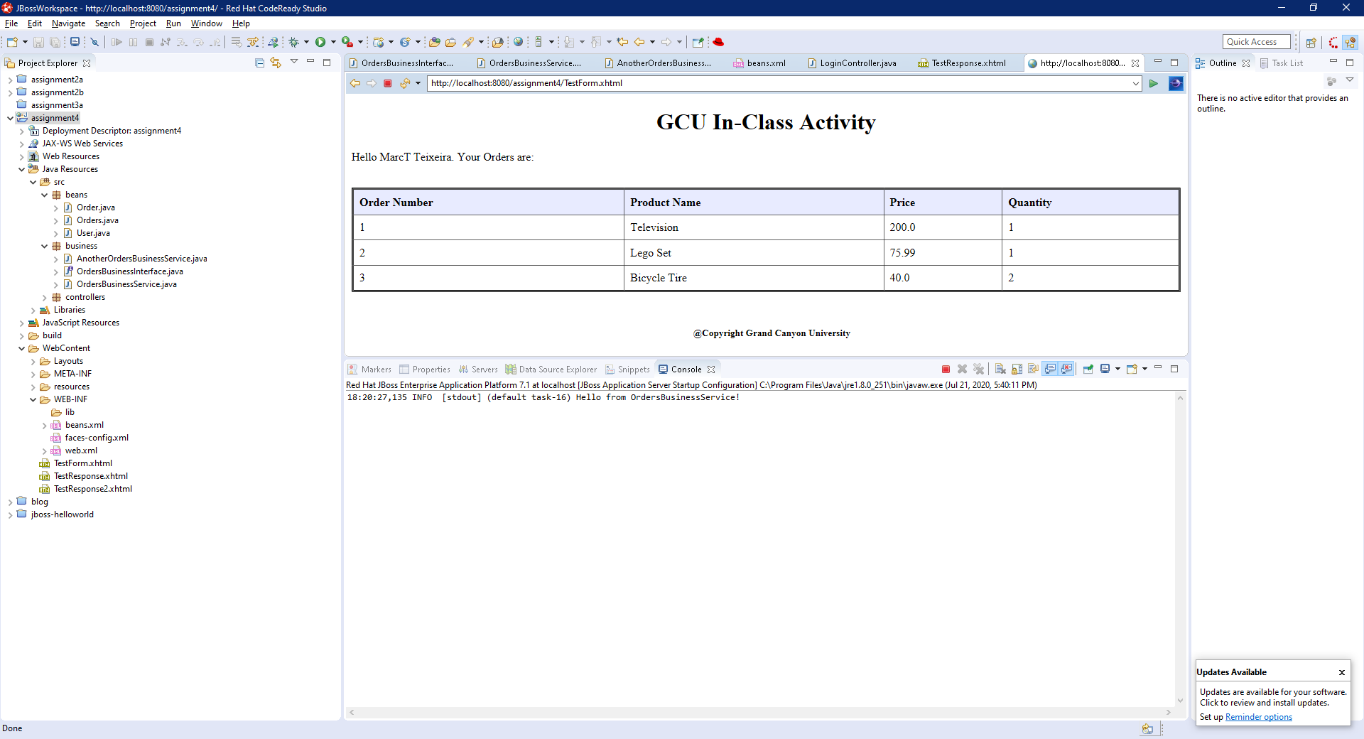

Part3:

Screenshot of MyTimerService ticking every 10 sec. and Programmic Timer once 10 sec after form submit:

