Name: Marc Teixeira

Date: 08/03/2020

Course: CST-235

Instructor: Charbel Elkhoury

Git Link: <https://github.com/MTeixeiraGCU/CST-235/tree/master/WeekSix>

Assignment 6a

REST-based services and Message-based services

Part 1:

Screenshot from getjson and getxml RESTful service calls:

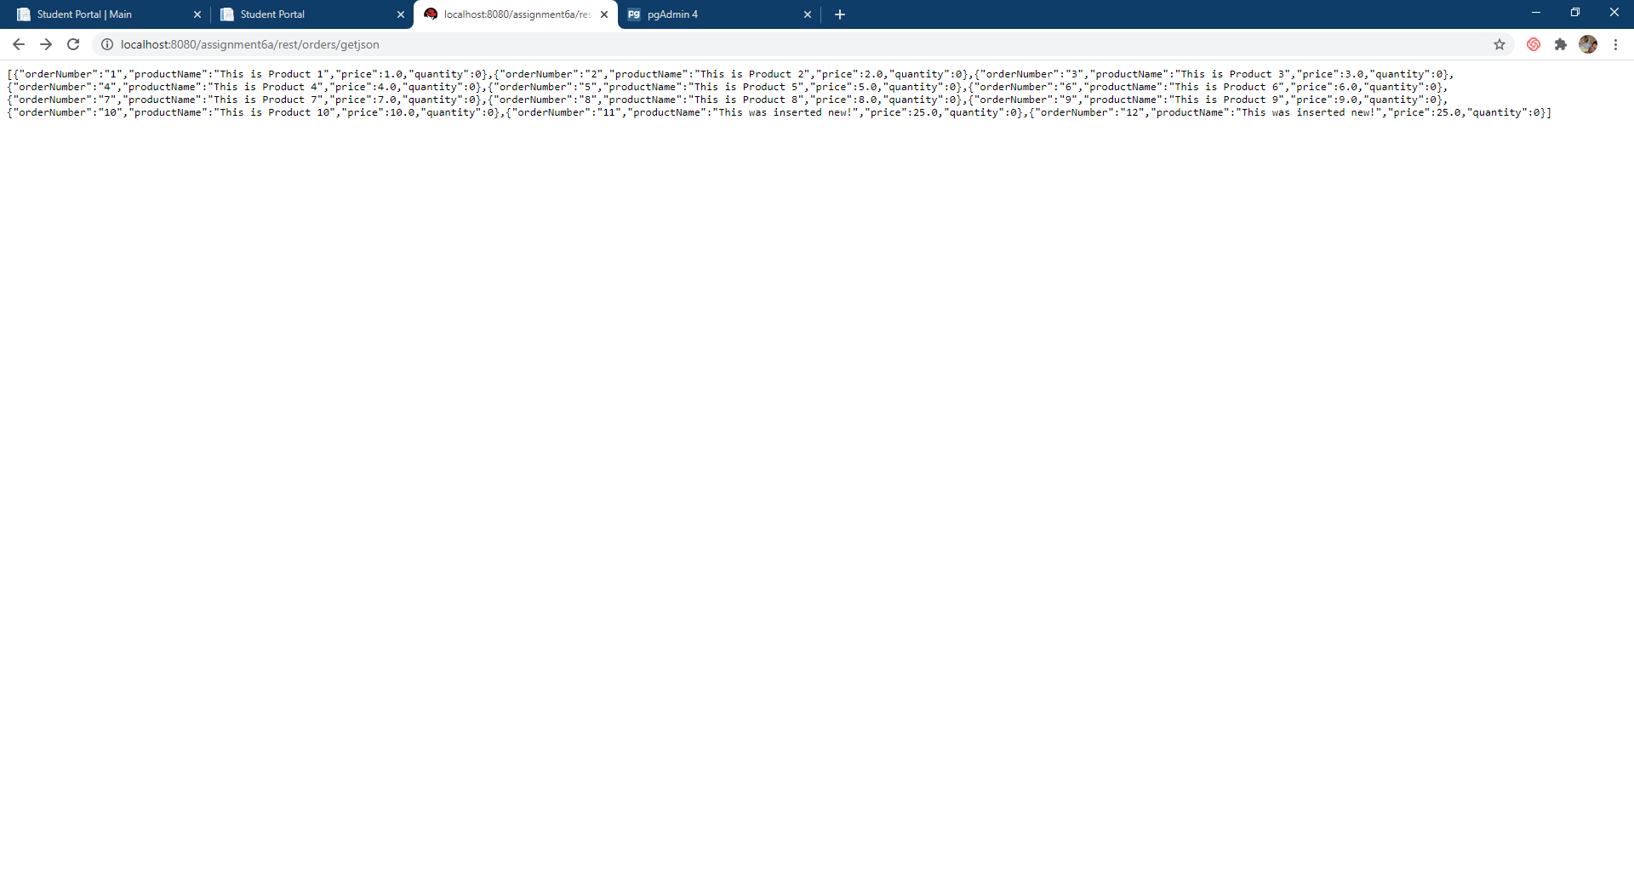

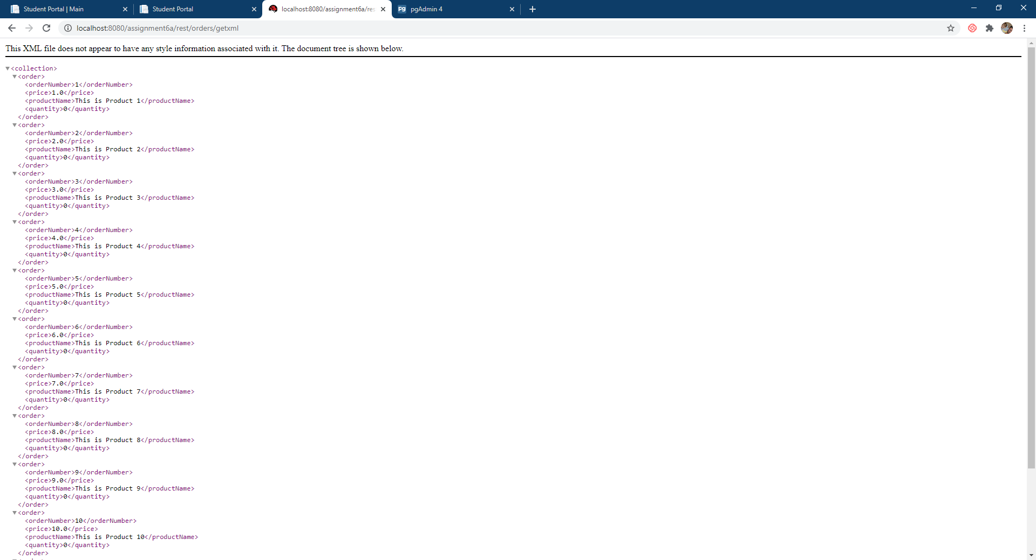

Screenshot from Json and XML REST Services through Postman:

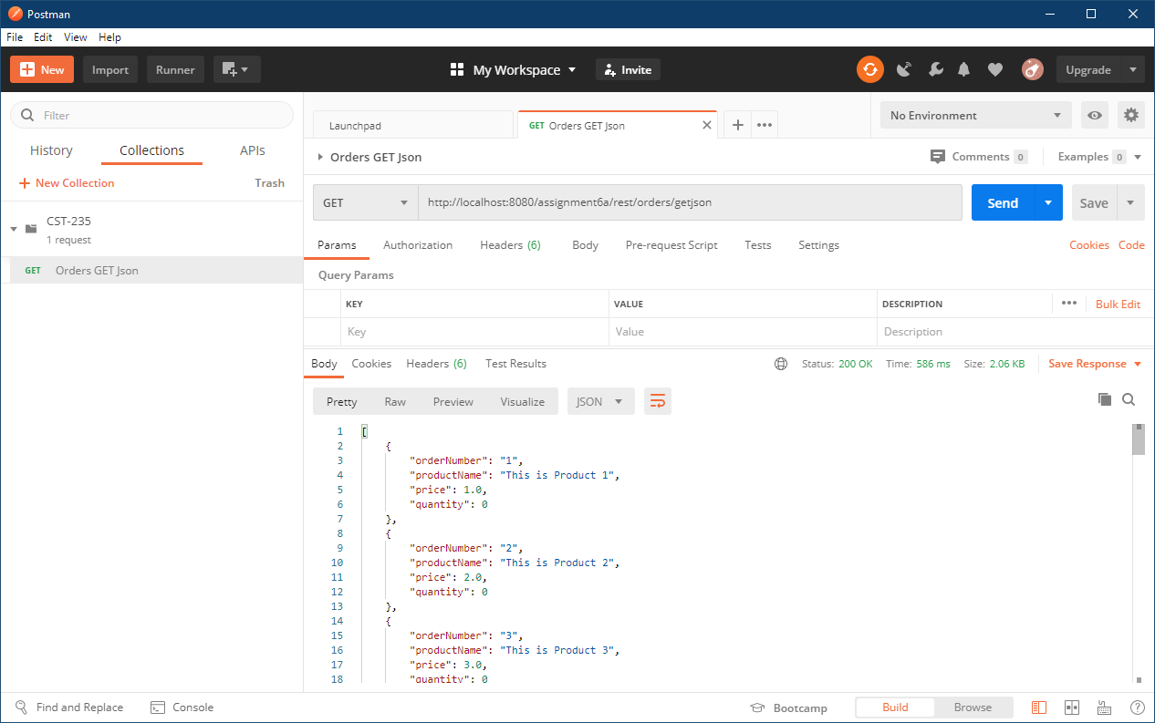

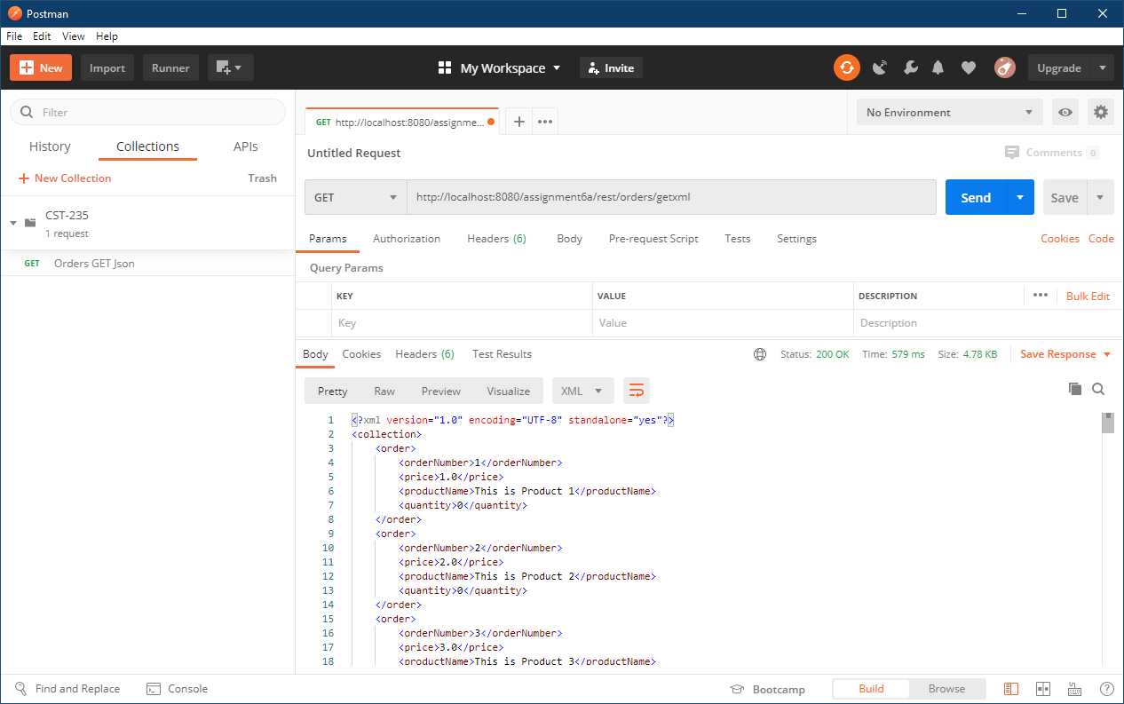

Part 2:

Screenshot of Send Order Confirmation Page for Message Queue:

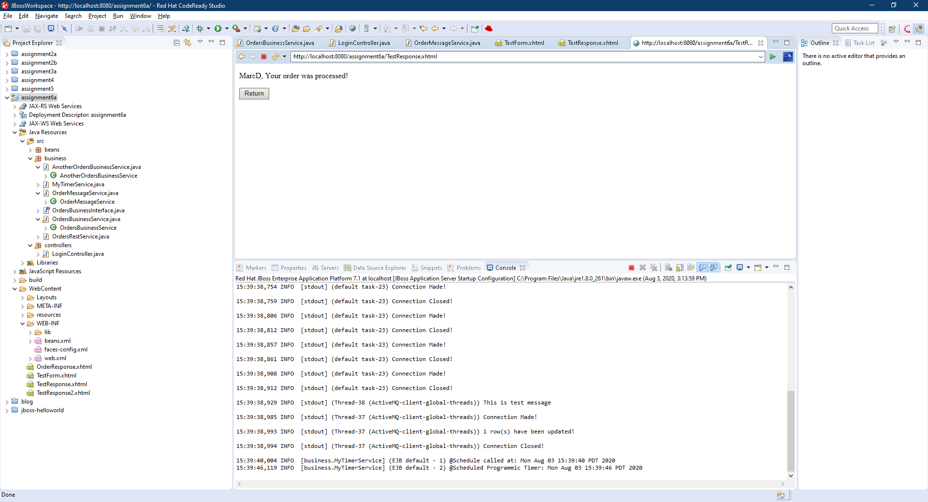

Screenshot of the new Order on the bottom of the list from Message Queue:

