Name: Marc Teixeira

Date: 08/07/2020

Course: CST-235

Instructor: Charbel Elkhoury

Git Link: <https://github.com/MTeixeiraGCU/CST-235/tree/master/WeekSix/benchmark>

Benchmark: RESTful Web Service

Rest service running on localhost:

Screenshot of a simple request for a verse using book/chapter/verse:

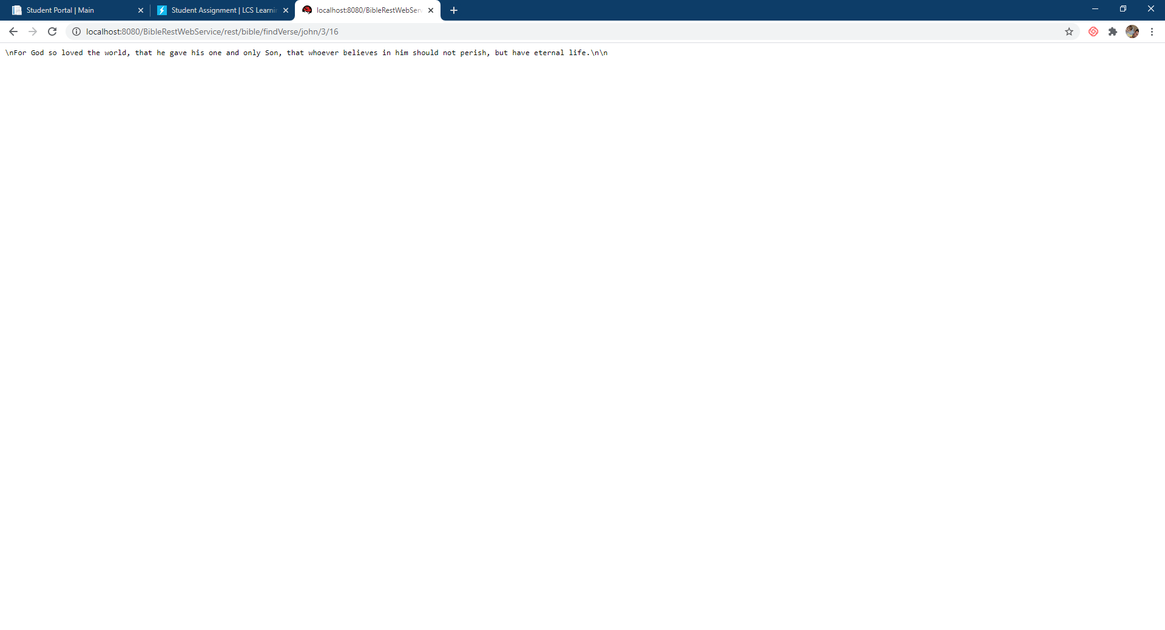

Screenshot of Rest Service code:

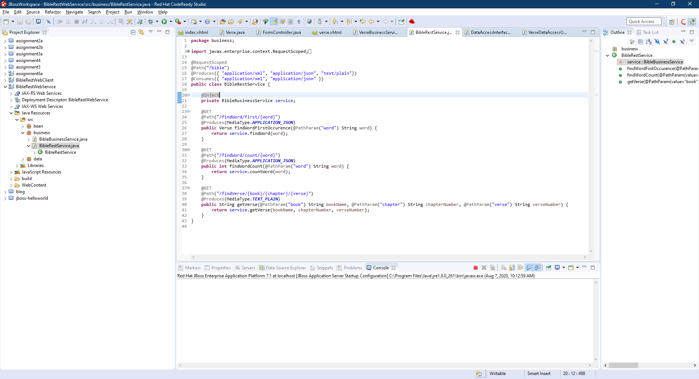

Rest service being used from a separate Client application:

Screenshot of form before submission:

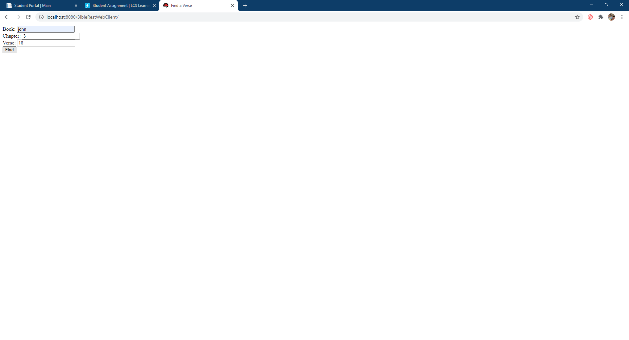

Screenshot of verse retrieved from the REST service by the form:

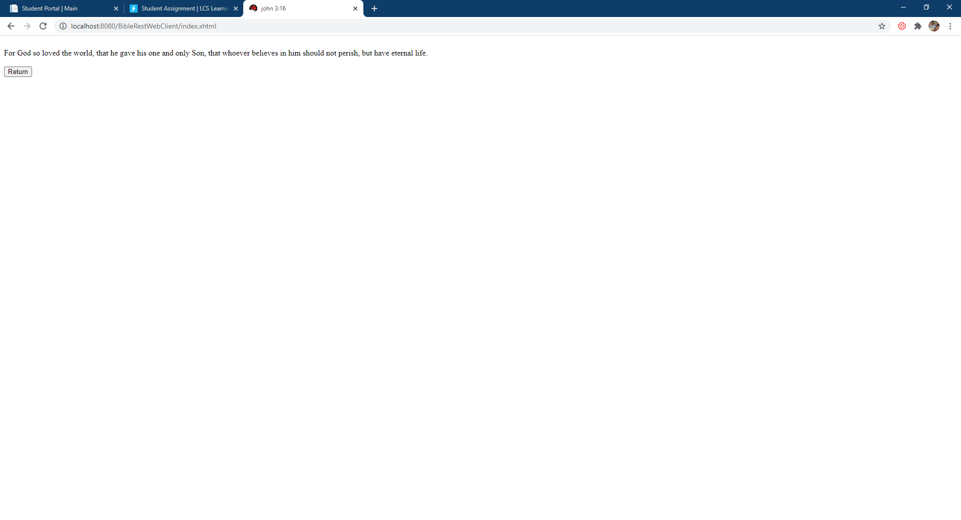

Screenshot of code the connects to the REST service:



Analyzing Biblical Text

A RESTful service such as the one created in this assignment can make finding specific texts within the Bible very quick. With a more elaborate implementation of the REST service and more features in a client-side application, it can become easier to make connections with different stories and verses within the Bible. This does not only have to be used academically. With all the negative current events going on in the world, it can be difficult to retain one’s faith without finding relevant scripture to what is happening around us. With a more fleshed out system than the one designed here, finding a specific verse can be made much easier than casually skimming. This can make way for a more complex analysis as well. The information exchange can be fed into multiple applications that can allow cataloging sections of the Bible or matching references across different stories. For example, multiple bible translations could be compared while exploring a specific verse.

“\*/bible/findVerse/{book}/{chapter}/{verse}/translations”

Using the set up in this assignment, you could add in something to give multiple translations of one verse.

Christian Worldview and REST Services

Any service in which information is provided comes along with its concerns of ethics and reliability. It might not be outwardly adherent that ethics can come into play with the simple information exchange of a REST service. Given a situation where information is freely accessible across a connection, it would not always be morally right to use the data. There needs to be accountability and safeguards in place so that information is accurate and not misused. Let's say a service was set up that provided information on several individuals bank records. The person who set it up does not care about the individuals that are being exposed. It is also unethical for anyone to relay the data or use the information provided for personal gain. Just as physically hurting another person is not ethical, using someone’s data against them or at their expense can also cause great harm and should be considered unethical.