Name: Marc Teixeira

Date: 07/15/2020

Course: CST-235

Instructor: Charbel Elkhoury

Github Link: <https://github.com/MTeixeiraGCU/CST-235/tree/master/WeekThree>

JSF Application and Grid Assignment

Part 1:

Screenshot of form field data validation error:

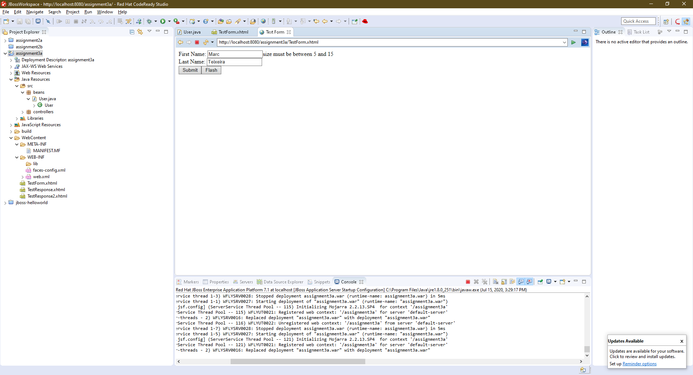

Screenshot of styled form and response page:

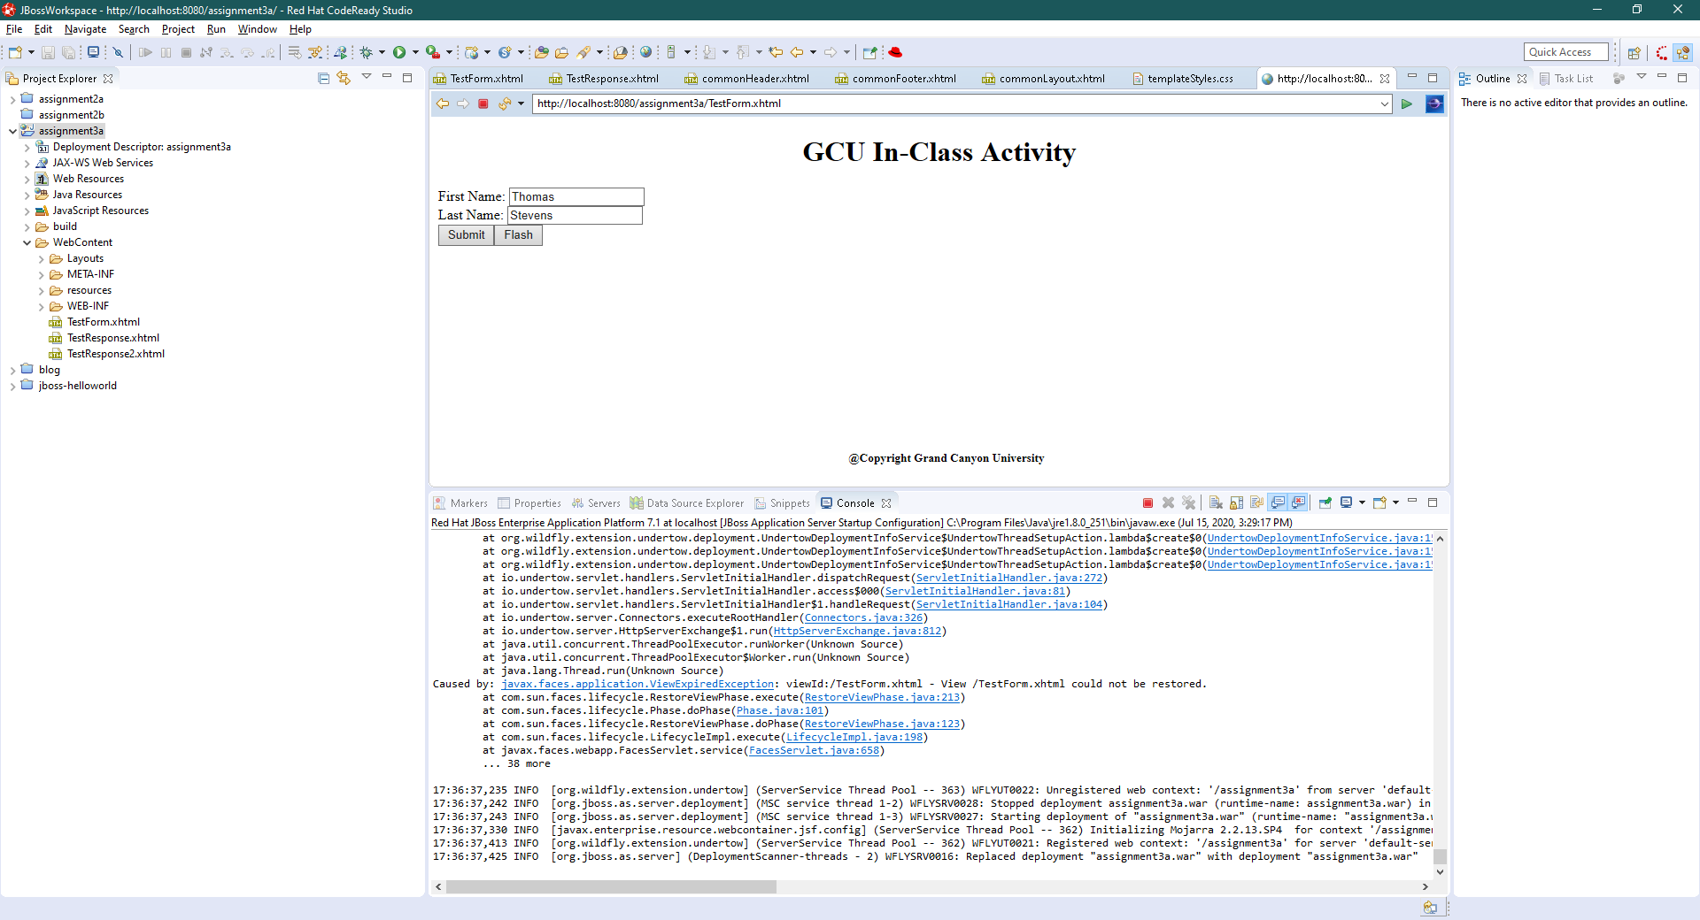

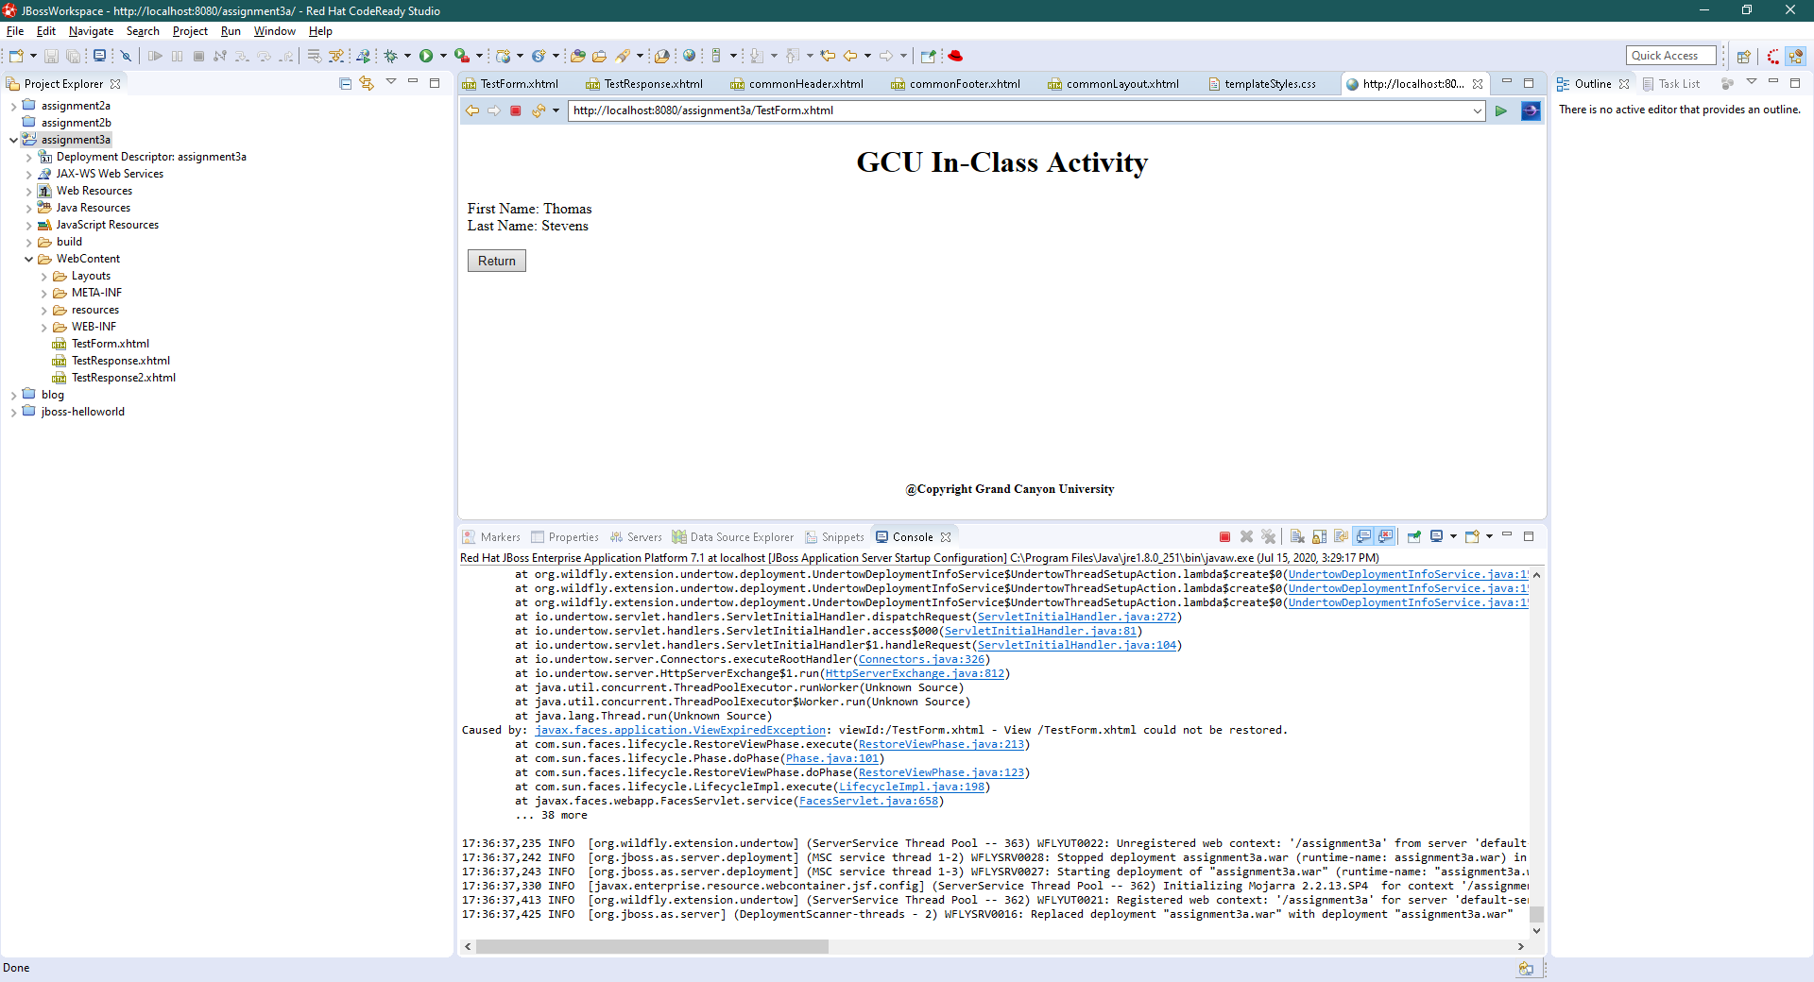

Part 2:

Screenshot of styled table:

