Name: Marc Teixeira

Date: 07/11/2020

Course: CST- 235

Instructor: Charbel Elkhoury

Git Link: <https://github.com/MTeixeiraGCU/CST-235/tree/master/WeekTwo>

Application Design and Implementation

Part 1:

Sreenshot of the init(), doGet(), and destroy() methods:

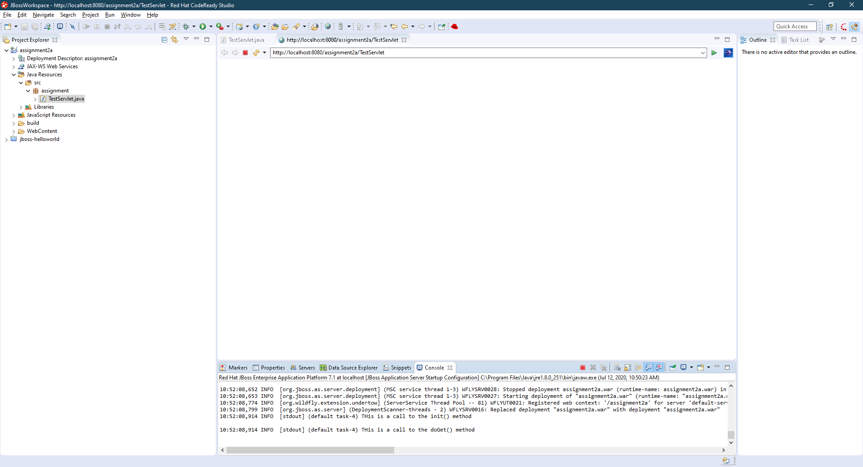

Screenshot of Servlet request parameters firstName and lastName:

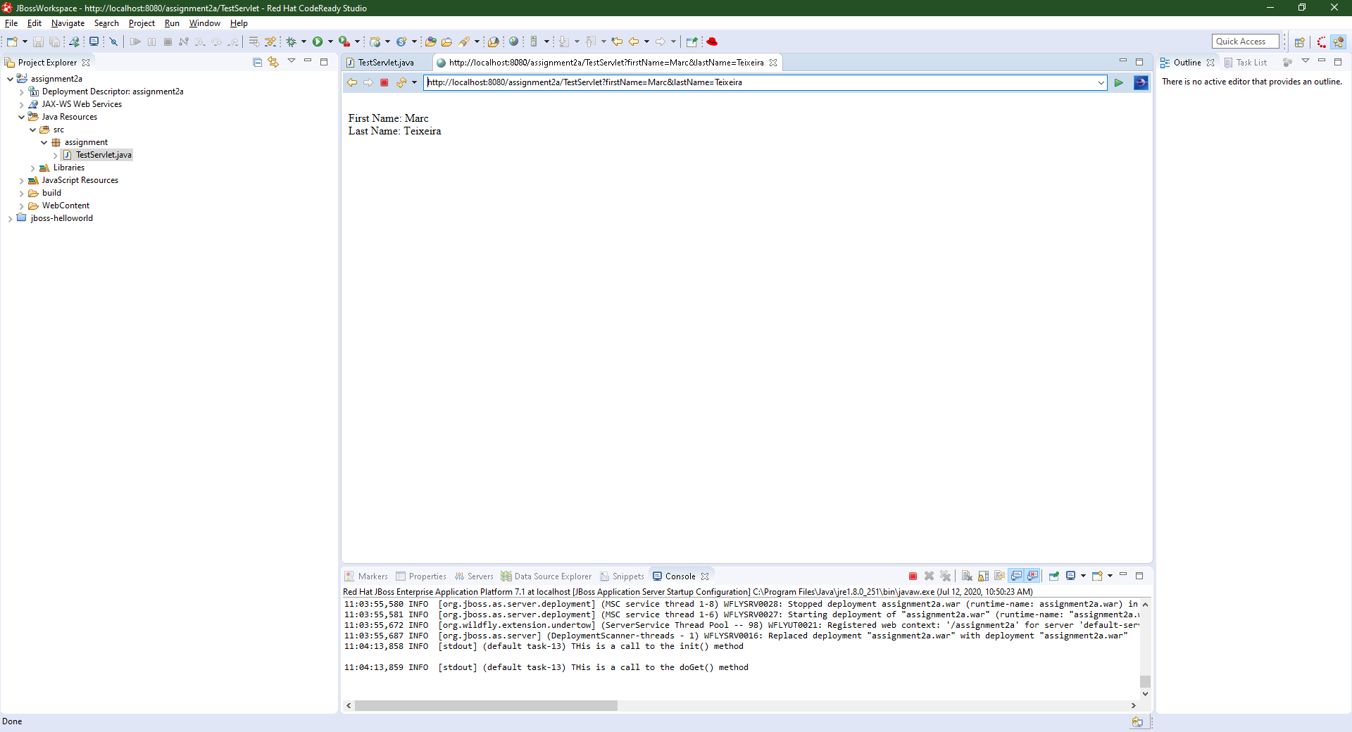

Screenshot of TestResponse.jsp forward:

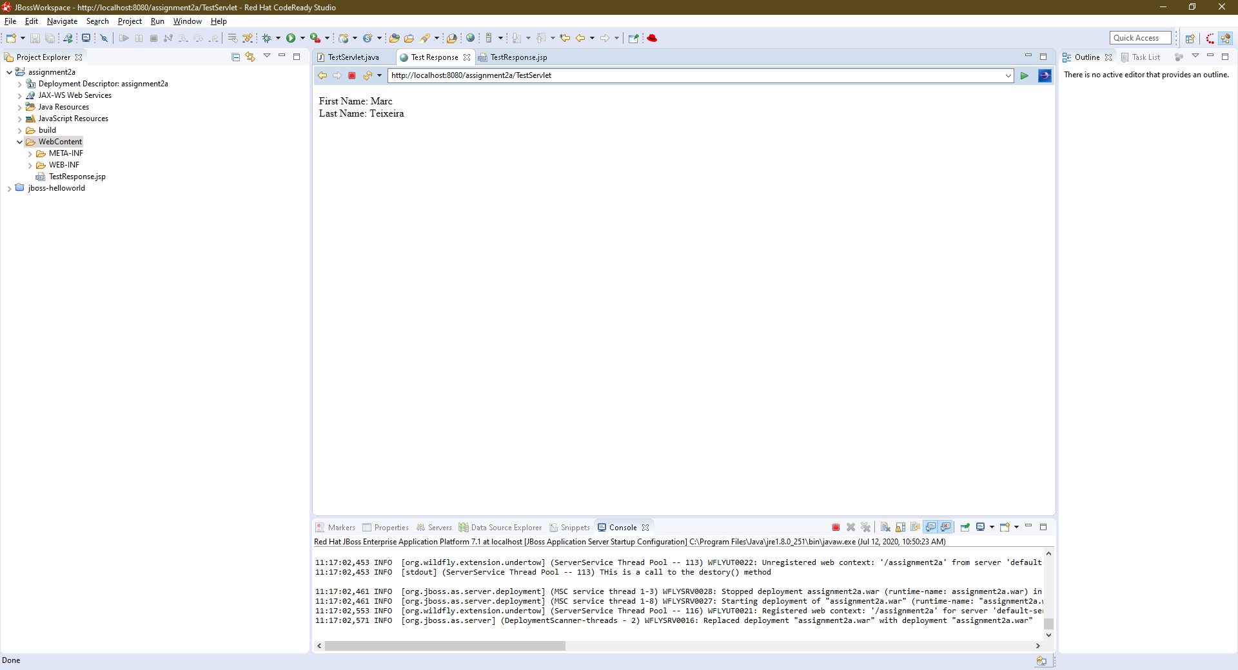

Screenshot of form and response:

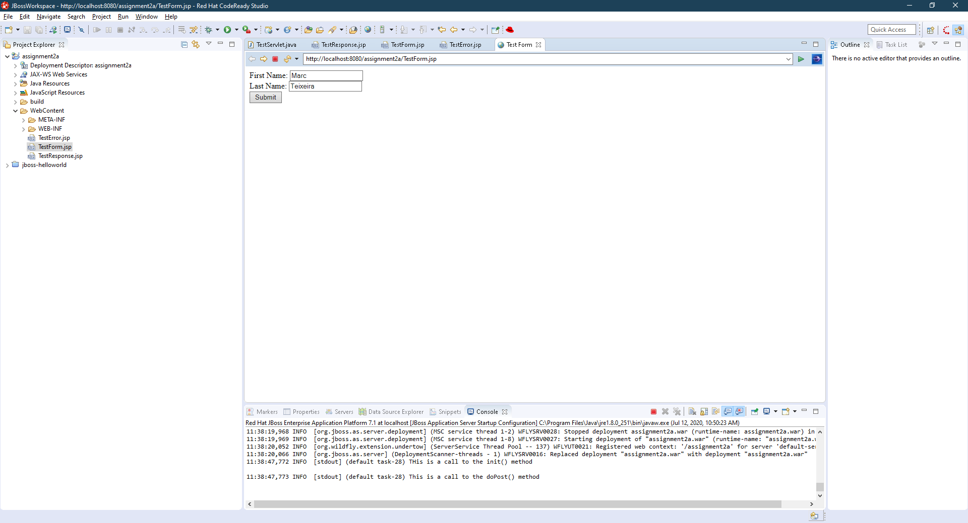

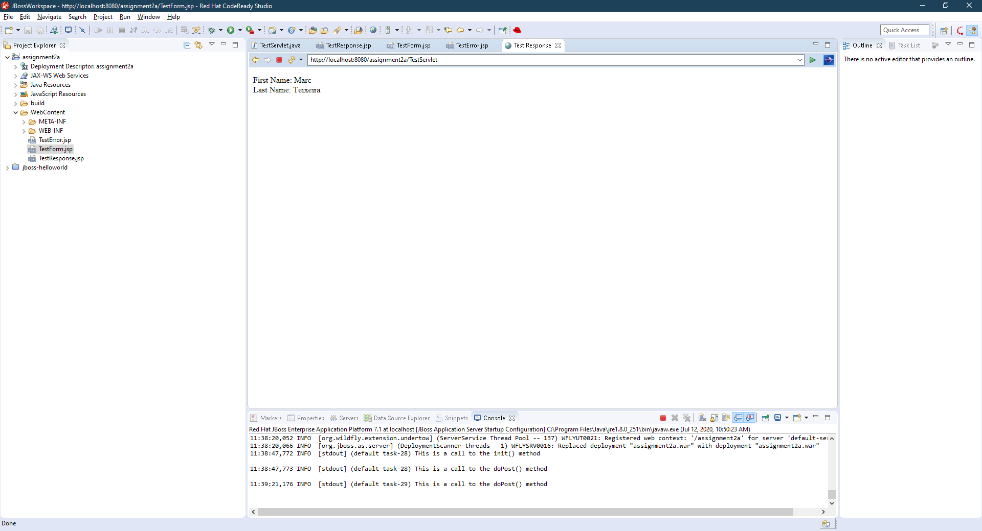

Part2:

Screenshot of TestResponse.jsf:

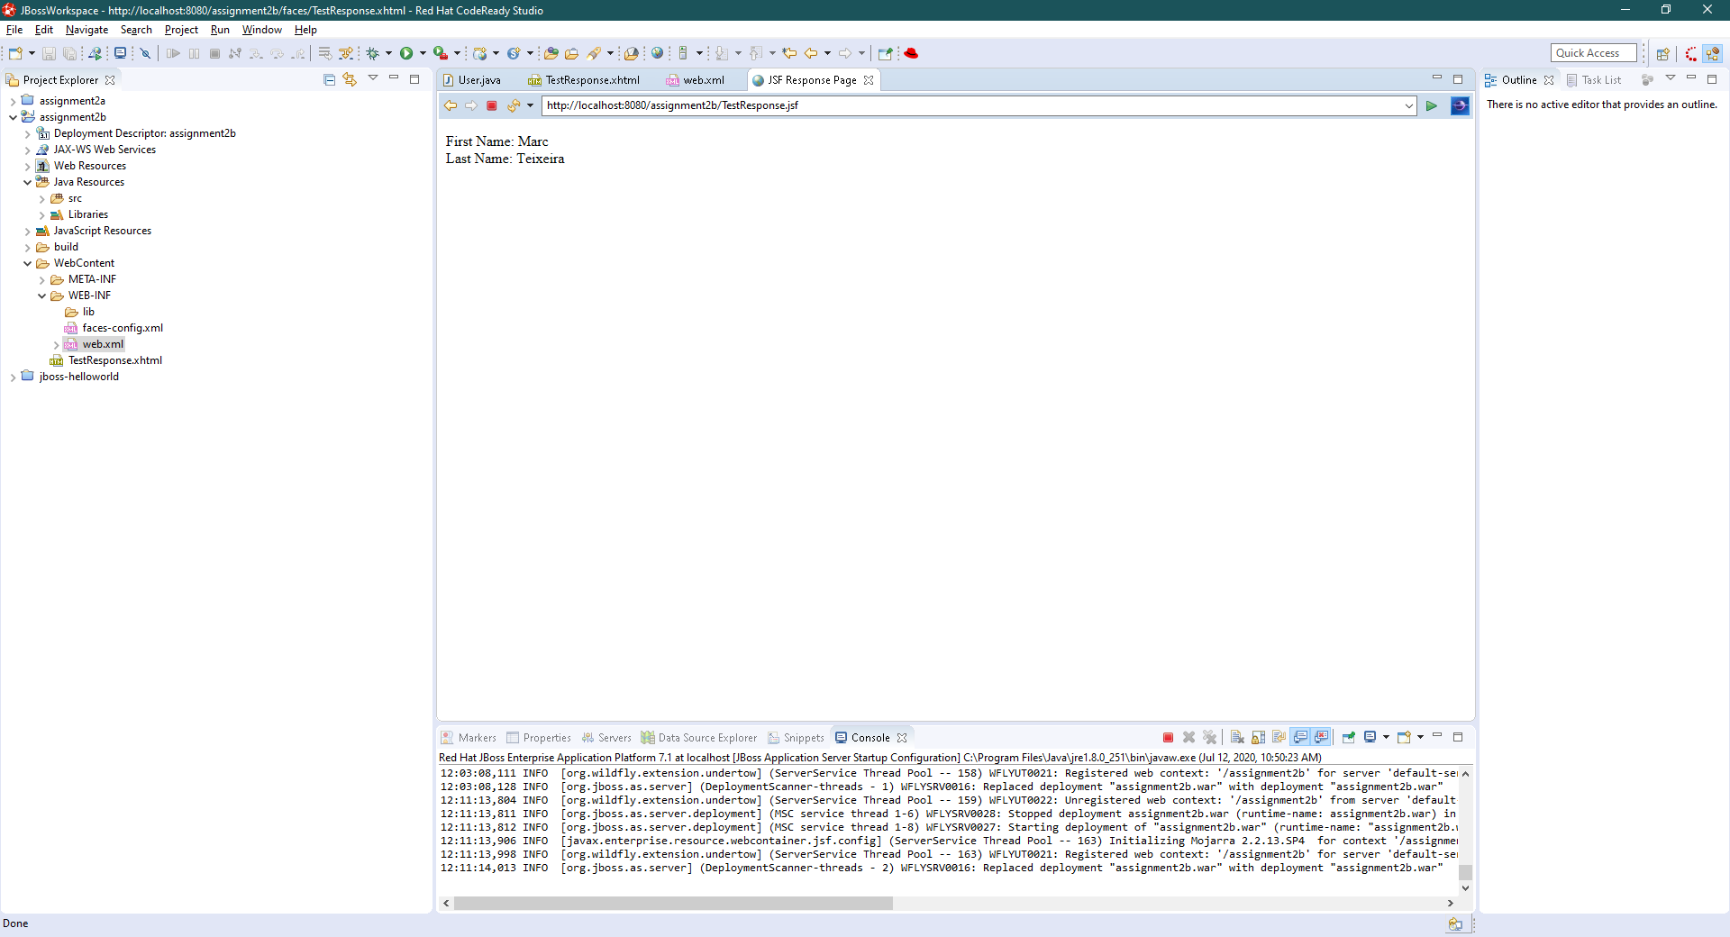

Screenshots of FormController:

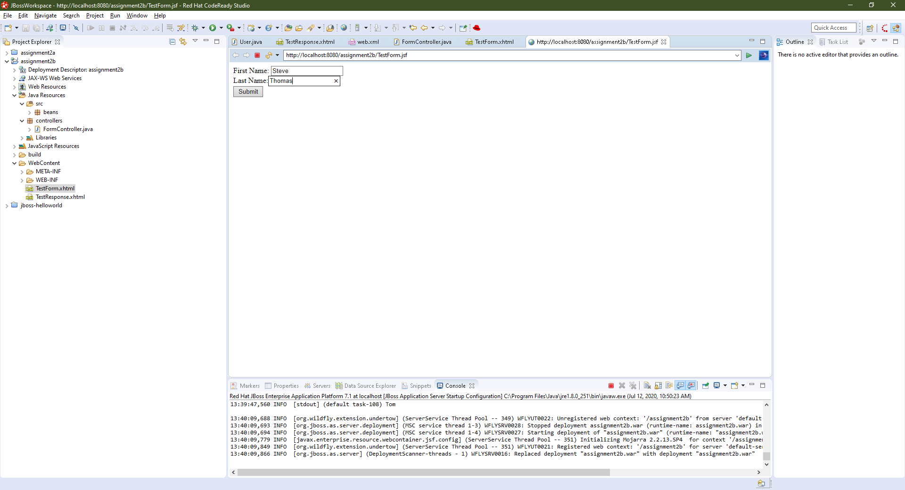

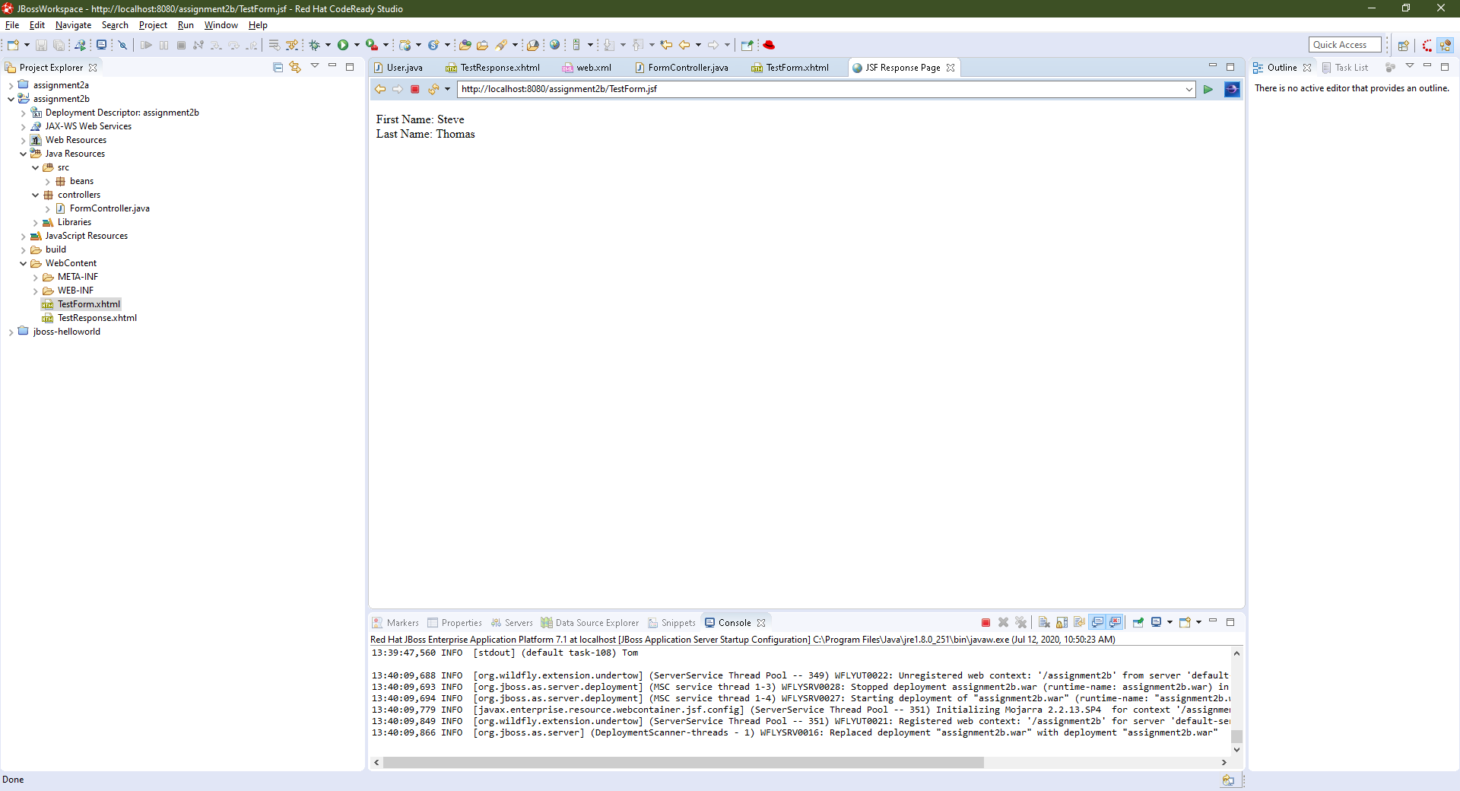

Screenshot of HTTP 302 redirect and no change to the user values:

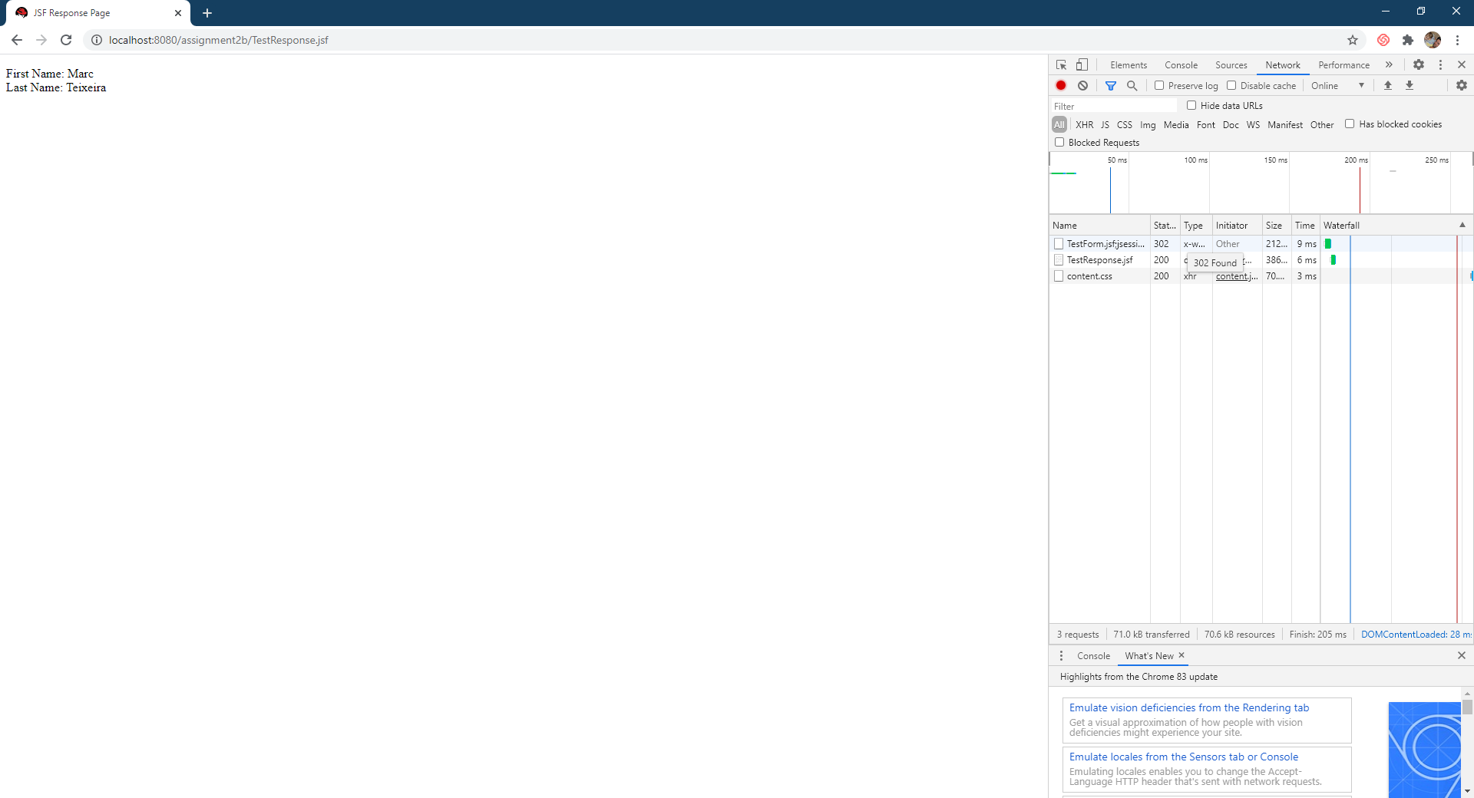

Screenshots of redirect after fixes to onFlash():

