Personal Store Application

Marc Teixeira

CST-452 Capstone Project Final Design Document

Grand Canyon University

Instructor: Professor Michael Landreth

Revision: 6

Date: 03/27/2022

**Repository Link:** [**https://github.com/MTeixeiraGCU/PersonalStoreApplication.git**](https://github.com/MTeixeiraGCU/PersonalStoreApplication.git)

**General Technical Approach:**

The initial design is in the C# ASP.NET and will use an MVC template as the baseline design. The project documentation also provides an additional Java project for reference. The project should start with this guide but only for the first two modules. Once the first modules become functional, the design should fit client feedback. The front-end code will use ASP tags and razor views to complete each page.

**Key Technical Design Decisions:**

* Visual Studio C# ASP.NET
  + VS is the primary IDE for the project and is used to create the back-end and front-end code. MVC templates built into VS make the excellent starting points for each controller, model, and project view.
  + The development will also use a MySQL server system built into VS for debugging and setting up the initial database models. GitHub
* GitHub is used as the repository provider to store version information.
* Azure
  + Azure is the deployment platform chosen for the project. Once the project is in working condition, a simplified version will release Azure’s PaaS.
  + The system will also use Azure’s accessible MySQL database server upon deployment.

**Database ER Diagram:**

*Figure 1 is an ER diagram of the initial purposed persistence layer structure.*

**Database DDL Scripts:**

The DDL script has been added to the project repo and is accessed [here](https://github.com/MTeixeiraGCU/PersonalStoreApplication/blob/92e79cec79fb1e9d183996f43276907f3ead6d7c/Documents/DDLScript.sql).

**Flow Charts/Process Flows:**

*Figure 2 is a flowchart of the user cart checkout process.*

**Sitemap Diagram:**

*Figure 3 sitemap for the application, including admin access pages.*

**User Interface Diagrams:**

*Figure 4 is a screenshot of the proposed home page with the item carousel.*

*Figures 5 and 6 depict the login and registration forms planned for the application.*

*Figure 7 is a screenshot of a typical user’s cart.*

*Figures 8 is of the user’s cart before checkout.*

*Figure 9 is the user’s checkout page and information.*

*Figure 10 is a screenshot of the initial Admin landing page.*

*Figure 11 is a screenshot of the product list view.*

*Figure 12 is a screenshot of the user list view.*

**UML Diagrams:**

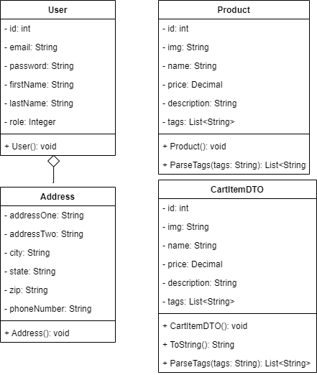

*Figure 13 UML class diagrams for persistence layer data*

**Service API Design:**

The application does not use third-party APIs at this point in the design.

**NFR’s (Security Design, etc.):**

*Table 1 contains the non-functional requirements for the project design.*

**Operational Support Design:**

This section should fully document how your design supports monitoring and logging.

**Other Documentation:**

N/A