5/28 Trained Convnet with Xception base on the augmented dataset:

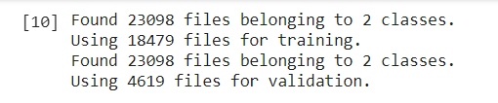

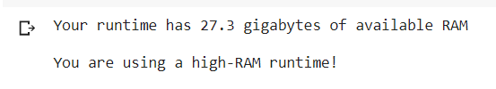



So I reduced the batch_size from 64 to 32 and had the same problem.

So I changed the configuration to use a TPU instead of GPU…..it trained like a champ.

