6/7 Tried to train Streamline 2 (with expanded dataset)

Tensorflow version 2.5.0

Running on TPU ['10.11.174.146:8470']

Your runtime has 37.9 gigabytes of available RAM

You are using a high-RAM runtime!

Found 35025 files belonging to 2 classes.

Using 28020 files for training.

Found 35025 files belonging to 2 classes.

Using 7005 files for validation.



5/28 Trained Convnet with Xception base on the augmented dataset:

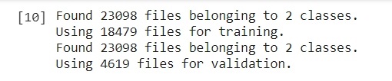

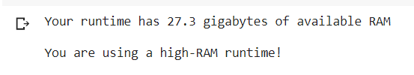



So I reduced the batch_size from 64 to 32 and had the same problem.

So I changed the configuration to use a TPU instead of GPU…..it trained like a champ.

