Group: Number 1

**Member**: Nguyen Manh Tien - 20184312 (Leader)

Nguyen Phu Truong - 20184319

Hoang Tho Tung - 20184325

**Topic**: Management Store

1. Business analysis

A store owner wants to manage a store. The management has two main periods: *import* merchandise and *sell*s merchandise. Owner wants a system which helps manager management the store and helps employee sell item more easily. Therefore, the system is designed for both *manager*s and *employees.*

1. The first period: import merchandise.

There is a list of vendors which include some main information:

* Vendor-Id
* Vendor Code (identify the vendor, unique, easy to remember)
* Vendor Name
* Address
* Phone Number
* Email
* Tax Number
* State

These vendors provide items that include some main information:

* Item id
* Vendor name
* Category name
* Item code (identify the item, unique, easy to remember)
* Item name
* Description
* Unit (example: pair, dozen, ...)
* State – not null
* Rate profit – to calculate a selling price
* Ave imported price

Each category can contain many items, but the item just belongs to one category. The category has a name and description of it. Category to group some items with the same properties. Category includes:

* Category id
* Category code
* Category name
* Description

The vendors can provide one or any kind of item, one item can be provided from one or many vendors. When a vendor stops providing, but we don't want to delete information about the vendor ( to keep info about the vendor, keep contact, ..). Each vendor has an attribute state to know that: the vendor still provides merchandise or not. And each item is stopped providing, we also don't delete information about it, so the item has an attribute: state to know that: it still is provided or not

When the item was imported from vendor to storehouse, there are invoices (to confirm that vendors provided merchandise). The invoice can contain one or many items, but these items (in the invoice) just belong to one vendor. The invoice has to contain information about the employee who buys these items. The invoice also has to record when transactions happen. In the invoice, we also need to know information about who imported these items at that time. The time also needs to record in the invoices. The invoice includes:

* Invoice id
* Invoice code (identify the invoice, unique, easy to remember)
* Item - *multiple values*
* Quantity - *multiple values*
* Importing price (from the vendors)
* Amount - infer from quantity* imported_price, *multiple values*
* Tax
* total amount
* Employee name – who received the invoice
* Date
* Vendor name – who provide the item

When the store owner imported goods, these items will be store in a storehouse. After imported, selling-price of the item = average imported_price * (1 + rate_profit)

So store owners also need to manage the storehouse. The storehouse may contain many items, price celling, quantity, ...

Storehouse include:

* Item id
* Quantity
* Price selling

1. The second period: sell merchandise

The store owner hires a part-time employee. Each employee works in three-shift: morning, afternoon, evening. When an employee stops working, but we don't want to delete information about the employee ( to keep info about the employee, keep contact, ..). Each employee has an attribute state to know that: the employee still working, or not.

The employee has an attribute: Group to privileges: employee, manager, ... Password to authentic when employee login the system. Formula to compute salary: coefficients salary * base salary ( specified) + sales * 5%. Coefficients salary = 1 + (number working months) / 12. Sale: total cost of items which the employee sells this month. Otherwise, to manage employee, the employee also has some information as following

Employee includes some information:

* Employee id
* Employee code (identify the employee, unique, easy to remember )
* Employee name
* DOB
* Address
* Gender
* Phone number
* Email
* Identify number
* Shift
* Password
* Group name
* Status
* join date – when employee enjoin the company

Each employee belongs to one Group. Group contains:

* Group id
* Group name
* Base salary – not null

Customers can buy one or more items. After paying, the customer will receive a bill ( order). Each time buying, the customer will receive the cumulative point. Cumulative point was computed by: cumulative point = total amount * percentage rate(E.g: 1%). The cumulative point can be used as money. E.g 1 point = 1vnd. Each customer has status to point that the customer in the blacklist nor not.

The customer includes some information:

* Customer id
* Customer code
* Customer name
* DOB
* Address
* Phone number
* Email
* Status
* Cumulative point

Order contains:

* Order id
* Customer name
* Employee name
* Date
* Discount voucher
* Items – *multiple values*
* Quantity – *multiple values*
* Amount = sum (quantity * price of items) *– multiple value*
* VAT tax = amount * 10%
* Cumulative point used
* Total amount = (sum of amount)* ( 1- Discount rate (%)) + VAT tax – cumulative point

When customers make a payment, they can use only one discount voucher and cumulative points. Store only accept discount voucher when it is valid (mean: in effective date, not out expired date, in range apply). When applying the valid discount, the total amount will decrease. Each order accepts only one discount voucher. One voucher belongs to only one order.

Discount voucher has some police to apply: it has to satisfied effective and expired date, the total amount of the order reaches a specified number, limit max discount.

The discount voucher contains:

* Discount voucher id
* Discount voucher code
* Expired date
* Min total amount (min amount in the order to get discount)
* Effective date
* Discount rate (%)
* Max discount amount

Store (item in storehouse) sell for a customer. Selling action need record information: bill, employee, customer, date.

3. Function of the system

**The system has functions for imported merchandise**

* Insert, update, delete information of vendor, item, invoice
* Search vendor, item, invoice by some condition, such as name, address, price,...
* Statistic:
* with the same item which vendor provides cheapest and most expensive
* Top vendors provide the most item
* Which items in the store exhaust. An item consider exhaust when it is a unit smaller than or equal to 10 (unit)
* Major item and a minor one in the store
* Statistic total amount money to imported items through months of a year.
* Compare total amount between years
* Which item was best imported in spring (1-3), summer (4-6), autumn (7-9), winter (10-12)
* Which vendor provides more than 10 distinct items
* Top 10 vendors provide item whose total amount maximum

1. Entity-relationship

1. Import + Selling items

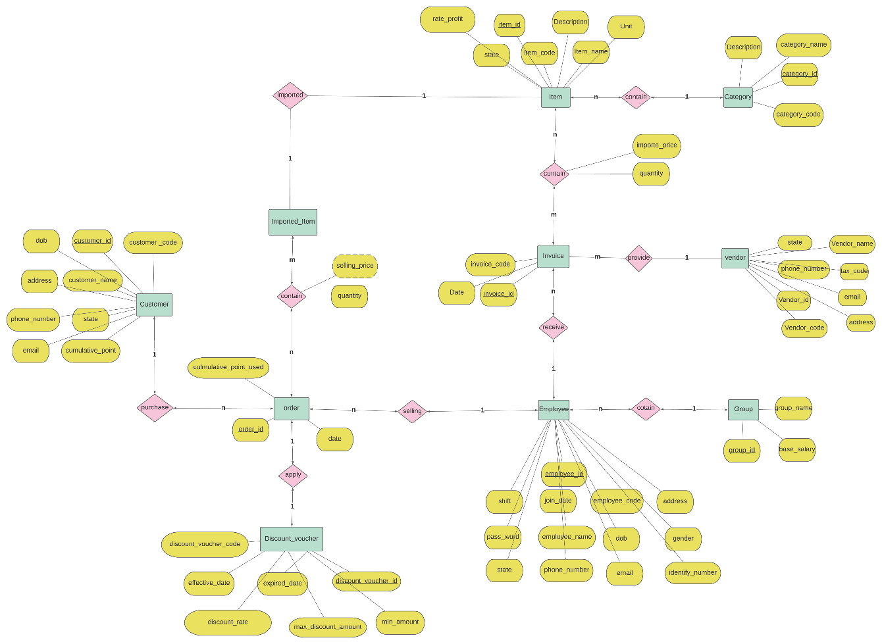

2. Schemas

