Heart Disease Diagnosis

Mustafa Toprak
47485536686

Abstract—This paper contains diagnosing whether a person has a heart disease by using logistic regression and naive bayes, and understanding the effects of using one-hot encoding to these machine learning methods.

Keywords – one-hot encoding, naive bayes, logistic regression, heart disease diagnosis, machine learning, classification algorithms

I. INTRODUCTION

Heart disease is the leading cause of death in the United States, causing about 1 in 4 deaths [1]. For the fair reason, the developing technology aids medicine experts to diagnose heart disease faster than ever. No doubt, data science and machine learning are the most helpful technologies that serve the purpose. This paper intends to indicate how one-hot encoding affects logistic regression and naive bayes classification algorithms while diagnosing whether a person has a heart disease.

II. DATASET SELECTION

Thanks to the internet, there are datasets that are able to be used in machine learning algorithms that aim at classifying heart diseases. ‘Kaggle’ is one of the most popular websites for data science and machine learning. Kaggle has many datasets ready to use in machine learning models. This paper’s dataset is one of Kaggle's datasets named Heart Disease UCI [2]. It is a simplified version of UCI’s ‘Heart Disease Data Set’ [3]. Kaggle’s dataset classifies only whether a person has a heart disease, it does not classify what the heart disease is. The attributes of the dataset is:
- age
- sex
- chest pain type (4 values)
- resting blood pressure
- serum cholesterol in mg/dl
- fasting blood sugar > 120 mg/dl
- resting electrocardiographic results (values 0,1,2)
- maximum heart rate achieved
- exercise induced angina
- oldpeak = ST depression induced by exercise relative to rest
- the slope of the peak exercise ST segment
- number of major vessels (0-3) colored by fluoroscopy
- thal: 3 = normal; 6 = fixed defect; 7 = reversible defect
III. PREPARING DATASET
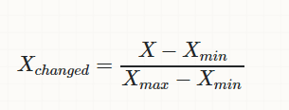
Dataset has several categorical attributes needed using one-hot encoding. One hot encoding is a process by which categorical variables are converted into a form that could be provided to ML algorithms to do a better job in prediction [4]. In this work, it is also used for binary categorical attributes to see whether there is a meaning difference or effect. To do that, all categorical attributes' columns are selected and turned into dummy variables, which is shown by 0’s and 1’s. Additionally, the columns are replaced with the dummy variables. Furthermore, numerical attributes are normalized. In statistics and applications of statistics, normalization can have a range of meanings. In the simplest cases, normalization of ratings means adjusting values measured on different scales to a notionally common scale, often prior to averaging. In more complicated cases, normalization may refer to more sophisticated adjustments where the intention is to bring the entire probability distributions of adjusted values into alignment [5].

Finally, the dataset is separated into train and test sets. Proportion of the separation differs on different dataset sizes. For instance, 8:2 proportion is used in the model, but if we have a much bigger dataset, the train set’s size might be much bigger than the test set.
IV. IMPLEMENTING THE CODE
The project has two different algorithms in use: logistic regression and naive bayes.
- LOGISTIC REGRESSION
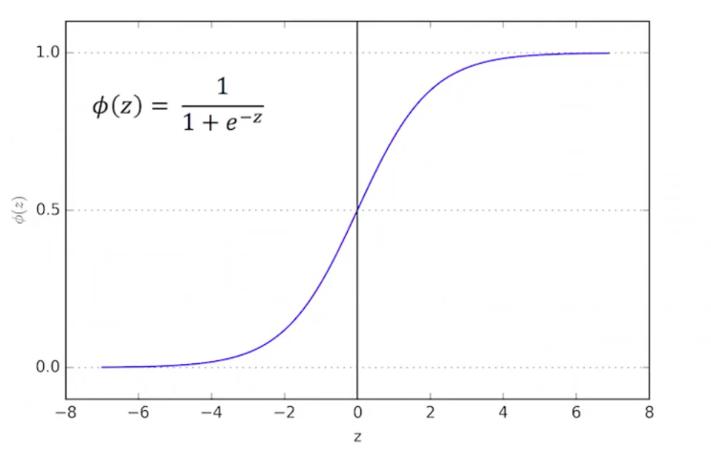
Logistic regression is a supervised ML algorithm used for binary classification problems (when target is categorical). The best way to think about logistic regression is that it is a linear regression but for classification problems. Logistic regression essentially uses a logistic function.
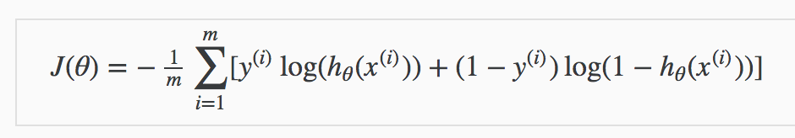
The primary difference between linear regression and logistic regression is that logistic regression's range is bounded between 0 and 1. In addition, as opposed to linear regression, logistic regression does not require a linear relationship between inputs and output variables. As opposed to linear regression where MSE or RMSE is used as the loss function, logistic regression uses a loss function referred to as “maximum likelihood estimation (MLE)” which is a conditional probability. If the probability is greater than 0.5, the predictions will be classified as class 0. Otherwise, class 1 will be assigned. Before going through logistic regression derivation, let's first define the logit function. Logit function is defined as the natural log of the odds. A probability of 0.5 corresponds to a logit of 0, probabilities smaller than 0.5 correspond to negative logit values, and probabilities greater than 0.5 correspond to positive logit values. It is important to note that as illustrated, logistic function ranges between 0 and 1 (P∈[0,1]) while logit function can be any real number from minus infinity to positive infinity (P∈[−∞, ∞]) [6].
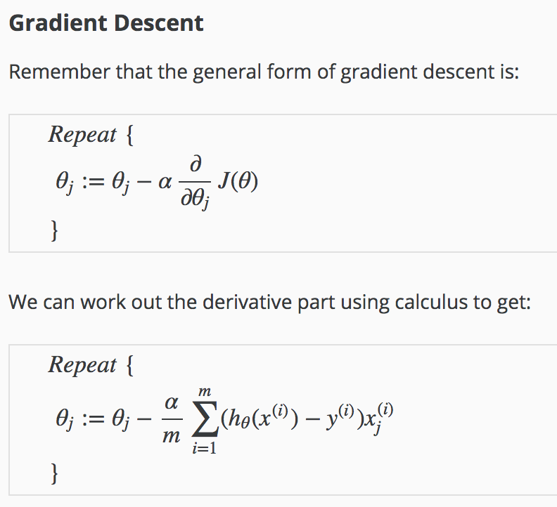
- NAIVE BAYES
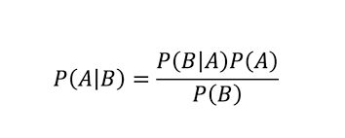
Bayes’ Theorem finds the probability of an event occurring given the probability of another event that has already occurred. Bayes’ theorem is stated mathematically as the following equation:
where A and B are events and P(B) ≠ 0. Basically, we are trying to find the probability of event A, given that event B is true. Event B is also termed as evidence. P(A) is the priori of A (the prior probability, i.e. Probability of event before evidence is seen). The evidence is an attribute value of an unknown instance(here, it is event B).P(A|B) is a posteriori probability of B, i.e. probability of event after evidence is seen.
Now, with regards to our dataset, we can apply Bayes’ theorem in following way:

where, y is class variable and X is a dependent feature vector (of size n) where:

Now, it's time to put a naive assumption to Bayes' theorem, which is, independence among the features. So now, we split evidence into the independent parts. Now, if any two events A and B are independent, then,
P(A,B) = P(A)P(B)
Hence, we reach to the result:
which can be expressed as:
Now, as the denominator remains constant for a given input, we can remove that term:
Now, we need to create a classifier model. For this, we find the probability of given set of inputs for all possible values of the class variable y and pick up the output with maximum probability. This can be expressed mathematically as:
So, finally, we are left with the task of calculating P(y) and P(xi | y). P(y) is also called class probability and P(xi | y) is called conditional probability. The different naive Bayes classifiers differ mainly by the assumptions they make regarding the distribution of P(xi | y) [7].
- LIBRARIES
1) Scikit-learn (formerly scikits.learn and also known as sklearn) is a free software machine learning library for the Python programming language. It features various classification, regression and clustering algorithms including support vector machines, random forests, gradient boosting, k-means and DBSCAN, and is designed to interoperate with the Python numerical and scientific libraries NumPy and SciPy [8].
2) Matplotlib is a comprehensive library for creating static, animated, and interactive visualizations in Python. [11]
3) Seaborn is a Python data visualization library based on matplotlib. It provides a high-level interface for drawing attractive and informative statistical graphics [12].
V. RESULTS

Sake of trying to see one-hot encoding effects, we have 3 different train sets: using directly, applying one-hot for even binary categories and applying one-hot for non-binary categories. To compare results, we have five metrics: accuracy, precision, recall sensitivity, specificity and F1 score. Although, we need a confusion matrix.

- Confusion Matrix

A confusion matrix is a summary of prediction results on a classification problem. The number of correct and incorrect predictions are summarized with count values and broken down by each class. This is the key to the confusion matrix [13]. Even just for this comparison, we can say that ‘Applying One-Hot For Non-Binary Categories’ is more accurate than others.

* 00: TN, 01: FP, 10: FN, 11: TP

Confusion Matrix For ‘Using Directly’

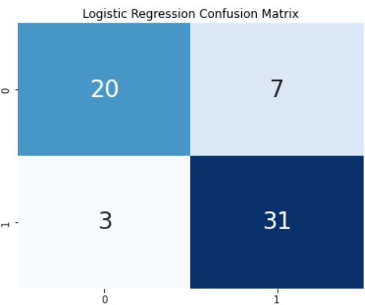

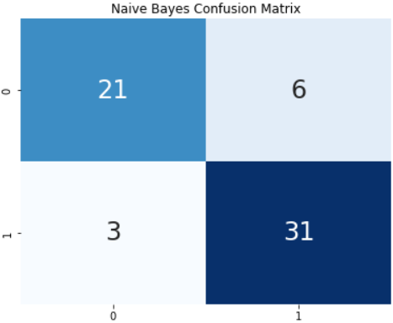

Confusion Matrix For ‘Applying One-Hot For Even Binary Categories’

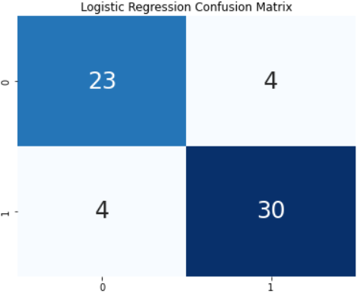

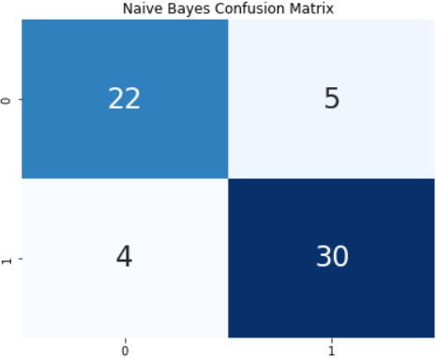

Confusion Matrix For ‘Applying One-Hot For Non-Binary Categories’

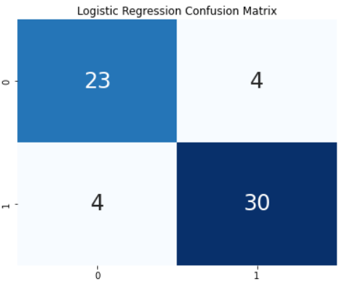

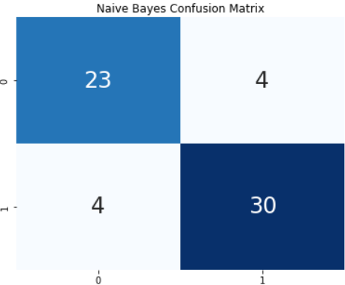

- ACCURACY
Overall performance of the model.
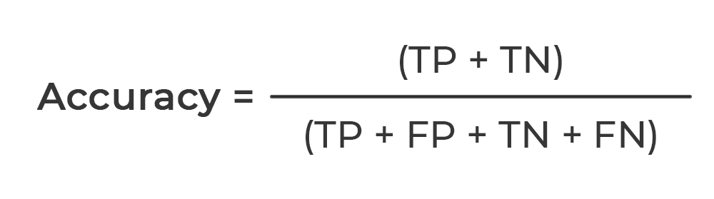

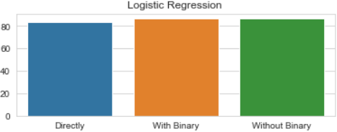
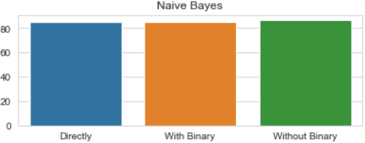

- Directly Using The Dataset:
- Sklearn Logistic Regression Accuracy: 83.61%
- Sklearn Naive Bayes Accuracy: 85.25%

- Using Dummy Variables Even For Binary Categories:

- Sklearn Logistic Regression Accuracy: 86.89%
- Sklearn Naive Bayes Accuracy: 85.25%

- Using Dummy Variables Without Binary Categories:

- Sklearn Logistic Regression Accuracy: 86.89%
- Sklearn Naive Bayes Accuracy: 86.89%

- PRECISION

How accurate the positive predictions are.
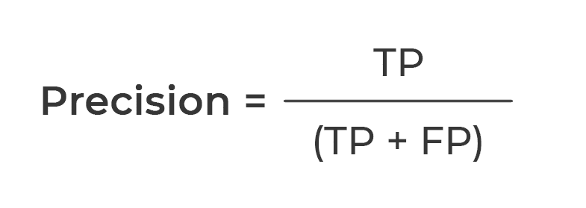

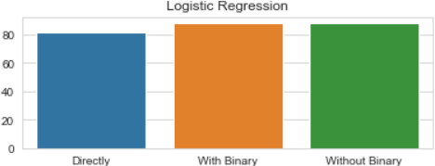
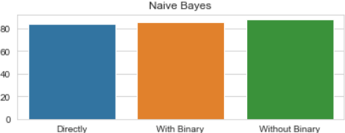

- Directly Using The Dataset:
- Sklearn Logistic Regression Accuracy: 81.58%
- Sklearn Naive Bayes Accuracy: 83.78%

- Using Dummy Variables Even For Binary Categories:

- Sklearn Logistic Regression Accuracy: 88.24%
- Sklearn Naive Bayes Accuracy: 85.71%

- Using Dummy Variables Without Binary Categories:

- Sklearn Logistic Regression Accuracy: 88.24%
- Sklearn Naive Bayes Accuracy: 88.24%

- RECALL SENSITIVITY
Coverage of actual positive sample.

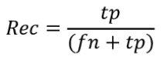

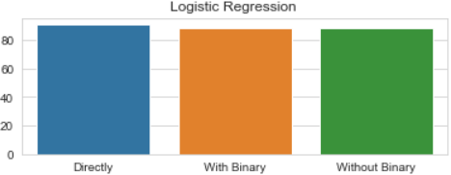
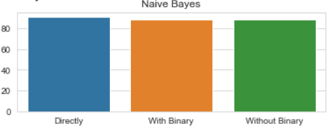

- Directly Using The Dataset:
- Sklearn Logistic Regression Accuracy: 91.18%
- Sklearn Naive Bayes Accuracy: 91.18%

- Using Dummy Variables Even For Binary Categories:

- Sklearn Logistic Regression Accuracy: 88.24%
- Sklearn Naive Bayes Accuracy: 88.24%

- Using Dummy Variables Without Binary Categories:

- Sklearn Logistic Regression Accuracy: 88.24%
- Sklearn Naive Bayes Accuracy: 88.24%

- SPECIFICITY
Coverage of actual negative sample.
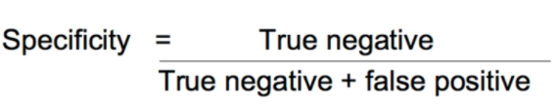
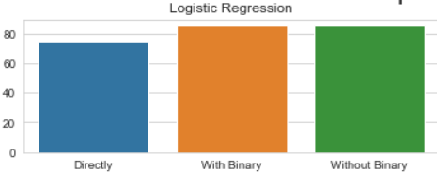
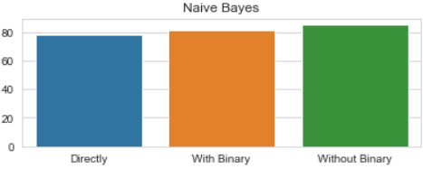

- Directly Using The Dataset:
- Sklearn Logistic Regression Accuracy: 74.07%
- Sklearn Naive Bayes Accuracy: 77.78%

- Using Dummy Variables Even For Binary Categories:

- Sklearn Logistic Regression Accuracy: 85.19%
- Sklearn Naive Bayes Accuracy: 81.48%

- Using Dummy Variables Without Binary Categories:

- Sklearn Logistic Regression Accuracy: 85.19%
- Sklearn Naive Bayes Accuracy: 85.19%

- F1 SCORE
Hybrid metric useful for unbalanced classes.
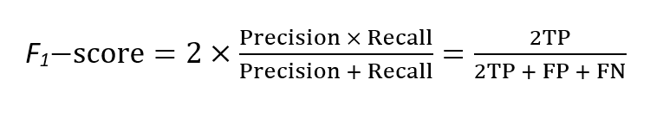
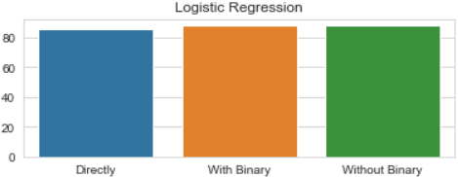

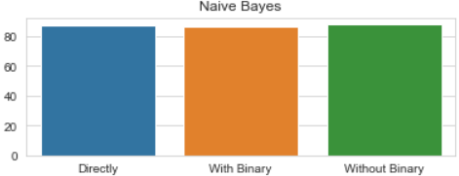

- Directly Using The Dataset:
- Sklearn Logistic Regression Accuracy: 86.11%
- Sklearn Naive Bayes Accuracy: 87.32%

- Using Dummy Variables Even For Binary Categories:

- Sklearn Logistic Regression Accuracy: 88.24%
- Sklearn Naive Bayes Accuracy: 86.96%

- Using Dummy Variables Without Binary Categories:

- Sklearn Logistic Regression Accuracy: 88.24%
- Sklearn Naive Bayes Accuracy: 88.24%

ETHICAL STATEMENT

While preparing the project, I did not take any action that could be considered as plagiarism.

REFERENCES

[1] Murphy SL, Xu J, Kochanek KD, Arias E. Mortality in the United States, 2017. NCHS data brief, no 328. Hyattsville, MD: National Center for Health Statistics; 2018.
[2] ‘Heart Disease UCI’ https://www.kaggle.com/ronitf/heart-disease-uci
[3] ‘Heart Disease Data Set’ https://archive.ics.uci.edu/ml/datasets/Heart+Disease
[4] ‘One-Hot Encoding’ https://hackernoon.com/what-is-one-hot-encoding-why-and-when-do-you-have-to-use-it-e3c6186d008f
[5] ‘Normalization’ https://en.wikipedia.org/wiki/Normalization_(statistics)
[6] ‘Logistic Regression’ https://www.sciencedirect.com/topics/computer-science/logistic-regression
[7]’Naive Bayes’ https://www.geeksforgeeks.org/naive-bayes-classifiers/
[8] ‘Scikit-Learn’ https://en.wikipedia.org/wiki/Scikit-learn
[9] ‘Scikit-Learn Logistic Regression’ https://scikit-learn.org/stable/modules/generated/sklearn.linear_model.LogisticRegression.html
[10] ‘Scikit-Learn Naive Bayes’ https://scikit-learn.org/stable/modules/naive_bayes.html
[11] ‘Matplotlib’ https://matplotlib.org
[12] ‘Seaborn’ https://seaborn.pydata.org/#:~:text=Seaborn%20is%20a%20Python%20data,attractive%20and%20informative%20statistical%20graphics.
[13] ‘Confusion Matrix’ https://machinelearningmastery.com/confusion-matrix-machine-learning/
[14] ‘Code Reference’ https://www.kaggle.com/cdabakoglu/heart-disease-classifications-machine-learning

