**QUIZORK 3**

1. In an August 2012 Gallup survey of 1012 randomly selected U.S. adults, 53% said that they were dissatisfied with the quality of education students receive in kindergarten through grade 12. They also report that the “margin of error is plus or minus 4%” for a 95% confidence interval.
2. What is the standard error of the sample proportion?
3. 2%
4. 1%
5. 8%
6. 4%
7. Which of the following is a correct interpretation of the confidence interval?
8. There is a 95% chance the proportion of U.S. adults who are dissatisfied with the quality of education students receive is in the interval (0.49, 0.57).
9. We are 95% confident the true proportion of U.S. adults who are dissatisfied with the quality of education students receive is in the interval (0.49, 0.57).
10. 95% of samples will show that the proportion of U.S. adults who are dissatisfied with the quality of education students receive is in the interval (0.49, 0.57).
11. We are 95% confident the proportion of these 1012 U.S. adults who are dissatisfied with the quality of education students receive is in the interval (0.49, 0.57).
12. A random sample of 169 Montana births was obtained after removing multiple births. The

researchers found that 35 of the babies were delivered by Caesarean section (C-section). They

want to estimate the true proportion of births via C-section.

1. Define the parameter of interests in words and notation. (2 points)

p = the true proportion of single live births in Montana delivered via C-section

1. What is the point estimate of the parameter? Use proper notation. (2 points)

p-hat = 35/169 = 0.207

1. Use the One Proportion applet from the [Rossman-Chance](http://www.rossmanchance.com/ISIapplets.html) website to obtain the bootstrap distribution. What value should you use for “Probability of Heads/Success”? What value should you use for “Number of tosses/Sample Size (n)”? (2 points)

Probability of success = 0.207, sample size = 169

1. Create 3000 samples and paste the plot here using a screen shot. Be sure to show the summary statistics and select the radio button for “Proportion of Successes”.

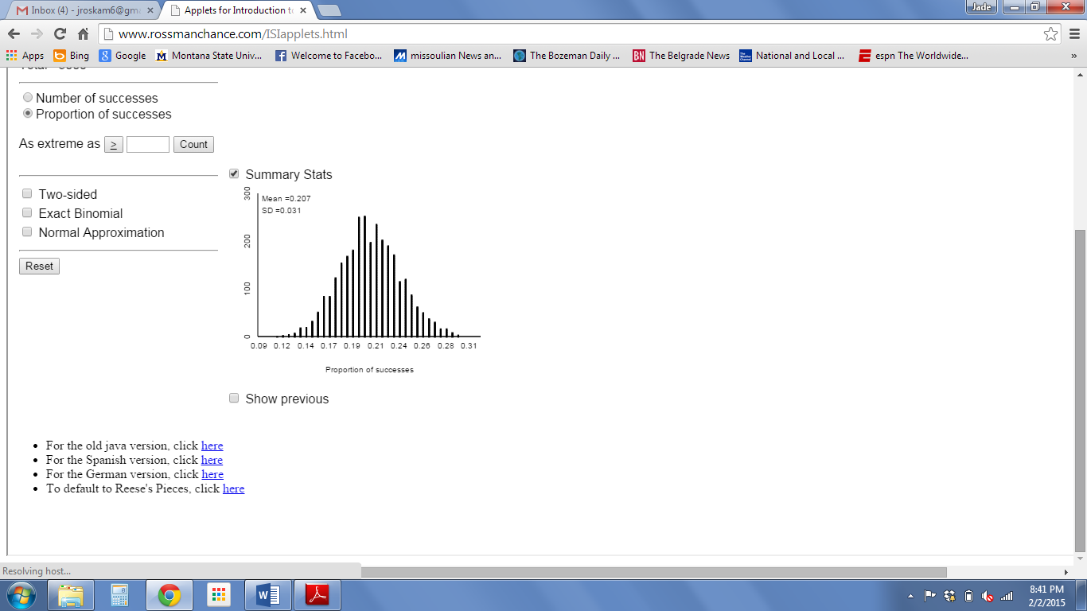

1. What is the standard error of the sample proportions?

I got 0.031

1. Calculate a 95% confidence interval for the parameter of interest. Be sure to show your work here!

0.207 +/- 2(0.031) = (0.145, 0.269)

1. Interpret this interval in the context of the problem.

We are 95% confident that the true proportion of MT single live births delivered via C-section is between 0.145 and 0.269.

1. What is meant by the word “confidence”?
2. 95% of the time the interval created above will contain the parameter.
3. Approximately 95% of samples will create intervals that contain the sample statistic 35/169.
4. There is a 95% chance the interval created contains the parameter of interest.
5. Approximately 95% of random samples of this size will create a confidence interval that contains the parameter of interest.