Quizork 1
16 Points

QUIZORK 1

This is currently in a word processing format. Make changes to it to include your answers, and turn it in to your instructors. They require you to turn in a pdf for the D2L system, so find and click “Export to Pdf” in the “File” menu. Each answer is one point unless noted differently.
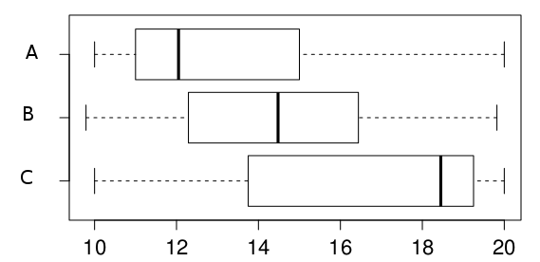
- Which of the following boxplots represents a right-skewed distribution?
A.
- Each of the variables displayed in the histograms below has a mean of 14.5, a range of 8, and 60 observations. Which has the largest standard deviation if the IQRs are 2, 3, and 6 respectively?
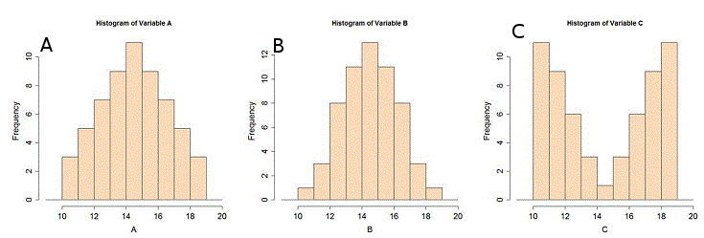
C.
- Read Section 1.4.2 in Open Intro Stat textbook, pages 14 to 16. They list three ways to collect random samples. Suppose that we want to find out how much student loan debt, on average, students at MSU have taken on. Identify the type of sample for each of these data collection methods:
  - We randomly select 20 classes from the current list of all MSU classes and interview each student in each chosen class. Cluster sampling.
  - We choose 200 MSU students randomly from a list of all MSU students. Interview each.
SRS
  - We randomly select 50 Seniors, 50 Juniors, 50 Sophomores and 50 Freshmen from a list of all MSU students (which includes their numbers of credits taken). Interview each.
Stratified random sample
- Suppose we want to estimate family size, where family is defined as one or more parents living with children. A parameter describes a characteristic of a population, whereas a statistic is computed just from a sample.
  - What type of variable is “family size”? Quantitative
  - What is the parameter of interest? Average, or mean, family size for all families with kids at this school.
  - What statistic will they compute from the sample? Be sure to distinguish this from your answer in 4b. Average size of families of the sample of selected kids.
- Suppose we get a list of phone numbers of all MSU students and choose 50 at random. We call each student selected and ask which provider they use for phone service.
  - What type of sample is this?
SRS
  - What type of variable is “provider”?
Categorical.
  - Suppose ATT wants to know what proportion of MSU students use ATT. Is that a parameter or statistic?
Parameter.
- Scores on an exam were:
79, 83, 57, 82, 94, 83, 72, 74, 73, 71, 66, 89, 78, 81, 78, 81, 88, 69, 77, 79
with summary statistics: min: 57, Q1: 72.5, M: 78.5, Q3: 82.5, Max: 94
Draw the boxplot of these data including an axis labeled by 10's from 50 to 100. (5 pts)
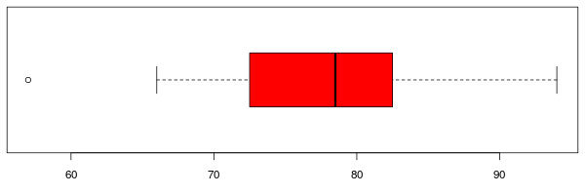
KEY (1 pt for box,
1 pt median, 1 for max
1 pt outlier and whisker):

Remember to submit this to the proper D2L Dropbox and it MUST BE IN PDF FORMAT!!

