QUIZORK 2

In recent years, 80% of those accused of Driving Under the Influence (DUI) get convicted (includes plea bargains). Suppose a firm of defense lawyers advertises that they can do much better than that. We randomly sample 20 from over 500 DUI cases handled by the law firm and find 12 convictions. Is there strong evidence that the firm's claim is true?
- What data are we using from a single defendant? Is it categorical or quantitative?
Convicted or not. categorical
- What proportion of the firm's DUI sampled cases resulted in conviction? Use correct notation.
    - 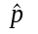= 0.60
    - p = 0.60
    - p = 20
    - = 20
p.hat = 0.60
- Write the null hypothesis we would use to say that this firm's conviction rate is no different from the overall rate.
H0: p = 0.80
- We'll use the firm's claim as the alternative hypothesis. Write it out with proper notation.
Ha: p < 0.80
- Use the Rossman-Chance applet on this page, clicking on One Proportion, entering the the value for p from (b) as Probability of success (π), the sample size of 20, and one sample. How many convictions (yes, a bad outcome for the defendant is considered 'success' here) did you get in your sample?
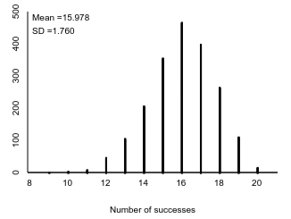
- Run 4999 more samples so you have 5000 in all. Be sure the Summary stats are showing, then take a screenshot and paste it here.
Key:
- Switch from “Number” to “Proportion” and put the results from (2) in the box near “As extreme as”. Do we count extreme as to the left or the right? Why? Explain which points in your plot above are “as or more extreme.”
12 and to the left because the law firm is trying to show that their conviction rate is lower.
- What proportion of your samples are as extreme or more extreme as the value from (2)? What is the statistical name of this proportion?
I got 0.034 for p-value.
- Describe the strength of evidence in context.
Moderate to strong evidence that the firm's true proportion of convictions is less than 80%.
- True or False: A p-value is always computed by assuming H0 is true.
TRUE
- From the “strength of evidence” plot on p 26, write down (2 pts)
  - a p-value which provides very strong evidence against H0.
0.00 to 0.01
  - a p-value which provides little to no evidence against H0.
0.10 and above

Turn this in as a PDF.

