Marissa Tullis

2/28/2021

IT FDN 130 A Wi 21

Assignment 07

SQL Functions

# Introduction

In this paper, I will discuss when to use a SQL User Defined Function (UDF), and I will explainthe differences between Scalar, Inline, and Multi-Statement Functions

# SQL UDFs

SQL user defined functions (UDFs) are functions created that do not already exist for use as a built-in function in order to perform a task or calculation. UDFs can be used to return a single value or a table of values by setting specific, customized parameters. These should be used when existing basic functions do not meet your needs, and you need to create a complex query that you want to store it for future use.

# Types of Functions

Scalar, Inline, and Multi-Statement functions are some of the different types of user defined functions that can be used in SQL. Scalar functions return a single value as an expression and are a great way to simplify complex code calculations. Schema must be used in Microsoft SQL Server for scalar functions. In contrast to Scalar functions that return a single value, there are functions called Inline functions and multi-statement functions that return a table of values. These functions do not require the use of a schema. Multi-statement functions are more complex than inline functions, as they require the use of variables, as well as the use of Begin and End in the query (see Figure 1).

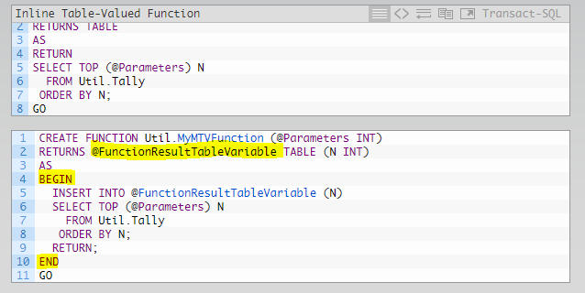

*Figure 1. An example of how multi-statement functions require a variable, and a begin and end. The top chart is an inline function, and the bottom is a multi-statement function.*

# Summary

In this paper I discussed when to use a SQL UDF, and the differences between scalar, inline, and multi-statement functions. UDFs are a handy way to save complex queries for tasks and calculations that are not already available in basic functions. Scalar functions are UDFs that return a single value, and inline and multi-statement functions return table values, and they are all useful ways to perform calculations and tasks that can be stored to use later.