
Installation User Guide

Supported Platforms: Windows 10/11 • macOS

Step 1: System Requirements
Before starting, make sure your computer meets these requirements:
Component | Windows Requirement | macOS Requirement
Operating System | 64-bit Windows 10 or Windows 11 | macOS
User Rights | Administrator privileges required to install Docker Desktop  https://docs.docker.com/desktop/setup/install/windows-permission-requirements/ | Administrator privileges required to install Docker Desktop  https://docs.docker.com/desktop/setup/install/mac-permission-requirements/

Step 2: Install Docker Desktop
Docker Desktop is required to run the containerized Fastaptamer3 application. Please ensure it is installed and running before proceeding with the Fastaptamer3 installation.
- If Docker Desktop does not start or keeps loading, uninstall it, download a new copy from the Docker website, and reinstall it.
- If you encounter any issues with Docker Desktop, please refer to the official Docker installation documentation.
Steps | Screenshot
Windows Users  - Download Docker Desktop:  https://docs.docker.com/desktop/setup/install/windows-install/  - Run the installer with default settings.  - If prompted, allow installation of WSL2.  - Restart your computer if requested.  - Open Docker Desktop.  - Wait until the whale icon in the Windows taskbar system tray (bottom-right corner of the screen) shows “Docker Desktop is running.” | 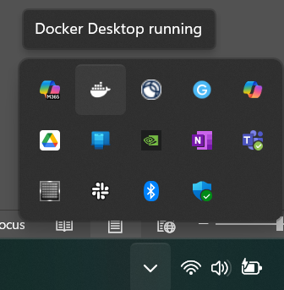
macOS Users  - Download Docker Desktop:  https://docs.docker.com/desktop/setup/install/mac-install/  - Choose the correct version: (Verify your chip: go to Apple menu → About This Mac)  - Apple Silicon (M1/M2/M3) → Apple chip version  - Intel Mac → Intel version  - Open the .dmg file.  - Drag Docker into the Applications folder.  - Launch Docker Desktop.  - Wait until the whale icon in the top right menu bar displays “Docker Desktop is running.” | 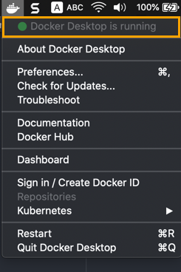

Step 3: Download the FASTAptameR3 Image
Steps | Screenshot
- Open Docker Desktop  - Click Search | 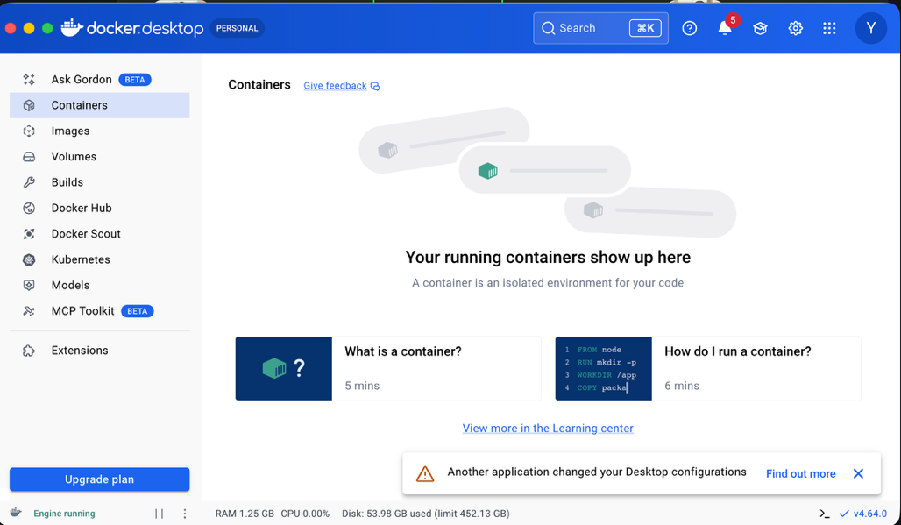
- Type fastaptamer3 in the search box.  - Select the image with the latest (largest) version tag.  - Click Pull to download the image.  Note: To update FASTAptamer3, pull the latest version of the image from Docker Hub. | 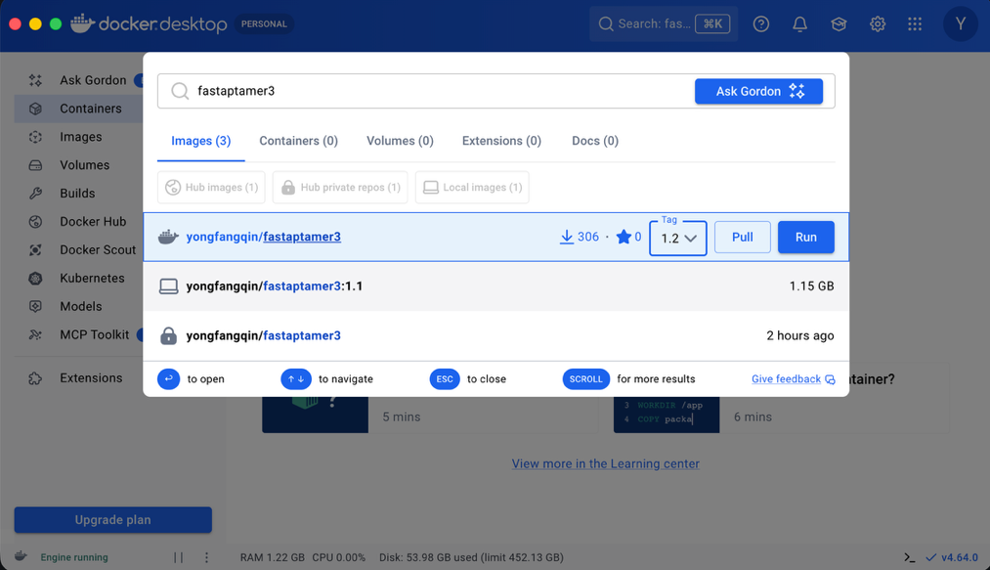

Step 4. Run FASTAptameR3

Steps | Screenshot
- In the Images tab, locate: fastaptamer3  - Under the Actions column, click the Run button. | 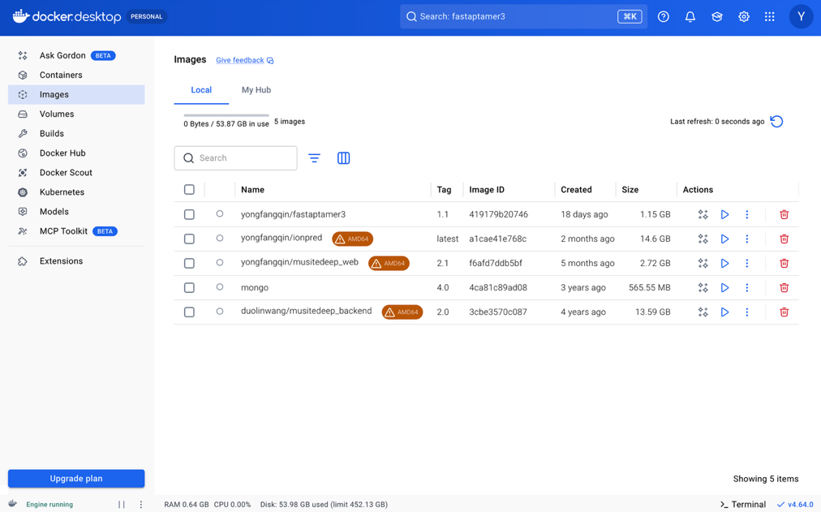
- A window will appear asking you to configure the application.  - Click the Expand down arrow. | 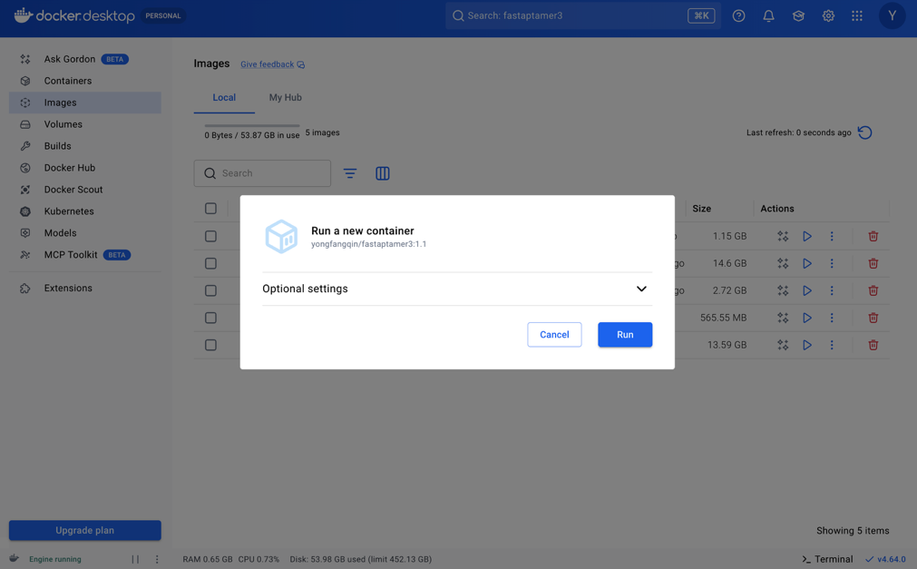
- Enter the port number you want to use (for example, 80) in the Host Port field. Make sure the port is not already in use.  - Then click Run button. | 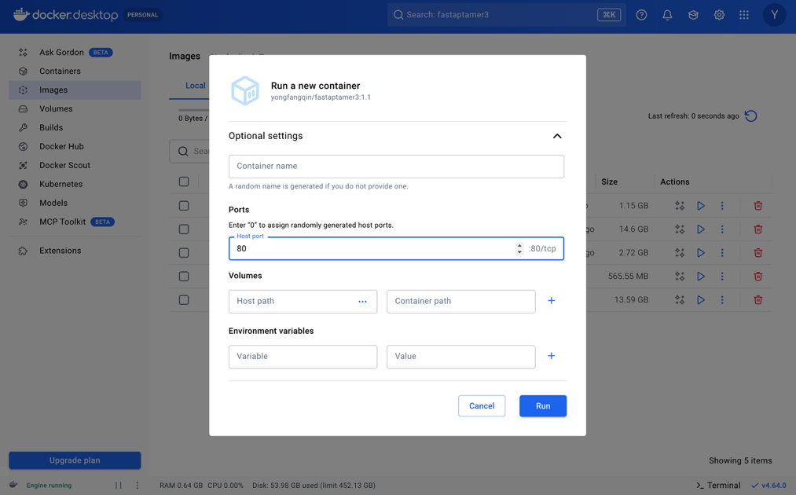
- Docker Desktop will automatically navigate to the container logs. If not, you can jump to the container log.  - The container status should change to Running. | 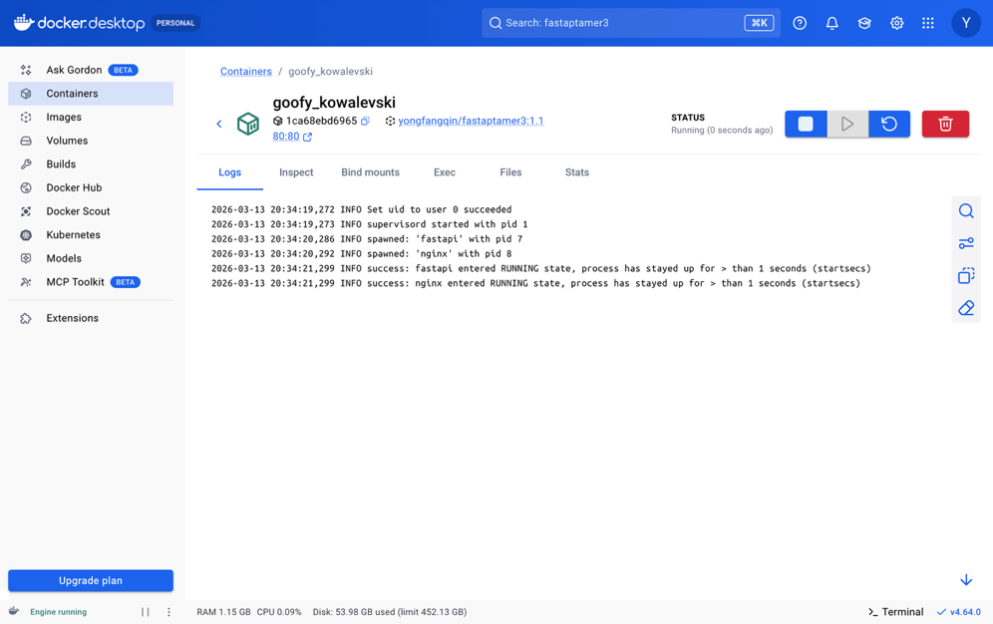

Step 5: Open the FASTAptameR3 Interface
Open your browser and go to http://localhost:80. If you used a different port in Step 4.5, replace 80 with your selected port number. You should now see the FASTAptamer3 web interface.
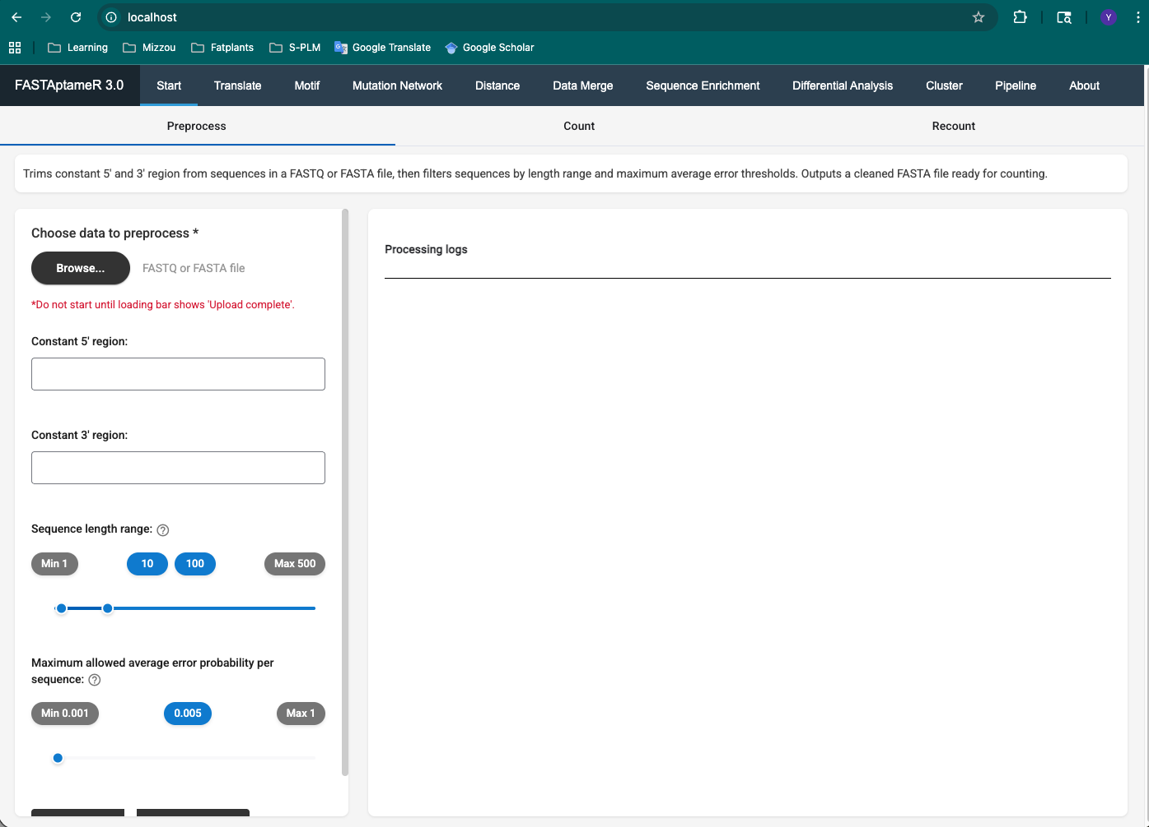

Step 6: Stopping the Application
Steps | Screenshot
- Open Docker Desktop.  - Go to the Containers tab.  - Click Stop next to the FASTAptamer3 container.  - Or remove the container | 