Practical NO:1

1. **Create one folder.**

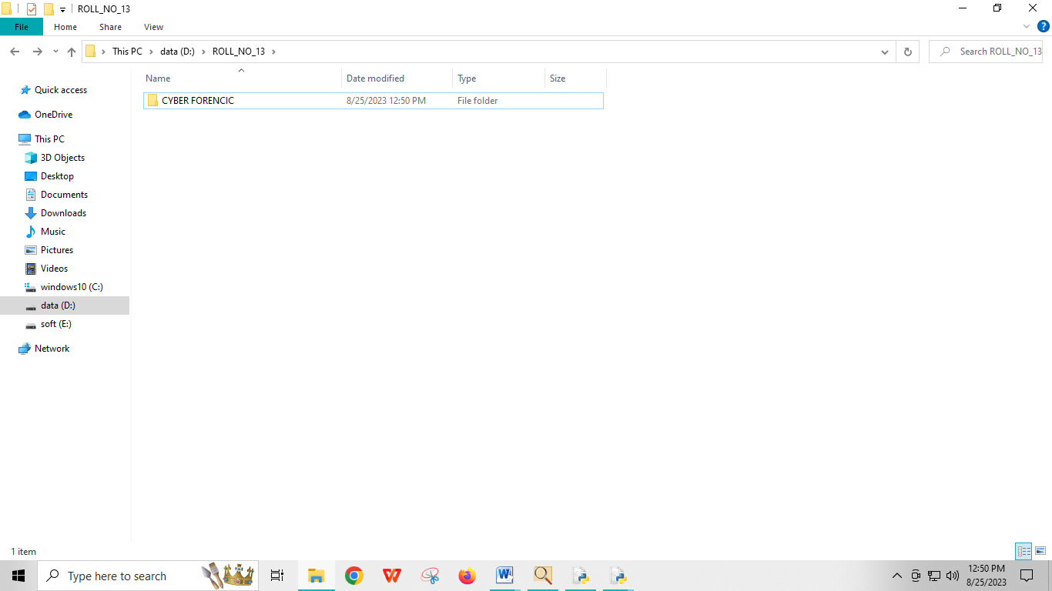

1. **Create two another folder inside your folder name with input and output**

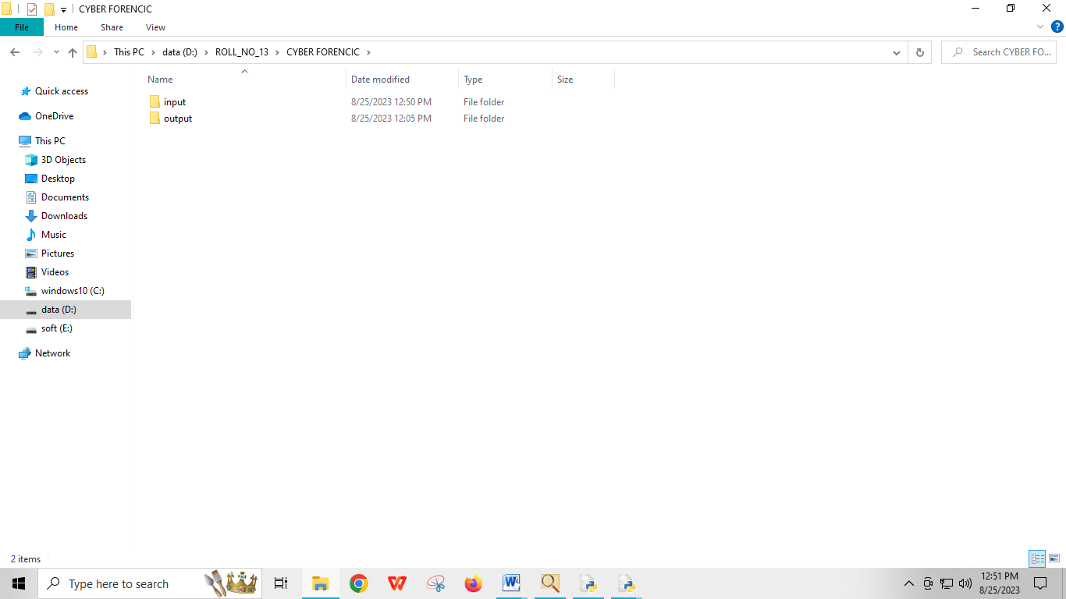

1. **Place the image inside input folder**

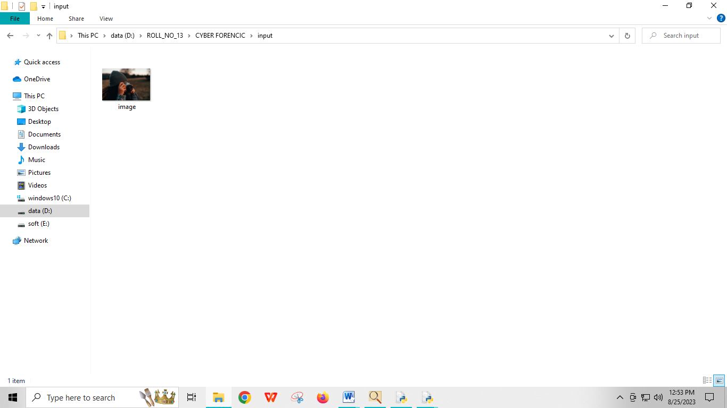

1. **Open the application app and go to file-create disk imager**

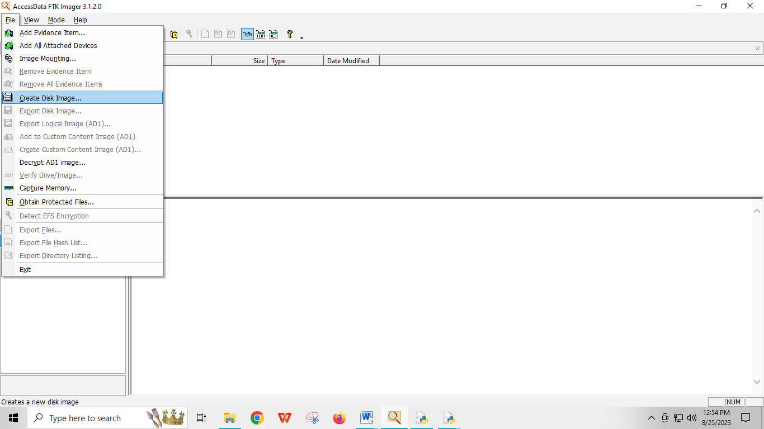

**5) Select source-content of a folder**

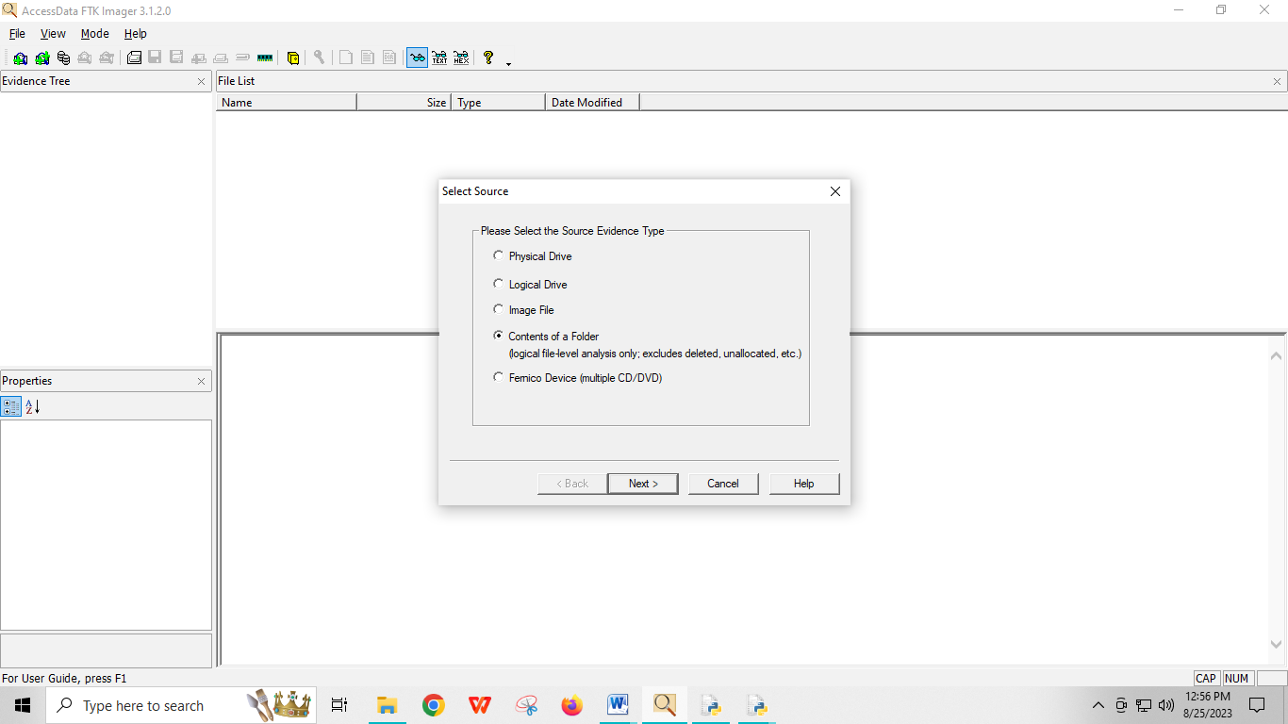

**6) Select file-enter the source location**

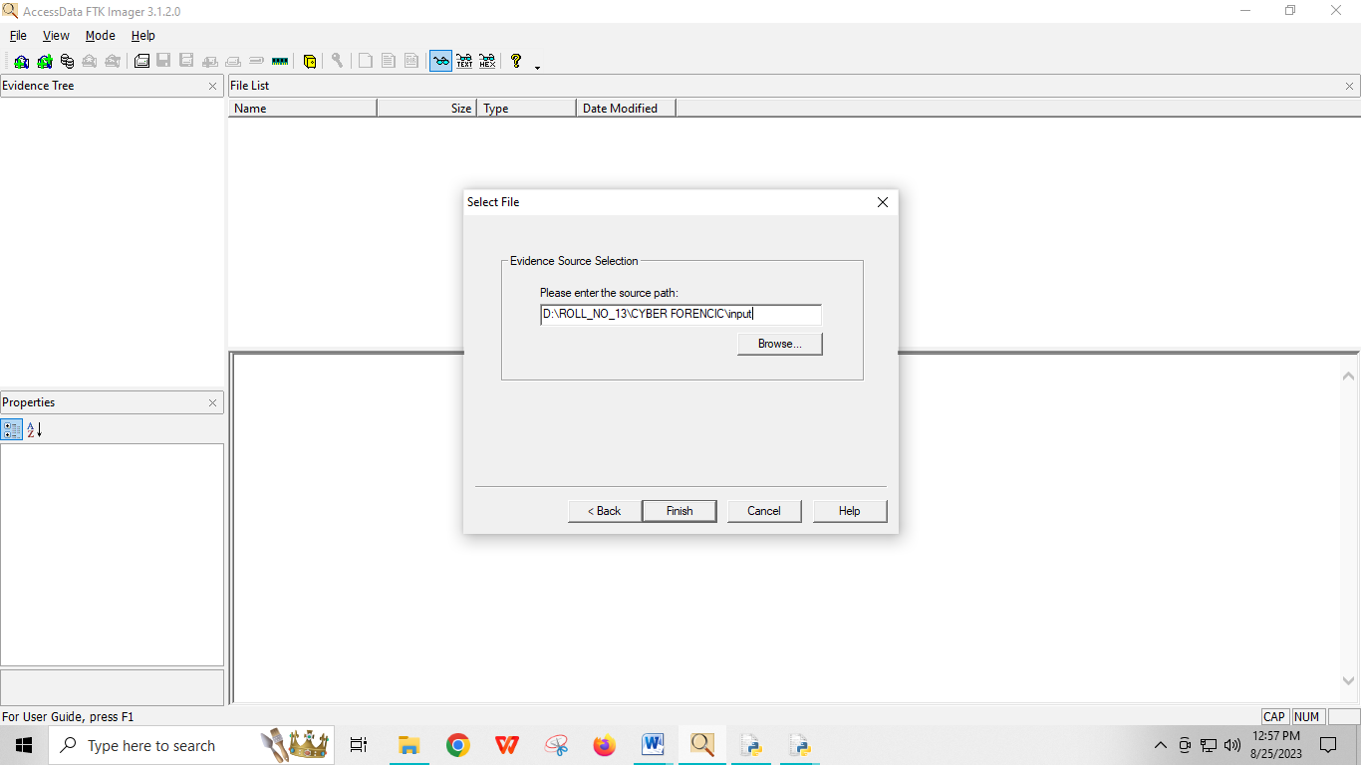

**7) Add the path**

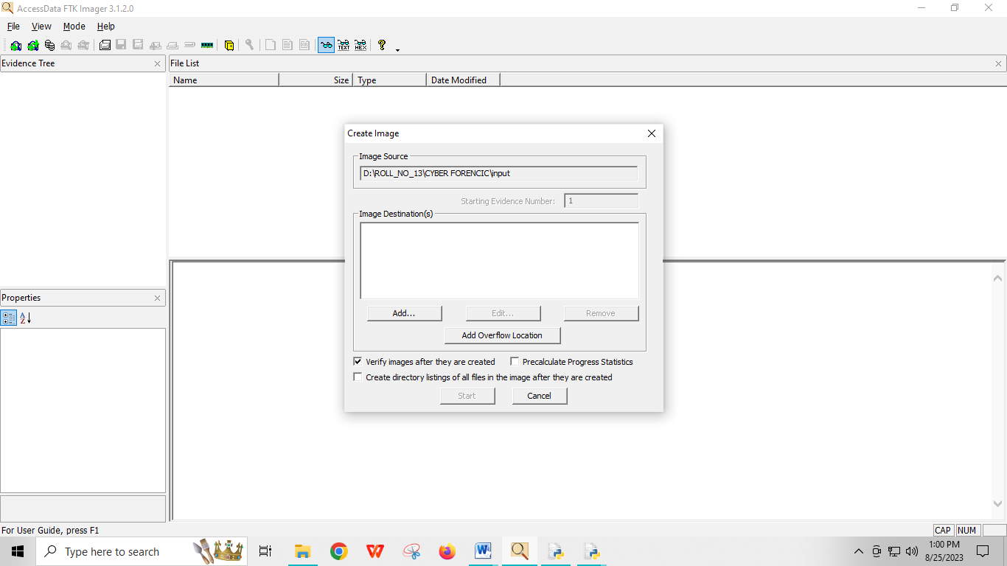

1. **Evidence item information**

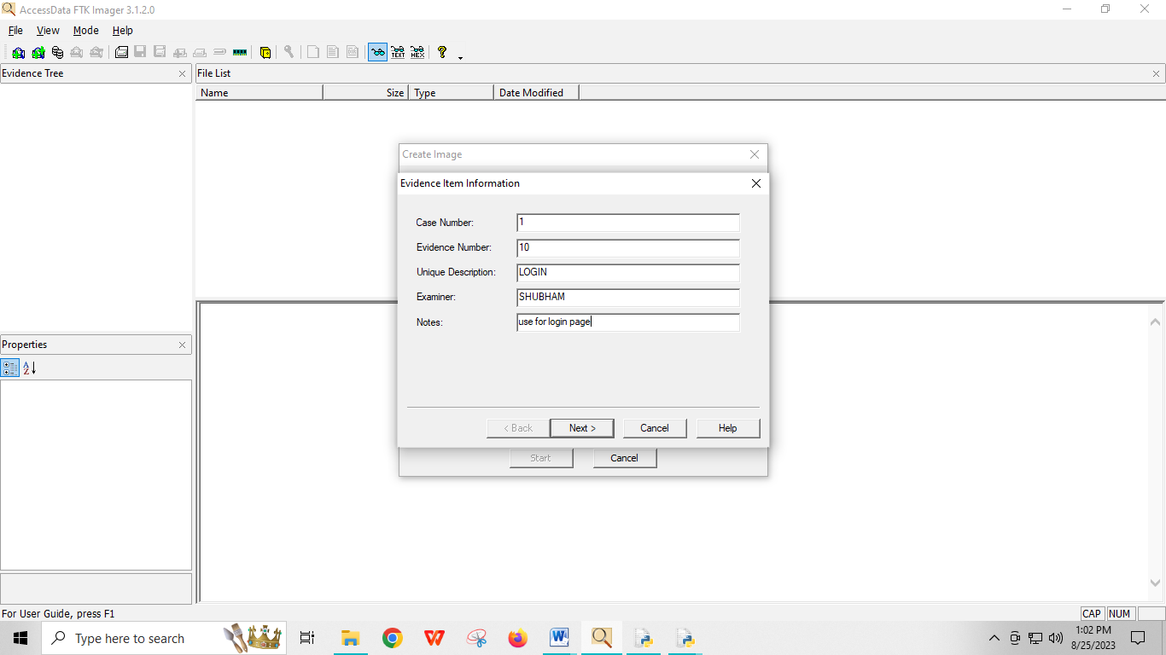

1. **Select image destination with output folder**

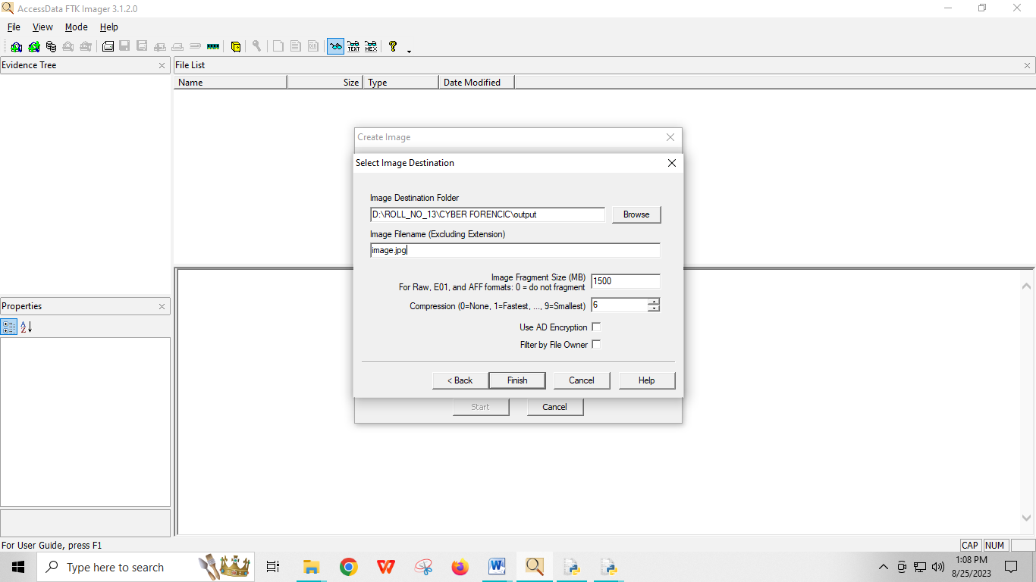

1. **After select destination we can click on start button**

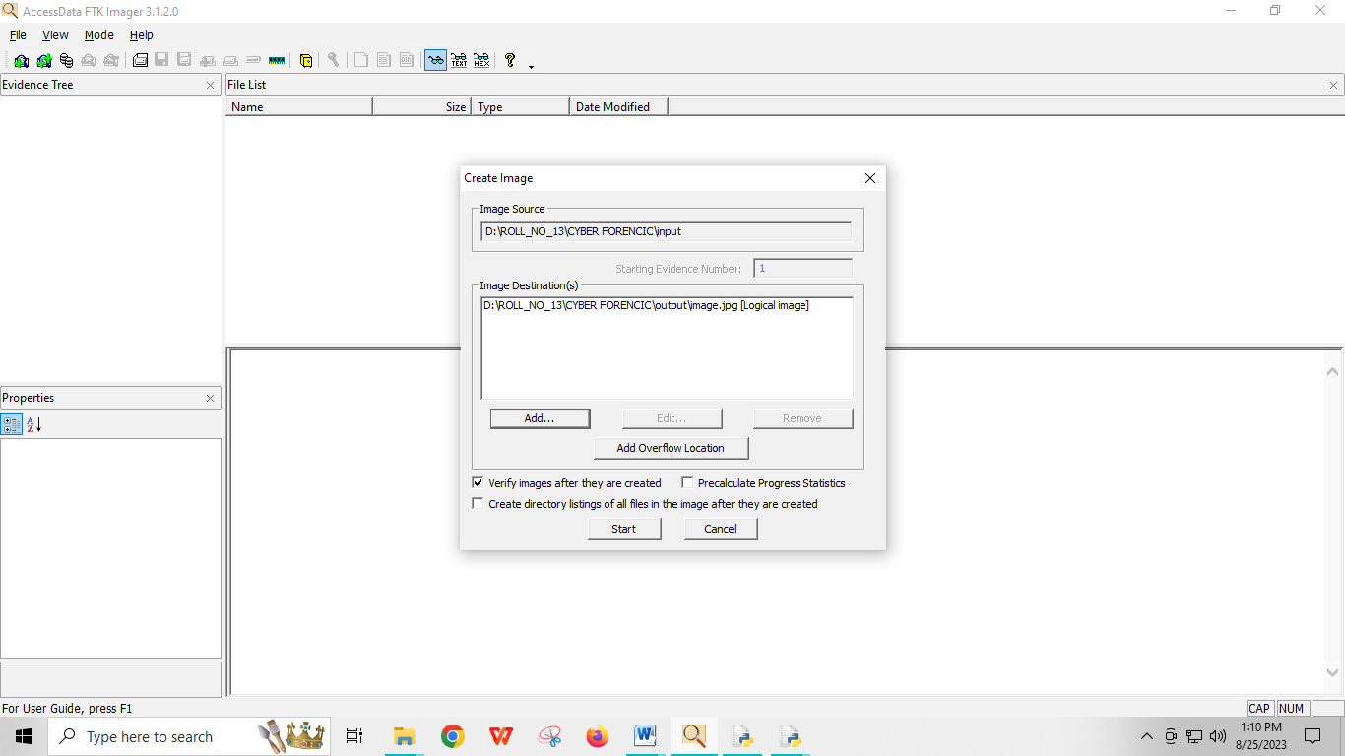

**Status will be printed is image created successfully**

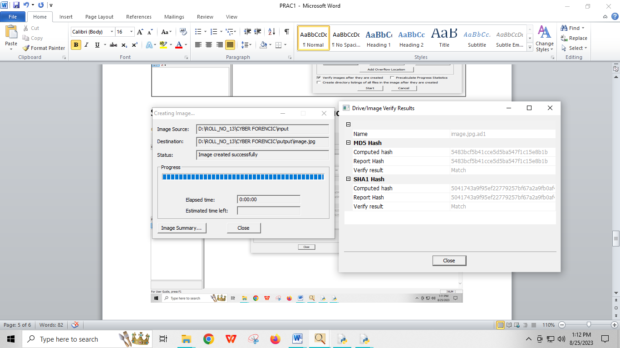

**12)file-add evidence item-image file-browse source-ad1**

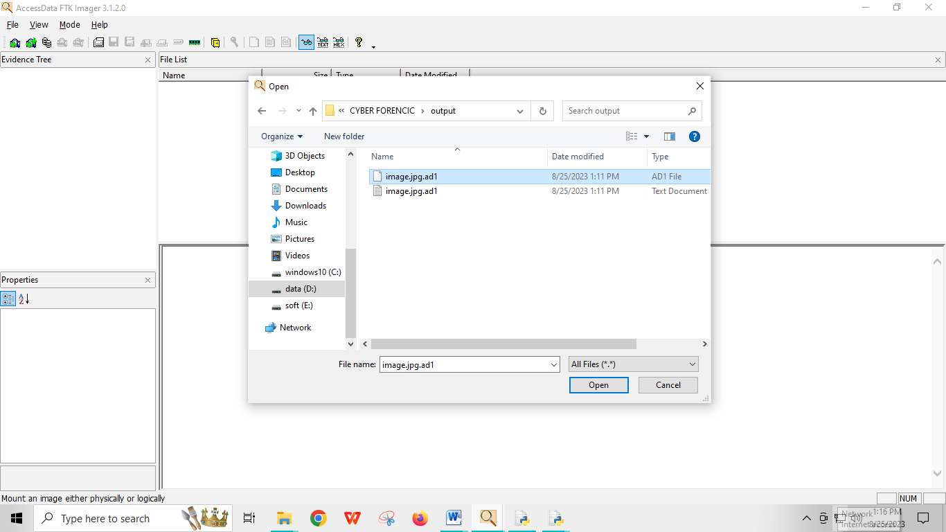

**View the image in click on image.jpg**

