**PRACTICAL NO.03**

**Title:- Analyze the memory dump of a running computer system.**

**• Extract volatile data, such as open processes, network connections, and registry information.**

**a)Open resource monitor with run as administrator**

**b)To check current working in CPU**

**For Brave, Microsoft Word ,Microsoft Edge-**

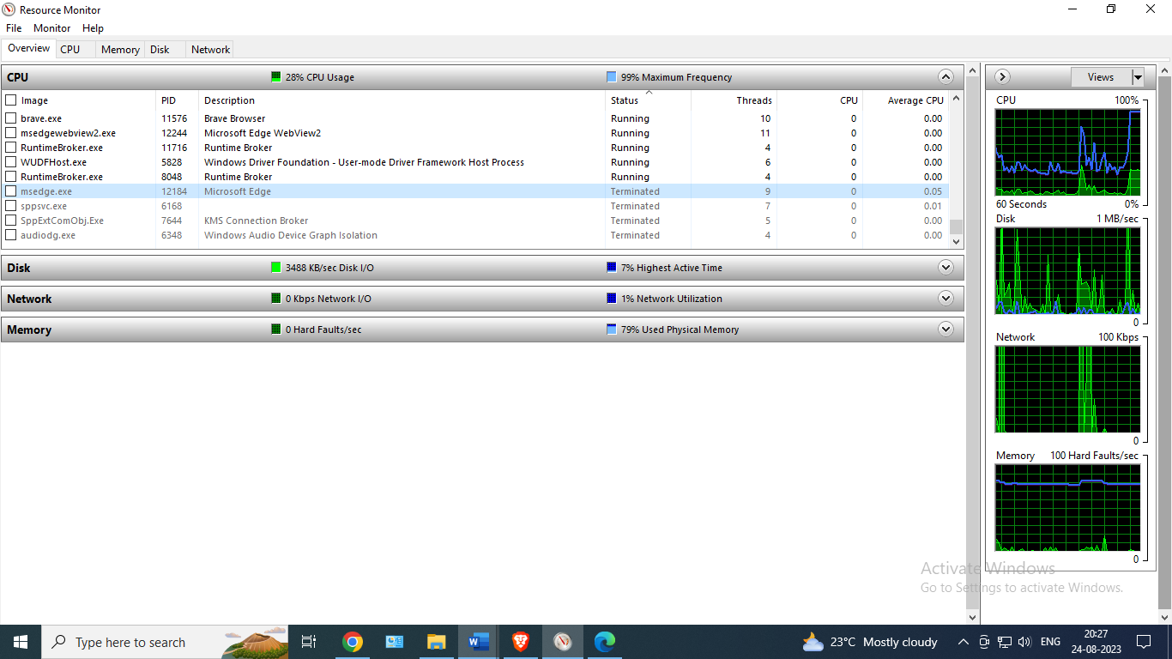

**c)To check current working in network**

**For Microsoft edge, chrome -**

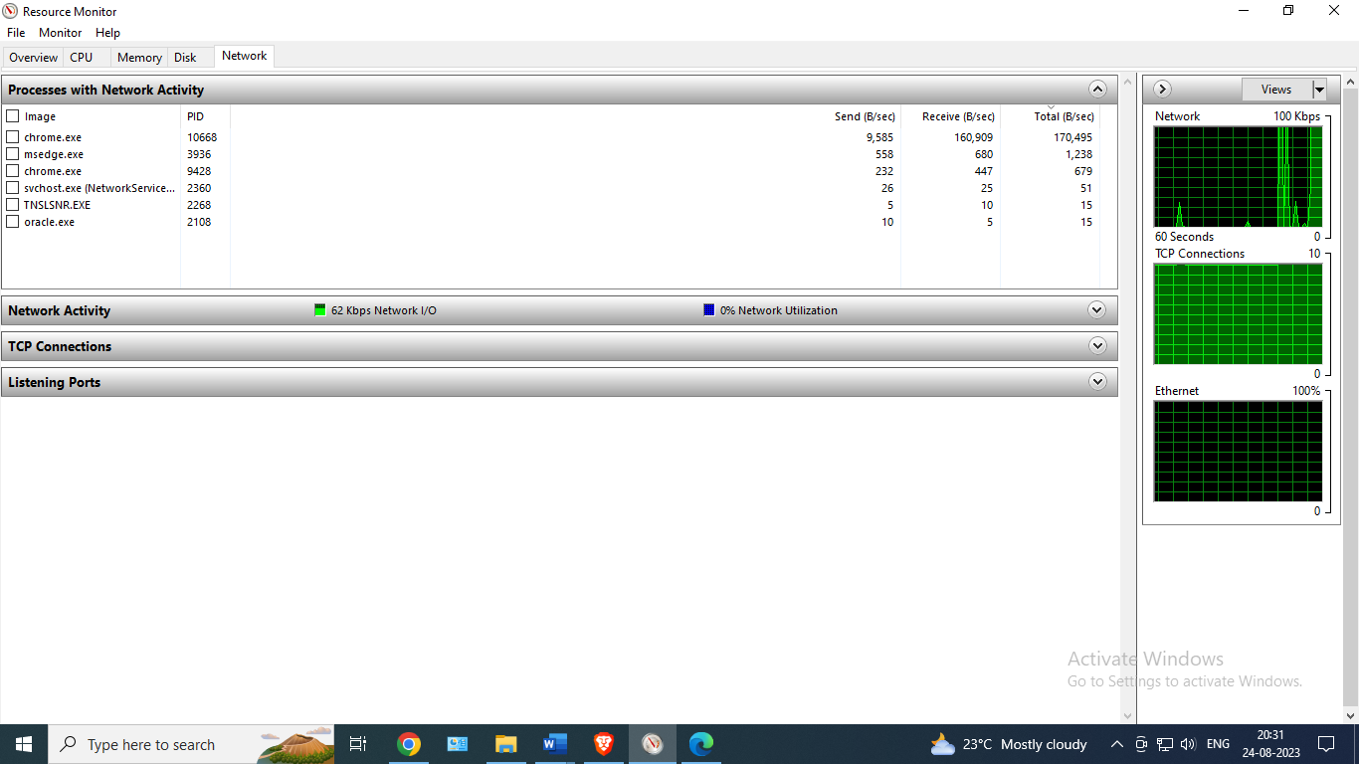



**d)To check current working in registry information**

