**Open Registry Editor**

* **Go to path Computer\HKEY_LOCAL_MACHINE\SYSTEM\CurrentControlSet\**
* **Create a key named “StorageDevicePolicies” and create a new DWORD (32-bit) value named “WriteProtect”**

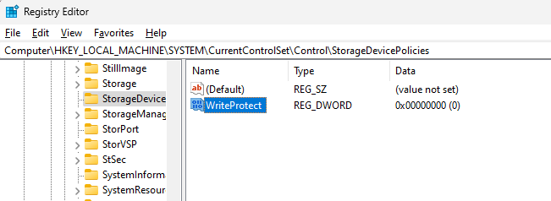

* **Set its value data to 1**

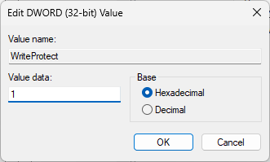

* **Now the drive is Write Protected**



* **Open the FTK image- file – create disk image-contents of folder**

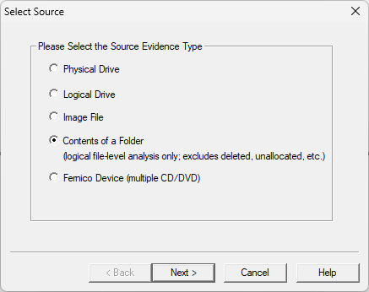

* **Select the path of the drive**

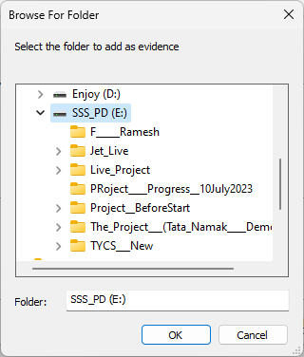

* **Evidence Item Information**

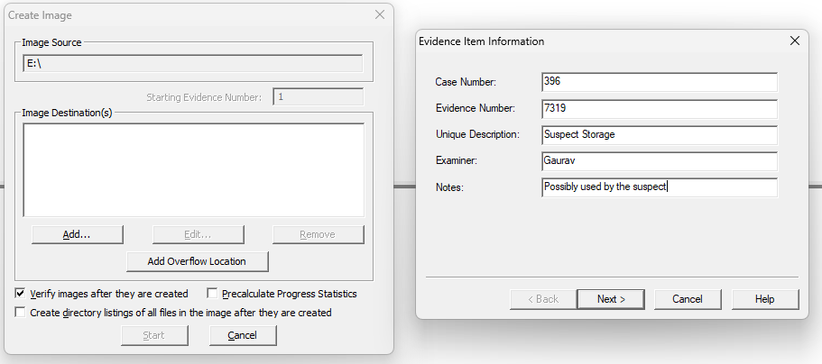

* **Destination Path**

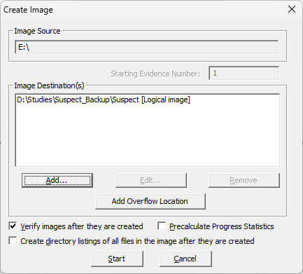

* **Hash values and Image Status**

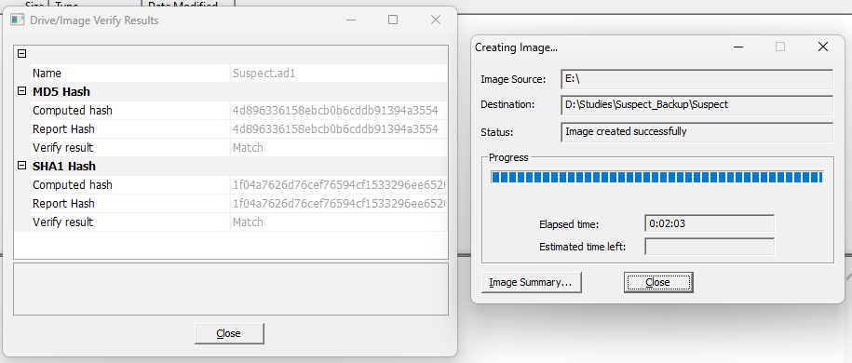

* **Now delete the “WriteProtect” DWORD (32-bit) value to disable write protect on the drive**



• **USB Write Blocker + Encase Imager**

1. **Connect the USB drive to your device and open command prompt with run as administrator**

**Command- diskpart**

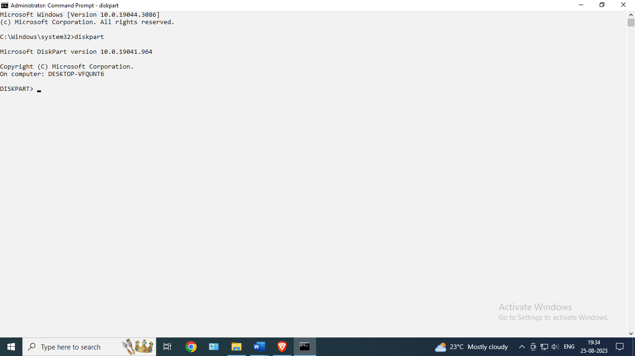

1. **Command – list disk**

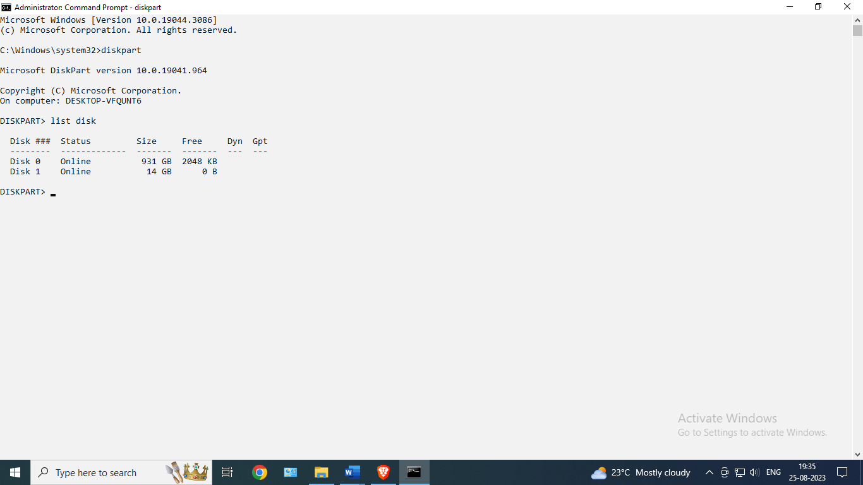

1. **Command – select disk 1(select USB disk)**

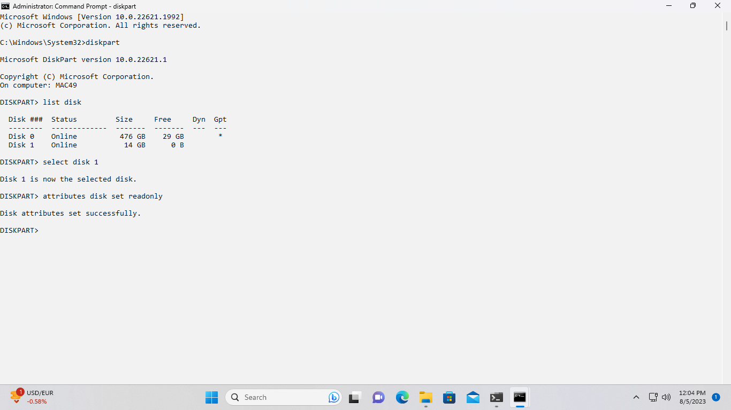

1. **Command – attributes disk set readonly**



1. **Check the USB files are movable or not.**

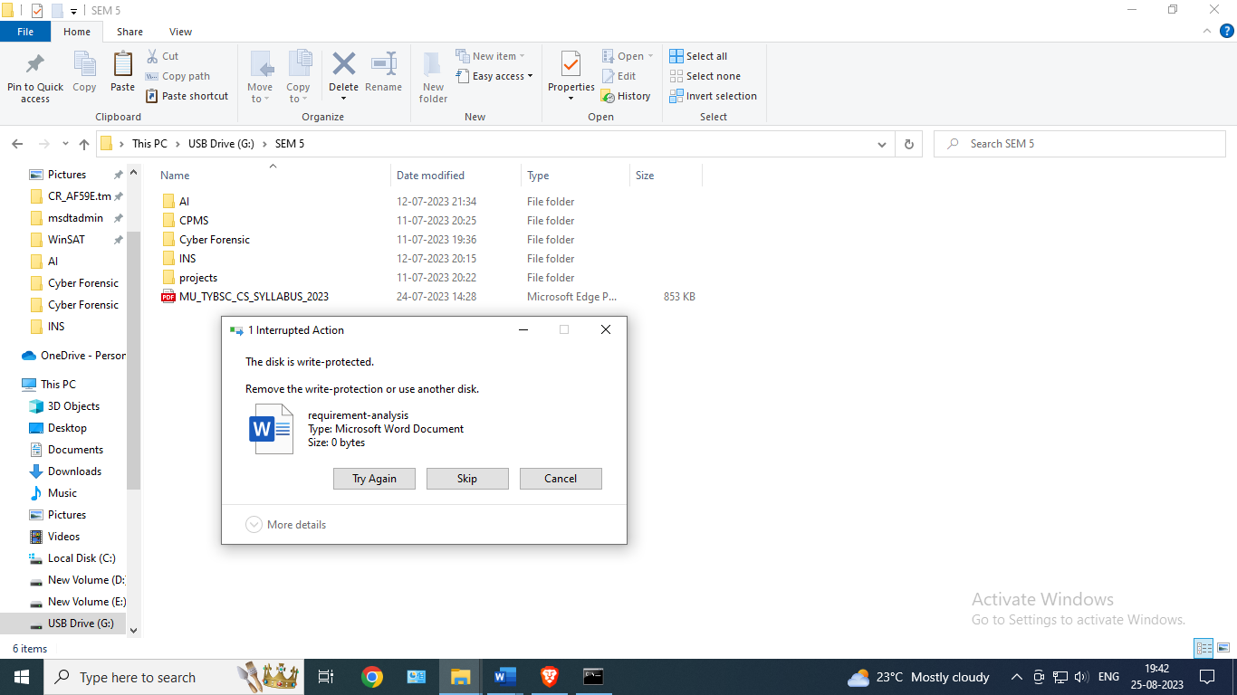

1. **Command – attributes disk clear readonly**

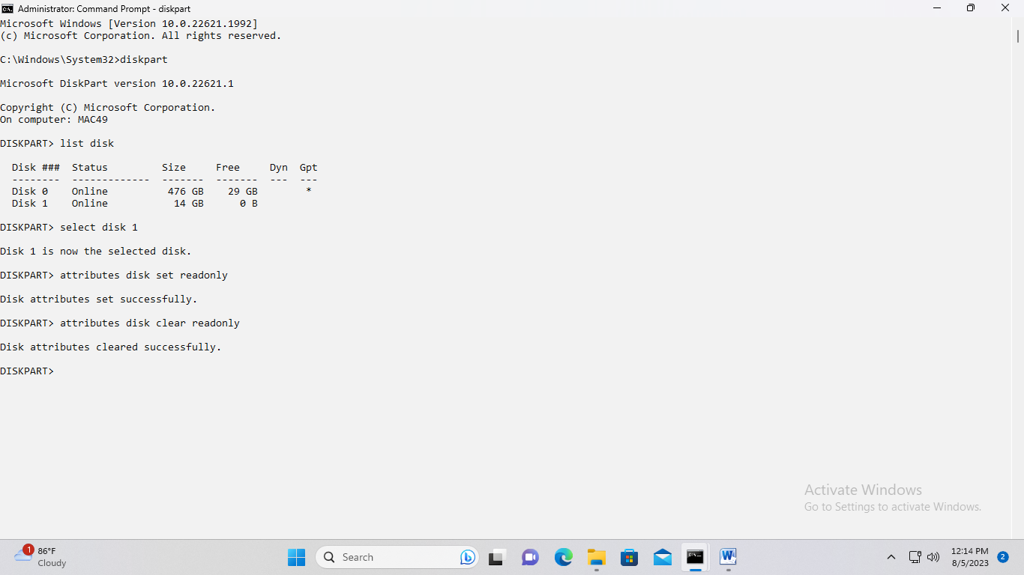

**7)After enter this command ,files are ready to move.**

