* **IP Security (IPsec) Configuration using cisco packet tracer**

**Design a network**

**Assign Ip for all pc and configure Routers Using RIP protocol**

**This is 200.0.0.0 network**

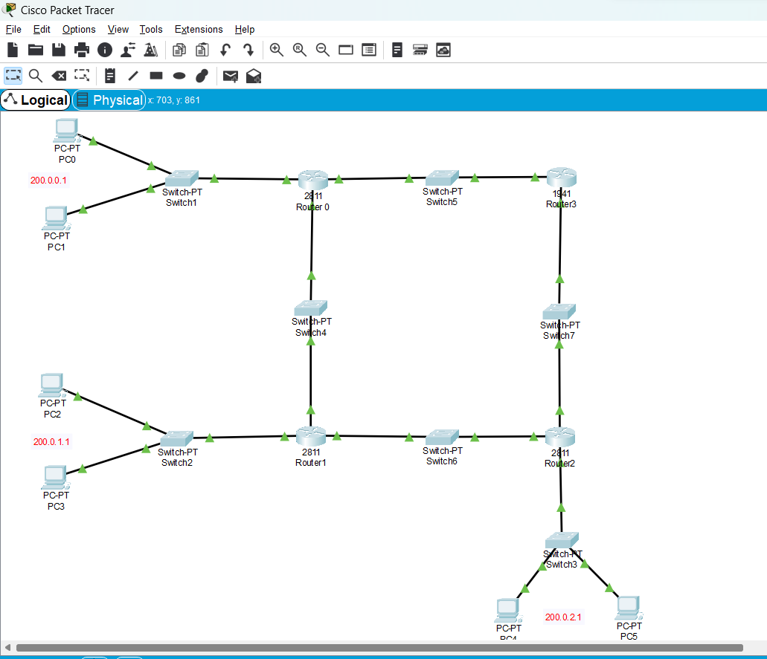

**Design second network same as it is (with RIP protocol)**

**For that I am using 192.168.0.0 network**

**Then Add One Router (ISP) connect with RIP networks(using serial DTE )**

**For VPN connection configure ISP Router as follows**

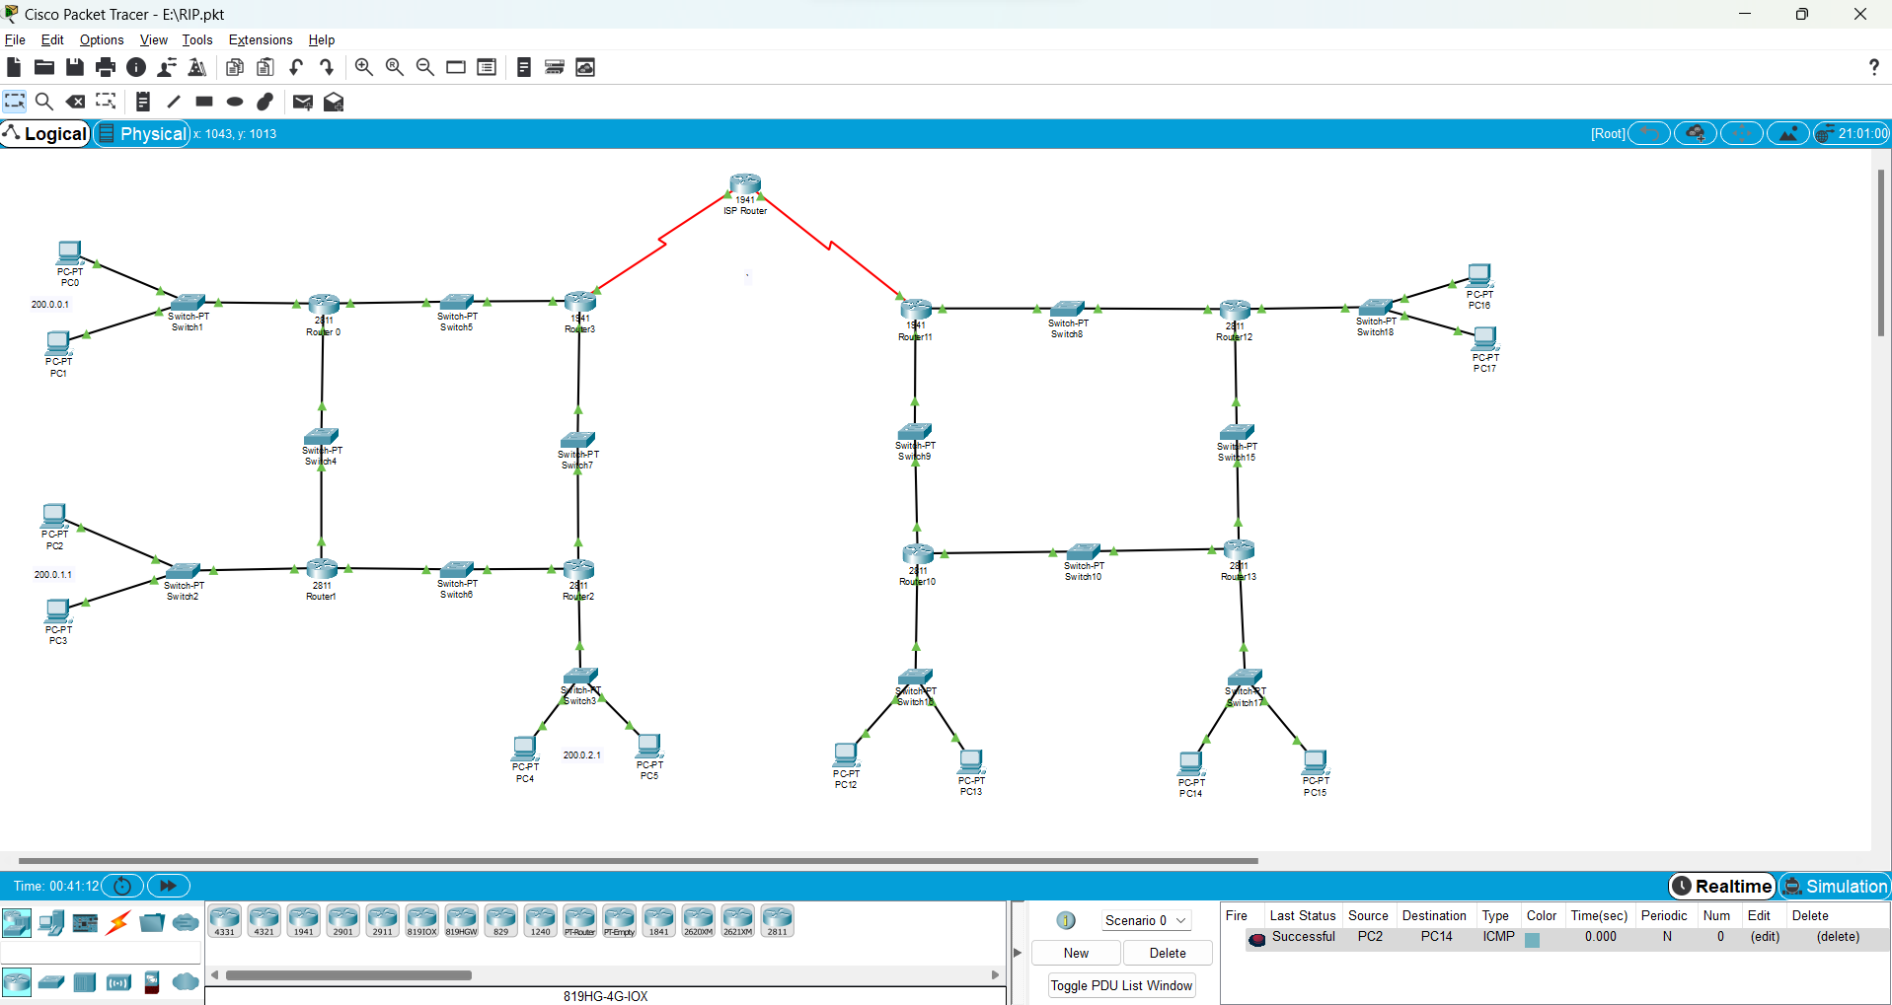

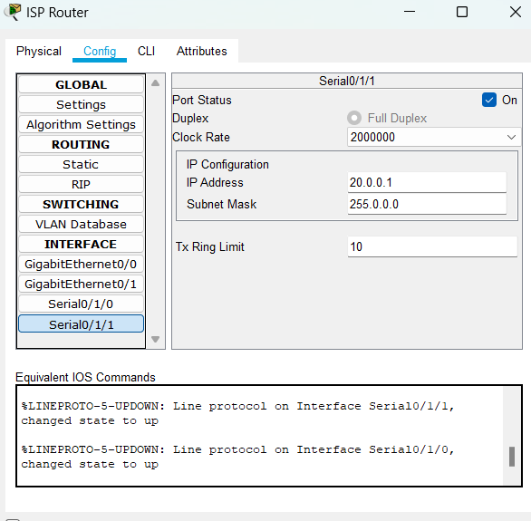 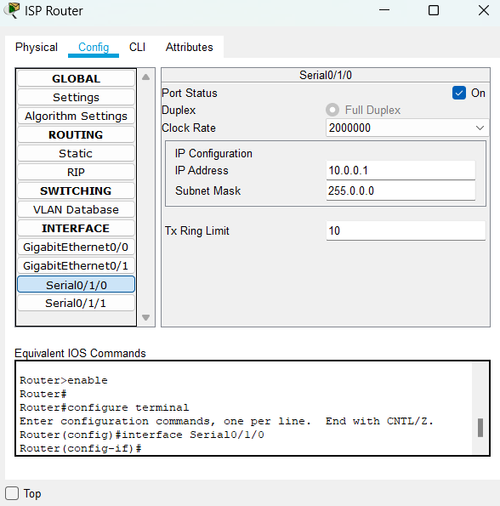

**Configuration of Router3 and Router11 which is connected to ISP router**

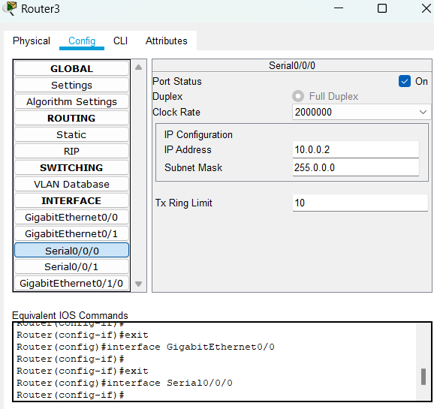 

**Configure both Router(use Static )**

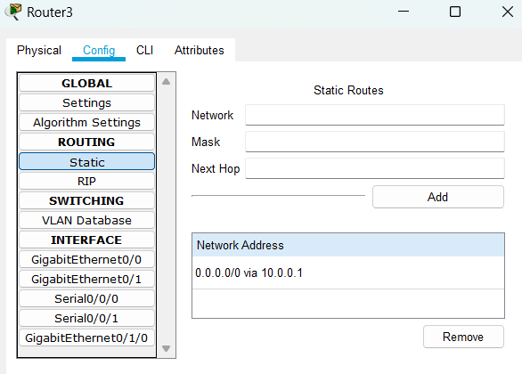 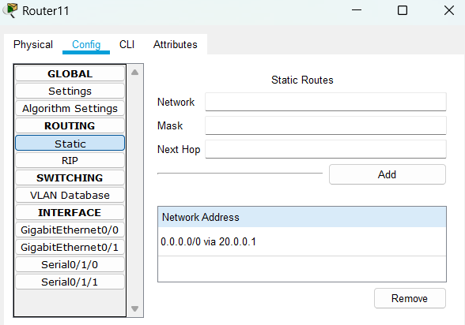

**Then after ISP**

**Open command line interface of Router3 and Router11 and give command for making IPSEC**

**After that transfer the packect from 200.0.0.0 to 192.168.0.0 or vice versa**



**Packet transfer Successfully**

**Open command prompt of PC 0 . and ping 192.168.1.11**

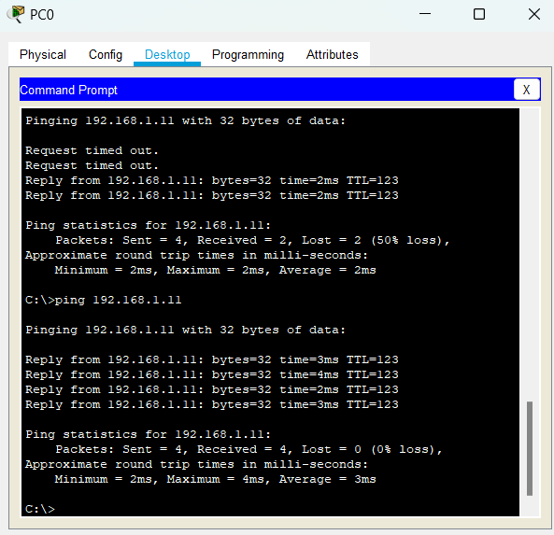 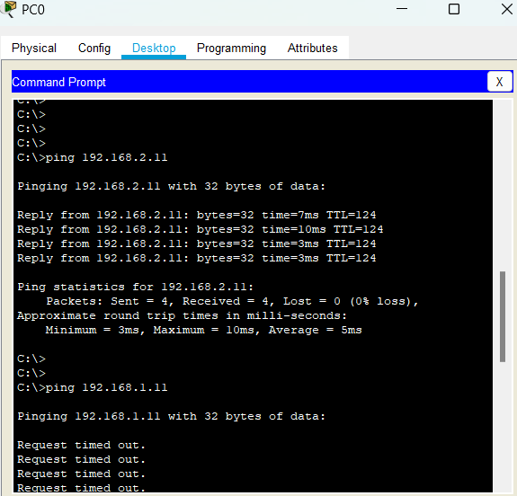

**Open command prompt of PC5 . and ping 192.168.1.11**

