* **Web Security with SSL/TLS:**

**Configure and implement secure web communication using SSL/TLS protocols,**

**including certificate management and secure session establishment.**

1. **Open control panel and click on programs:**

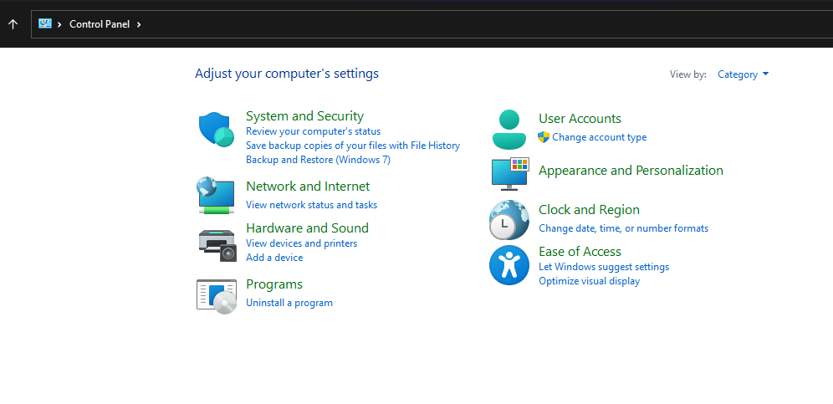

1. **Turn on windows features and select IIS**

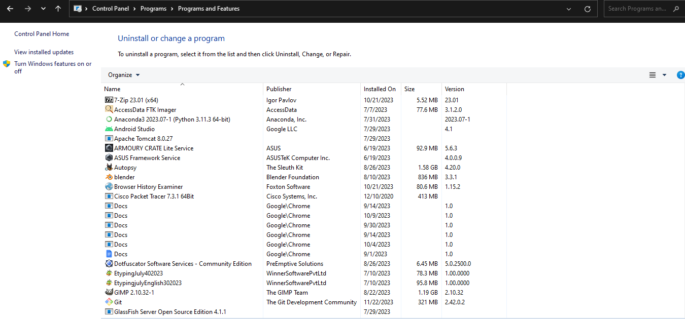

1. **Type localhost on browser:**

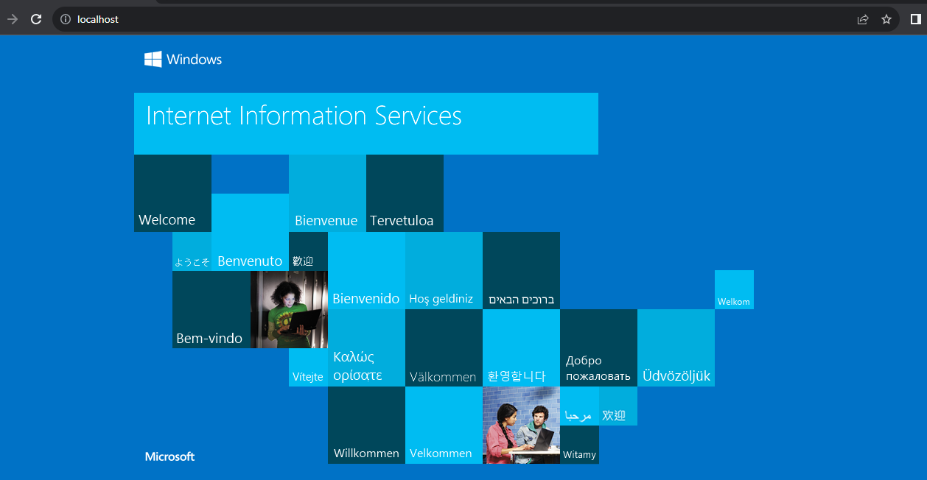

1. **Open IIS:**

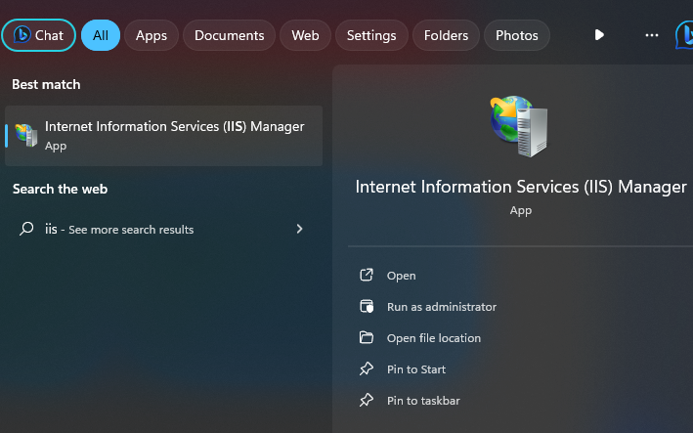

1. **IIS Manager:**

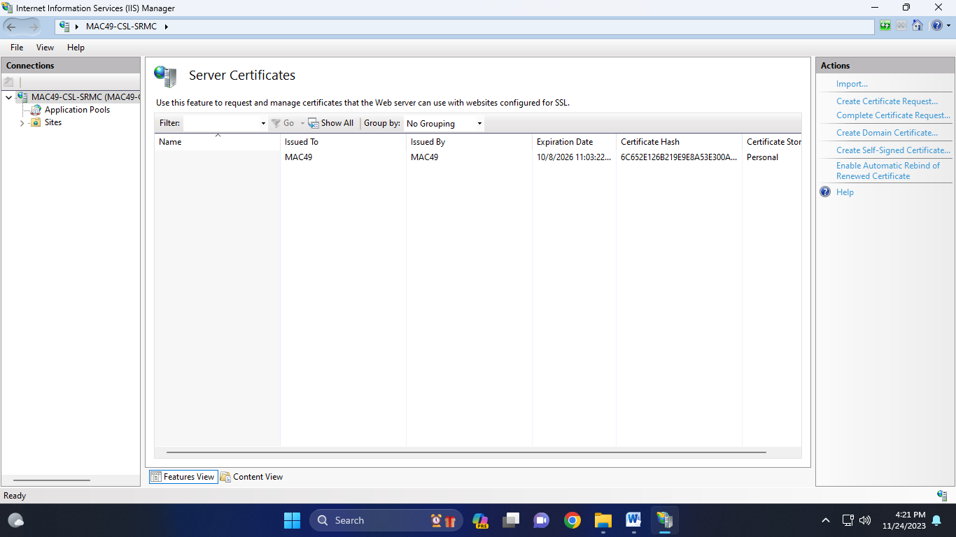

1. **Click on Create self-signed certificate and fill the name and click on OK:**

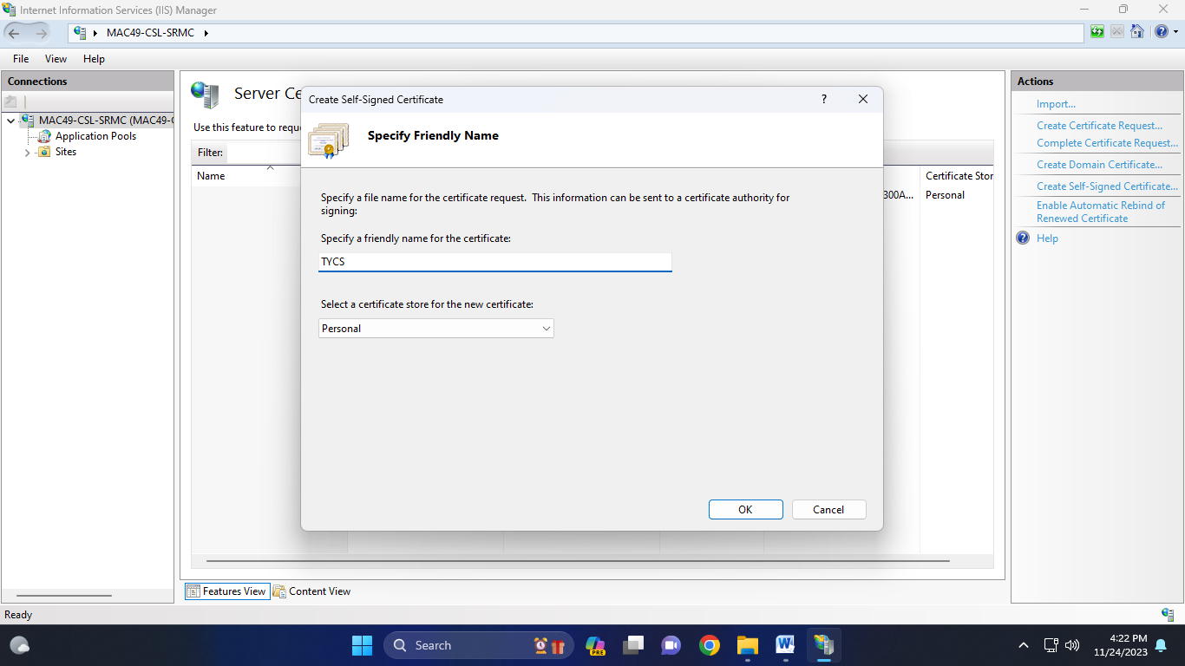

1. **Server Certificate:**

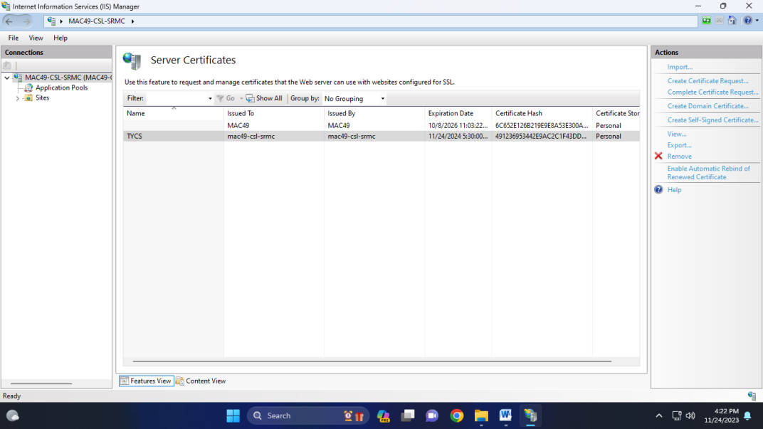

1. **Click on sites and right click and Click on Add website:**

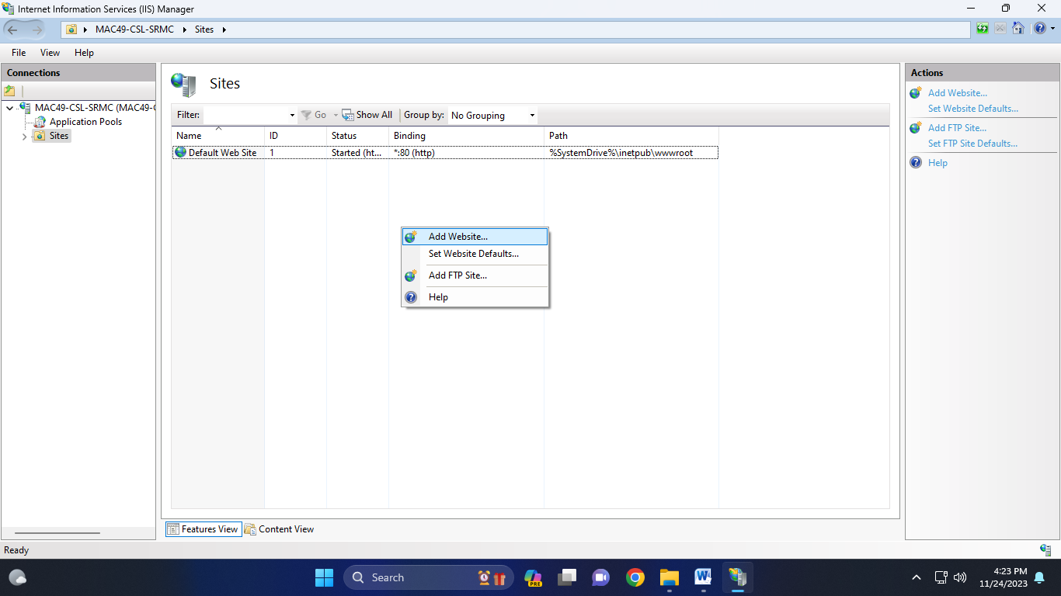

1. **Fill details on Website and click on OK:**

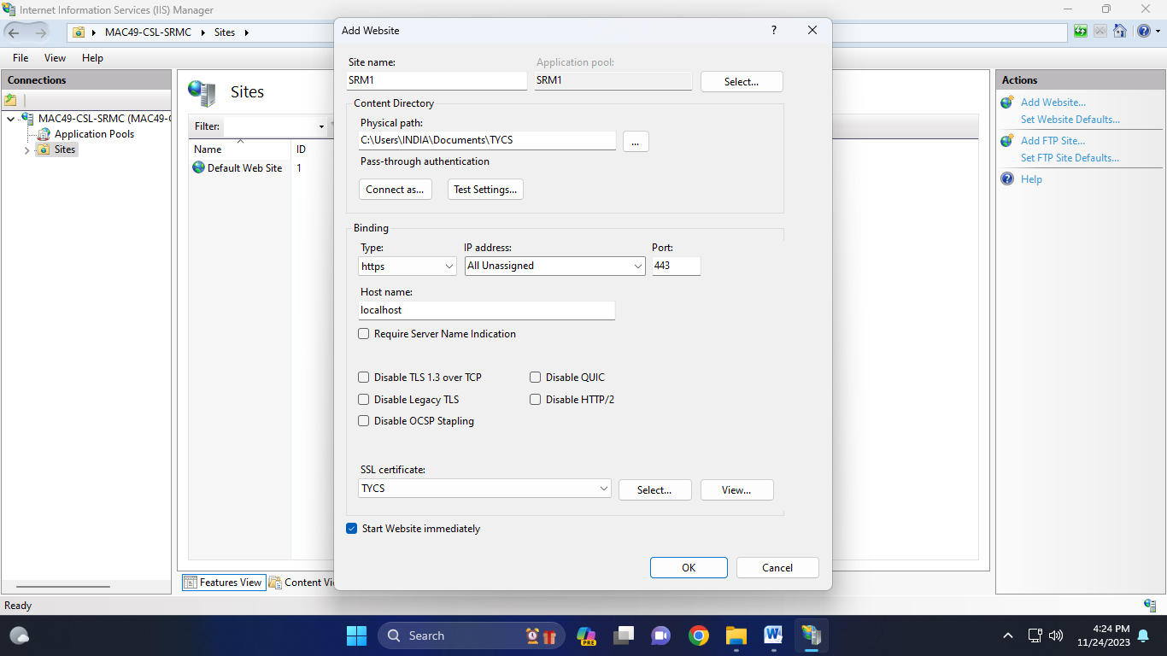

1. [**https://localhost**](https://localhost) **type on browser:**

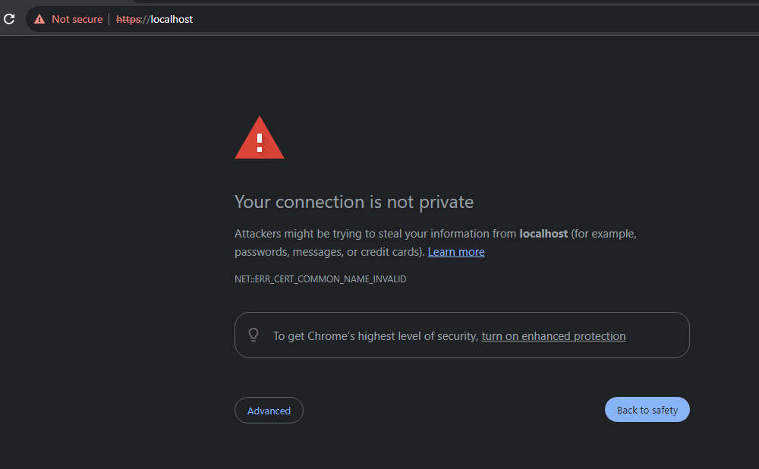

1. **Certificate:**

