Configure DHCP Server, Configure DHCP(Dynamic Host ConfigurationProtocol)

Server, Configure NFS server to share directories on your NFS, Configure NFS Client.(Ubuntu and Windows Client OS)

Install dhcp server into your system

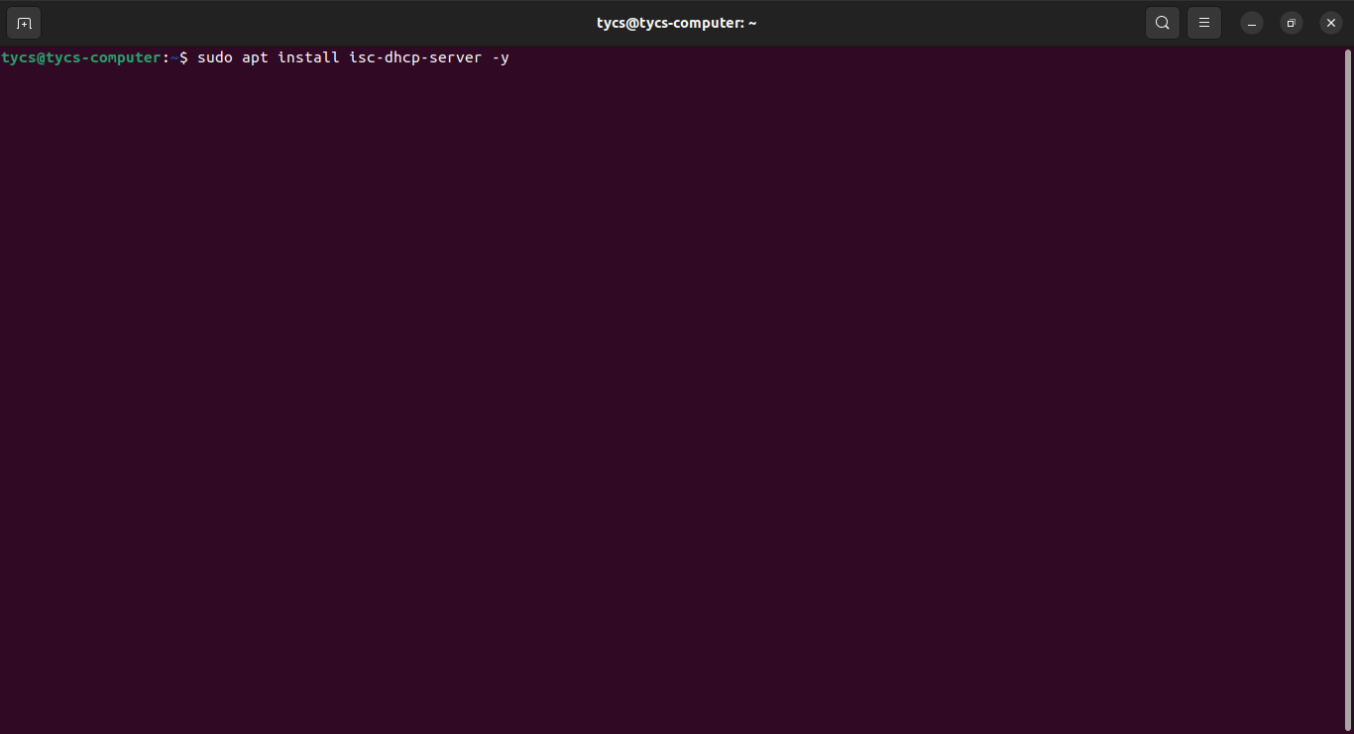

Check the ip address and interface name :-

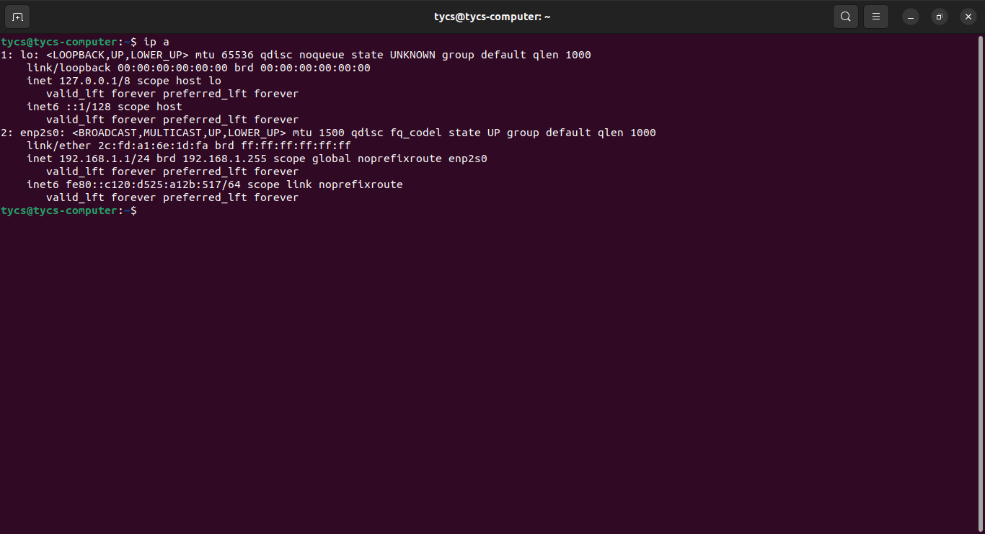

Provide the name of the network interface in /etc/default /isc-dhcp-server :-

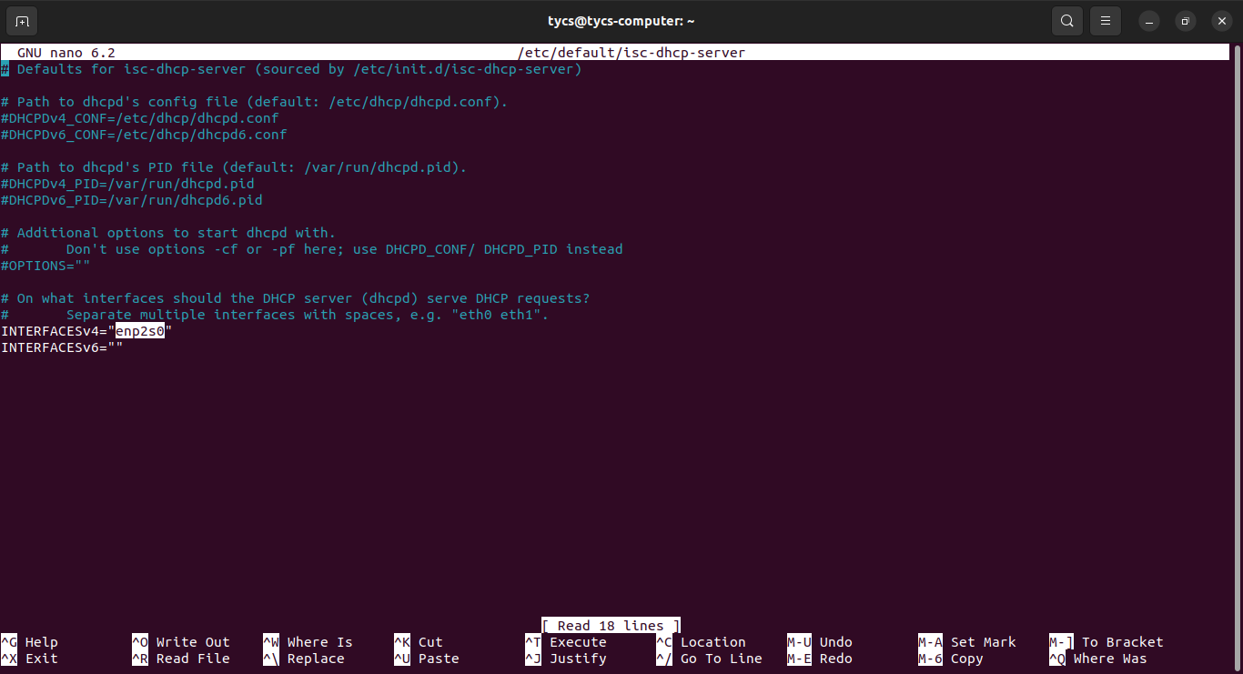

Edit configuration file - /etc/dhcp/dhcp.d.conf

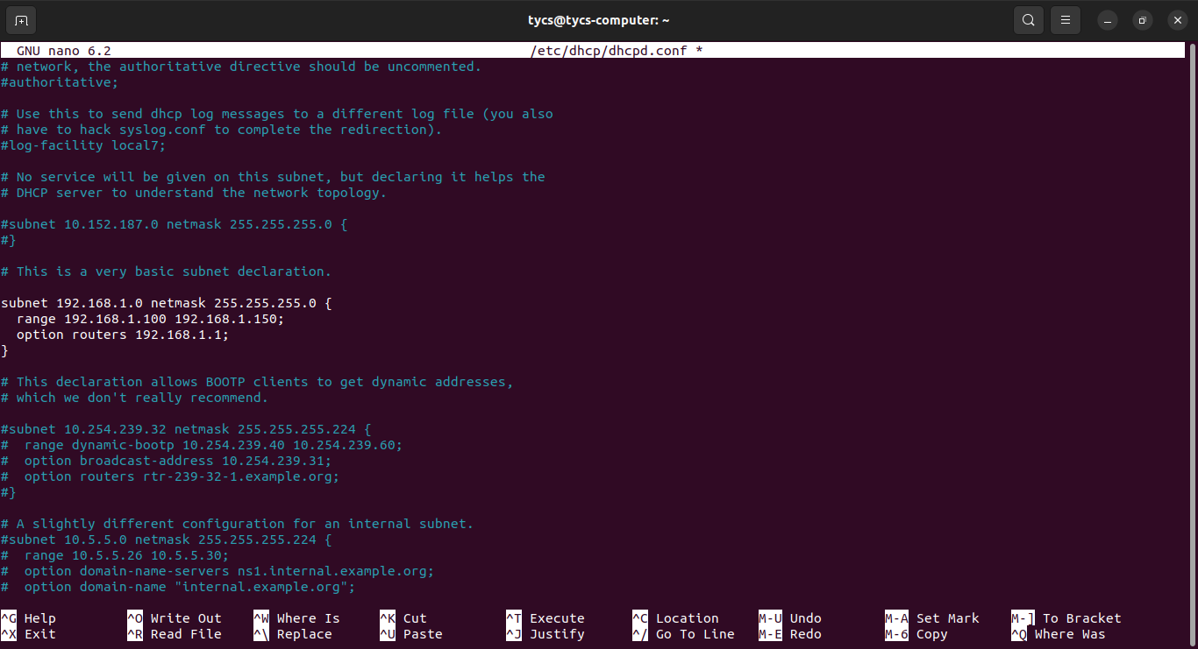

Restart the service :-

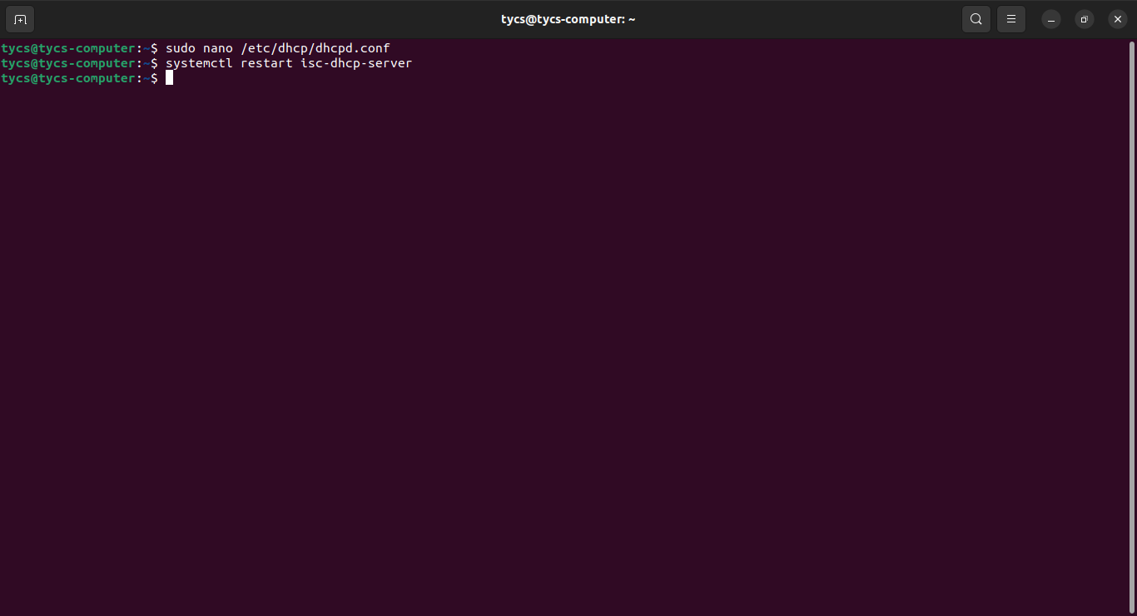

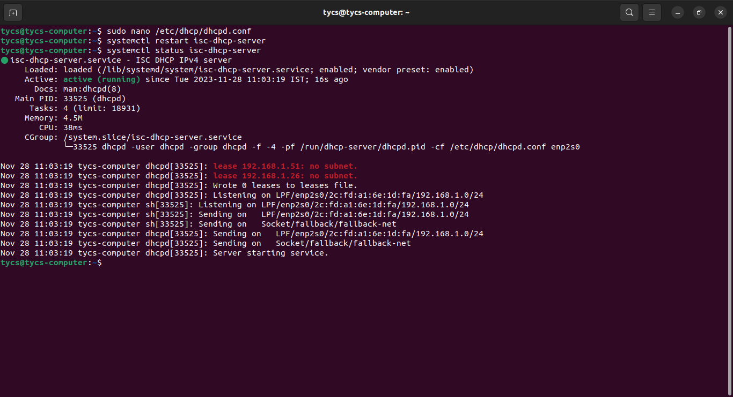

ip sets as per new dhcp server :-