Configure NTP Server (NTPd), Install and configure NTPd, Configure NTP Client(Ubuntu and Windows)

Install NTP server into your system

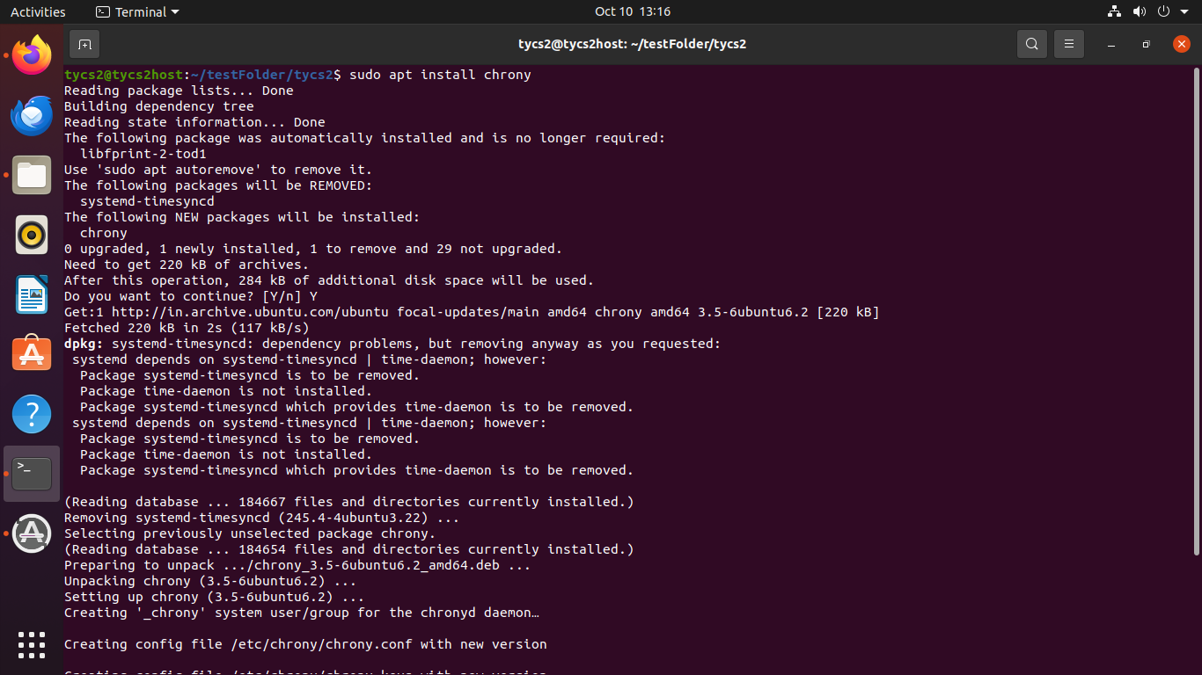

Configure chrony.conf file by adding time server addresses and allowing LAN clients by entering their IP range

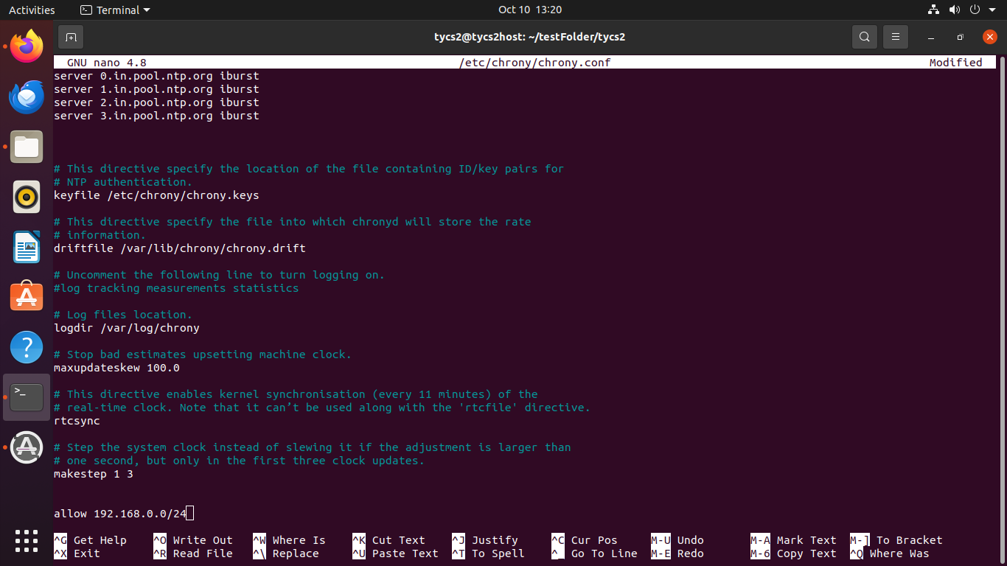

Restart the service

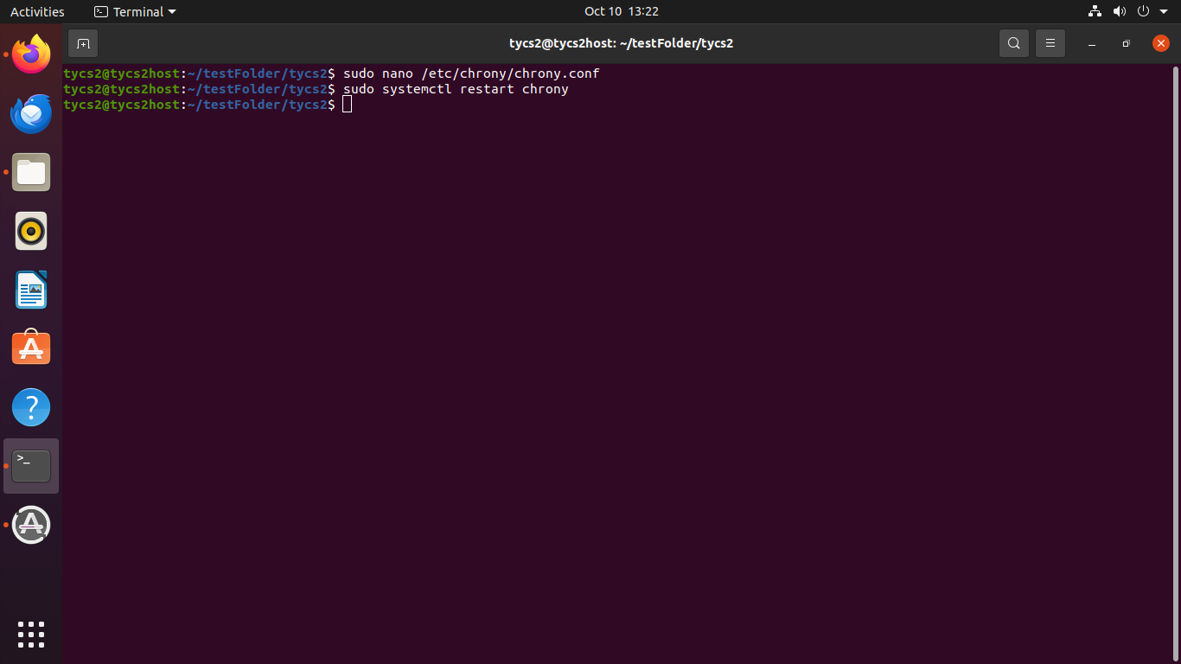

Updating the time in another windows system

