SSH Server : Password Authentication

Configure SSH server to manage a server from the remote computer, SSH Client :

(Ubuntu and Windows)

Installing ssh server into our system(openssh-server)

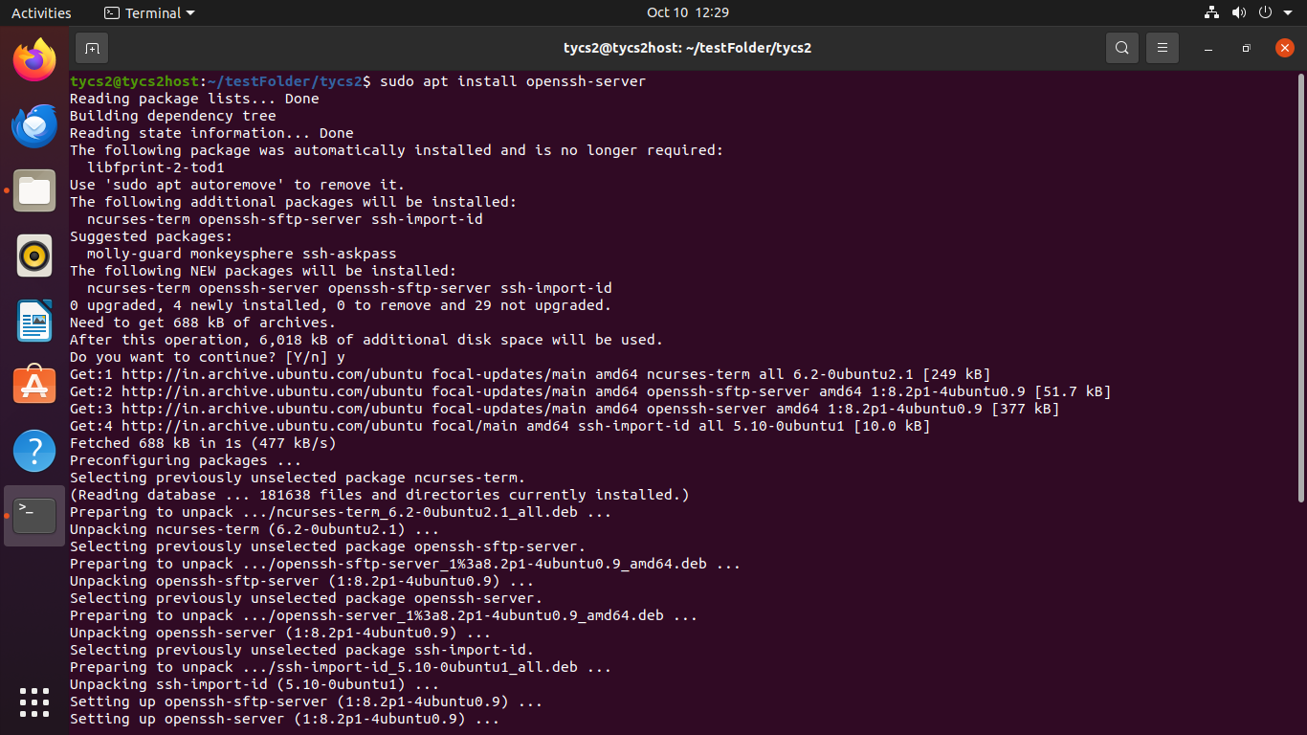

Verify status of the ssh service. If not active start openssh-server service

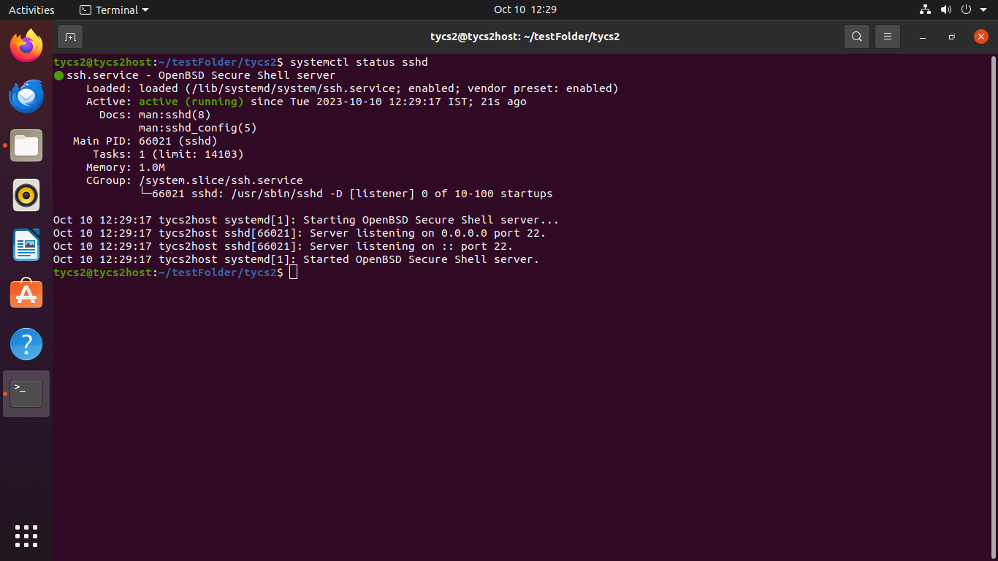

Access windows system in the network by starting the ssh service.

