**SOFTWARE DEVELOPMENT LIFE CYCLE**

Software Development Life Cycle (SDLC) is a framework that defines the steps involved in the development of software at each phase. It covers the detailed plan for building, deploying and maintaining the software.

SDLC defines the complete cycle of development i.e. all the tasks involved in planning, creating, testing, and deploying a Software Product.

## **Software Development Life Cycle Process**

SDLC is a process that defines the various stages involved in the development of software for delivering a high-quality product. SDLC stages cover the complete life cycle of a software i.e. from inception to retirement of the product.

Adhering to the SDLC process leads to the development of the software in a systematic and disciplined manner.

****Purpose:****

Purpose of SDLC is to deliver a high-quality product which is as per the customer’s requirement.

SDLC has defined its phases as, Requirement gathering, Designing, Coding, Testing, and Maintenance. It is important to adhere to the phases to provide the Product in a systematic manner.

****For Example:**** A software has to be developed and a team is divided to work on a feature of the product and is allowed to work as they want. One of the developers decides to design first whereas the other decides to code first and the other on the documentation part.

This will lead to project failure because of which it is necessary to have a good knowledge and understanding among the team members to deliver an expected product.

## **SDLC Phases**

****Given below are the various phases:****

* Requirement gathering and analysis
* Design
* Implementation or coding
* Testing
* Deployment
* Maintenance

## **Software Development Life Cycle Models**

**1) Waterfall Model**

[Waterfall model](https://www.softwaretestinghelp.com/what-is-sdlc-waterfall-model/) is the very first model that is used in SDLC. It is also known as the linear sequential model.

****Advantages of the Waterfall Model:****

1. - Waterfall model is the simple model which can be easily understood and is the one in which all the phases are done step by step.
2. - Deliverables of each phase are well defined, and this leads to no complexity and makes the project easily manageable.

****Disadvantages of Waterfall model:****

1. - Waterfall model is time-consuming & cannot be used in the short duration projects as in this model a new phase cannot be started until the ongoing phase is completed.
2. - Waterfall model cannot be used for the projects which have uncertain requirement or wherein the requirement keeps on changing as this model expects the requirement to be clear in the requirement gathering and analysis phase itself and any change in the later stages would lead to cost higher as the changes would be required in all the phases.

### **2) Prototype Model**

The prototype model is a model in which the prototype is developed prior to the actual software.

Prototype models have limited functional capabilities and inefficient performance when compared to the actual software. Dummy functions are used to create prototypes. This is a valuable mechanism for understanding the customers’ needs.

****Advantages of Prototype Model:****

1. Prototype model reduces the cost and time of development as the defects are found much earlier.
2. Missing feature or functionality or a change in requirement can be identified in the evaluation phase and can be implemented in the refined prototype.
3. Involvement of a customer from the initial stage reduces any confusion in the requirement or understanding of any functionality.

****Disadvantages of Prototype Model:****

1. Since the customer is involved in every phase, the customer can change the requirement of the end product which increases the complexity of the scope and may increase the delivery time of the product.

### **3) Iterative Incremental Model**

The iterative incremental model divides the product into small chunks.

****Advantages of Iterative & Incremental Model:****

1. Any change in the requirement can be easily done and would not cost as there is a scope of incorporating the new requirement in the next iteration.
2. Risk is analyzed & identified in the iterations.
3. Defects are detected at an early stage.
4. As the product is divided into smaller chunks it is easy to manage the product.

****Disadvantages**** ****of Iterative & Incremental Model:****

1. Complete requirement and understanding of a product are required to break down and build incrementally.

### **4) Agile Model**

Agile Model is a combination of the Iterative and incremental model. This model focuses more on flexibility while developing a product rather than on the requirement.

In Agile, a product is broken into small incremental builds. It is not developed as a complete product in one go. Each build increments in terms of features. The next build is built on previous functionality.

****Advantages of Agile Model:****

1. It allows more flexibility to adapt to the changes.
2. The new feature can be added easily.
3. Customer satisfaction as the feedback and suggestions are taken at every stage.

****Disadvantages:****

1. Lack of documentation.
2. Agile needs experienced and highly skilled resources.
3. If a customer is not clear about how exactly they want the product to be, then the project would fail.

## **Conclusion**

Adherence to a suitable life cycle is very important, for the successful completion of the Project. This, in turn, makes the management easier.

Different Software Development Life Cycle models have their own Pros and Cons. The best model for any Project can be determined by the factors like Requirement (whether it is clear or unclear), System Complexity, Size of the Project, Cost, Skill limitation, etc.

**CREATING A SERVER INSTANCE ON AWS CLOUD SERVICES**

On te AWS console we navigate to ec2 and click the ‘launch an instance button ‘ we then provide a name for the instance and select the AMI type

then move to storage size

then network configs

then we create a private .pem key so we can use ti ti access the instance from our local terminal .

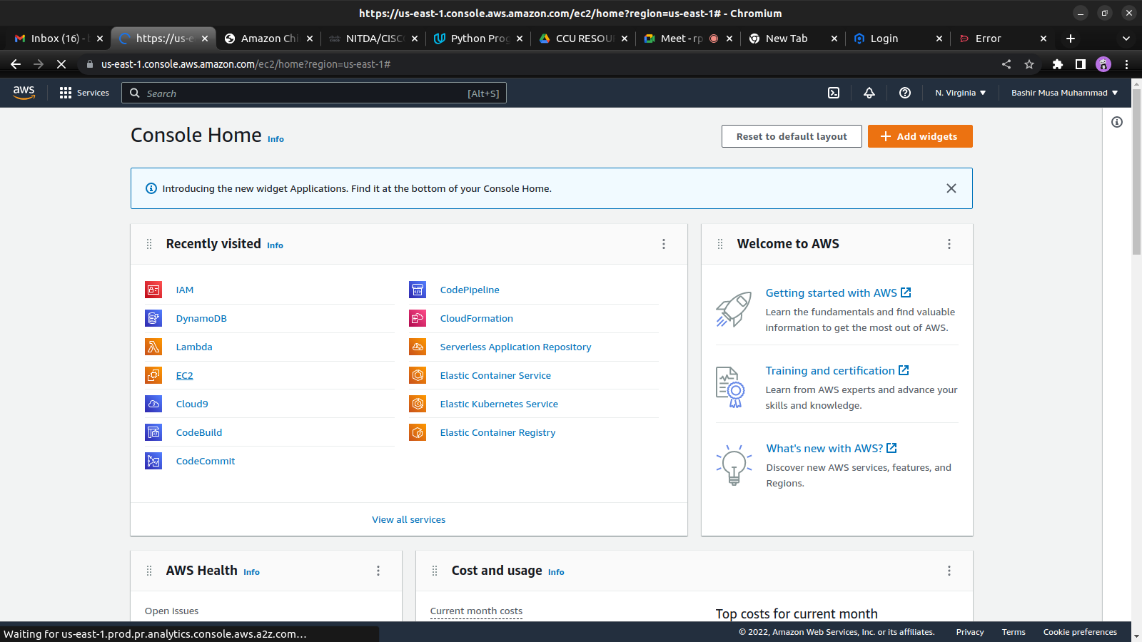

aftermath of launching the instance with the aforementioned configurations

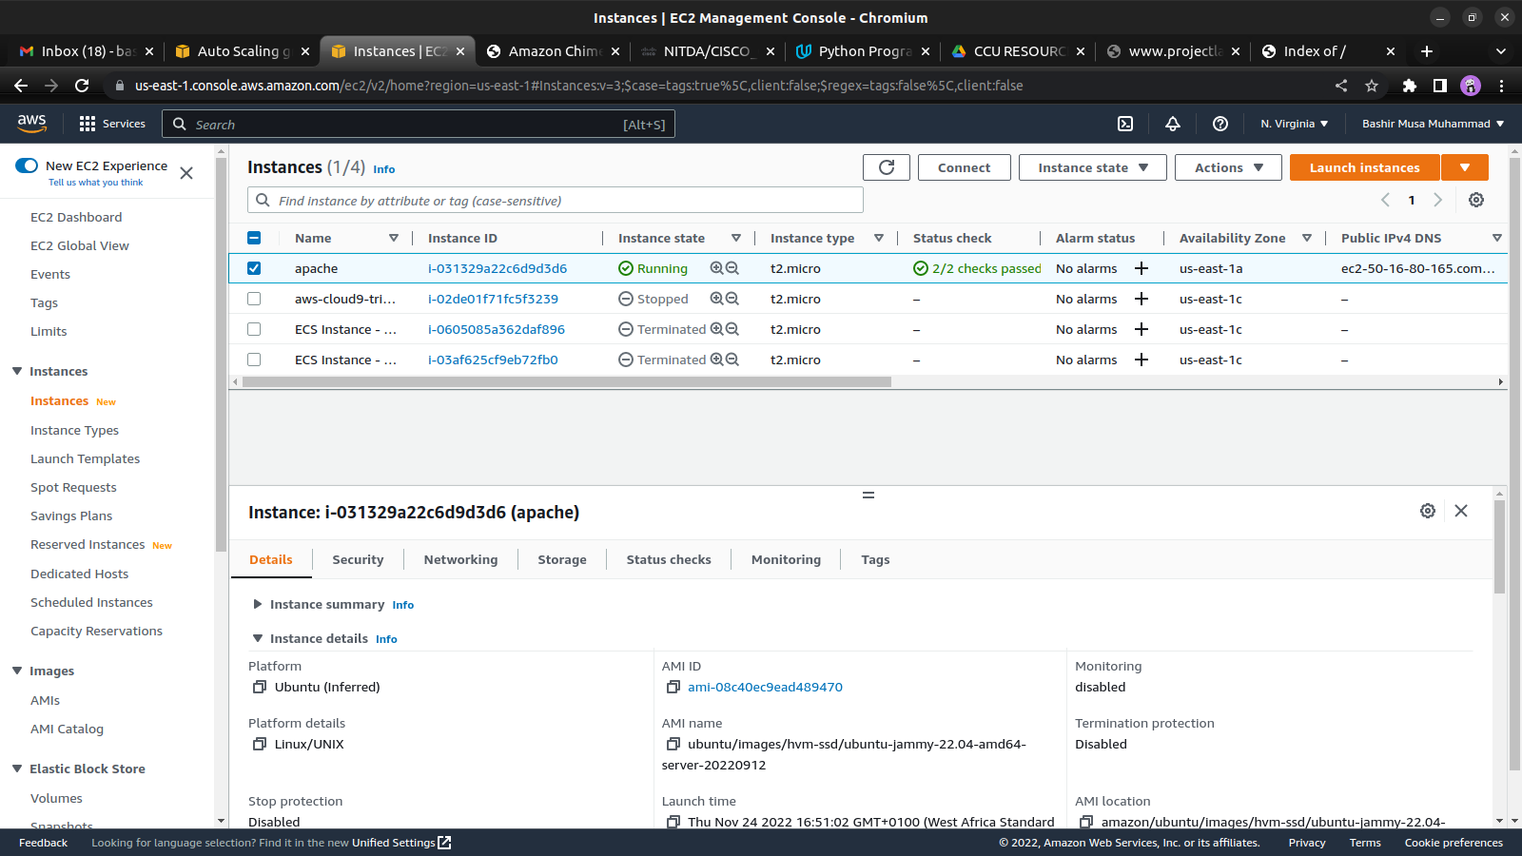

Connecting to ec2 on terminal via SSH(secure Shell ) connection

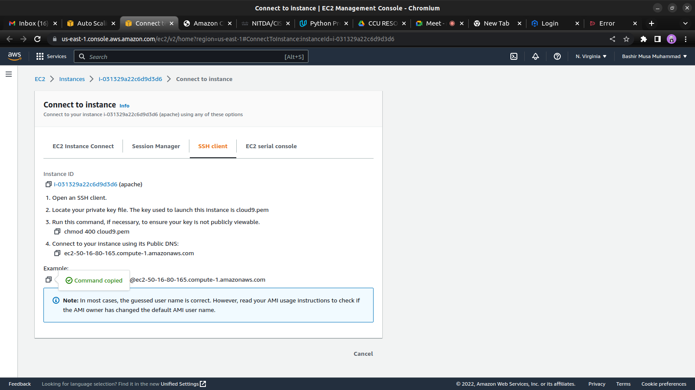

created the private .pem key when launching the ec2 instance and i downloaded it to my local machine where i use the chmod command to change the file mode.

Connecting to the ec2 instance from the local terminal

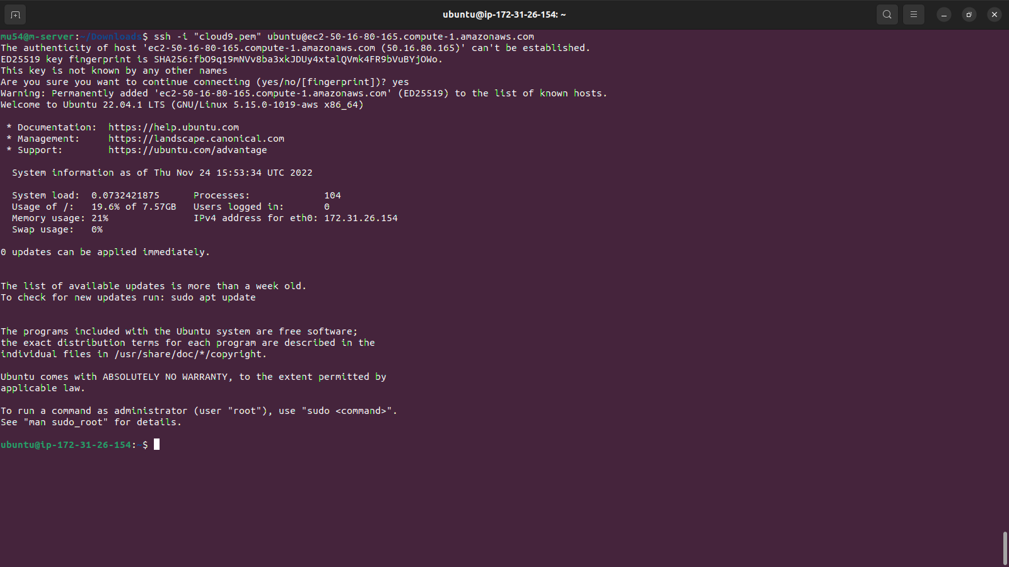

installing Apache on the ec2 instance

using the Ubuntu’s package manager ‘apt’ to install the apache from

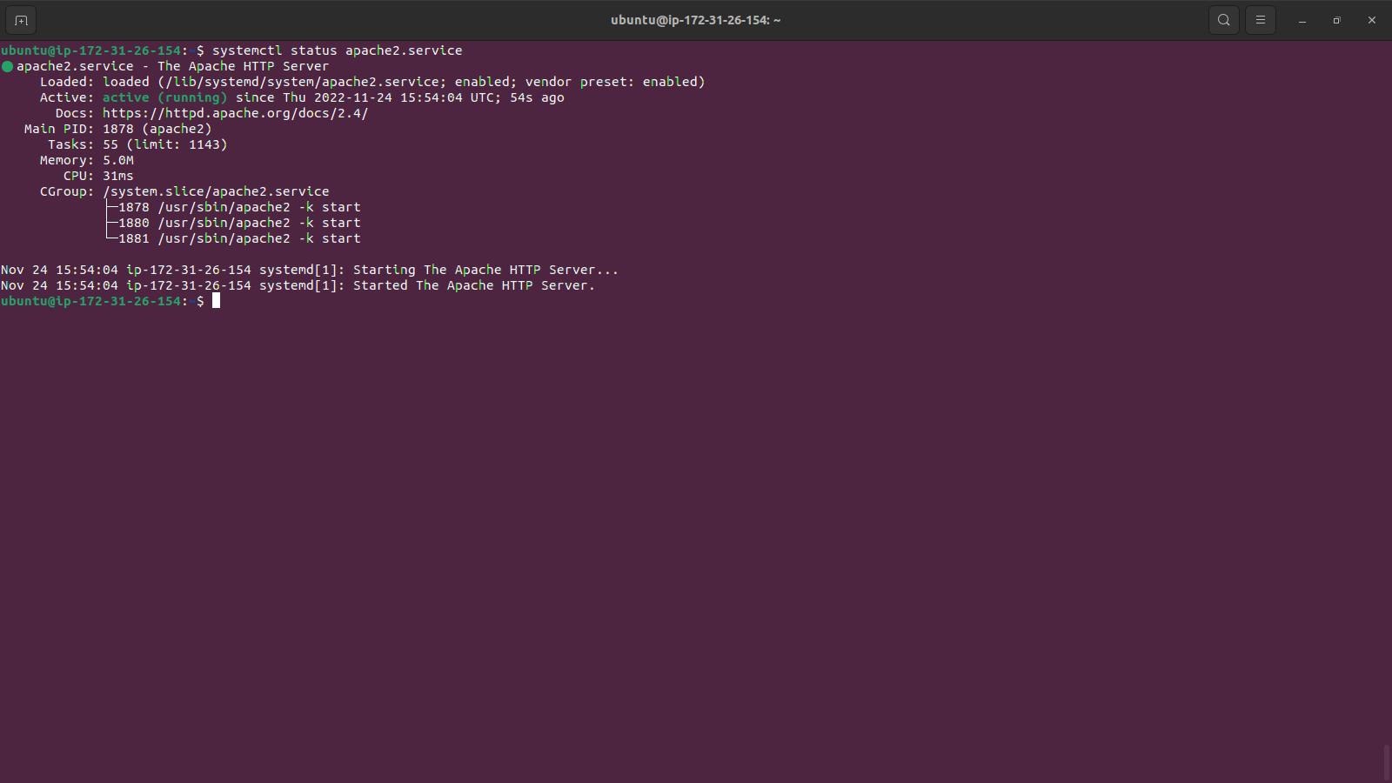

Now it is time for us to test how our Apache HTTP server can respond to requests from the Internet. Open a web browser of your choice and try to access following url

http://<Public-IP-Address>:80

Another way to retrieve your Public IP address, other than to check it in AWS Web console, is to use following command:

curl -s http://169.254.169.254/latest/meta-data/public-ipv4

The URL in browser shall also work if you do not specify port number since all web browsers use port 80 by default

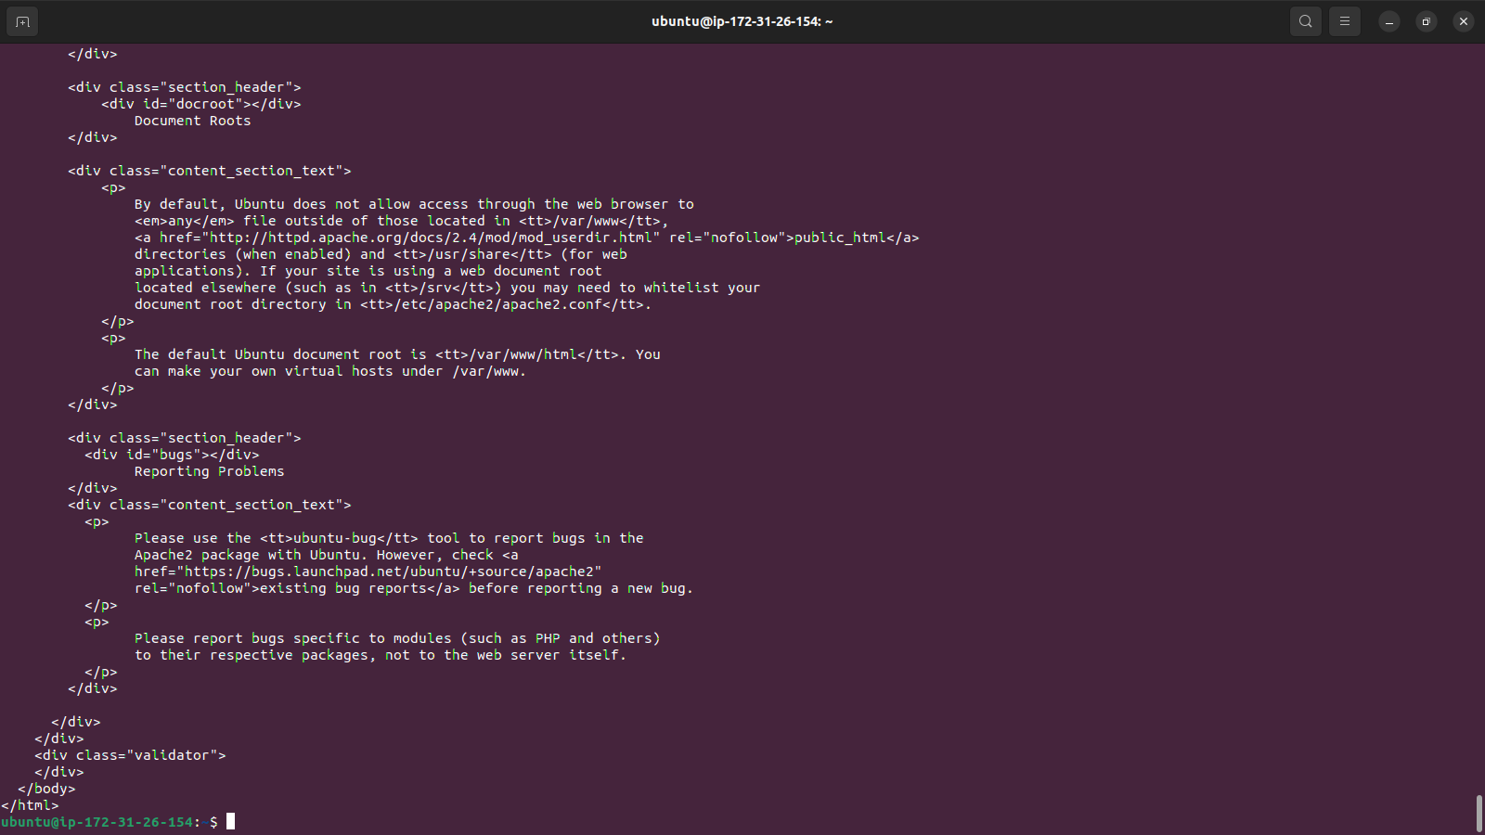below is the output of the curl command

the url in browser showing the Apache2 default page.

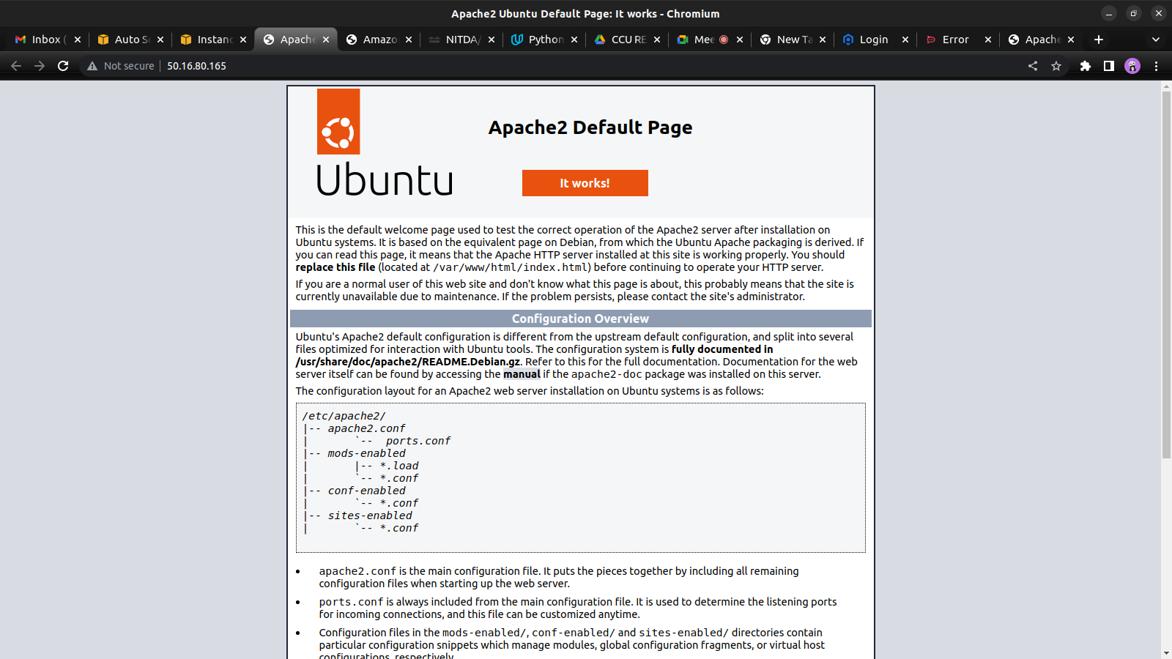

Now that we have a web server up and running, we need to install a Database Management System (DBMS) to be able to store and manage data for your site in a relational database. MySQL is a popular relational database management system used within PHP environments, so we will use it in our project.

Again, use ‘apt’ to acquire and install this software:

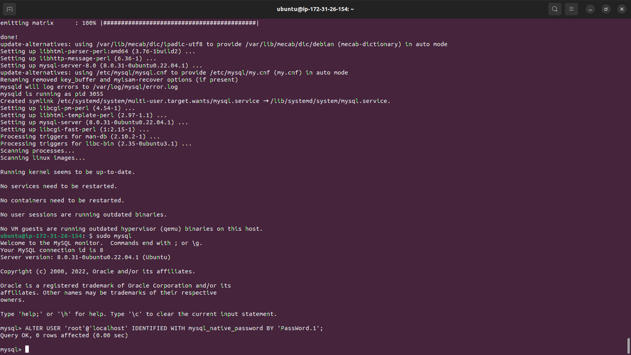

It’s recommended that you run a security script that comes pre-installed with MySQL. This script will remove some insecure default settings and lock down access to your database system. Before running the script, you will set a password for the root user, using mysql_native_password as default authentication method. We’re defining this user’s password as PassWord.1.

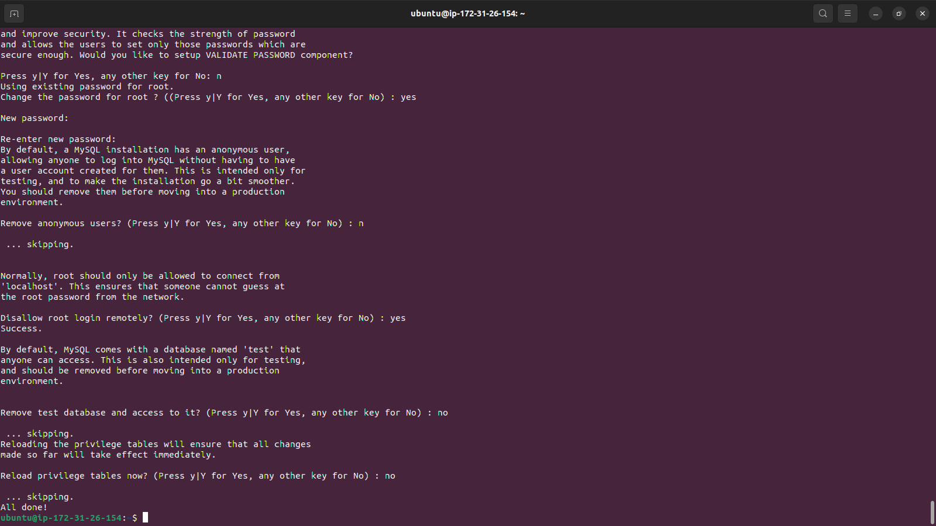

we have Apache installed to serve your content and MySQL installed to store and manage your data. PHP is the component of our setup that will process code to display dynamic content to the end user. In addition to the php package, you’ll need php-mysql, a PHP module that allows PHP to communicate with MySQL-based databases. We will also need libapache2-mod-php to enable Apache to handle PHP files. Core PHP packages will automatically be installed as dependencies.

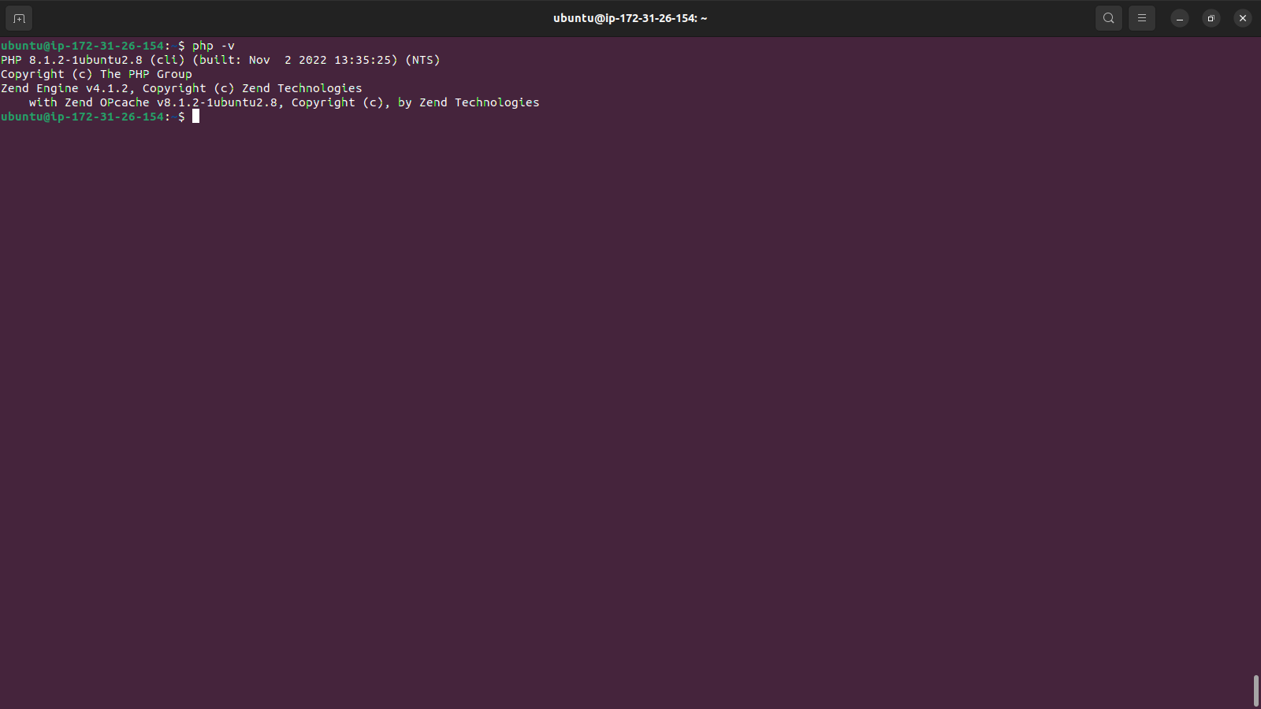

CREATING A VIRTUAL HOST FOR YOUR WEBSITE USING APACHE

In this project, you will set up a domain called projectlamp, but you can replace this with any domain of your choice.

Apache on Ubuntu 20.04 has one server block enabled by default that is configured to serve documents from the /var/www/html directory.

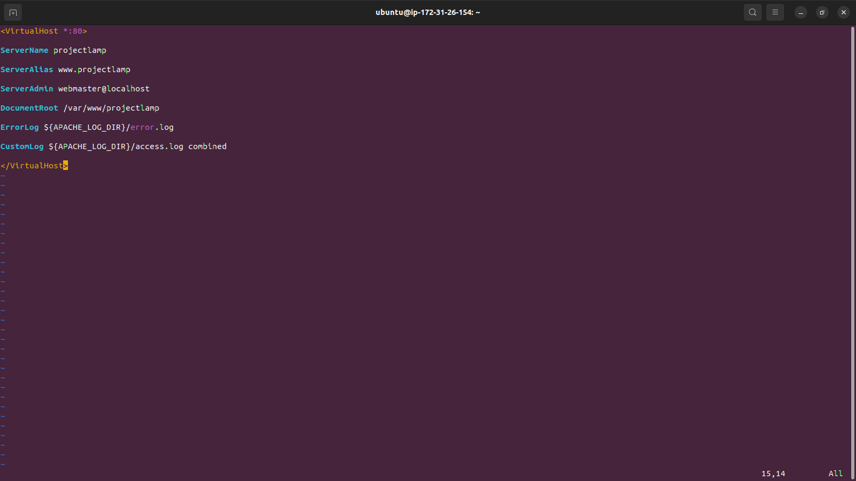

ENABLING PHP ON THE WEBSITE

With the default DirectoryIndex settings on Apache, a file named index.html will always take precedence over an index.php file. This is useful for setting up maintenance pages in PHP applications, by creating a temporary index.html file containing an informative message to visitors. Because this page will take precedence over the index.php page, it will then become the landing page for the application. Once maintenance is over, the index.html is renamed or removed from the document root, bringing back the regular application page.

In case we want to change this behavior, we will need to edit the /etc/apache2/mods-enabled/dir.conf file and change the order in which the index.php file is listed within the DirectoryIndex directive:

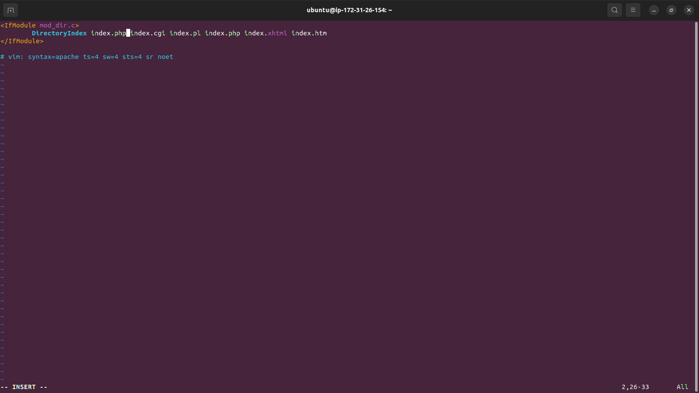

Finally, we will create a PHP script to test that PHP is correctly installed and configured on your server.

Now that we have a custom location to host our website’s files and folders, we’ll create a PHP test script to confirm that Apache is able to handle and process requests for PHP files.

We create a new file named index.php inside our custom web root folder:

vim /var/www/projectlamp/index.php

This will open a blank file. Then we add the following text, which is valid PHP code, inside the file:

<?php

phpinfo();

When we are finished, we save and close the file, refresh the page

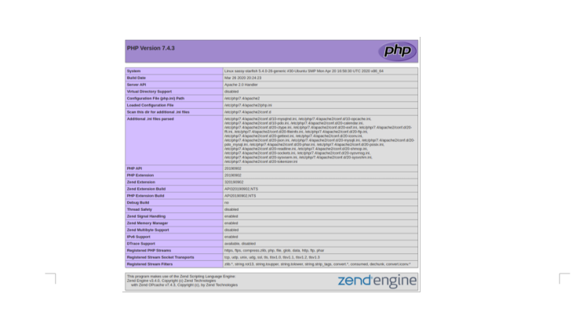

this shows our PHP installation was succesfully and its working as expected.