IILM UNIVERSITY
School of Computer Science and Engineering

INTERNSHIP / TRAINING REPORT
ON
INTRODUCTION TO MODERN AI

Through Cisco Networking Academy

Submitted in partial fulfilment of the requirements
for the degree of Bachelor of Technology in Computer Science and Engineering

Submitted By
MUBARAK ALIK
Roll No.: [CS-23411290]
Batch: 2023–2027

IILM University, Greater Noida, Uttar Pradesh
Academic Session: 2026–27

CANDIDATE'S DECLARATION
I, Mubarak Alik, hereby declare that this report titled “Introduction to Modern AI” has been prepared as a record of my learning and training completed through the Cisco Networking Academy program at IILM University. The report presents the course-related concepts, learning outcomes, tools, and applications in my own words. The official completion information reproduced in this report is based on the certificate issued to me.
I understand that the report should not contain fabricated certificates, signatures, emails, or internship records.
Signature:
Student Name: Mubarak Alik
Roll No.: CS-23411290

ACKNOWLEDGEMENT

I express my sincere gratitude to IILM University and Cisco Networking Academy for providing the opportunity to study Introduction to Modern AI. The course helped me understand the basic ideas behind modern artificial intelligence and its growing role in technology and society.
I am thankful to my instructor, Swati Vashisht, for the guidance and academic support provided during the learning process. I also thank my faculty members, friends, and family for their encouragement and support.
Mubarak Alik

CERTIFICATE OF COMPLETION

The following official certificate is included as received. It states that Mubarak Alik successfully completed “Introduction to Modern AI”, offered by IILM University through the Cisco Networking Academy program, with completion date 09 June 2026.

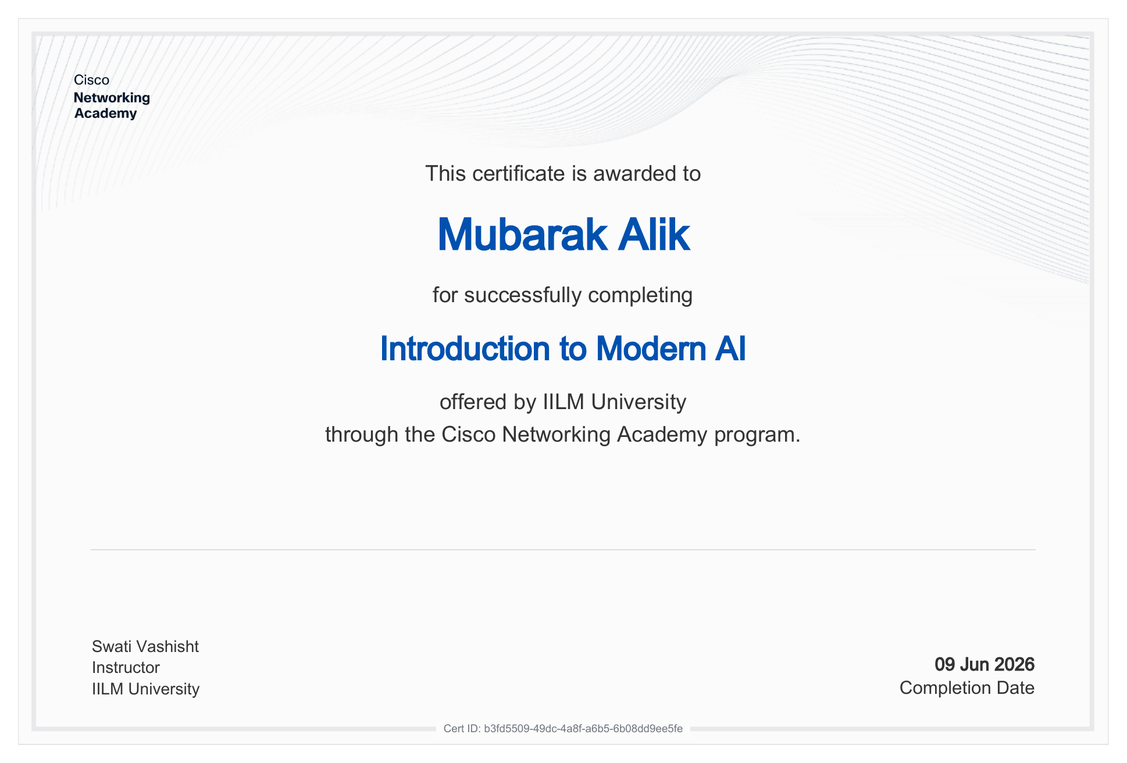

TABLE OF CONTENTS
Chapter | Chapter Name | Page
1 | Introduction | 5
2 | Organization / Program Profile | 6
3 | Course Overview | 7
4 | Fundamentals of Modern AI | 8
5 | Machine Learning and Data | 9
6 | Deep Learning and Generative AI | 10
7 | AI Applications and Use Cases | 11
8 | Responsible and Ethical AI | 12
9 | Learning Methodology and Outcomes | 13
10 | Conclusion | 14
11 | References | 15

INTRODUCTION

Artificial Intelligence (AI) is a major area of computer science focused on building systems that can perform tasks commonly associated with human intelligence, such as recognizing patterns, understanding language, making predictions, generating content, and supporting decisions.
Modern AI combines data, algorithms, computing resources, and increasingly powerful machine-learning models. The objective of this training was to develop a foundational understanding of modern AI and its practical relevance. The official certificate confirms completion of the Introduction to Modern AI course through Cisco Networking Academy at IILM University.

1.1 Purpose of the Report
This report documents the learning journey, major concepts, applications, responsible-AI considerations, and outcomes associated with the Introduction to Modern AI training.

1.2 Objectives
- Understand the basic concepts and terminology of Artificial Intelligence.
- Understand how machine learning uses data to identify patterns and make predictions.
- Develop a conceptual understanding of deep learning and modern AI systems.
- Understand the role of generative AI and large language models.
- Recognize common AI applications in real-world domains.
- Understand important concerns such as bias, privacy, security, transparency, and responsible use.

ORGANIZATION / PROGRAM PROFILE

Cisco is a global technology company widely associated with networking, cybersecurity, collaboration, and digital infrastructure. Cisco Networking Academy provides learning opportunities in networking, cybersecurity, programming, and emerging technology areas.
For this report, the official certificate identifies IILM University as the institution offering Introduction to Modern AI through the Cisco Networking Academy program.

2.1 Official Certificate Details
Field | Certificate Information
Learner | Mubarak Alik
Course | Introduction to Modern AI
Institution | IILM University
Program | Cisco Networking Academy
Instructor | Swati Vashisht
Completion Date | 09 June 2026
Certificate ID | b3fd5509-49dc-4a8f-a6b5-6b08dd9ee5fe

2.2 Important Note
The supplied certificate is a course-completion certificate. It does not itself state an internship designation. Therefore, this report uses “internship/training report” as an academic format while describing the verified activity as completion of the Introduction to Modern AI course.

3.COURSE OVERVIEW

Introduction to Modern AI provides a foundation for understanding how AI systems are designed and used. Modern AI is not a single algorithm; it is a broad field containing approaches such as machine learning, deep learning, natural language processing, computer vision, and generative AI.

3.1 Core Areas
Area | Purpose
Artificial Intelligence | Systems that perform tasks requiring intelligent behavior.
Machine Learning | Learning patterns from data to make predictions or decisions.
Deep Learning | Neural-network-based learning using multiple processing layers.
Natural Language Processing | Working with human language in text or speech.
Computer Vision | Understanding and analyzing images and video.
Generative AI | Creating new text, images, audio, code, or other content.

3.2 AI System Lifecycle
- Define the problem
- Collect and prepare data
- Select a suitable model
- Train and evaluate
- Deploy the system
- Monitor performance and improve

4. FUNDAMENTALS OF MODERN AI

AI systems generally combine data, computational methods, and a defined objective. Depending on the task, a system may use rules, statistical models, machine learning, neural networks, or generative models.

4.1 Types of Learning
Type | Description | Example
Supervised Learning | Learns from labeled examples. | Classification of emails.
Unsupervised Learning | Finds structure in unlabeled data. | Customer grouping.
Reinforcement Learning | Learns actions from rewards or penalties. | Game-playing agent.

4.2 Model Evaluation
Evaluation depends on the problem. Classification can use measures such as accuracy, precision, recall, and F1-score. Regression can use measures such as mean absolute error or mean squared error. For generative systems, evaluation can also include human review, factuality checks, safety tests, and task-specific quality measures.

5. MACHINE LEARNING AND DATA
Machine learning enables a computer system to learn useful relationships from examples instead of requiring every rule to be manually programmed. Data quality is therefore critical to the reliability of the resulting system.

5.1 Typical Machine Learning Workflow
- Problem definition and selection of the target outcome.
- Data collection from appropriate and permitted sources.
- Data cleaning and preparation.
- Feature selection or representation.
- Training and validation.
- Testing on data that was not used for training.
- Deployment and monitoring.

5.2 Overfitting
Overfitting occurs when a model learns the training examples too closely and performs poorly on new data. Techniques such as validation, regularization, simpler models, and appropriate training procedures can help reduce this problem.

6. DEEP LEARNING AND GENERATIVE AI

Deep learning uses neural networks containing multiple layers that learn increasingly useful representations of data. It has become important in areas such as computer vision, speech processing, language understanding, recommendation systems, and generative AI.

6.1 Generative AI
Generative AI refers to models that can produce new content based on learned patterns. Depending on the model and application, generated outputs may include text, code, images, audio, or other media.

6.2 Large Language Models
Large language models process and generate language by learning statistical patterns from large text datasets. They can support tasks such as summarization, question answering, drafting, coding assistance, and information transformation. Their outputs still require appropriate verification because fluent text does not guarantee correctness.

6.3 AI and Human Collaboration
A practical approach is to treat AI as an assistive technology: humans define goals, provide appropriate context, review outputs, and make final decisions where accuracy or accountability matters.

7. AI APPLICATIONS AND USE CASES

Modern AI is applied across many domains. The value of an AI solution depends on the quality of the problem definition, data, model, deployment environment, and human oversight.
Domain | Potential AI Application
Healthcare | Decision support, medical-image analysis, and patient-service assistance.
Education | Personalized learning, tutoring assistance, and content support.
Finance | Fraud detection, risk analysis, and customer-service automation.
Cybersecurity | Anomaly detection, threat analysis, and security operations support.
Retail | Recommendations, demand forecasting, and customer analytics.
Transportation | Route optimization, prediction, and driver-assistance technologies.
Software | Code assistance, testing support, documentation, and automation.

7.1 Example: AI-Assisted Healthcare
An AI-based healthcare system can help organize symptoms, medical information, or operational data and provide decision-support recommendations. Such systems should not replace qualified medical professionals; privacy, safety, validation, and human oversight are essential.

8. RESPONSIBLE AND ETHICAL AI

Responsible AI is essential because AI systems can influence decisions and may affect individuals or organizations. Ethical considerations should be included throughout the AI lifecycle rather than treated as a final step.

8.1 Major Considerations
- Fairness and bias: training data and model design can create unequal outcomes.
- Privacy: personal or sensitive data should be handled lawfully and appropriately.
- Security: AI systems and their data must be protected against misuse and attacks.
- Transparency: users should understand the role and limitations of an AI system.
- Accountability: organizations should define responsibility for AI-assisted decisions.
- Reliability: systems should be tested for errors and monitored after deployment.
- Human oversight: high-impact decisions should include appropriate human review.

8.2 Limitations of Generative AI
Generative AI can produce inaccurate, incomplete, biased, or misleading content. It may also reflect limitations in its training data or the context supplied to it. Important outputs should therefore be checked against trustworthy sources and domain expertise.

9. LEARNING METHODOLOGY AND OUTCOMES
The training was approached as a structured learning activity: concepts were studied, terminology was reviewed, practical relevance was considered, and the relationship between AI techniques and real-world applications was examined.

9.1 Learning Outcomes
- Explain the basic meaning and scope of Artificial Intelligence.
- Differentiate major machine-learning approaches at a conceptual level.
- Describe the role of data in training and evaluating AI systems.
- Explain the basic idea of neural networks and deep learning.
- Describe generative AI and large language models.
- Identify practical AI use cases in different industries.
- Recognize risks involving bias, privacy, security, reliability, and misuse.
- Understand why human oversight and responsible deployment are important.

9.2 Skills Developed

Skill | Outcome
AI Fundamentals | Improved understanding of modern AI terminology and concepts.
Analytical Thinking | Ability to break an AI problem into data, model, evaluation, and deployment stages.
Responsible AI Awareness | Understanding of ethical and safety considerations.
Technology Awareness | Better understanding of modern AI applications and limitations.

10. CONCLUSION

The Introduction to Modern AI training provided a useful foundation for understanding the modern AI landscape. The learning covered the relationship between artificial intelligence, machine learning, deep learning, and generative AI, along with their applications and limitations.
The training also highlighted that successful AI systems require more than a capable model. Data quality, evaluation, security, privacy, responsible design, and human oversight are important parts of the overall AI lifecycle.
The official certificate records that Mubarak Alik successfully completed Introduction to Modern AI, offered by IILM University through the Cisco Networking Academy program, on 09 June 2026.

10.1 Future Scope
- Build small machine-learning projects using Python.
- Explore neural networks and deep-learning frameworks.
- Study natural language processing and computer vision.
- Experiment with responsible use of generative AI.
- Learn model evaluation, deployment, monitoring, and AI security.

11. REFERENCES

1. Cisco Networking Academy — course and learning materials associated with Introduction to Modern AI.
2. IILM University — academic and course information associated with the supplied certificate.
3. NIST — Artificial Intelligence Risk Management Framework (AI RMF).
4. NIST — Artificial Intelligence publications and guidance.
5. Kubernetes Documentation — background reference for modern computing environments where relevant.
Note: The certificate details in this report are reproduced from the official certificate supplied with the report materials.

