Pfizer – On Boarding – MOHOTP – Pankaj D. Mohotkar

- Manager will send an e-mail to newly joined team member with the blank registration form; also will ask for soft copy of identity and / or address proof document(s) like passport / PAN card etc.

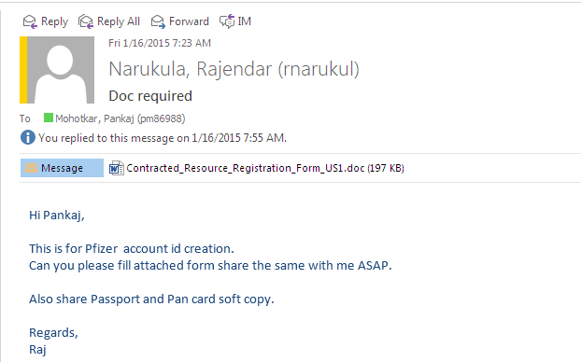

The copy of registration form is attached herewith:


New joiner employee needs to fill the above form with requested details and send the duly filled form back to manager. Also he / she needs to send the soft copy of required identity / address proof documents. Below is the sample reply from employee to his / her manager.
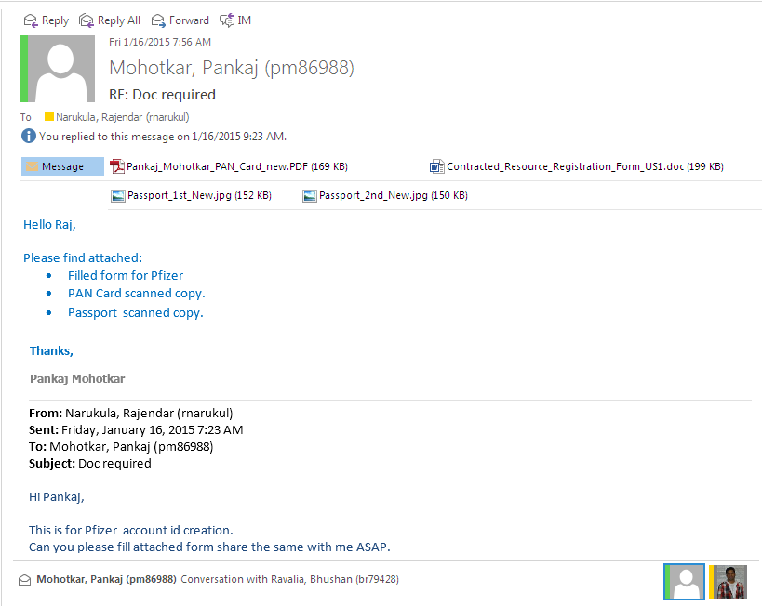

- CompuCom offshore manager will forward the duly filled form and requested documents to CompuCom onsite coordinator for Pfizer. Generating your credentials may take a week or 2 as it has certain process.

- Once the login id (NT id) is generated, CompuCom onsite coordinator will send the credentials to offshore manager and then he will share the same with newly joined employee in below manner:

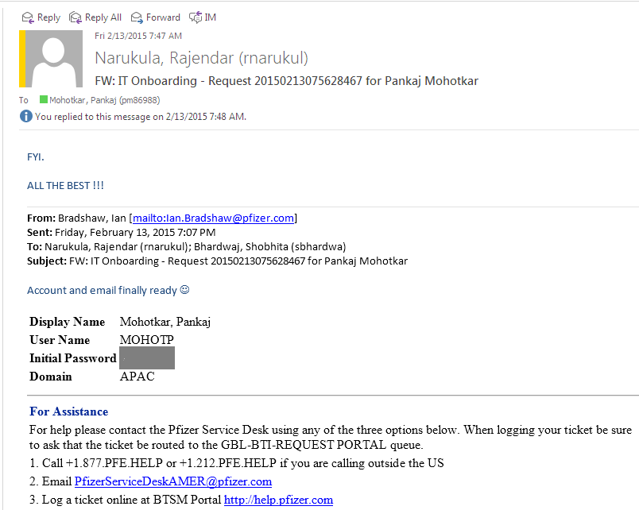

- Please note once you are on the stage of logging into the new Pfizer network, you should have below installed on your system:

Prerequisite:
- Citrix Client – Should have installed on your computer.
- Internet Explorer version 8 – Should have newest version installed.
- Java – Latest version availability
- Add https://partners.pfizer.com to the trusted sites list on IE browser.

- Once the employee has got his / her credentials, he needs to follow below process:
Steps:-
  - Replace the current “hosts” file in folder C:\Windows\System32\Drivers\Etc with the attached one.
  - Run command “nbtstat –RR” (without quotes) from command line.
  - Wait for couple of minutes.
  - Launch https://partners.pfizer.com or https://148.168.133.48/
  - Logon to Pfizer using your logon id and password as shared by your manager. (Refer screen shot in below point).
  - Start https://p2l.pfizer.com and complete the courses listed in the excel and update accordingly.

Use below hosts file, which is referred in point # a.

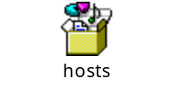

- When you visit to the page given on point # d. i.e. https://partners.pfizer.com, it will show below screen:

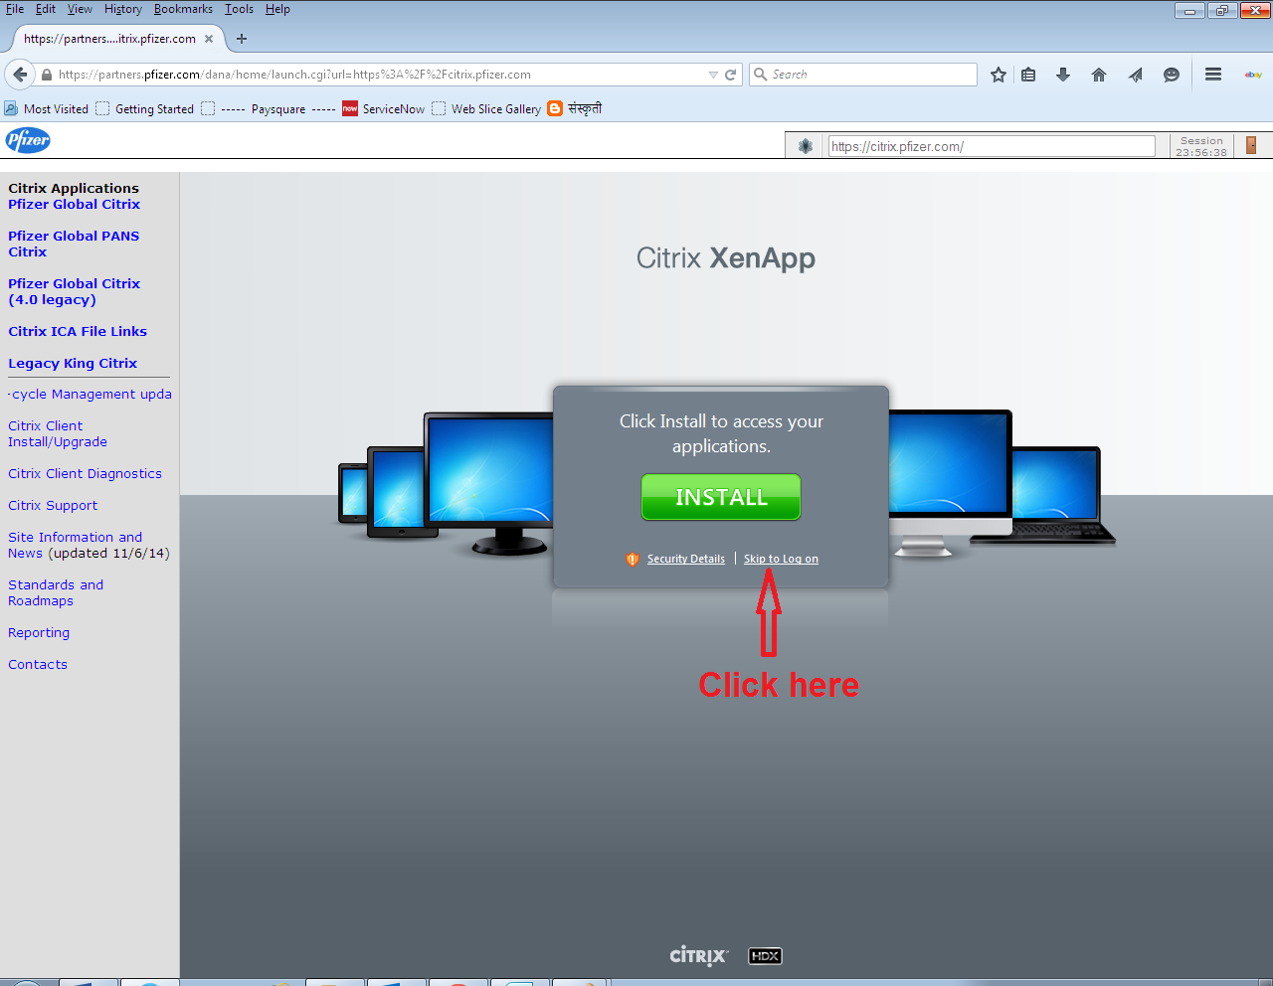

This is CITRIX XenApp for Pfizer account.
Once you click on the “skip to log on”, it will ask you to login with your new credentials:

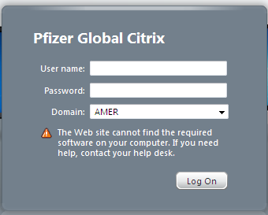

Enter user name, password as provided and select Domain as “APAC” from the drop down list.

- Once you are logged in, you will see below web page:

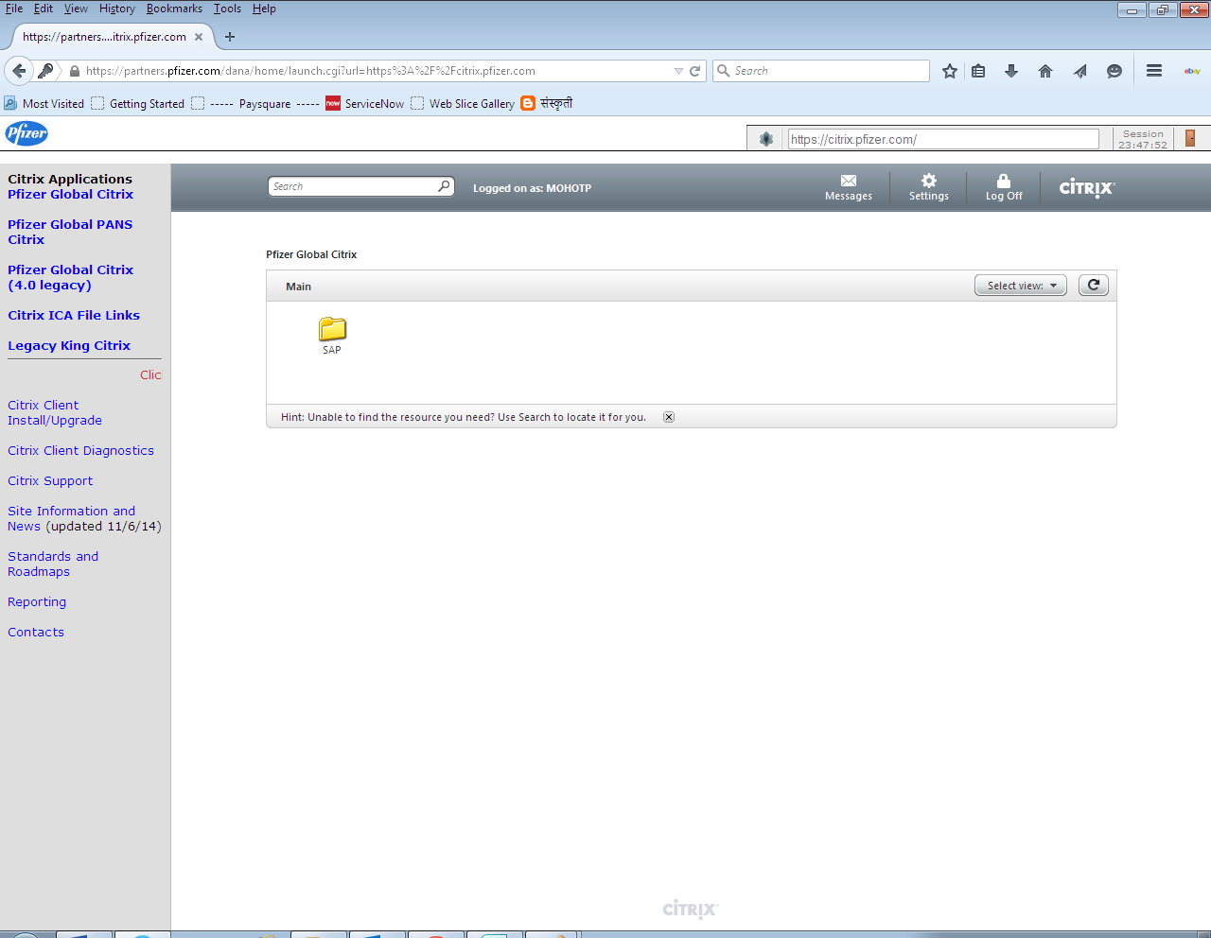

So, you probably have only one folder on your Citrix webpage when you login first time. To work on the IT part / project we may need to have several applications on the page and access to them. For eg. ServiceCenter, BO Applications, Informatica, Microsoft Office, TOAD, Outlook, Communicator etc.

- You need to request CompuCom onsite coordinator asking for access to other required applications:

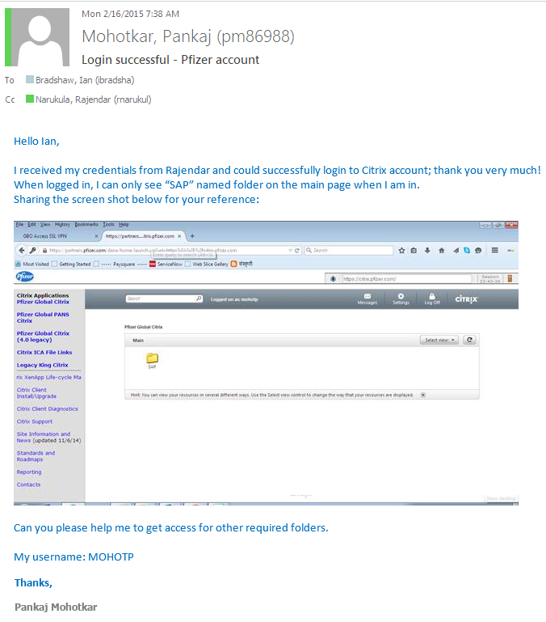

- Also, at the same time, user needs to initiate a request for installing / having other required applications. So, he requests somebody from Pfizer CITRIX team asking to have other application access on his / her CITRIX web page. Something like below:
----------------------------------------------------------------------------------------------------------------
I am a new comer to pfizer SAP team and have got my credentials and my NT id is “MOHOTP”. I can only see "SAP" named folder when I login. Can you please check what / which accesses I have on CITRIX - Pfizer? I need all pfizer apps which other pfizer SAP team has - I work with ‘Dinesh Gurav’, ‘Srinivasulu Muddeti’ and ‘Abhipsa Das’ and need to have all the apps which these 3 guys has. Pease send me a copy (put me in CC) when you raise a ticket... so that I will get updates.
----------------------------------------------------------------------------------------------------------------

On above e-mail request, he / she may reply like below:

----------------------------------------------------------------------------------------------------------------
May ask for your NT id, phone number and will open a ticket on your behalf. Respond like “Ticket # GBL22904727i is opened“.
----------------------------------------------------------------------------------------------------------------

- Once an Incident is raised for user, they checked for possibilities and reverted him/her as below:

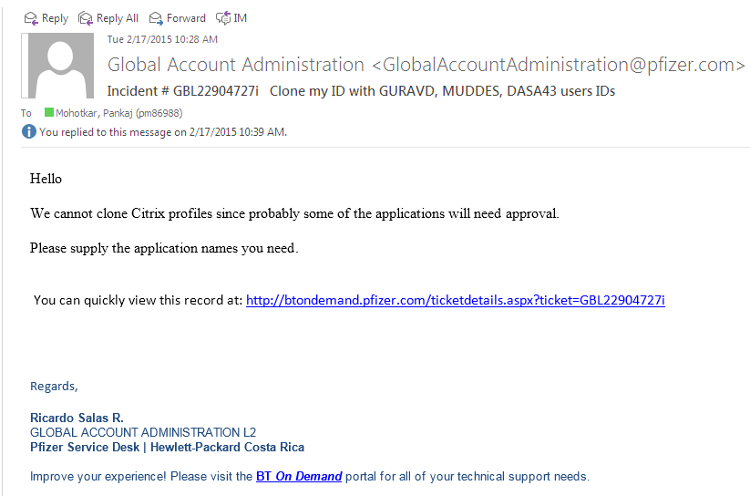

- So, here user needs to send the list of applications for which he / she needs access. Instead of listing the applications manually, the better way is simply provide the screen shot of applications by getting it from team members. So that they can clone the profile as theirs. Below is an e-mail which user replied to above mail, by keeping CompuCom onsite coordinator in CC.

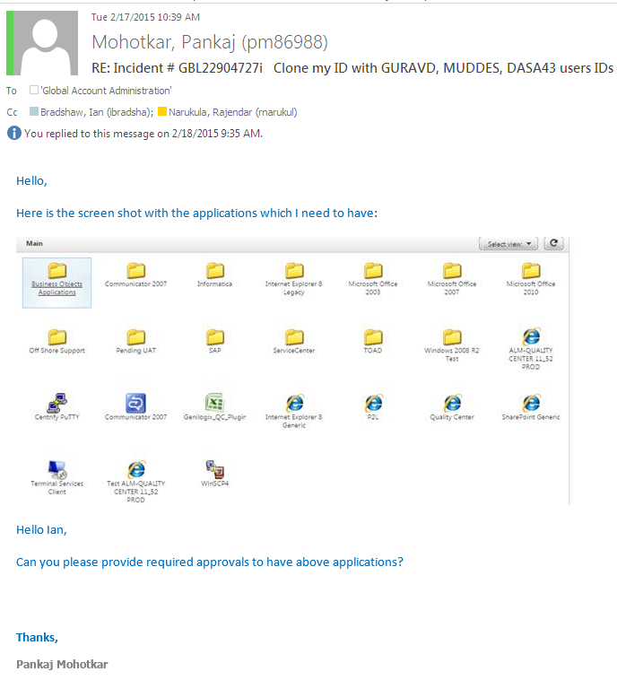

- Once they get the list of above requested applications, they will allow your profile to access all those applications. So, when next day user logins into the CITRIX, he is able to see all above applications in his / her CITRIX web page. Below is the CITRIX page with all the required applications for new user.

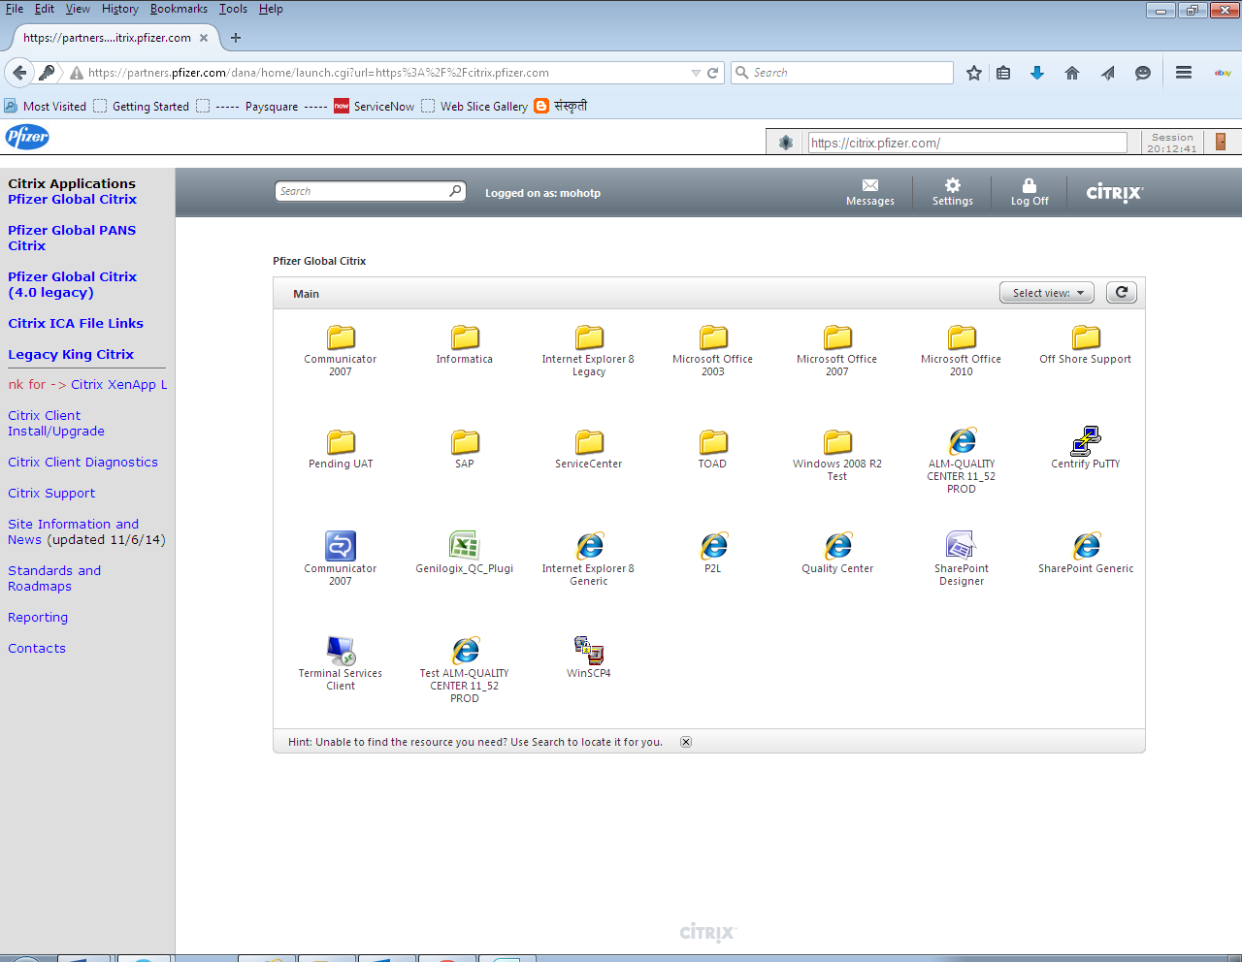

- Now, user can see all the required application on his / her CITRIX page, but when tried to open any of them he / she faced some issue. For eg. when he selected “Microsoft Office 2007” and tried opening “Microsoft Outlook 2007”, he / she faced below message. This message asks user to download ***.ica file. Please refer below screen shot:

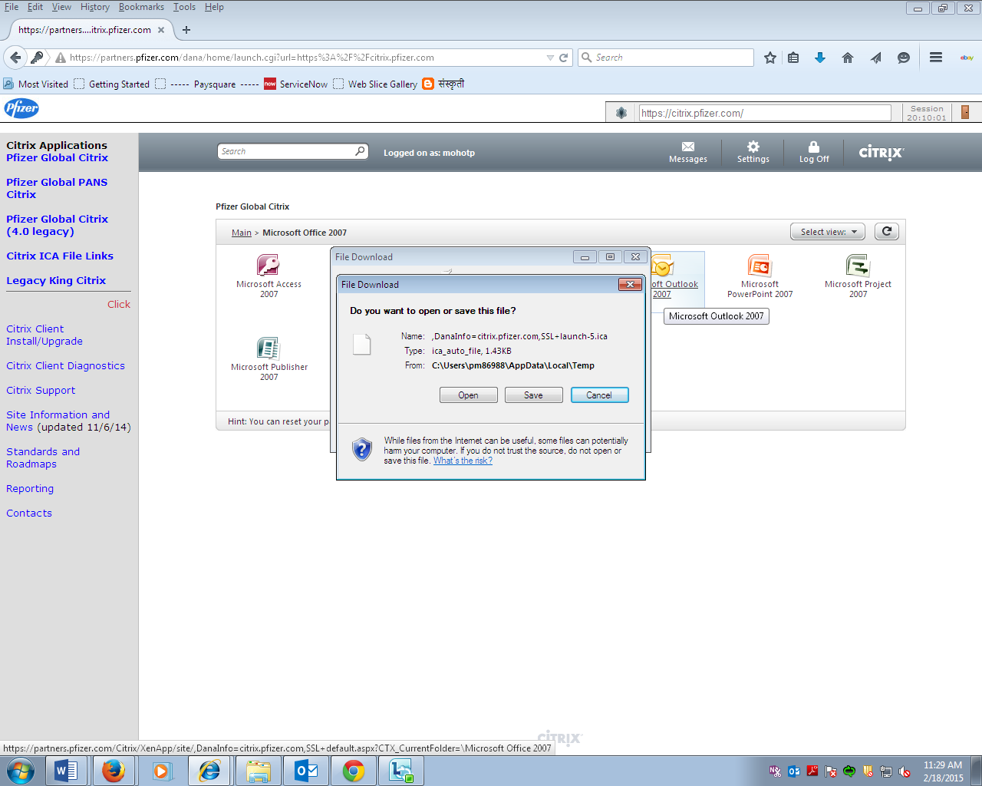

- User then communicated this issue back to the ‘Gobal Account Administration’ team. Also provided above error screen shot. The format of raising this issue may be as given below:

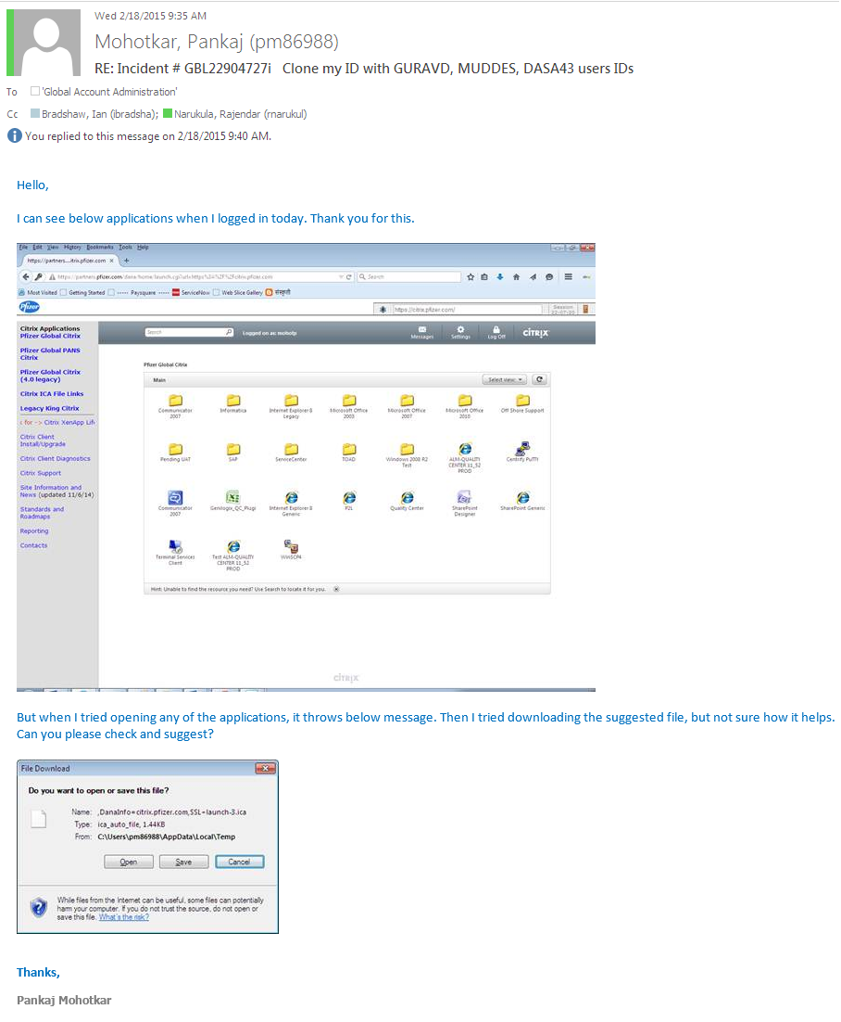

- ‘Gobal Account Administration’ team will then check for the given issue and respond accordinlgy. In this scenario, the team responded saying, “ica client is necessary to open Citrix icons”. They’ll reply to the user accordinlgy. Below is sample reply from them:

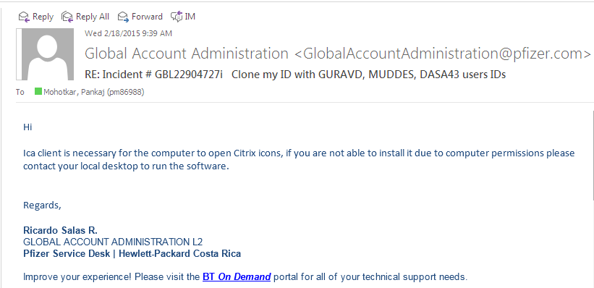

- User then contacted local Desktop Support Team to get admin rights and install ica client as suggested. Desktop Support Team member got in touch and installed / updated necessary software(s) (like updating Java with newest version, checking settings for IE or respective browser. And finally he could fix the issue.

- So, when next time user logged in into Citrix and tried opening any of the applications, he did not face the issue of ica client and could successfully go ahead.

- But there he faced another issue of privileges. When user tries to open any of the applications, he faced the same errors for all the applications. So, again he writes an e-mail to ‘Gobal Account Administration’ sharing the screen shot of the error. Something like below:

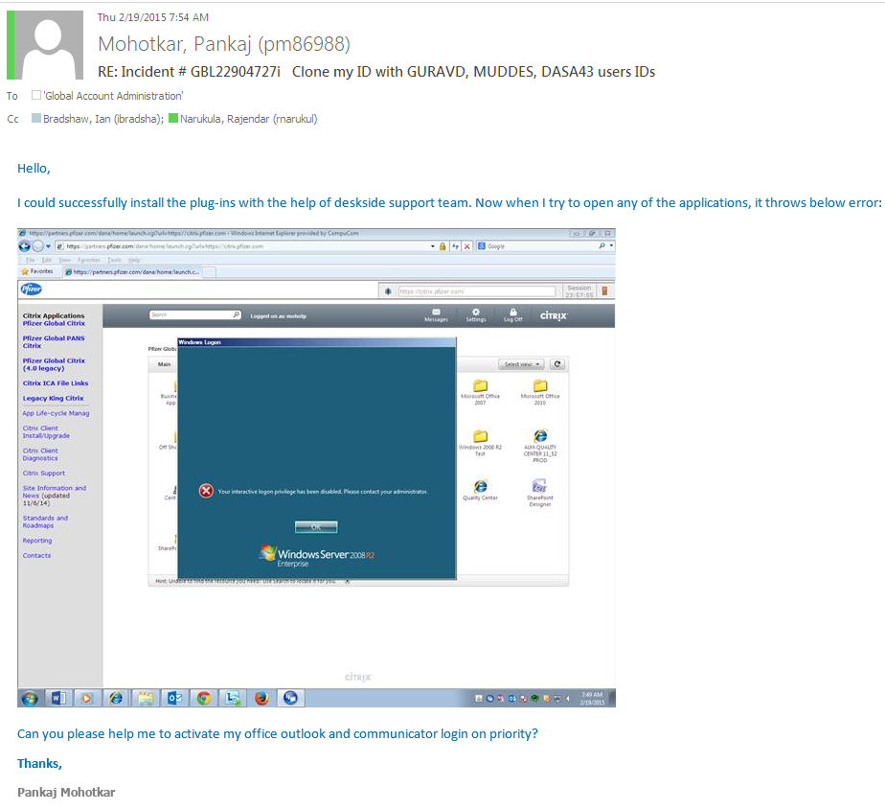

- After looking at the shared error, ‘Global Account Administration’ team, they could recognize that this is known issue. So, they could fix this issue immediately and replied so:

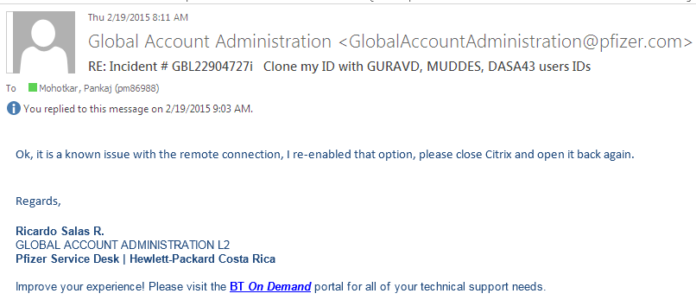

- As suggested when user tried getting into the Citrix again and opening any of the applications, he could successfully open / install any of the applications as per his needs. Accordingly he needs to update / revert back to ‘Global Account Administration’ team, so that they can close the ticket if they have opened any.

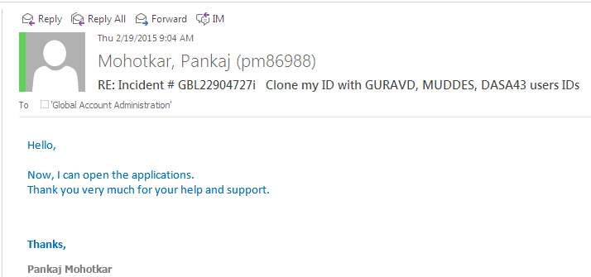

- Once you have access to all the applications, the very first thing is one needs to complete all the required trainings for understanding Pfizer system flow and company values.
Follow below steps to get on the training page:

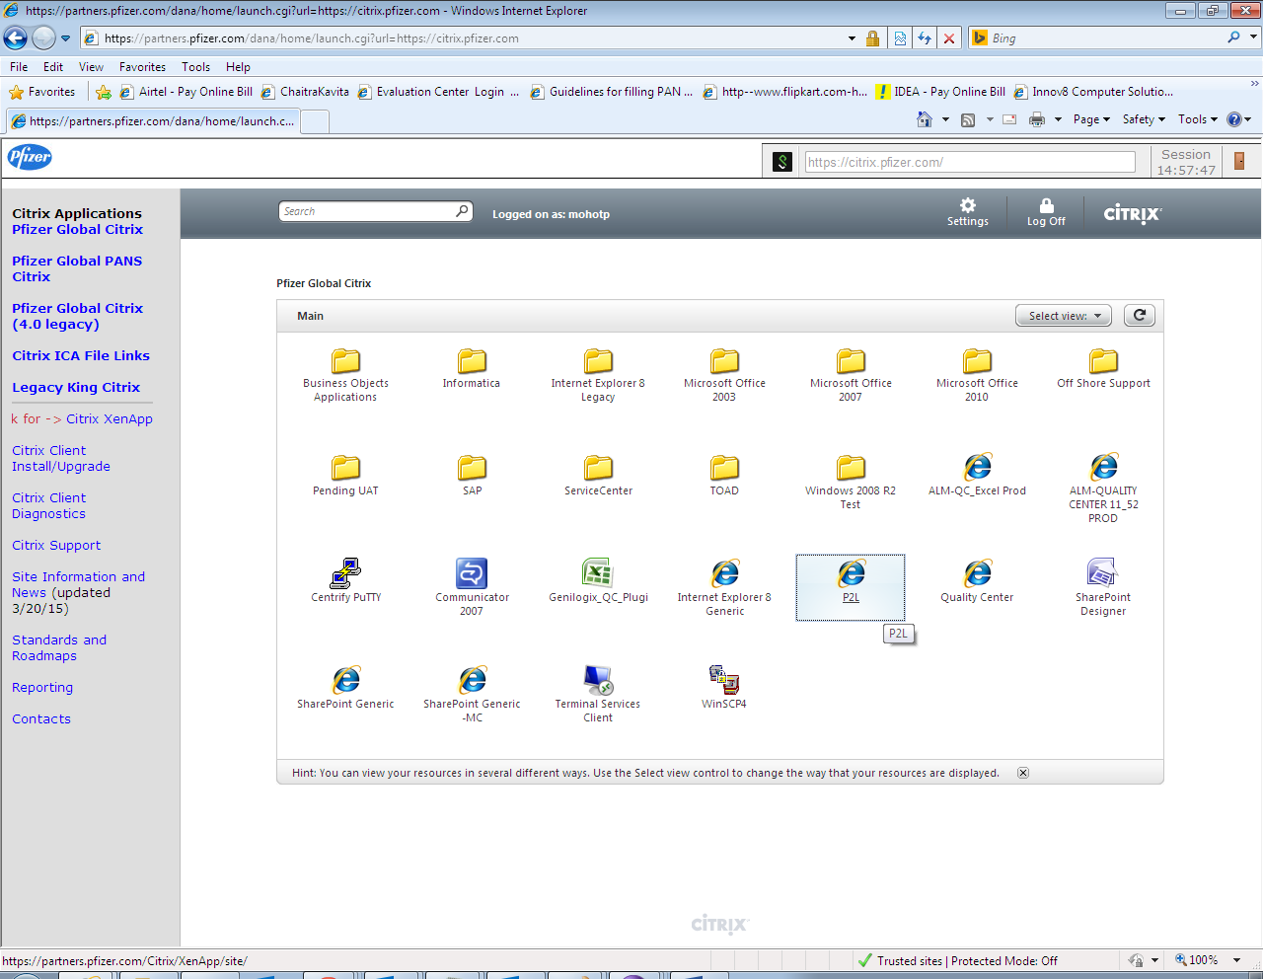

Click on “P2L” application link and it should open a new training home page. This will show the list of training which you need to complete. Also, if not listed some training sessions on the home page, place the cursor on “Learner” tab and select “Search”. Provide the name of training session and search through this way.

I am providing herewith the list of training sessions which I needed to complete:

