Software Requirement Specifications
Web Vulnerability Scanning and Testing



Submitted by
Mueen Haider

Submitted to
Dost Muhammad Khan

Department of Information Technology
Faculty of Computing
The Islamia University of Bahawalpur

Revision History

Date | Description | Author | Comments
<25.04.2026> | <Version 1> | <Mueen Haider> | <First Revision>

Table of Contents

- Introduction 1
  - Purpose 1
  - Scope 2
  - Definitions, Acronyms, and Abbreviations. 2
  - References 2
  - Overview 2
- The Overall Description 2
  - Product Perspective 2
    - Operations 3
    - Site Adaptation Requirements 3
  - Product Functions 4
  - User Characteristics 4
  - General Constraints 5
  - Assumptions and Dependencies 5
- Specific Requirements 5
  - External Interface Requirements 5
    - System Interfaces 5
    - Interfaces 5
    - Hardware Interfaces 5
    - Software Interfaces 6
    - Communications Interfaces 6
  - Functional Requirements 6
    - <FR#1> 7
    - <FR#2> 7
  - Use Cases 8
    - UC#1 8
    - UC#2 9
  - Classes / Objects 9
    - <Class / Object #1> 9
    - <Class / Object #2> 9
  - Non-Functional Requirements 10
    - Performance 11
    - Reliability 11
    - Availability 11
    - Security 11
    - Maintainability 11
    - Portability 11
  - Inverse Requirements 12
  - Logical Database Requirements 12
  - Design Constraints 13
    - Standards Compliance 13

Introduction
The title of the project is "Online College Management System". An intranet-based application is defined as providing information within a college. This system can be used as an information management system for the college. For the given student / staff (technical / non-technical) administrator login ID and password, upload or database system to download information about your student / staff (technical / non-technical) Can access this system by creating their accounts.

Purpose
Some purposes of this product are given below.
- Main objective of this product is to online the whole office daily work.
- To provide a friendly graphical user interface to user to perform different tasks for the college.
- It will help to save time which was consume in student registration, finding student info etc.
.

Scope
Web site is to provide a set of parameters that are easy to navigate on the web pages and provide information sufficient depth and college at the same time.
The existence of two possible groups of viewers:

- Student can get more detailed about intermediate, graduate, post graduate and professional.
- Students of college looking for some information.

Web site aims to ultimately increase the number of college students, to encourage more students to choose a college.

This product will be launch to maintain the whole work that caught the attention of the audience information and guidance is considered of the highest importance.
Benefits of this product will be:

  - Info about intermediate, graduate and postgraduate on a wide spectrum of personal and professional career.
  - Up to date information in a timely and encourages readers to return to the site.

  - The new user can get home online.

Definitions, Acronyms, and Abbreviations.
Bootstrap - This is a tool for designing web sites. In this the use of CSS, JavaScript and PHP and Html also. It has a very effective tool forms.

References

- http://www.w3schools.com
- Wikipedia

Overview
The entire SRS is documented in view of both ADMIN and user and the following subsection are arranged to give a complete outlook of the site, its perspective, features, system requirements and users know how’s.

The Overall Description

Product Perspective
This product is an update of the existing website http://www.aicbwp.edu.pk/ version 1. The new site will be version 2. A future version 3 may be needed to incorporate ideas learned from version 2.

Website is aimed toward students who have completed their higher studies or graduation and are looking for a college for further studies.
Website should be user-friendly, ‘quick to learn’ for the above purpose.

Operations

- Programs

  - All the courses offering by the institute.
  - Get admission in the institute online.
- Downloads
  - Syllabus of each semester for students of the college
  - Time Table of all departments and there classes for students
  - Time Table of all exams conducted by college, including the Time Table of final exam as declared by IUB.
  - Assignments and notes provided by college faculties.
  - Fee structure of each year.
- News and events
  - Any notice that is to be displayed by college.
  - Announcement or Information College wants to provide.

- About Us/Mission
  - It specifies the aim of college
- About Us/Our Uniqueness

  - It specifies the qualities and uniqueness of college, including the details and pros that why one should opt this college and not any other

Product Functions
- Programs
  - All the courses offering by the institute.
  - Get admission in the institute online.
- Downloads
  - Syllabus of each semester for students of the college
  - Time Table of all departments and there classes for students
  - Time Table of all exams conducted by college, including the Time Table of final exam as declared by IUB.
  - Assignments and notes provided by college faculties.
  - Fee structure of each year.

- News and events
  - Any notice that is to be displayed by college.
  - Announcement or Information College wants to provide.

- About Us/Mission
  - It specifies the aim of college

- About Us/Our Uniqueness
  - It specifies the qualities and uniqueness of college, including the details and pros that why one should opt this college and not any other

User Characteristics
There are mainly some types of user:
- Students interested in Intermediate, graduate, post graduate and Professional seeking more in-depth information about a College.

- Students that are in that college but are seeking for some information.
- Users can get admission online.
Changes to version 2 should include design changes to all existing pages to shorten up paragraphs and add bullets and charts where possible to accommodate faster page reading and shorter reader attention span keeping in mind most of the users are high school teen- agers.

General Constraints
This project works well in pc’s having Microsoft dream viewer and WAMP server installed properly. Anyone can use this site to get knowledge about the institute and authorize person can only manage the site.

Assumptions and Dependencies
We are assuming that the users will not use our product to download copyright and harmful materials. Also, we expect that the users not only use the software to download resources, they will also be uploading files and resources for being downloaded by other users. We also assume that product users will not upload files containing malicious software like viruses, worms and spy bots etc.

Specific Requirements

External Interface Requirements

System Interfaces
The software provides good graphical interface for the front end of the database so that naïve users can make use of the system with ease.

Hardware Interfaces
The system should have these hardware requirements:

- The processor should contain Pentium 4.
- The processor should be greater than 1 GHz.
- RAM should be, or greater than 1GB.

- Hard disk should be 40GB.

Software Interfaces
The software requires the support of the following software for the database. SQL server 2008 for the database

Functional Requirements
When the user open the site, User go to the main page of the college website.

MODULE 1 : LOGIN

When the user logs in, the user goes to this module which contains a menu strip that has 7 menu items.

- Student

When the user clicks the Student menu item, a dropdown list appears that contains

  - Profile entry
  - Other details
  - Result entry
- Employee

When the user clicks the Employee menu item, a dropdown list appears that contains

  - Staff entry
  - Attendance
- Search
- When the user clicks the Search menu item, a dropdown list appears that contains
  - Student information
  - Employee information
- Report

When the user clicks the Report menu item, a dropdown list appears that contains

  - Student report
    - Result report
- Exit

When the user clicks the Exit menu item, a message box appears which confirms the user whether he wants to continue the application or not, depending on the choice made the user can exit from the application

MODULE 2: MASTER
When the user clicks the Master menu item, a dropdown list appears that contains

  - Department
  - Course
  - Designation
  - Subject details
  - Examination details
  - Fees details

MODULE 2: COURSES

This module enables the user to manipulate and view the course details- Department wise and Description.

MODULE 3 : EXAM DETAILS

This enables the user to manipulate and view the exam details

- Subject name
- Date when the exam is held
- Total marks
- Pass marks

MODULE 4 : FEES DETAILS

This enables the user to manipulate and view the fees details like

- Tuition fees
- Exam fees
- Donation fees

MODULE 5 : DOWNLOAD
When user open the download tab, it allows the user to download the courses details, daily assignments, syllabus, course outline etc.

Use Cases
This section contains use cases of the College system.

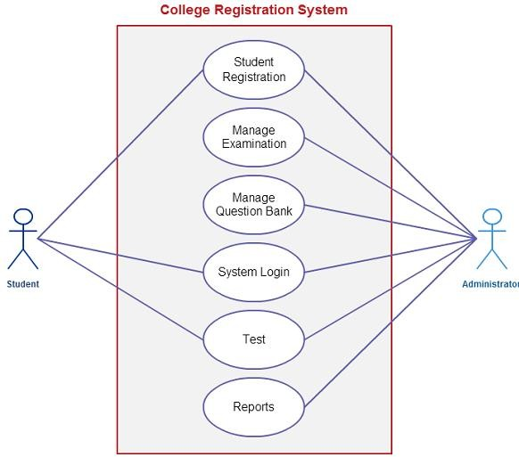

Classes / Objects
This section contains major classes of the College system.

<Class / Object >
- Administrator
- Student
- Teacher

Attributes

Administrator

          - Name, ID, Password.

Student
          - ID, Name, Class, Address, Batch Year, Phone No.

Teacher
    - ID, Name, Class, Address, Phone No, Qualification .

Functions
- Login
- Add Data
- Delete Data
- Edit Data
- View Details
- Generate Reports
- Logout

Non-Functional Requirements

    - Performance Requirements

The website should be hosted on a server that can provide adequate response time. High school students tend to have short attentions spans, so a slow server would not be satisfactory for this application. The current college (www.aicbwp.edu.pk) site is a good example of rapid response time.

- 16-bit computer.
- Minimum 5 GB HDD
- Pentium III processor, 500 MHz
- Minimum 256 MB RAM

Safety Requirements
There are no special safety requirements

Security Requirements

Copyright and other security measures for college website should be the same as the AIC site.

Software Quality Attributes

Web design conventions should be consistent with the standards and conventions used on the college website

Logical Database Requirements
    - The data will not duplicate.
    - Very Quick Processing Of Query.
    - The data will be stored in tables and easy to maintain.
    - Data should be Secure by cyber-crimes.

Design Constraints
    - Administrator can access this to add, delete, view data and generate reports after entering the appropriate user id and password.

Analysis Models

  - Sequence Diagrams
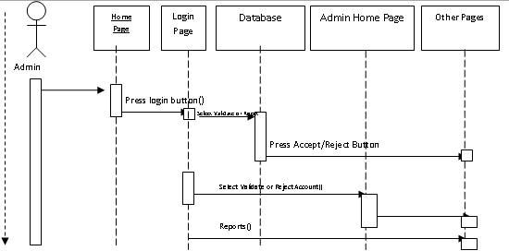

  - Data Flow Diagrams (DFD)

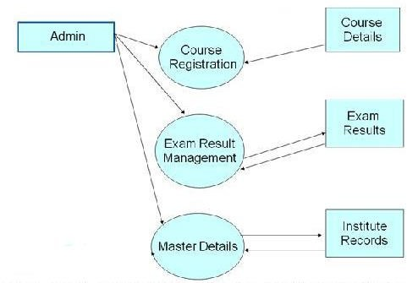

  - State-Transition Diagrams (STD)
