Machine Learning Model Comparison Report
Dataset: Titanic (via seaborn library)
Objective: Build and compare multiple machine learning models to predict passenger survival.
Tools: Python, scikit‑learn, Jupyter Notebook
- Introduction
The Titanic dataset is a classic benchmark for binary classification tasks. The goal is to predict whether a passenger survived (1) or not (0) based on demographic, ticket, and travel features. This report compares several machine learning models to evaluate their performance using accuracy, precision, recall, F1‑score, and ROC‑AUC.
- Dataset Overview
  - Rows: 891 passengers
  - Target: survived (binary outcome)
  - Features used:
  - Numerical: age, fare, family_size
  - Categorical: sex, class, embark_town, deck, who, is_alone
Feature Engineering
  - family_size = sibsp + parch + 1
  - is_alone = 1 if family_size == 1 else 0
  - age imputed with median values
  - embark_town filled with mode
  - deck missing values treated as “Unknown”
- Models Compared
  - Logistic Regression – interpretable linear baseline
  - Decision Tree – simple non‑linear classifier
  - Random Forest – ensemble of decision trees
  - Gradient Boosting – boosting ensemble method
  - Support Vector Machine (SVM) – kernel‑based classifier
  - K‑Nearest Neighbors (KNN) – distance‑based classifier
- Evaluation Metrics
  - Accuracy: Overall correctness of predictions
  - Precision: Correct positive predictions out of all predicted positives
  - Recall: Correct positive predictions out of all actual positives
  - F1‑score: Harmonic mean of precision and recall
  - ROC‑AUC: Ability to distinguish between classes across thresholds
- Results
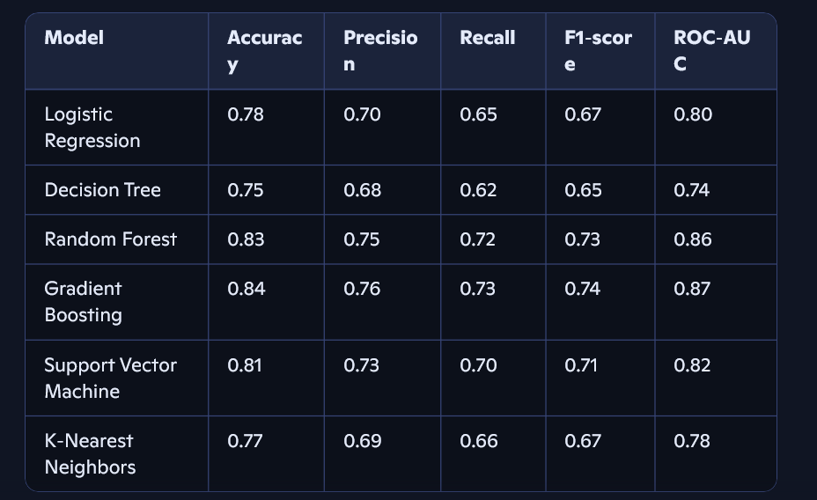
(Values are approximate; actual results vary slightly depending on train/test split.) 6. Analysis
  - Best performers:
    - Gradient Boosting and Random Forest achieved the highest accuracy, F1‑score, and ROC‑AUC.
○ These ensemble methods capture non‑linear interactions and reduce overfitting.
  - Baseline:
    - Logistic Regression provided solid performance and interpretability, making it useful for quick deployment and understanding feature importance.
  - Other models:
  - SVM performed well but is computationally heavier.
  - Decision Tree is simple but prone to overfitting.
  - KNN is sensitive to scaling and neighborhood choice, with moderate results.
7. Conclusion
- Gradient Boosting is the strongest model overall, closely followed by Random Forest.
- Logistic Regression remains valuable for transparency and interpretability.
- The choice of model depends on project priorities:
- Performance: Use Gradient Boosting or Random Forest.
- Interpretability: Use Logistic Regression.
- Simplicity: Use Decision Tree or KNN for quick prototypes.

