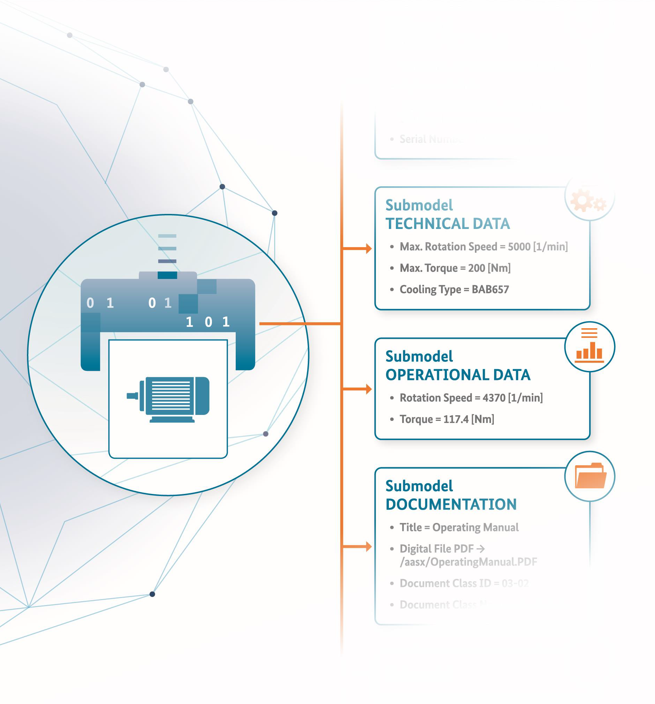

**RestServices**

(Version 1.0)

Content

General 3

About this document 3

Scope of the submodel 3

Relevant providers of properties for the submodel template 3

Submodel for RestServices description 4

Approach 4

Attributes of the submodel instance 5

Annex A. Explanations on used table formats 8

General 8

Tables on Submodels and SubmodelElements 8

Annex B. Bibliography 9

# General

## About this document

This document is a part of a specification series. Each part specifies the contents of a Submodel template for the Asset Administration Shell (AAS). The AAS is described in [1], [2], [3] and [6]. The first exemplary Submodel contents were described in [4], while the actual format of this document was derived from the "Administration Shell in Practice" [5]. The format aims to be very concise, giving only minimal necessary information for applying a Submodel template, while leaving deeper descriptions and specifications of concepts, structures and mapping to the respective documents [1] to [6]. Common terms and abbreviations can be found in [8].

The target audience of the specification is developers and editors of technical documentation and manufacturer information, which are describing assets in smart manufacturing through the Asset Administration Shell (AAS) and therefore need to create a Submodel instance with a hierarchy of SubmodelElements. This document especially details the question, of which SubmodelElements with which semantic identification shall be used for this purpose.

## Scope of the submodel

This Submodel template aims at interoperable provision of technical data describing the asset of the respective Asset Administration Shell. The central element is the provision of properties [7], ideally interoperable by the means of dictionaries such as ECLASS and IEC CDD (Common data dictionary).

A new RestServices AAS submodel is created to allow the registration of machine services. In specific, the presented submodel permits characterizing properties of rest services such as URL, Name, Method, IsAsync, RequestBody, and Response. These properties correspond to the basic components of a typical rest service. However, it may not be complete for reasons of this prototype.

The proposed submodel aims to allow the description of machine services. Once AAS packages are deployed to the AAS Repository, it is possible to query the stored information through the AAS Repository's API. In matters of this proposal, a business process modeling software has to be modified to consume the API and get the RestServices of all the assets in the network. In this way, the Service-Discovery mechanism can be enabled. Full prototype and the source code can be found at <https://github.com/MUFacultyOfEngineering/AASBPM>

## Relevant providers of properties for the submodel template

According [3], interoperable properties might be defined by standards, consortium specifications or manufacturer specifications. For the former two cases, so called dictionaries, repositories or classification systems exist in the market. In the further document, these entities are summarized by "property dictionaries" (see Terms and Definitions of [6]).

Such property dictionaries include:

* **ECLASS**, see: <https://www.eclasscontent.com/>
* **IEC CDD**, see: <https://cdd.iec.ch/cdd/iec61987/iec61987.nsf>and <https://cdd.iec.ch/cdd/iec62683/cdddev.nsf>

However, as of this writing, we did not find any property related to RestServices. Therefore, the properties included in this submodel are based on Oracle’s web document:

* **Oracle, see:** <https://docs.oracle.com/javaee/6/tutorial/doc/gijqy.html>

# Submodel for RestServices description

## Approach

A Submodel according to this Submodel template specification consists of four areas, represented by four SubmodelElementCollections:

* URL: The Request URL is how you can make the call. It is composed of keywords that indicate to the server what you are trying to do.
* Name: The name of the operation.
* Method: HTTP Methods are essential to every call to the REST API. HTTP Methods represent an action to the FME Server that you would like to complete. Could be POST, GET, PUT, DELETE.
* IsAsync: To specify whether the operation is executed asynchronously or synchronously.
* RequestBody: The request body defines the parameters of what is being completed. It specifies the information to be modified, created, or deleted.
* Response: The actual response of the operation.

If possible, the Submodel utilizes the AAS provisions for multiple-language support. Specifically, the AAS LangStringSet data structure is used for accessing the description of SubmodelElements, the idShort, preferred names of ConceptDescriptions, and the values of MultiLanguageProperties. By such provisions, the same technical data entities can be provided for multiple language domains required by multiple target markets of the industrial equipment and therefore fosters cross-relationships between these language domains for engineering and analytics.

Figure 1 shows, how such information might be rendered in a user application.

**Figure 1 Screenshot of the AASX Package Explorer with Submodel "RestServices" of an example asset.**

## Attributes of the submodel instance

The tables below break down the attribute specifications of the RestServices submodel. First, at the top level, the “RestServices” submodel contains one property of type SubmodelElementCollection and its multiplicity is set to 1..* to allow the registration of 1 to many services of an asset. Next, the “RestService” SubmodelElementCollection allows the characterization of an individual service by using properties such as URL, Name, Method, IsAsync, RequestBody, and Response. Finally, the “Response” SubmodelElementCollection allows specifying how a service would respond to a request.

|  |  |  |  |
| --- | --- | --- | --- |
| **idShort:** | **RestServices** |  |  |
| **Class:** | **Submodel** |  |  |
| **semanticId:** | **[IRI] https://mondragon.com/ids/sm/7471_5180_3022_3423** |  |  |
| **Parent:** | **RestServices** |  |  |
| **Explanation:** | **A submodel template for mapping device rest services@en, Una plantilla de submodelo para mapear propiedades de un servicio rest de un dispositivo@es** |  |  |
| **[SME type] idShort** | **semanticId = [idType]value Description@en** | **[valueType] example** | **card.** |
| [SMC] RestService | [IRI]https://mondragon.com/ids/cd/0422_5130_5022_9484 Rest Service Rest Service Information about an individual Rest Service | [-] 6 elements | 1..* |

|  |  |  |  |
| --- | --- | --- | --- |
| **idShort:** | **RestService** |  |  |
| **Class:** | **SubmodelElementCollection** |  |  |
| **semanticId:** | **[IRI] https://mondragon.com/ids/cd/0422_5130_5022_9484** |  |  |
| **Parent:** | **RestService** |  |  |
| **Explanation:** | **Information about an individual Rest Service@en, Información respecto a un Servicio Rest@es** |  |  |
| **[SME type] idShort** | **semanticId = [idType]value Description@en** | **[valueType] example** | **card.** |
| [Property] URL | [IRI]https://mondragon.com/ids/cd/0241_0190_3022_9102 URL URL The rest service endpoint. Make sure it is reachable within the network. | [string] http://127.0.0.1/myRestService/?parameter1=val1 |  |
| [Property] Name | [IRI]https://mondragon.com/ids/cd/7052_0190_3022_2921 Name - The name of the rest service | [string] My rest service name |  |
| [Property] Method | [IRI]https://mondragon.com/ids/cd/1561_0190_3022_7753 Method Method The type of method | [string] GET POST PUT PATCH DELETE |  |
| [Property] IsAsync | [IRI]https://mondragon.com/ids/cd/2582_3130_5022_8052 IsAsync IsAsync Specify whether or not the operation is executed asynchronously | [boolean] false true |  |
| [Property] RequestBody | [IRI]https://mondragon/ids/cd/6321_8081_5022_2401 RequestBody - Payload or request body. The actual data to be sent to the HTTP rest endpoint. | [string] {} </> 0 text |  |
| [SMC] Response | [IRI]https://mondragon.com/ids/cd/2262_0190_3022_6903 - - Service response | [-] 3 elements | 1..* |

|  |  |  |  |
| --- | --- | --- | --- |
| **idShort:** | **Response** |  |  |
| **Class:** | **SubmodelElementCollection** |  |  |
| **semanticId:** | **[IRI] https://mondragon.com/ids/cd/2262_0190_3022_6903** |  |  |
| **Parent:** | **Response** |  |  |
| **Explanation:** | **Service response@en, Respuesta del servicio@es** |  |  |
| **[SME type] idShort** | **semanticId = [idType]value Description@en** | **[valueType] example** | **card.** |
| [Property] Code | [IRI]https://mondragon.com/ids/cd/9562_0190_3022_6374 - - Responde code | [int] 200 201 |  |
| [Property] MediaType | [IRI]https://mondragon.com/ids/cd/4572_0190_3022_0456 - - Media type | [string] application/json application/xml text/xml |  |
| [Property] ExampleValue | [IRI]https://mondragon.com/ids/cd/6192_0190_3022_6082 ExampleValue - An example of the response body | [string] {} </> 0 text |  |

# Annex A. Explanations on used table formats

## General

The used tables in this document try to outline information as concise as possible. They do not convey all information on Submodels and SubmodelElements. For this purpose, the definitive definitions are given by the following annex in form of an XML mapping of the Submodel template and its elements

## Tables on Submodels and SubmodelElements

For clarity and brevity, a set of rules is used for the tables for describing Submodels and SubmodelElements.

* The tables follow in principle the same conventions as in [5].
* The table heads abbreviate 'cardinality' with 'card'.
* The tables often place two informations in different rows of the same table cell. In this case, the first information is marked out by sharp brackets [] from the second information. A special case are the semanticIds, which are marked out by the format: (type)(local)[idType]value.
* The types of SubmodelElements are abbreviated:

|  |  |
| --- | --- |
| SME type | SubmodelElemetType |
| Prop | Property |
| MLP | MultiLanguageProperty |
| Range |  |
| File |  |
| Blob |  |
| Ref | ReferenceElement |
| Ref | RelationshipElement |
| SMC | SubmodelElementCollection |
| SME | SubmodelElement |

* If an idShort ends with '{00}', this indicates a suffix of the respective length (here: 2) of decimal digits, in order to make the idShort unique. A different idShort might be choosen, as long as it is unique in the parents context.
* The Keys of semanticId in the main section feature only idType and value, such as: [IRI]https://admin- shell.io/vdi/2770/1/0/DocumentId/Id. The attributes "type" and "local" (typically "ConceptDescription" and "(local)" or "GlobalReference" and (no-local)") need to be set accordingly; see [6].
* If a table does not contain a column with "parent" heading, all represented attributes share the same parent. This parent is denoted in the head of the table.
* Multi-language strings are represented by the text value, followed by '@'-character and the ISO639 language code: example@EN.
* The [valueType] is only given for Properties.

# Annex B. Bibliography

“Recommendations for implementing the strategic initiative INDUSTRIE 4.0”, acatech, April 2013. [Online]. Available [https://www.acatech.de/Publikation/recommendations-for-](https://www.acatech.de/Publikation/recommendations-for-implementing-the-strategic-initiative-industrie-4-0-final-report-of-the-industrie-4-0-working-group/) [implementing-the-strategic-initiative-industrie-4-0-final-report-of-the-industrie-4-0-working-](https://www.acatech.de/Publikation/recommendations-for-implementing-the-strategic-initiative-industrie-4-0-final-report-of-the-industrie-4-0-working-group/) [group/](https://www.acatech.de/Publikation/recommendations-for-implementing-the-strategic-initiative-industrie-4-0-final-report-of-the-industrie-4-0-working-group/)

“Implementation Strategy Industrie 4.0: Report on the results of the Industrie 4.0 Platform”; BITKOM e.V. / VDMA e.V., /ZVEI e.V., April 2015. [Online]. Available: [https://www.bitkom.org/noindex/Publikationen/2016/Sonstiges/Implementation-Strategy-](https://www.bitkom.org/noindex/Publikationen/2016/Sonstiges/Implementation-Strategy-Industrie-40/2016-01-Implementation-Strategy-Industrie40.pdf) [Industrie-40/2016-01-Implementation-Strategy-Industrie40.pdf](https://www.bitkom.org/noindex/Publikationen/2016/Sonstiges/Implementation-Strategy-Industrie-40/2016-01-Implementation-Strategy-Industrie40.pdf)

“The Structure of the Administration Shell: TRILATERAL PERSPECTIVES from France, Italy and Germany”, March 2018, [Online]. Available: [https://www.plattform-](https://www.plattform-i40.de/I40/Redaktion/EN/Downloads/Publikation/hm-2018-trilaterale-coop.html) [i40.de/I40/Redaktion/EN/Downloads/Publikation/hm-2018-trilaterale-coop.html](https://www.plattform-i40.de/I40/Redaktion/EN/Downloads/Publikation/hm-2018-trilaterale-coop.html)

“Beispiele zur Verwaltungsschale der Industrie 4.0-Komponente – Basisteil (German)”; ZVEI e.V., Whitepaper, November 2016. [Online]. Available: [https://www.zvei.org/presse-](https://www.zvei.org/presse-medien/publikationen/beispiele-zur-verwaltungsschale-der-industrie-40-komponente-basisteil/) [medien/publikationen/beispiele-zur-verwaltungsschale-der-industrie-40-komponente-basisteil/](https://www.zvei.org/presse-medien/publikationen/beispiele-zur-verwaltungsschale-der-industrie-40-komponente-basisteil/)

“Verwaltungsschale in der Praxis. Wie definiere ich Teilmodelle, beispielhafte Teilmodelle und Interaktion zwischen Verwaltungsschalen (in German)”, Version 1.0, April 2019, Plattform Industrie 4.0 in Kooperation mit VDE GMA Fachausschuss 7.20, Federal Ministry for Economic Affairs and Energy (BMWi), Available: [https://www.plattform-](https://www.plattform-i40.de/PI40/Redaktion/DE/Downloads/Publikation/2019-verwaltungsschale-in-der-praxis.html) [i40.de/PI40/Redaktion/DE/Downloads/Publikation/2019-verwaltungsschale-in-der-praxis.html](https://www.plattform-i40.de/PI40/Redaktion/DE/Downloads/Publikation/2019-verwaltungsschale-in-der-praxis.html)

“Details of the Asset Administration Shell; Part 1 - The exchange of information between partners in the value chain of Industrie 4.0 (Version 2.0.1)”, May 2020, [Online]. Available: [https://www.plattform-i40.de/PI40/Redaktion/EN/Downloads/Publikation/Details-of-the-Asset-](https://www.plattform-i40.de/PI40/Redaktion/EN/Downloads/Publikation/Details-of-the-Asset-Administration-Shell-Part1.html) [Administration-Shell-Part1.html](https://www.plattform-i40.de/PI40/Redaktion/EN/Downloads/Publikation/Details-of-the-Asset-Administration-Shell-Part1.html)

Semantic interoperability: challenges in the digital transformation age, IEC, International Electronical Commision; 2019; Available: [https://basecamp.iec.ch/download/iec-white-paper-](https://basecamp.iec.ch/download/iec-white-paper-semantic-interoperability-challenges-in-the-digital-transformation-age-en/) [semantic-interoperability-challenges-in-the-digital-transformation-age-en/?](https://basecamp.iec.ch/download/iec-white-paper-semantic-interoperability-challenges-in-the-digital-transformation-age-en/)

Common terms and abbreviations according to VDI FA 7.21 Wiki; Available: <http://i40.iosb.fraunhofer.de/>