MuGate
A University AI Platform for Academic Excellence

Al Maaref University
Department of Computer Sciences
Academic Year 2025-2026

Capstone Project Report

Submitted By:
Mohammad Jomaa — Backend Developer, AI Integration, Database Admin
Abo Al Fadel Ismael — UI/UX Designer, Frontend Developer, Project Manager

© 2026 Al Maaref University

Abstract
MuGate is a comprehensive university AI platform developed at Al Maaref University, Department of Computer Sciences, during the 2025-2026 academic year. The platform addresses the fragmented nature of student academic tooling by consolidating intelligent scheduling, AI-powered academic assistance, resume enhancement, internship discovery, capstone collaboration, event aggregation, and degree planning into a unified web and mobile experience.
The system comprises three applications: a React 19 frontend built with Vite 7, an Express 5 TypeScript backend connected to Microsoft SQL Server, and a partial Expo 56 mobile port providing 13 screens across five tab navigations. Authentication integrates directly with the Al Maaref University student portal via Playwright-based credential verification, issuing JSON Web Tokens with a 24-hour expiry.
Artificial intelligence is delivered through a resilient three-provider cascade (DeepSeek → Gemini → OpenRouter) with retrieval-augmented generation (RAG) powered by ChromaDB vector storage and reciprocal rank fusion between vector and keyword search. The schedule generator employs prerequisite-aware backtracking with multi-criteria scoring to produce ranked, conflict-free timetables. The Resume Enhancer provides analyzer, builder, and live editor modes with local and global CV templates.
The backend exposes 50+ REST API endpoints across 22 database tables. Testing was conducted exclusively through manual verification; no automated test suite or Docker containerization is present in the repository. This report documents the complete system lifecycle from requirements through deployment, presenting architecture diagrams, database design, algorithm specifications, and an honest assessment of challenges and future work.
Keywords: university platform, retrieval-augmented generation, schedule optimization, resume enhancement, Playwright authentication, React, Express, SQL Server, Expo

Acknowledgements
We extend our sincere gratitude to the faculty and staff of Al Maaref University for their guidance, resources, and encouragement throughout the development of the MuGate platform.
We thank our dedicated instructors and mentors who reviewed our design decisions and offered constructive feedback during each phase of development.
Special recognition goes to fellow students who participated in early testing sessions and reported bugs that shaped the user experience.
We acknowledge the open-source communities behind React, Express, Playwright, ChromaDB, and Expo, whose tools made this integration project feasible within an academic timeline.
Finally, we thank our families for their patience and support during development.

Table of Contents

(Right-click the table of contents and select 'Update Field' in Microsoft Word to populate page numbers.)

List of Figures
Figure 1: MuGate three-tier system architecture (frontend, backend, mobile)
Figure 2: Use case diagram showing student and admin interactions
Figure 3: Authentication sequence — MU Portal Playwright scrape to JWT issuance
Figure 4: RAG retrieval sequence — vector + keyword fusion with live fallback
Figure 5: Resume Enhancer activity diagram (analyzer, builder, editor flows)
Figure 6: Entity-relationship diagram of the MuGate database schema
Figure 7: Data flow diagram (Level 0) for the MuGate platform
Figure 8: Deployment architecture (no Docker — native Node.js services)
Figure 9: Component diagram of backend modules
Figure 10: Project Gantt chart for the 2025-2026 development timeline
Figure 11: AuthService.login — MU Portal verification flow
Figure 12: AiProvider — multi-provider cascade with retry
Figure 13: resumeSchema.js — normalized template-agnostic data model
Figure 14: App.jsx — lazy-loaded route definitions
Figure 15: MuGate web interface — home
Figure 16: MuGate web interface — resume
Figure 17: Entity-relationship diagram
Figure 18: Deployment architecture (native services)

List of Tables
Table 1: Project team members and responsibilities
Table 2: Feature comparison
Table 3: Functional requirements
Table 4: Non-functional requirements
Table 5: Use case descriptions
Table 6: User roles
Table 7: Backend module decomposition
Table 8: Frontend route map
Table 9: Mobile screen inventory
Table 10: Technology stack
Table 11: Database table inventory
Table 12: Data dictionary — Users
Table 13: Data dictionary — PortalCredentials
Table 14: Data dictionary — Courses
Table 15: Data dictionary — CourseSections
Table 16: Data dictionary — AcademicHistory
Table 17: Data dictionary — Schedules
Table 18: Data dictionary — ScheduleSections
Table 19: Data dictionary — Sessions
Table 20: Data dictionary — ChatSessions
Table 21: Data dictionary — ChatMessages
Table 22: Data dictionary — ChatAnalytics
Table 23: Data dictionary — KnowledgePages
Table 24: Data dictionary — KnowledgeChunks
Table 25: Data dictionary — ScraperRuns
Table 26: Data dictionary — ScrapeQueue
Table 27: Data dictionary — Admins
Table 28: Data dictionary — Companies
Table 29: Data dictionary — InternshipReviews
Table 30: Data dictionary — CapstonePartners
Table 31: Data dictionary — CapstoneIdeas
Table 32: Data dictionary — Events
Table 33: Data dictionary — UserRoadmap
Table 34: Manual test cases
Table 35: Complete API endpoint inventory
Table 36: Environment variables
Table 37: Development challenges

Chapter 1: Introduction

1.1 Background and Motivation
University students at Al Maaref University navigate a complex academic ecosystem spanning course registration, degree planning, career preparation, capstone project formation, and campus engagement. Traditionally, these activities are supported by disconnected tools: the official student portal for registration, static PDF degree plans, third-party resume builders, social media for event discovery, and informal networks for capstone partner matching.
This fragmentation imposes cognitive overhead on students who must context-switch between systems, manually reconcile prerequisite requirements when building schedules, and rely on generic AI chatbots that lack institution-specific knowledge.
The MuGate project was conceived to address these gaps by delivering an integrated, AI-augmented platform tailored specifically to Al Maaref University's Computer Science curriculum and administrative workflows.
The motivation extends beyond convenience: accurate schedule generation directly impacts graduation timelines, resume quality affects employment outcomes, and timely access to capstone partners and internship reviews shapes career trajectories.

1.2 Problem Statement
Students face four interconnected problems: manual schedule construction against prerequisite chains and section availability; scattered academic policy information; disconnected career preparation tools; and unstructured capstone and event discovery.
MuGate unifies solutions within a single authenticated platform that reads live data from the MU portal and augments it with AI capabilities grounded in a curated university knowledge base.

1.3 Project Objectives
- Implement secure MU Portal authentication via Playwright with JWT (24h).
- Develop prerequisite-aware schedule generator with backtracking and scoring.
- Build MuChat RAG chatbot with ChromaDB vector storage.
- Create Resume Enhancer (analyzer, builder, live editor) with local/global templates.
- Deliver 3D Internships explorer with peer reviews.
- Provide Capstone partner matching, ideas database, and AI advisor.
- Aggregate events via scraping and admin CRUD.
- Enable drag-and-drop degree roadmap planning.
- Implement Admin Control for users and knowledge base.
- Port core features to Expo mobile (13 screens).

1.4 Scope and Limitations
Scope covers web frontend, Express backend, SQL Server database, and partial mobile port. Limitations: no automated tests, no Docker, hardcoded super-admin ID 101230004, desktop min-width 1200px, mobile partial port only.

1.5 Project Team
Table 1: Project team members and responsibilities
Name | Role(s)
Mohammad Jomaa | Backend Developer, AI Integration, Database Admin
Abo Al Fadel Ismael | UI/UX Designer, Frontend Developer, Project Manager

1.6 Report Organization
Chapters 2–12 cover literature review, requirements, design, implementation, UI, database, algorithms, testing, deployment, challenges, and conclusion.

Chapter 2: Literature Review

2.1 University Student Portals
University portals provide transactional access but lack intelligent advisory features. MuGate scrapes live portal data and applies combinatorial optimization for schedules.

2.2 AI Assistants in Education
Generic LLMs hallucinate on institution-specific facts. RAG mitigates this by injecting retrieved documents. MuGate uses ChromaDB, hybrid retrieval, and Reciprocal Rank Fusion.

2.3 Schedule Optimization
Course scheduling is a constrained optimization problem. MuGate uses depth-first backtracking with pruning and multi-criteria scoring, returning top 20 ranked schedules.

2.4 Resume Analysis and ATS
MuGate combines heuristic and AI scoring across ATS, content, impact, structure, and keywords. Normalized resumeSchema.js separates data from Lebanese/international templates.

2.5 Technology Landscape
React 19 + Vite 7 frontend, Express 5 + TypeScript backend, SQL Server, ChromaDB, Expo 56 mobile.

2.6 Research Gap and Contribution
MuGate demonstrates a unified student success platform for Al Maaref University CS students, honestly documenting academic-project limitations.

2.7 Comparative Analysis
Table 2: Feature comparison
Dimension | MuGate | University Portal | Generic AI
Schedule Generation | Prerequisite-aware backtracking with scoring | Manual section selection only | Advisory text only, no data integration
Authentication | Live MU Portal Playwright verification | Native SSO | No university authentication
Academic Data | Scraped history + course sync | Built-in transcript | No access to student records
AI Assistance | RAG over university KB + student context | FAQ pages | General knowledge, may hallucinate
Resume Tools | Analyzer + builder + live editor + export | Career office appointments | Text suggestions only
Internships | 3D explorer with peer reviews | Static listings | No structured review system
Capstone | Partner matching + ideas DB + AI advisor | Faculty bulletin boards | Generic project suggestions
Events | Automated scraping + manual admin CRUD | Manual calendar posts | No event integration
Mobile | Expo partial port (13 screens) | Often responsive web only | Mobile app available
Offline Resilience | AI cascade across 3 providers | N/A | Single provider dependency

Chapter 3: Requirements Analysis

3.1 Stakeholders
Primary: CS students. Secondary: administrators. Development: two-member team.

3.2 Functional Requirements
Table 3: Functional requirements
ID | Category | Requirement
FR-01 | Auth | Portal Playwright verify + JWT 24h
FR-02 | Registration | Auto-register on first login
FR-03 | Credentials | AES-encrypt portal creds for scraping
FR-04 | Schedule | Conflict-free prerequisite-aware generation
FR-05 | Persistence | Save/delete schedules
FR-06 | MuChat | RAG for university questions
FR-07 | Sessions | Separate chat and resume sessions
FR-08 | Resume | AI scoring + PDF/DOCX export
FR-09 | Internships | 3D explorer + one review per company
FR-10 | Capstone | Partners + ideas + AI advisor
FR-11 | Events | Scrape + admin CRUD
FR-12 | Roadmap | Drag-and-drop degree plan
FR-13 | Admin | Grant/revoke admin, KB management
FR-14 | Mobile | 13-screen Expo partial port
FR-15 | AI Cascade | DeepSeek → Gemini → OpenRouter fallback

3.3 Non-Functional Requirements
Table 4: Non-functional requirements
ID | Category | Requirement
NFR-01 | Performance | Schedule gen < 30s typical
NFR-02 | Resilience | AI cascade on provider failure
NFR-03 | Security | AES credentials, JWT sessions
NFR-04 | Scalability | ChromaDB or local vector fallback
NFR-05 | Integrity | 22 tables with FK constraints

3.4 Use Cases
Table 5: Use case descriptions
ID | Name | Actor | Description | Postcondition
UC-01 | Student Login | Student | Authenticate via MU Portal credentials | JWT token issued; user auto-registered if new
UC-02 | Ask MuChat | Student | Submit academic question to AI chatbot | RAG-retrieved answer with university context
UC-03 | Generate Schedule | Student | Request optimal semester schedule | Ranked list of conflict-free schedules returned
UC-04 | Save Schedule | Student | Save preferred generated schedule | Schedule persisted with selected sections
UC-05 | Analyze Resume | Student | Upload CV for AI scoring | ATS/content/impact scores with breakdown
UC-06 | Build Resume | Student | Create CV via form builder | Structured resume data with local/global template
UC-07 | Edit Resume Live | Student | Inline edit with AI suggestions | Normalized schema updated; export to PDF/DOCX
UC-08 | Browse Internships | Student | Explore 3D company carousel | Company details and aggregated ratings displayed
UC-09 | Submit Review | Student | Rate internship company | Review stored (one per user per company)
UC-10 | Find Capstone Partner | Student | Post or browse partner listings | Matching students connected via listings
UC-11 | Browse Capstone Ideas | Student | Search faculty project ideas | Filtered ideas list with tags
UC-12 | Plan Degree Roadmap | Student | Drag-and-drop course planning | Personalized CS curriculum roadmap saved
UC-13 | View Events | Student | Browse upcoming campus events | Scraped and manual events displayed
UC-14 | Sync Academic History | Student | Refresh grades from portal | AcademicHistory table updated
UC-15 | Grant Admin | Admin | Add admin privileges by university ID | User added to Admins table
UC-16 | Manage Knowledge Base | Admin | Crawl/sync/reindex university website | RAG knowledge base updated
UC-17 | Manage Capstone Ideas | Admin | CRUD capstone project ideas | Ideas database maintained
UC-18 | Manage Events | Admin | Add/edit/delete manual events | Events table updated
UC-19 | Manage Companies | Admin | CRUD internship companies | 3D carousel data maintained
UC-20 | Mobile Access | Student | Use core features on mobile app | 13 screens via Expo tab navigation

3.5 User Roles
Table 6: User roles
Role | Auth | Capabilities
Anonymous | Browse public endpoints | Events list, internship companies, capstone ideas, resume tools
Authenticated Student | JWT bearer token (24h) | Schedule, history, saved data, reviews, roadmap, chat sessions
Administrator | Admins table or super admin ID | User management, KB controls, events CRUD, capstone ideas CRUD
Super Admin (101230004) | Hardcoded in auth middleware | Cannot be demoted; full admin privileges

Chapter 4: System Design
MuGate follows a three-tier architecture: presentation (React 19 + Expo 56), application (Express 5 TypeScript REST API), and data (SQL Server + ChromaDB). Playwright bridges the application tier to the external MU Portal for authentication and academic data scraping.

4.1 Architecture Overview
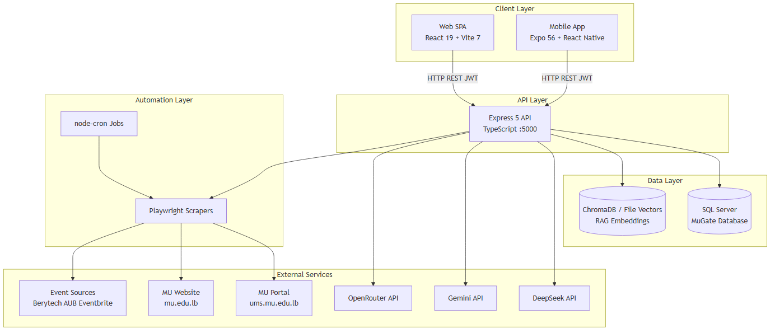
Figure 1: MuGate three-tier system architecture (frontend, backend, mobile)

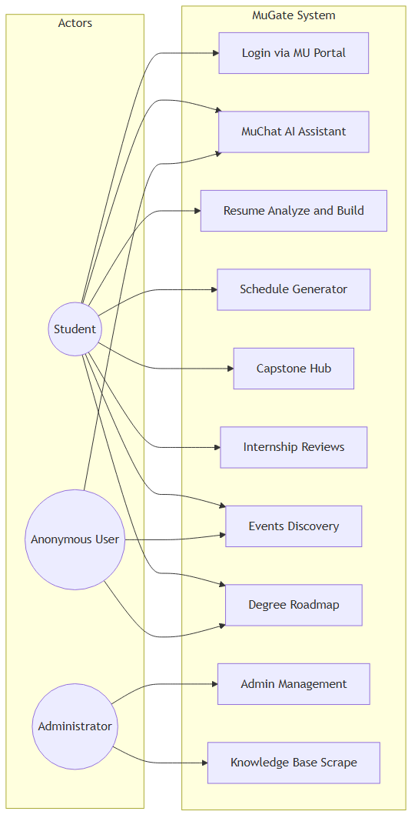
Figure 2: Use case diagram showing student and admin interactions

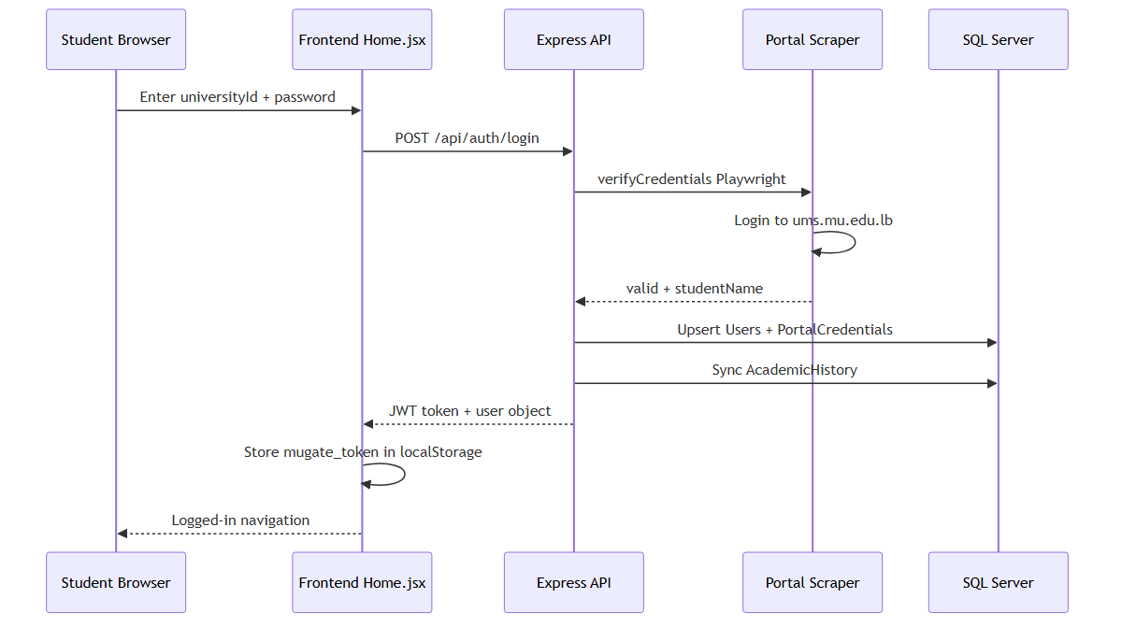
Figure 3: Authentication sequence — MU Portal Playwright scrape to JWT issuance

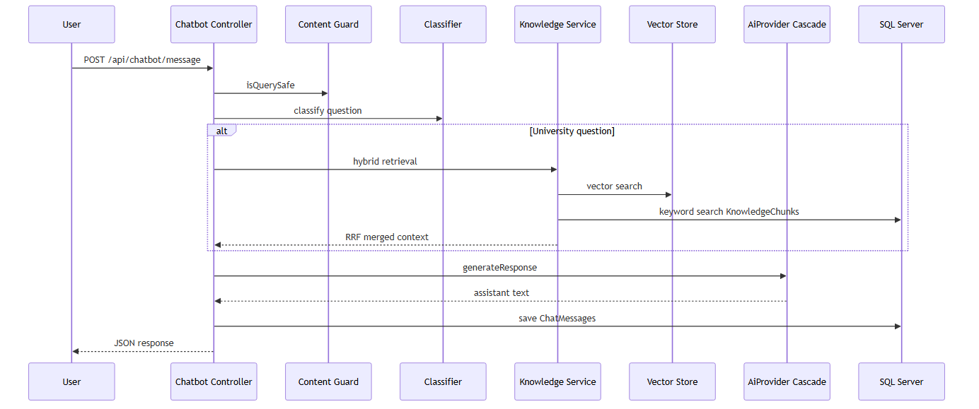
Figure 4: RAG retrieval sequence — vector + keyword fusion with live fallback

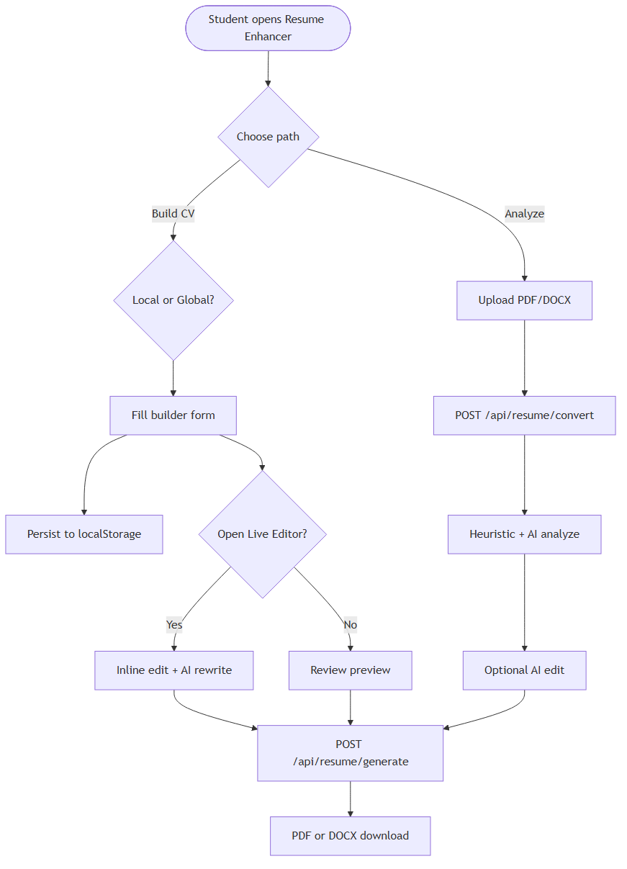
Figure 5: Resume Enhancer activity diagram (analyzer, builder, editor flows)

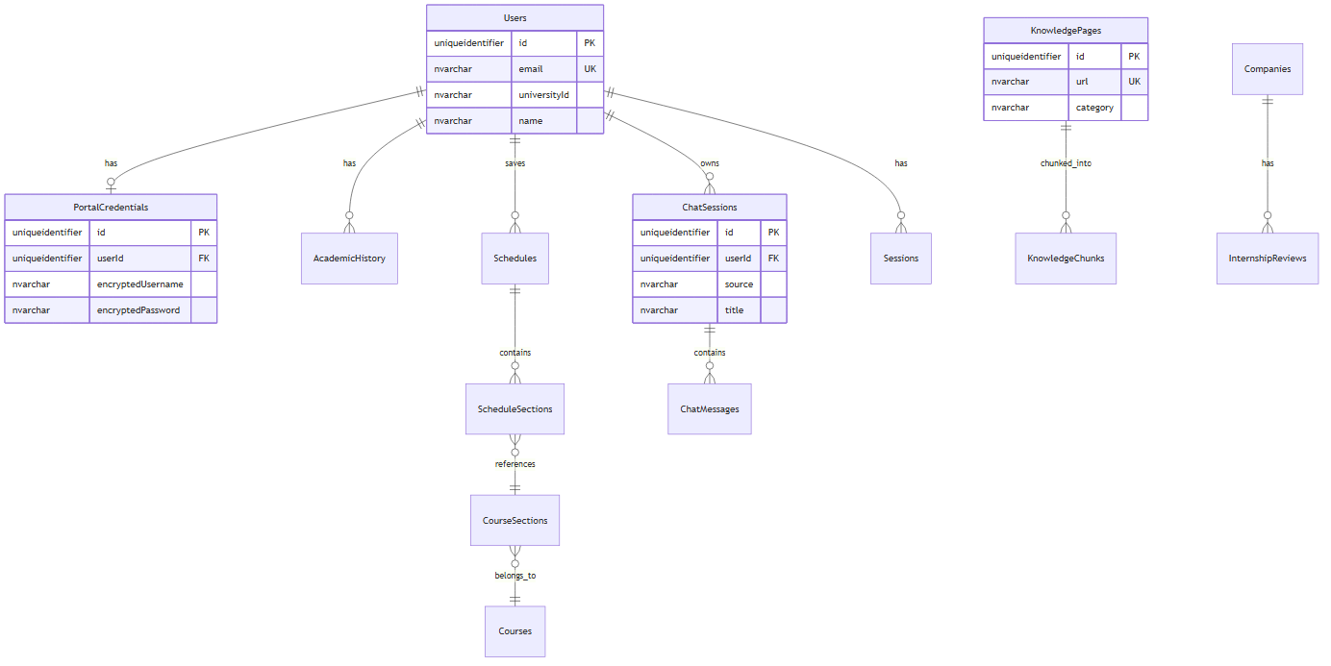
Figure 6: Entity-relationship diagram of the MuGate database schema

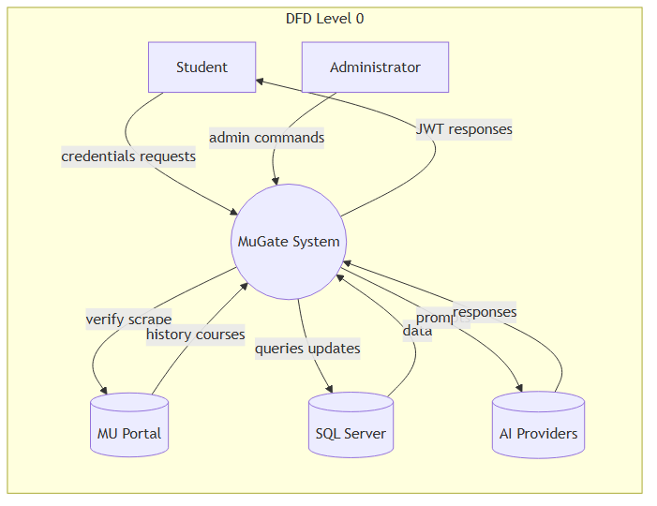
Figure 7: Data flow diagram (Level 0) for the MuGate platform

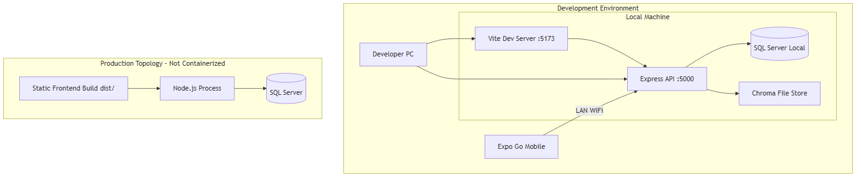
Figure 8: Deployment architecture (no Docker — native Node.js services)

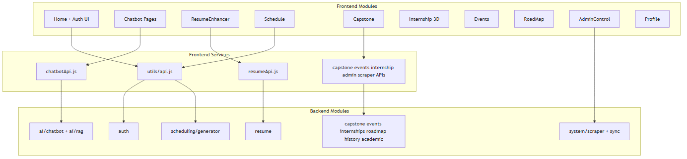
Figure 9: Component diagram of backend modules

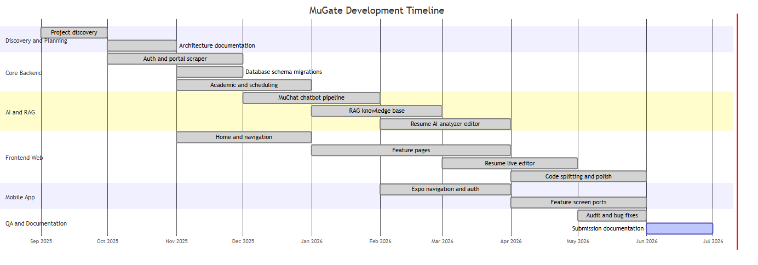
Figure 10: Project Gantt chart for the 2025-2026 development timeline

4.2 Module Decomposition
Table 7: Backend module decomposition
Module | Responsibility
Auth Module | Portal verification, JWT, admin checks, credential encryption.
Scheduling Module | Course sync, eligibility, backtracking generator, saved schedules.
AI/Chatbot Module | MuChat sessions, classifier, RAG pipeline, AI cascade.
Resume Module | Analyze, parse, convert, AI edit, PDF/DOCX generation.
Scraper Module | Portal scraper, university crawler, event scraper, CRON jobs.
Internships Module | Company CRUD, 3D assets, review system.
Capstone Module | Partners, ideas, soft-delete, AI advisor.
Events Module | Scraped + manual events with categories.
Roadmap Module | Default CS curriculum + user overrides.
Admin Module | User/admin management, KB controls.

4.3 Frontend Routes
Table 8: Frontend route map
Path | Component | Description
/ | Home | Landing page with MU portal login and feature showcases
/chatbot | Chatbot | MuChat AI assistant with RAG and file upload
/internships | InternshipList | 3D company carousel with reviews
/schedule | Schedule | Smart schedule generator and saved schedules
/resume-enhancer | ResumeEnhancer | CV analyzer, builder, and live editor
/capstone | Capstone | Partner finder, ideas database, AI advisor
/events | Events | Campus and academic events hub
/roadmap | RoadMap | Drag-and-drop CS degree planner
/about | About | Project credits and team information
/admin-control | AdminControl | Admin management and KB controls
/profile | Profile | User profile and session management

4.4 Mobile Architecture
Table 9: Mobile screen inventory
Screen | Directory | Description
LoginScreen | auth/ | Root stack modal — MU portal login
HomeScreen | home/ | Home tab main screen
ChatScreen | chat/ | MuChat tab
ToolsHubScreen | tools/ | Tools tab hub
ScheduleScreen | schedule/ | Schedule generator
ResumeScreen | resume/ | Resume enhancer
CapstoneScreen | capstone/ | Capstone partner/ideas
RoadmapScreen | roadmap/ | Degree roadmap
EventsScreen | events/ | Events listing
InternshipsScreen | internships/ | Internships explorer tab
ProfileScreen | profile/ | Profile tab
AboutScreen | about/ | About/credits
AdminScreen | admin/ | Admin controls

Five tabs: Home, MuChat, Tools, Internships, Profile.

4.5 Security Design
JWT 24h expiry. AES encryption for PortalCredentials. Admin middleware checks Admins table or super-admin 101230004. Rate limiting via express-rate-limit.

Chapter 5: Implementation

5.1 Technology Stack
Table 10: Technology stack
Layer | Technology | Version | Purpose
Frontend | React | 19.2.0 | Component-based SPA UI
Frontend | Vite | 7.2.4 | Build tool and dev server
Frontend | React Router | 7.13.0 | Client-side routing
Frontend | Tailwind CSS | 4.1.18 | Utility-first styling
Frontend | Three.js | 0.182.0 | 3D internship carousel
Backend | Express | 5.2.1 | REST API server
Backend | TypeScript | 5.9.3 | Type-safe server code
Backend | SQL Server | mssql 12.2.0 | Relational database
Backend | Playwright | 1.60.0 | Portal authentication scraping
Backend | ChromaDB | 3.5.0 | Vector store for RAG
Backend | jsonwebtoken | 9.0.3 | JWT session tokens (24h)
Mobile | Expo | 56.0.12 | Cross-platform mobile runtime
Mobile | React Native | 0.85.3 | Native mobile UI
Mobile | React Navigation | 7.x | Tab and stack navigation
AI | DeepSeek API | deepseek-chat | Primary LLM provider
AI | Google Gemini | gemini-2.5-flash | Fallback LLM + embeddings
AI | OpenRouter | free models | Tertiary LLM fallback cascade

5.2 Backend Implementation
Express 5 server in TypeScript 5.9.3. Modular structure under backend/src/modules/. mssql driver with msnodesqlv8 for Windows integrated auth option. 50+ endpoints registered across route files. node-cron schedules: course sync (3h), KB sync (daily 3AM), vector sync (4AM), sitemap refresh (Sunday 2AM).

5.3 Frontend Implementation
React 19 SPA with Vite 7. Route-level lazy loading via React.lazy — 24 production chunks. Tailwind CSS 4 for styling. Three.js for internship 3D carousel. @dnd-kit for roadmap drag-and-drop.

5.4 Mobile Implementation
Expo 56 with React Native 0.85.3. React Navigation 7 (tabs + stacks + drawer). expo-secure-store for JWT. Partial port: 13 screens covering core features.

5.5 Authentication Implementation
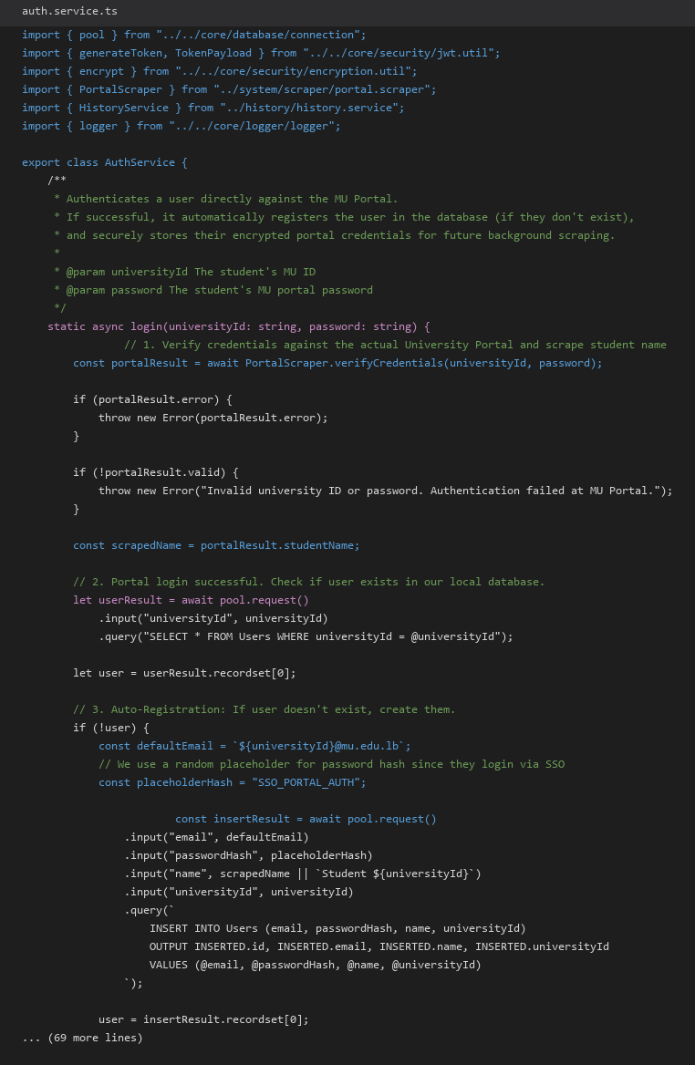
Figure 11: AuthService.login — MU Portal verification flow

auth.service.ts: PortalScraper.verifyCredentials → auto-register → encrypt creds → sync history → generateToken → isAdmin check.

5.6 AI Provider Implementation
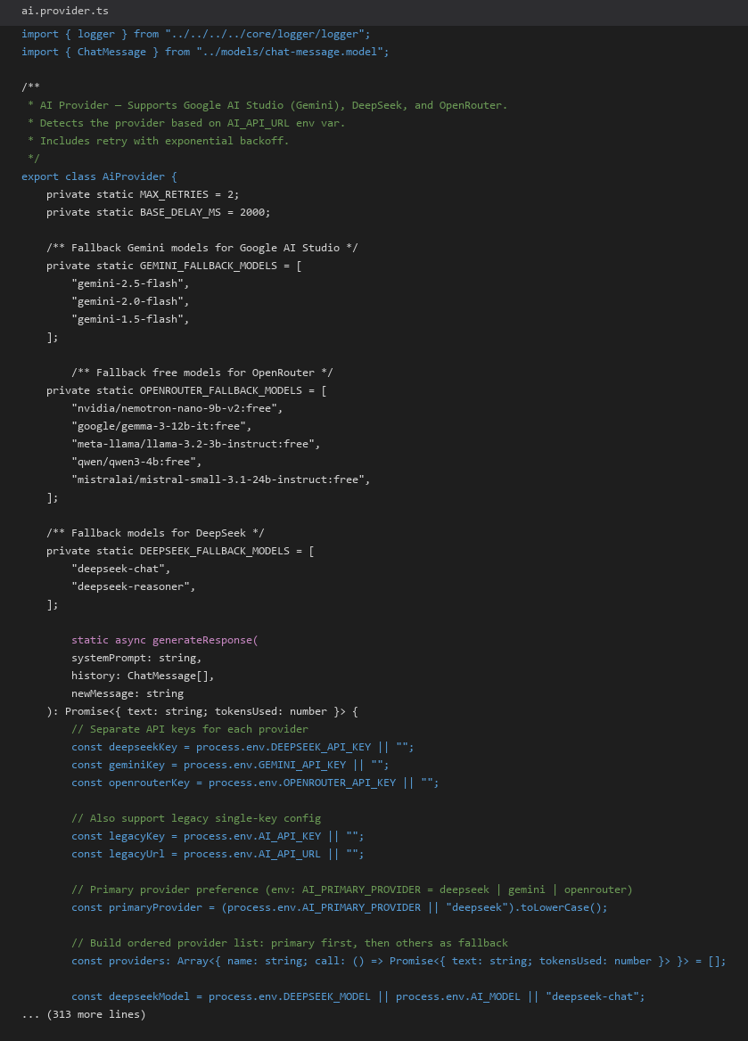
Figure 12: AiProvider — multi-provider cascade with retry

5.7 RAG Implementation
KnowledgeService.retrieveContext: term extraction → parallel vector+keyword → RRF merge → confidence check (0.55) → LiveSearchService fallback. ChromaDB collection mugate_knowledge_chunks with local vectors.json fallback. Gemini text-embedding-004 with hash-vector fallback.

5.8 Resume Enhancer Implementation
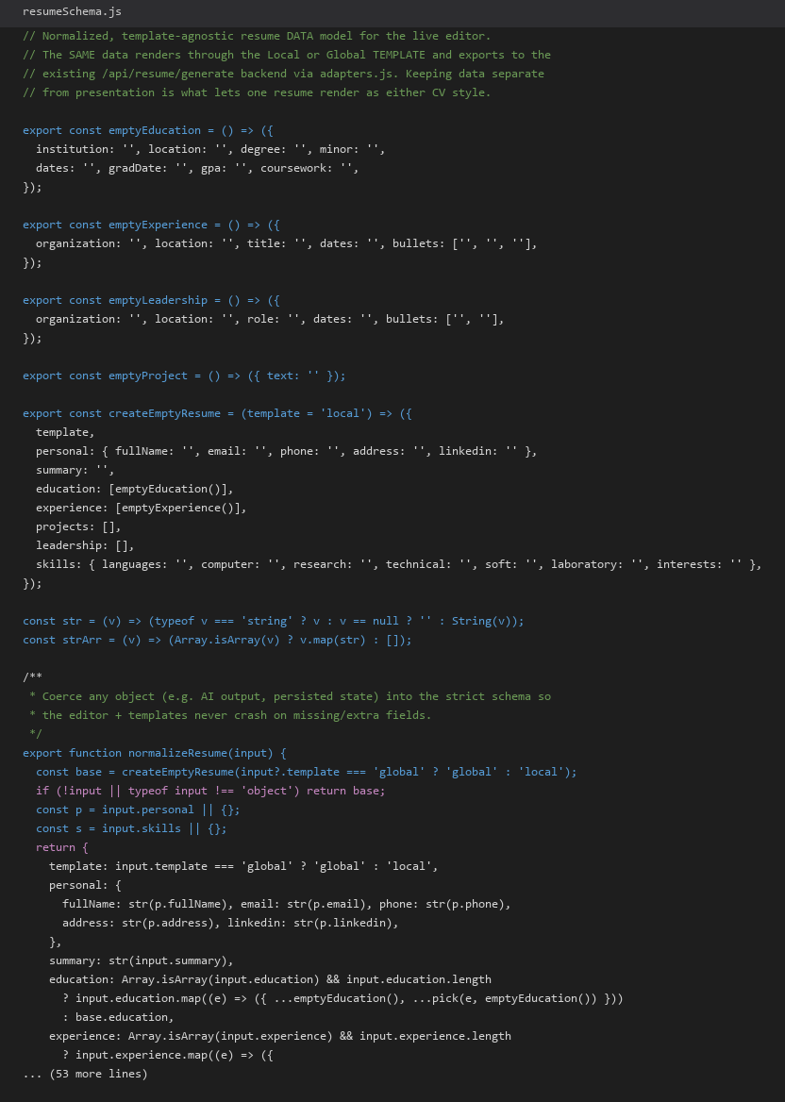
Figure 13: resumeSchema.js — normalized template-agnostic data model

Three modes: WelcomeView → Analyzer/Builder/Editor. pdfkit + docx backend generators. localStorage persistence via usePersistentState.

5.9 Schedule Generator Implementation
GeneratorService: auto-scrape history → sync courses → getEligibleCourses (CS_CURRICULUM) → backtracking → score → top 20. Preferences: maxCredits, excludeDays, startTime, twoDaysOnly.

5.10 Frontend Routes
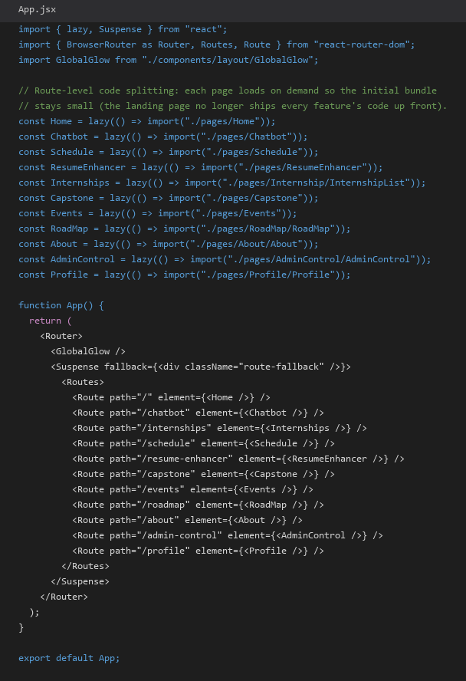
Figure 14: App.jsx — lazy-loaded route definitions

Chapter 6: User Interface
The MuGate web interface employs a consistent navigation bar across 11 routes with admin-gated features. Visual design uses custom CSS with Tailwind utilities and a GlobalGlow ambient effect. Desktop layout requires min-width 1200px.

6.1 Home and Authentication
Landing page with MU portal login form, feature showcases, and animated branding.

6.2 MuChat Interface
Chat sessions with markdown rendering, file upload, pin/delete, separate resume advisor.

6.3 Schedule Interface
Preference panel, generated schedule cards with scores, save/delete functionality.

6.4 Resume Enhancer Interface
Welcome mode selector, analyzer score rings, builder forms, Jobsuit-style live editor.

6.5 Internships 3D Explorer
Three.js carousel with company logos, review submission, admin company management.

6.6 Capstone, Events, Roadmap
Capstone: partner listings, searchable ideas, AI chat advisor. Events: category filters, scraped + manual events. Roadmap: drag-and-drop semester planning against CS curriculum.

6.7 Admin Control Panel
Grant/demote admins, KB stats, crawl/sync/reindex/rescrape buttons, scraper run history. BroadcastChannel for cross-tab sync.

6.8 Application Screenshots
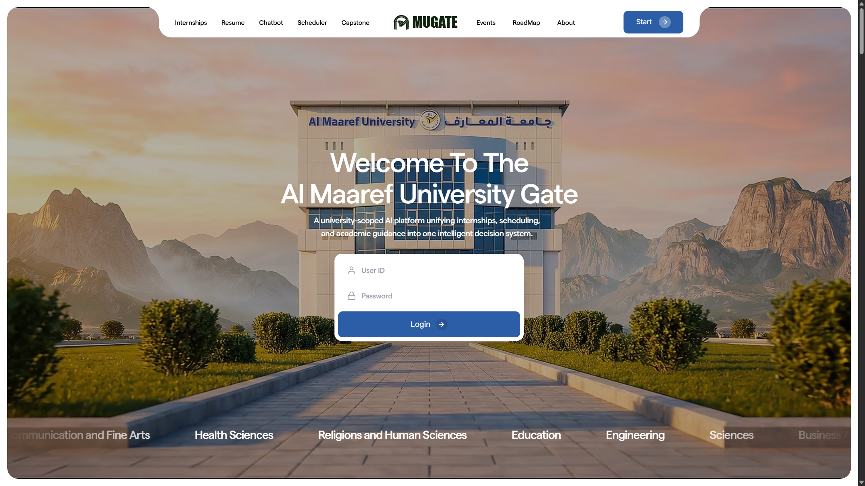
Figure 15: MuGate web interface — home

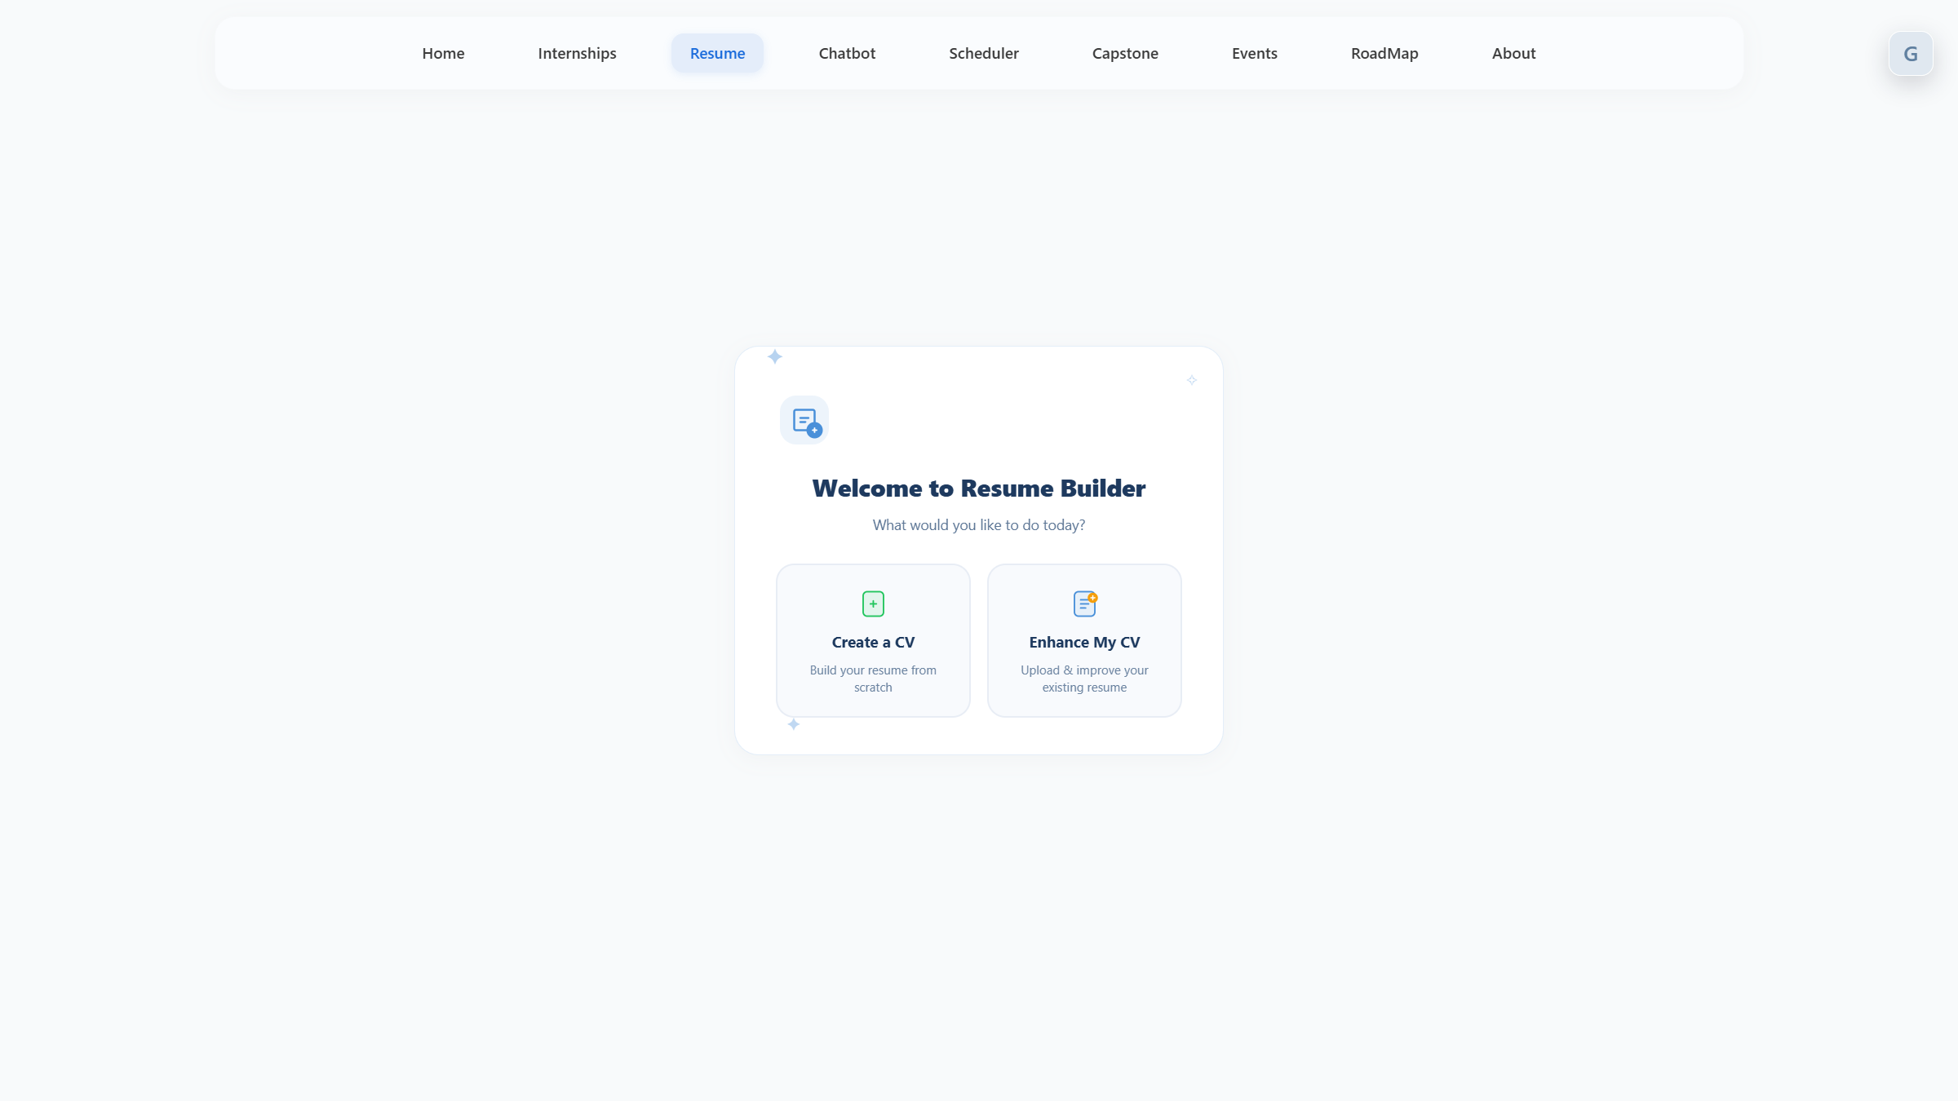
Figure 16: MuGate web interface — resume

Chapter 7: Database Design
MuGate uses Microsoft SQL Server database 'MuGate' with 22 tables across core academic, chat, RAG, and feature-specific schemas. Runtime migrations in connection.ts add columns and tables (Admins, Companies, Events, etc.) beyond init.sql.

7.1 Schema Overview

Figure 17: Entity-relationship diagram

7.2 Table Inventory
Table 11: Database table inventory
# | Table | Purpose
1 | Users | 8 columns
2 | PortalCredentials | 6 columns
3 | Courses | 7 columns
4 | CourseSections | 11 columns
5 | AcademicHistory | 11 columns
6 | Schedules | 6 columns
7 | ScheduleSections | 2 columns
8 | Sessions | 5 columns
9 | ChatSessions | 8 columns
10 | ChatMessages | 6 columns
11 | ChatAnalytics | 5 columns
12 | KnowledgePages | 14 columns
13 | KnowledgeChunks | 11 columns
14 | ScraperRuns | 12 columns
15 | ScrapeQueue | 8 columns
16 | Admins | 2 columns
17 | Companies | 12 columns
18 | InternshipReviews | 7 columns
19 | CapstonePartners | 10 columns
20 | CapstoneIdeas | 8 columns
21 | Events | 19 columns
22 | UserRoadmap | 9 columns

7.3 Data Dictionary

7.3.1 Users
Table 12: Data dictionary — Users
Column | Type | Constraint | Description
id | UUID | PK | Unique user identifier
email | NVARCHAR |  | User email (default: {universityId}@mu.edu.lb)
passwordHash | NVARCHAR |  | Placeholder hash for SSO users
name | NVARCHAR |  | Display name from portal scrape
universityId | NVARCHAR | UNIQUE | MU student ID
createdAt | DATETIME |  | Registration timestamp
updatedAt | DATETIME |  | Last profile update
lastActiveAt | DATETIME |  | Last API activity for online status

The Users table stores user identity and profile records for the MuGate platform. Referential integrity is enforced through foreign key relationships where indicated.

7.3.2 PortalCredentials
Table 13: Data dictionary — PortalCredentials
Column | Type | Constraint | Description
id | UUID | PK | Credential record ID
userId | UUID | FK→Users | Owner of encrypted credentials
encryptedUsername | NVARCHAR |  | AES-encrypted portal username
encryptedPassword | NVARCHAR |  | AES-encrypted portal password
createdAt | DATETIME |  | Creation timestamp
updatedAt | DATETIME |  | Last credential update

The PortalCredentials table stores domain-specific records for the MuGate platform. Referential integrity is enforced through foreign key relationships where indicated.

7.3.3 Courses
Table 14: Data dictionary — Courses
Column | Type | Constraint | Description
id | UUID | PK | Course identifier
courseCode | NVARCHAR |  | e.g. CSC245
courseName | NVARCHAR |  | Full course title
credits | INT |  | Credit hours
department | NVARCHAR |  | Offering department
semester | NVARCHAR |  | Semester code
createdAt | DATETIME |  | Record creation time

The Courses table stores domain-specific records for the MuGate platform. Referential integrity is enforced through foreign key relationships where indicated.

7.3.4 CourseSections
Table 15: Data dictionary — CourseSections
Column | Type | Constraint | Description
id | UUID | PK | Section identifier
courseId | UUID | FK→Courses | Parent course
sectionNumber | NVARCHAR |  | Section number
instructor | NVARCHAR |  | Instructor name
day | NVARCHAR |  | Day of week
startTime | TIME |  | Class start time
endTime | TIME |  | Class end time
type | NVARCHAR |  | Lecture/Lab/Tutorial
capacity | INT |  | Maximum enrollment
enrolled | INT |  | Current enrollment count
room | NVARCHAR |  | Room location

The CourseSections table stores domain-specific records for the MuGate platform. Referential integrity is enforced through foreign key relationships where indicated.

7.3.5 AcademicHistory
Table 16: Data dictionary — AcademicHistory
Column | Type | Constraint | Description
id | UUID | PK | History record ID
userId | UUID | FK→Users | Student owner
courseCode | NVARCHAR |  | Completed course code
courseName | NVARCHAR |  | Course title
grade | NVARCHAR |  | Letter grade
credits | INT |  | Credits earned
semester | NVARCHAR |  | Completion semester
status | NVARCHAR |  | Pass/Fail/In Progress
category | NVARCHAR |  | Core/Elective/Free
isElective | BIT |  | Elective flag
updatedAt | DATETIME |  | Last sync timestamp

The AcademicHistory table stores domain-specific records for the MuGate platform. Referential integrity is enforced through foreign key relationships where indicated.

7.3.6 Schedules
Table 17: Data dictionary — Schedules
Column | Type | Constraint | Description
id | UUID | PK | Saved schedule ID
userId | UUID | FK→Users | Owner
name | NVARCHAR |  | User-assigned schedule name
score | FLOAT |  | Optimizer score
totalCredits | INT |  | Total credits in schedule
createdAt | DATETIME |  | Save timestamp

The Schedules table stores domain-specific records for the MuGate platform. Referential integrity is enforced through foreign key relationships where indicated.

7.3.7 ScheduleSections
Table 18: Data dictionary — ScheduleSections
Column | Type | Constraint | Description
scheduleId | UUID | FK→Schedules | Parent schedule
sectionId | UUID | FK→CourseSections | Selected section

The ScheduleSections table stores domain-specific records for the MuGate platform. Referential integrity is enforced through foreign key relationships where indicated.

7.3.8 Sessions
Table 19: Data dictionary — Sessions
Column | Type | Constraint | Description
id | UUID | PK | Portal session ID
userId | UUID | FK→Users | Session owner
cookies | NVARCHAR(MAX) |  | Serialized portal cookies
expiresAt | DATETIME |  | Session expiry
createdAt | DATETIME |  | Creation time

The Sessions table stores domain-specific records for the MuGate platform. Referential integrity is enforced through foreign key relationships where indicated.

7.3.9 ChatSessions
Table 20: Data dictionary — ChatSessions
Column | Type | Constraint | Description
id | UUID | PK | Chat session ID
userId | UUID | FK→Users | Owner (nullable for anonymous)
title | NVARCHAR |  | Session title
source | NVARCHAR |  | chat or resume
isPinned | BIT |  | Pinned flag
isActive | BIT |  | Active session flag
createdAt | DATETIME |  | Creation time
updatedAt | DATETIME |  | Last message time

The ChatSessions table stores domain-specific records for the MuGate platform. Referential integrity is enforced through foreign key relationships where indicated.

7.3.10 ChatMessages
Table 21: Data dictionary — ChatMessages
Column | Type | Constraint | Description
id | UUID | PK | Message ID
sessionId | UUID | FK→ChatSessions | Parent session
role | NVARCHAR |  | user/assistant/system
content | NVARCHAR(MAX) |  | Message text
tokensUsed | INT |  | AI tokens consumed
createdAt | DATETIME |  | Timestamp

The ChatMessages table stores domain-specific records for the MuGate platform. Referential integrity is enforced through foreign key relationships where indicated.

7.3.11 ChatAnalytics
Table 22: Data dictionary — ChatAnalytics
Column | Type | Constraint | Description
id | UUID | PK | Analytics record ID
questionCategory | NVARCHAR |  | Classifier category
isFailed | BIT |  | Failed response flag
responseTimeMs | INT |  | Response latency
createdAt | DATETIME |  | Timestamp

The ChatAnalytics table stores domain-specific records for the MuGate platform. Referential integrity is enforced through foreign key relationships where indicated.

7.3.12 KnowledgePages
Table 23: Data dictionary — KnowledgePages
Column | Type | Constraint | Description
id | UUID | PK | Page ID
url | NVARCHAR | UNIQUE | Source URL
title | NVARCHAR |  | Page title
content | NVARCHAR(MAX) |  | Full page text
contentHash | NVARCHAR |  | Change detection hash
category | NVARCHAR |  | Content category
subcategory | NVARCHAR |  | Sub-category
language | NVARCHAR |  | Content language
wordCount | INT |  | Word count
lastScrapedAt | DATETIME |  | Last scrape time
isActive | BIT |  | Active in KB flag
sourceDomain | NVARCHAR |  | Source domain
createdAt | DATETIME |  | Creation time
updatedAt | DATETIME |  | Update time

The KnowledgePages table stores domain-specific records for the MuGate platform. Referential integrity is enforced through foreign key relationships where indicated.

7.3.13 KnowledgeChunks
Table 24: Data dictionary — KnowledgeChunks
Column | Type | Constraint | Description
id | UUID | PK | Chunk ID
pageId | UUID | FK→KnowledgePages | Parent page
chunkIndex | INT |  | Position in page
content | NVARCHAR(MAX) |  | Chunk text
keywords | NVARCHAR |  | Extracted keywords
category | NVARCHAR |  | Inherited category
title | NVARCHAR |  | Chunk title
chromaSyncedAt | DATETIME |  | Vector sync timestamp
embeddingModel | NVARCHAR |  | Model used for embedding
entityType | NVARCHAR |  | Entity classification
createdAt | DATETIME |  | Creation time

The KnowledgeChunks table stores domain-specific records for the MuGate platform. Referential integrity is enforced through foreign key relationships where indicated.

7.3.14 ScraperRuns
Table 25: Data dictionary — ScraperRuns
Column | Type | Constraint | Description
id | UUID | PK | Run ID
runType | NVARCHAR |  | crawl/sync/rescrape
status | NVARCHAR |  | running/completed/failed
baseUrl | NVARCHAR |  | Starting URL
pagesScraped | INT |  | Total pages processed
pagesUpdated | INT |  | Updated pages
pagesNew | INT |  | New pages
pagesUnchanged | INT |  | Unchanged pages
errorCount | INT |  | Errors encountered
errorDetails | NVARCHAR(MAX) |  | Error log
startedAt | DATETIME |  | Start time
completedAt | DATETIME |  | Completion time

The ScraperRuns table stores domain-specific records for the MuGate platform. Referential integrity is enforced through foreign key relationships where indicated.

7.3.15 ScrapeQueue
Table 26: Data dictionary — ScrapeQueue
Column | Type | Constraint | Description
id | UUID | PK | Queue item ID
url | NVARCHAR |  | URL to scrape
priority | INT |  | Queue priority
status | NVARCHAR |  | pending/processing/done
runId | UUID | FK→ScraperRuns | Associated run
depth | INT |  | Crawl depth
createdAt | DATETIME |  | Queued time
updatedAt | DATETIME |  | Last update

The ScrapeQueue table stores domain-specific records for the MuGate platform. Referential integrity is enforced through foreign key relationships where indicated.

7.3.16 Admins
Table 27: Data dictionary — Admins
Column | Type | Constraint | Description
universityId | NVARCHAR | PK | Admin student ID
createdAt | DATETIME |  | Grant timestamp

The Admins table stores domain-specific records for the MuGate platform. Referential integrity is enforced through foreign key relationships where indicated.

7.3.17 Companies
Table 28: Data dictionary — Companies
Column | Type | Constraint | Description
id | INT | PK IDENTITY | Company ID
name | NVARCHAR |  | Company name
description | NVARCHAR |  | Description
colors | NVARCHAR |  | Brand colors JSON
scale | FLOAT |  | 3D model scale
svgString | NVARCHAR(MAX) |  | SVG logo data
email | NVARCHAR |  | Contact email
phone | NVARCHAR |  | Contact phone
website | NVARCHAR |  | Company website
forceWhiteBack | BIT |  | Logo background flag
forceBlackBack | BIT |  | Logo background flag
isMetallic | BIT |  | 3D material flag

The Companies table stores domain-specific records for the MuGate platform. Referential integrity is enforced through foreign key relationships where indicated.

7.3.18 InternshipReviews
Table 29: Data dictionary — InternshipReviews
Column | Type | Constraint | Description
id | INT | PK IDENTITY | Review ID
companyId | INT | FK→Companies | Reviewed company
userId | UUID | FK→Users | Reviewer
userName | NVARCHAR |  | Display name
rating | INT |  | 1-5 star rating
feedback | NVARCHAR |  | Written feedback
createdAt | DATETIME |  | Submission time

The InternshipReviews table stores domain-specific records for the MuGate platform. Referential integrity is enforced through foreign key relationships where indicated.

7.3.19 CapstonePartners
Table 30: Data dictionary — CapstonePartners
Column | Type | Constraint | Description
id | INT | PK IDENTITY | Listing ID
userId | UUID | FK→Users | Poster
userName | NVARCHAR |  | Display name
email | NVARCHAR |  | Contact email
phone | NVARCHAR |  | Contact phone
major | NVARCHAR |  | Student major
skills | NVARCHAR |  | Skills list
description | NVARCHAR |  | Self description
lookingFor | NVARCHAR |  | Partner requirements
createdAt | DATETIME |  | Post time

The CapstonePartners table stores domain-specific records for the MuGate platform. Referential integrity is enforced through foreign key relationships where indicated.

7.3.20 CapstoneIdeas
Table 31: Data dictionary — CapstoneIdeas
Column | Type | Constraint | Description
id | INT | PK IDENTITY | Idea ID
title | NVARCHAR |  | Project title
description | NVARCHAR |  | Project description
faculty | NVARCHAR |  | Faculty area
year | NVARCHAR |  | Academic year
tags | NVARCHAR |  | Comma-separated tags
isActive | BIT |  | Visible flag
createdAt | DATETIME |  | Creation time

The CapstoneIdeas table stores domain-specific records for the MuGate platform. Referential integrity is enforced through foreign key relationships where indicated.

7.3.21 Events
Table 32: Data dictionary — Events
Column | Type | Constraint | Description
id | INT | PK IDENTITY | Event ID
title | NVARCHAR |  | Event title
description | NVARCHAR |  | Event description
location | NVARCHAR |  | Venue
startDate | DATETIME |  | Start date/time
endDate | DATETIME |  | End date/time
category | NVARCHAR |  | Event category
tags | NVARCHAR |  | Tags
imageUrl | NVARCHAR |  | Event image URL
externalUrl | NVARCHAR |  | External link
source | NVARCHAR |  | manual/scraped
sourceId | NVARCHAR |  | External source ID
scraperSource | NVARCHAR |  | Scraper origin
organizer | NVARCHAR |  | Organizer name
isFree | BIT |  | Free admission flag
isActive | BIT |  | Visible flag
createdBy | UUID | FK→Users | Creator (manual events)
createdAt | DATETIME |  | Creation time
updatedAt | DATETIME |  | Update time

The Events table stores domain-specific records for the MuGate platform. Referential integrity is enforced through foreign key relationships where indicated.

7.3.22 UserRoadmap
Table 33: Data dictionary — UserRoadmap
Column | Type | Constraint | Description
id | INT | PK IDENTITY | Roadmap entry ID
userId | UUID | FK→Users | Owner
courseCode | NVARCHAR |  | Planned course code
courseName | NVARCHAR |  | Course title
credits | INT |  | Credit hours
category | NVARCHAR |  | Core/Elective
year | INT |  | Planned year
semester | NVARCHAR |  | Fall/Spring/Summer
createdAt | DATETIME |  | Entry creation time

The UserRoadmap table stores domain-specific records for the MuGate platform. Referential integrity is enforced through foreign key relationships where indicated.

7.4 Indexing Strategy
Indexes on userId, sessionId, courseId, category, isActive, startDate, status columns for query performance on high-traffic endpoints.

Chapter 8: Algorithms

8.1 Schedule Generation Algorithm
Backtracking over eligible courses with conflict detection and scoring.

Algorithm 8.1: Schedule Generation
FUNCTION GenerateSchedules(userId, semesterId, preferences):
IF AcademicHistory empty THEN SyncHistoryFromPortal(userId)
IF no cached sections THEN SyncCoursesFromPortal(semesterId)
eligible ← GetEligibleCourses(userId, CS_CURRICULUM)
offerings ← FetchSections(semesterId) FILTER full, A-building, TBA
offerings ← ApplyPreferences(offerings, preferences)
schedules ← []
FUNCTION Backtrack(index, currentSections, currentCourses):
IF index = len(eligible) THEN
IF ValidateCorequisites(currentCourses) AND ValidateElectiveLimits(currentCourses):
schedules.APPEND(Score(currentSections))
RETURN
course ← eligible[index]
sections ← offerings[course] OR skip
FOR EACH section IN sections:
IF NOT HasTimeConflict(section, currentSections):
Backtrack(index+1, currentSections + [section], currentCourses + [course])
Backtrack(index+1, currentSections, currentCourses) // skip course
Backtrack(0, [], [])
IF preferences.twoDaysOnly THEN FILTER schedules BY campusDays ≤ 2
SORT schedules BY score DESC
RETURN schedules[0:20]
Scoring: major credits ×10, other ×5, +8 per course, +15 for 0-credit, compactness bonus, +totalCredits.

8.2 RAG Retrieval Algorithm

Algorithm 8.2: Hybrid RAG Retrieval
FUNCTION RetrieveContext(question):
terms ← ExtractSearchTerms(question) WITH synonym expansion
vectorResults ← VectorSearch(Embed(question), topK=8)
keywordResults ← KeywordSearch(terms, topK=8)
merged ← ReciprocalRankFusion(vectorResults, keywordResults)
filtered ← merged WHERE relevanceScore >= 2
context ← FormatTopN(filtered, 5)
confidence ← ComputeConfidence(filtered)
IF confidence < 0.55 THEN
liveResults ← LiveSearchAndIngest(question, maxURLs=3)
context ← MERGE(context, liveResults)
RETURN { context, sources, confidence }

8.3 AI Provider Cascade

Algorithm 8.3: AI Provider Cascade
FUNCTION GenerateResponse(systemPrompt, history, message):
providers ← [DeepSeek, Gemini, OpenRouter] SORT BY AI_PRIMARY_PROVIDER first
FOR EACH provider IN providers WHERE apiKey exists:
FOR EACH model IN provider.fallbackModels:
FOR attempt IN 1..3:
response ← provider.call(model, systemPrompt, history, message)
IF response.tokensUsed > 0 AND NOT isConnectionError(response):
RETURN response
IF rateLimited THEN WAIT exponentialBackoff(attempt)
RETURN mockFallbackMessage()

8.4 Resume Analysis Algorithm

Algorithm 8.4: Resume Analysis
FUNCTION AnalyzeResume(resumeText):
structured ← ParseToJSON(resumeText)
atsScore ← CheckATSCompatibility(structured) // formatting, sections
contentScore ← EvaluateContentQuality(structured) // completeness
impactScore ← ScoreImpactStatements(structured) // action verbs, metrics
structureScore ← ValidateStructure(structured) // section order
keywordScore ← MatchKeywords(structured, domain) // CS/tech keywords
aiInsights ← AiProvider.enhance(analysisPrompt, structured)
RETURN { scores, breakdown, suggestions: aiInsights }

8.5 Authentication Flow

Algorithm 8.5: Portal Authentication
FUNCTION Login(universityId, password):
result ← Playwright.verifyCredentials(universityId, password)
IF NOT result.valid THEN THROW AuthenticationError
user ← FindOrCreateUser(universityId, result.studentName)
UpsertEncryptedCredentials(user.id, universityId, password)
TRY SyncStudentHistory(user.id) CATCH log non-fatal
token ← JWT.sign({ userId, email, name, universityId }, expiry=24h)
isAdmin ← (universityId = '101230004') OR EXISTS(Admins, universityId)
RETURN { token, user, isAdmin }

Chapter 9: Testing
The MuGate repository contains no automated test suite. No Jest, Mocha, Cypress, or Playwright test configurations exist in package.json files. Testing was conducted exclusively through manual verification during development and the final audit phase.
This approach is common in academic capstone projects prioritizing feature breadth, but represents a documented limitation for production deployment.

9.1 Testing Strategy
Manual exploratory testing covered all 11 frontend routes, 50+ API endpoints, mobile 13 screens, and admin workflows. Test data used real MU portal credentials in development environment.

9.2 Test Cases and Results
Table 34: Manual test cases
ID | Module | Scenario | Expected | Result
TC-01 | Login | Valid MU credentials | JWT returned; user in database | Pass
TC-02 | Login | Invalid credentials | 401 error from portal verification | Pass
TC-03 | MuChat | University policy question | RAG context injected; relevant answer | Pass
TC-04 | MuChat | Resume session (source=resume) | Resume advisor prompt; no RAG | Pass
TC-05 | Schedule | Generate with preferences | Top 20 ranked schedules returned | Pass
TC-06 | Schedule | Save and reload schedule | Persisted in Schedules table | Pass
TC-07 | Resume | Upload PDF for analysis | ATS/content/impact scores returned | Pass
TC-08 | Resume | Export PDF local template | Valid PDF generated | Pass
TC-09 | Resume | Export DOCX global template | Valid DOCX generated | Pass
TC-10 | Internships | Submit company review | Review stored; stats updated | Pass
TC-11 | Capstone | Post partner listing | Listing visible in search | Pass
TC-12 | Events | Trigger scrape | New events ingested | Pass
TC-13 | Roadmap | Save custom plan | UserRoadmap persisted | Pass
TC-14 | Admin | Grant admin privileges | User in Admins table | Pass
TC-15 | Admin | Delete super admin | Protected — 101230004 cannot be removed | Pass
TC-16 | Admin | Full KB crawl | ScraperRuns record created | Pass
TC-17 | Mobile | Login on Expo app | JWT stored in secure store | Pass
TC-18 | Mobile | Chat from mobile | Same backend RAG pipeline | Pass
TC-19 | AI Cascade | Primary provider rate-limited | Falls back to next provider | Pass
TC-20 | RAG | Low confidence query | Live search fallback triggered | Pass

9.3 API Endpoint Verification
Table 35: Complete API endpoint inventory
Method | Path | Auth | Description
GET | / | Public | Health check — MuGate Backend Running
GET | /test-db | Public | SQL Server connection test
GET | /api/auth/login | Public | Returns 405 — login requires POST
POST | /api/auth/login | Public | Portal SSO login; returns JWT + user + isAdmin
GET | /api/auth/me/is-admin | JWT | Self-check admin status
GET | /api/auth/users | Admin | List all registered users
GET | /api/auth/admins | Admin | List admins with online/offline activity
POST | /api/auth/admins | Admin | Grant admin by universityId
DELETE | /api/auth/admins/:universityId | Admin | Revoke admin (super admin protected)
GET | /api/history/ | JWT | Get student's scraped academic history
POST | /api/history/sync | JWT | Re-scrape portal history
GET | /api/courses/ | JWT | List all courses with sections
GET | /api/courses/:id | JWT | Get single course by ID
POST | /api/courses/sync | JWT | Sync course offerings from MU portal
POST | /api/generate/ | JWT | Generate optimal conflict-free schedules
GET | /api/schedules/ | JWT | Get all saved schedules for user
POST | /api/schedules/save | JWT | Save chosen schedule
DELETE | /api/schedules/:id | JWT | Delete saved schedule
POST | /api/chatbot/sessions | Optional JWT | Create chat session (source: chat|resume)
POST | /api/chatbot/message | Optional JWT | Send message; RAG for university questions
POST | /api/chatbot/upload | Optional JWT | Upload file (max 5MB) for chat context
GET | /api/chatbot/sessions | Optional JWT | List user's chat sessions
DELETE | /api/chatbot/sessions/:sessionId | Optional JWT | Delete session
GET | /api/chatbot/sessions/:sessionId/messages | Optional JWT | Get message history
GET | /api/chatbot/analytics | JWT | Chat analytics
POST | /api/chatbot/enhance-prompt | Optional JWT | AI prompt enhancement
POST | /api/scraper/scrape | Public | Portal scrape trigger
POST | /api/scraper/university/crawl | Admin | Start full university website crawl
POST | /api/scraper/university/sync | Admin | Incremental KB sync (24h threshold)
GET | /api/scraper/university/stats | Admin | Knowledge base statistics
GET | /api/scraper/university/runs | Admin | Scraper run history
GET | /api/scraper/university/status | Public | Check if scraper is running
POST | /api/scraper/university/rescrape | Admin | Full rescrape — clears and rebuilds KB
POST | /api/scraper/university/reindex | Admin | Reindex all vectors to Chroma/local store
POST | /api/scraper/university/sitemap-refresh | Admin | Refresh sitemap and queue new URLs
POST | /api/resume/generate | Public | Generate PDF/DOCX resume
POST | /api/resume/analyze | Public | AI resume scoring (ATS, content, impact)
POST | /api/resume/ai-edit | Public | Structured AI rewrite of resume section
POST | /api/resume/parse | Public | Parse raw resume text to structured JSON
POST | /api/resume/convert | Public | Upload PDF/DOCX → structured JSON
POST | /api/resume/convert-base64 | Public | Convert via base64 (mobile-friendly)
POST | /api/resume/edit | Public | Legacy upload-and-edit path
GET | /api/internships/companies | Public | List all companies
POST | /api/internships/companies | Admin | Add company
PUT | /api/internships/companies/:id | Admin | Update company
DELETE | /api/internships/companies/:id | Admin | Delete company
GET | /api/internships/stats | Public | Aggregated rating stats per company
GET | /api/internships/reviews/:companyId | Public | Reviews for a company
POST | /api/internships/reviews/:companyId | JWT | Submit review (1 per user per company)
PUT | /api/internships/reviews/:reviewId | JWT | Update own review
DELETE | /api/internships/reviews/:reviewId | JWT | Delete own review
GET | /api/capstone/partners | Public | Partner listings with search
POST | /api/capstone/partners | JWT | Add partner listing (one per user)
DELETE | /api/capstone/partners/:partnerId | JWT | Delete own listing
GET | /api/capstone/ideas | Public | Capstone ideas with search/filter
GET | /api/capstone/ideas/deleted | Admin | Soft-deleted default ideas
POST | /api/capstone/ideas | Admin | Add capstone idea
PUT | /api/capstone/ideas/:id | Admin | Update idea
DELETE | /api/capstone/ideas/:id | Admin | Delete idea
POST | /api/capstone/ideas/:id/restore | Admin | Restore soft-deleted idea
GET | /api/capstone/ideas/faculties | Public | Distinct faculties from ideas
POST | /api/capstone/ai/chat | Public | Capstone AI advisor chat
GET | /api/events/ | Public | Upcoming events
GET | /api/events/categories | Public | Event categories
GET | /api/events/stats | Public | Event statistics
GET | /api/events/:id | Public | Event by ID
POST | /api/events/ | Admin | Add manual event
PUT | /api/events/:id | Admin | Update manual event
DELETE | /api/events/:id | Admin | Delete manual event
POST | /api/events/scrape | Public | Trigger event scraping
GET | /api/roadmap/ | Optional JWT | Get user's degree roadmap
POST | /api/roadmap/ | JWT | Save/overwrite roadmap
POST | /api/roadmap/reset | JWT | Reset roadmap to defaults

9.4 Known Issues
- Desktop-only navigation (min-width 1200px) — not tested on mobile browsers.
- Legacy resume editor path (editor.service.ts) — brittle regex; structured ai-editor preferred.
- Secrets in git history — rotation required before production.
- No load testing performed on schedule generator or RAG pipeline.

9.5 Recommendations for Future Testing
- Add Jest unit tests for GeneratorService, KnowledgeService, AuthService.
- Add Supertest integration tests for API routes.
- Add Playwright E2E tests for login and schedule generation flows.
- Add CI pipeline running tests on pull requests.

Chapter 10: Deployment
MuGate is deployed as native Node.js processes without Docker containerization. No Dockerfile, docker-compose.yml, or container orchestration configuration exists in the repository. This chapter documents the actual deployment architecture.

10.1 Deployment Architecture

Figure 18: Deployment architecture (native services)

Three independently deployed applications: backend (port 5000), frontend (Vite dev or static build via nginx), mobile (Expo build). SQL Server instance hosts MuGate database. Optional ChromaDB server for production vector search.

10.2 Environment Configuration
Table 36: Environment variables
Variable | Purpose
DB_SERVER | SQL Server hostname
DB_NAME | MuGate
JWT_SECRET | Token signing key
DEEPSEEK_API_KEY | Primary AI provider
GEMINI_API_KEY | Fallback AI + embeddings
OPENROUTER_API_KEY | Tertiary AI fallback
CHROMA_URL | Optional ChromaDB server
AI_PRIMARY_PROVIDER | deepseek | gemini | openrouter
ENCRYPTION_KEY | Portal credential AES key

10.3 Backend Deployment
npm run build (TypeScript compile) → node dist/server.js. Playwright browsers must be installed on server (npx playwright install). Windows: msnodesqlv8 for SQL Server integrated auth. CRON jobs start with server.

10.4 Frontend Deployment
npm run build → dist/ static files served by nginx or IIS. API URL configured in frontend config.

10.5 Mobile Deployment
expo build / eas build for iOS and Android. API base URL points to deployed backend.

10.6 Database Initialization
Run init.sql, rag-tables.sql, rag-v2.sql. connection.ts creates runtime tables (Admins, Companies, etc.). rag.bootstrap.ts seeds knowledge and syncs vectors on startup.

10.7 Why No Docker
The repository does not include Docker configuration. Deployment assumes direct Node.js installation on Windows Server or Linux VM with SQL Server connectivity. Docker could be added in future work but is outside current project scope.

Chapter 11: Challenges and Future Work

11.1 Development Challenges
Table 37: Development challenges
Challenge | Impact | Mitigation
Portal Scraping Reliability | Playwright depends on portal DOM structure; layout changes break scrapers. | Implement selector health checks and alert admins.
AI Provider Rate Limits | Free tier APIs throttle under load. | Cascade across 3 providers mitigates; paid tiers for production.
RAG Knowledge Freshness | Stale KB pages yield outdated answers. | CRON sync + live search fallback + admin rescrape tools.
Hardcoded Super Admin | ID 101230004 cannot be changed without code edits. | Move to environment variable or bootstrap seed.
No Automated Tests | Regression risk on changes. | Add Jest + Supertest + Playwright suite.
Desktop-Only UI | min-width 1200px excludes mobile browsers. | Responsive redesign with mobile-first breakpoints.
Secret Management | API keys were committed to git history. | Rotate all secrets; use secret manager.
Mobile Feature Parity | 13 screens vs 11 web routes with varying depth. | Complete mobile port of all features.

11.2 Future Enhancements
- Docker containerization for reproducible deployment.
- Automated test suite with CI/CD pipeline.
- Responsive mobile-web design.
- OAuth2/OIDC if university provides official API.
- Real-time notifications for events and capstone matches.
- Multi-faculty curriculum support beyond CS.
- Offline mobile mode with sync.
- Analytics dashboard for admin usage metrics.

Chapter 12: Conclusion
MuGate successfully demonstrates an integrated university AI platform combining portal-authenticated data access, intelligent scheduling, retrieval-augmented generation, multi-provider AI resilience, and comprehensive student success tools within a single codebase.
Developed by Mohammad Jomaa and Abo Al Fadel Ismael at Al Maaref University, Department of Computer Sciences, the platform encompasses a React 19 frontend, Express 5 TypeScript backend with 50+ API endpoints and 22 database tables, and a partial Expo 56 mobile port with 13 screens.
Key technical achievements include Playwright-based MU Portal authentication with JWT sessions, prerequisite-aware schedule backtracking returning top-20 ranked timetables, hybrid RAG with ChromaDB and reciprocal rank fusion, and a three-mode Resume Enhancer with local and global templates.
The project honestly documents its limitations: manual testing only, no Docker deployment, hardcoded admin privileges, and desktop-oriented UI. These represent appropriate scope boundaries for an academic capstone while providing a clear roadmap for production hardening.
We believe MuGate provides a meaningful contribution to student academic success at Al Maaref University and serves as a reference implementation for institution-specific AI platforms in higher education.

References
Al Maaref University. (2026). Student Portal Documentation. https://portal.mu.edu.lb
Anthropic. (2024). Retrieval-Augmented Generation for Knowledge-Intensive NLP Tasks. arXiv preprint.
ChromaDB Team. (2025). ChromaDB Documentation. https://docs.trychroma.com
DeepSeek AI. (2025). DeepSeek API Documentation. https://api.deepseek.com
Express.js Foundation. (2025). Express 5.x Guide. https://expressjs.com
Facebook Inc. (2025). React 19 Documentation. https://react.dev
Google. (2025). Gemini API Reference. https://ai.google.dev
Microsoft. (2025). SQL Server Documentation. https://docs.microsoft.com/sql
Microsoft. (2025). Playwright Documentation. https://playwright.dev
OpenRouter. (2025). OpenRouter API Documentation. https://openrouter.ai/docs
Sommerville, I. (2016). Software Engineering (10th ed.). Pearson.
Pressman, R. S., & Maxim, B. R. (2019). Software Engineering: A Practitioner's Approach (9th ed.). McGraw-Hill.
Expo Team. (2025). Expo SDK 56 Documentation. https://docs.expo.dev
Vite Team. (2025). Vite 7 Guide. https://vitejs.dev
Cormack, G. V., Clarke, C. L., & Buettcher, S. (2009). Reciprocal Rank Fusion outperforms Condorcet and individual Rank Learning Methods. SIGIR.
OWASP Foundation. (2024). OWASP Top Ten Web Application Security Risks.
IEEE. (2014). IEEE Std 830-1998 — Recommended Practice for Software Requirements Specifications.
Gamma, E., Helm, R., Johnson, R., & Vlissides, J. (1994). Design Patterns: Elements of Reusable Object-Oriented Software. Addison-Wesley.

Integration Architecture Notes
The three-application architecture (web, API, mobile) communicates exclusively through REST JSON over HTTP. No GraphQL, WebSocket, or gRPC protocols are used. Mobile clients use the same API surface as the web frontend, with convert-base64 endpoint provided specifically for mobile file upload constraints.
CORS is configured on the Express server to allow frontend origin during development. Production deployment requires matching CORS origins to the deployed frontend domain.

Error Handling Philosophy
Route handlers catch exceptions and return appropriate HTTP status codes with JSON error messages. Portal scraping failures during login are fatal; history sync failures during login are non-fatal and logged. AI provider failures cascade to next provider before returning a user-friendly fallback message.

Caching and State Management
Frontend uses localStorage for resume builder state via usePersistentState hook. JWT tokens are stored in browser localStorage on web and expo-secure-store on mobile. No Redis or server-side session store is used; JWT is stateless.
Course offerings are cached in SQL Server after portal sync; schedule generator reuses cached sections unless semester changes.

Content Moderation
MuChat includes content moderation checks before sending messages to AI providers. Inappropriate content is rejected with user notification rather than forwarded to external APIs, reducing policy violation risk with third-party AI services.

Classifier Service
The ClassifierService routes incoming chat messages to appropriate handlers. UNIVERSITY_ACADEMIC questions trigger RAG retrieval; other categories may use general AI knowledge or student academic context without RAG.

CRON Job Schedule
Course sync every 3 hours keeps section availability current during registration periods. Knowledge base incremental sync runs daily at 3 AM, targeting pages not scraped within 24 hours. Vector reindex at 4 AM ensures ChromaDB stays synchronized with SQL chunks. Sitemap refresh on Sundays at 2 AM discovers new university website URLs.

Capstone Module Details
Capstone partners are student-posted listings with skills, major, and partner requirements. Each authenticated user may post one listing; administrators are exempt from this limit. Capstone ideas are admin-managed faculty suggestions with soft-delete for default entries. The capstone AI advisor uses a dedicated prompt separate from MuChat RAG pipeline.

Events Scraping Pipeline
Events are ingested from external sources via scraper plus manual admin entry. Each event records source, sourceId, scraperSource for deduplication. Public endpoints expose upcoming events, categories, and aggregate statistics.

Internship 3D Rendering
The internship module stores company visual assets as SVG strings with configurable colors, scale, and metallic rendering flags. Three.js with @react-three/fiber and @react-three/drei renders an interactive 3D carousel on the web frontend.

Roadmap Curriculum Model
The default CS curriculum is embedded in backend roadmap module. Authenticated users may override with personalized plans stored in UserRoadmap table. Reset endpoint restores defaults. Drag-and-drop on frontend maps to POST /api/roadmap.

Resume Export Pipeline
PDF generation uses pdfkit with template-specific layout functions. DOCX generation uses the docx npm package with structured document assembly. Both accept normalized formData from frontend adapters.js mapping resumeSchema to backend payload format.

BroadcastChannel Admin Sync
AdminControl.jsx uses BroadcastChannel API to synchronize admin panel state across browser tabs. When one tab triggers a KB crawl, other tabs receive notification to refresh statistics and scraper run history.

Rate Limiting
express-rate-limit middleware protects authentication and AI endpoints from abuse. Configured limits apply per IP address within sliding time windows.

Optional Authentication Pattern
Chatbot and roadmap routes use optionalAuthMiddleware: authenticated users get personalized sessions and saved roadmaps; anonymous users receive generic defaults and ephemeral chat sessions without userId linkage.

Development Workflow
Frontend: npm run dev (Vite HMR on port 5173). Backend: npm run dev (ts-node/nodemon on port 5000). Mobile: npx expo start. Database: SQL Server local instance with init.sql seed scripts. Environment: backend/.env from .env.example template.

Audit Findings Summary
FINAL_AUDIT_REPORT.md documents project status as university-submission-ready after manual verification. Critical fixes applied: resume extras data-loss bug, builder persistence, secret hygiene (.env untracked). Production blockers: secret rotation, responsive design, automated tests.

Appendix A: Feature Deep Dives

MuChat Session Management
Chat sessions support create, list, delete, pin, and message history. The source column distinguishes university chat (RAG-enabled) from resume advisor sessions (dedicated prompt, no RAG). File upload accepts documents up to 5MB for contextual chat.
This capability is implemented within the MuGate monorepo and integrates with the Express 5 backend through typed service classes. The design prioritizes separation of concerns between route handlers, business logic, and data access layers.
From a user perspective, muchat session management contributes to the platform goal of consolidating academic tools into a single authenticated experience at Al Maaref University.

Academic History Sync
HistoryService scrapes completed courses, grades, and credits from MU portal using stored encrypted credentials. AcademicHistory table feeds schedule generator eligibility engine and may be injected into MuChat system prompt as student context.
This capability is implemented within the MuGate monorepo and integrates with the Express 5 backend through typed service classes. The design prioritizes separation of concerns between route handlers, business logic, and data access layers.
From a user perspective, academic history sync contributes to the platform goal of consolidating academic tools into a single authenticated experience at Al Maaref University.

Course Section Filtering
Schedule generator excludes sections in A-building (parking structure classrooms), TBA rooms, and fully enrolled sections. Time conflict detection compares day overlap and interval intersection for startTime/endTime pairs.
This capability is implemented within the MuGate monorepo and integrates with the Express 5 backend through typed service classes. The design prioritizes separation of concerns between route handlers, business logic, and data access layers.
From a user perspective, course section filtering contributes to the platform goal of consolidating academic tools into a single authenticated experience at Al Maaref University.

Elective Category Enforcement
CS curriculum defines elective categories with maximum counts per category. Generator validates that selected electives do not exceed category limits including free elective slots.
This capability is implemented within the MuGate monorepo and integrates with the Express 5 backend through typed service classes. The design prioritizes separation of concerns between route handlers, business logic, and data access layers.
From a user perspective, elective category enforcement contributes to the platform goal of consolidating academic tools into a single authenticated experience at Al Maaref University.

Corequisite Validation
Courses with corequisite requirements must be scheduled together. Generator checks mutual corequisite satisfaction before accepting a complete schedule candidate.
This capability is implemented within the MuGate monorepo and integrates with the Express 5 backend through typed service classes. The design prioritizes separation of concerns between route handlers, business logic, and data access layers.
From a user perspective, corequisite validation contributes to the platform goal of consolidating academic tools into a single authenticated experience at Al Maaref University.

Knowledge Base Bootstrap
rag.bootstrap.ts runs on server startup: seeds manual knowledge entries, syncs unsynced chunks to vector store, triggers full reindex if vector store empty, optionally starts auto-crawl if fewer than 10 active pages.
This capability is implemented within the MuGate monorepo and integrates with the Express 5 backend through typed service classes. The design prioritizes separation of concerns between route handlers, business logic, and data access layers.
From a user perspective, knowledge base bootstrap contributes to the platform goal of consolidating academic tools into a single authenticated experience at Al Maaref University.

Live Search Fallback
When RAG confidence falls below 0.55 threshold, LiveSearchService scrapes up to 3 candidate URLs on-demand, ingests content into knowledge base, and includes fresh context in AI response.
This capability is implemented within the MuGate monorepo and integrates with the Express 5 backend through typed service classes. The design prioritizes separation of concerns between route handlers, business logic, and data access layers.
From a user perspective, live search fallback contributes to the platform goal of consolidating academic tools into a single authenticated experience at Al Maaref University.

Resume AI Editor
ai-editor.service.ts provides structured rewrite returning JSON matching resumeSchema. Legacy editor.service.ts uses regex extraction — retained for backward compatibility but documented as brittle.
This capability is implemented within the MuGate monorepo and integrates with the Express 5 backend through typed service classes. The design prioritizes separation of concerns between route handlers, business logic, and data access layers.
From a user perspective, resume ai editor contributes to the platform goal of consolidating academic tools into a single authenticated experience at Al Maaref University.

Portal Credential Lifecycle
On login, credentials encrypted with AES and upserted to PortalCredentials. Background scrapers decrypt for portal access. Sessions table stores serialized cookies with expiry for session reuse.
This capability is implemented within the MuGate monorepo and integrates with the Express 5 backend through typed service classes. The design prioritizes separation of concerns between route handlers, business logic, and data access layers.
From a user perspective, portal credential lifecycle contributes to the platform goal of consolidating academic tools into a single authenticated experience at Al Maaref University.

Admin Online Status
Admin list endpoint computes online/offline from lastActiveAt with 5-minute threshold. Users table lastActiveAt updated on authenticated API requests.
This capability is implemented within the MuGate monorepo and integrates with the Express 5 backend through typed service classes. The design prioritizes separation of concerns between route handlers, business logic, and data access layers.
From a user perspective, admin online status contributes to the platform goal of consolidating academic tools into a single authenticated experience at Al Maaref University.

Appendix B: API Endpoint Reference
This appendix provides extended narrative documentation for each REST API endpoint implemented in the MuGate backend. All endpoints return JSON unless otherwise noted. Authentication uses Bearer token in the Authorization header for JWT-protected routes.

POST /api/auth/login
Accepts universityId and password in request body. Invokes Playwright portal verification. On success, auto-registers user, encrypts credentials, syncs academic history, issues 24-hour JWT, and returns isAdmin flag.

GET /api/auth/users
Admin-only. Returns all registered users with id, name, email, universityId, and lastActiveAt for administrative oversight.

POST /api/generate/
Core schedule generation endpoint. Accepts optional semesterId and preferences object. Returns up to 20 scored, conflict-free schedules.

POST /api/chatbot/message
Primary MuChat endpoint. Runs classifier, optionally retrieves RAG context, builds system prompt with student academic data, invokes AI cascade, persists message pair.

POST /api/scraper/university/crawl
Admin-only background job. Initiates full university website crawl, populating KnowledgePages and KnowledgeChunks tables.

POST /api/resume/analyze
Accepts resume text or structured content. Returns multi-dimensional scoring with AI-generated improvement suggestions.

POST /api/resume/generate
Accepts format (pdf/docx), formData, template type. Returns file download or base64 for mobile clients.

GET /api/internships/companies
Public endpoint returning all companies with 3D rendering metadata for frontend carousel.

POST /api/capstone/partners
Authenticated students post one partner listing. Admin users exempt from one-per-user limit.

GET /api/roadmap/
Returns user-specific roadmap or default CS curriculum. Optional auth allows anonymous preview of default plan.

GET /
Authorization: Public. Health check — MuGate Backend Running.
This endpoint is part of the MuGate REST API and follows standard Express middleware chain including CORS, JSON body parsing, and conditional JWT or admin validation.

GET /test-db
Authorization: Public. SQL Server connection test.
This endpoint is part of the MuGate REST API and follows standard Express middleware chain including CORS, JSON body parsing, and conditional JWT or admin validation.

GET /api/auth/login
Authorization: Public. Returns 405 — login requires POST.
This endpoint is part of the MuGate REST API and follows standard Express middleware chain including CORS, JSON body parsing, and conditional JWT or admin validation.

POST /api/auth/login
Authorization: Public. Portal SSO login; returns JWT + user + isAdmin.
This endpoint is part of the MuGate REST API and follows standard Express middleware chain including CORS, JSON body parsing, and conditional JWT or admin validation.

GET /api/auth/me/is-admin
Authorization: JWT. Self-check admin status.
This endpoint is part of the MuGate REST API and follows standard Express middleware chain including CORS, JSON body parsing, and conditional JWT or admin validation.

GET /api/auth/users
Authorization: Admin. List all registered users.
This endpoint is part of the MuGate REST API and follows standard Express middleware chain including CORS, JSON body parsing, and conditional JWT or admin validation.

GET /api/auth/admins
Authorization: Admin. List admins with online/offline activity.
This endpoint is part of the MuGate REST API and follows standard Express middleware chain including CORS, JSON body parsing, and conditional JWT or admin validation.

POST /api/auth/admins
Authorization: Admin. Grant admin by universityId.
This endpoint is part of the MuGate REST API and follows standard Express middleware chain including CORS, JSON body parsing, and conditional JWT or admin validation.

DELETE /api/auth/admins/:universityId
Authorization: Admin. Revoke admin (super admin protected).
This endpoint is part of the MuGate REST API and follows standard Express middleware chain including CORS, JSON body parsing, and conditional JWT or admin validation.

GET /api/history/
Authorization: JWT. Get student's scraped academic history.
This endpoint is part of the MuGate REST API and follows standard Express middleware chain including CORS, JSON body parsing, and conditional JWT or admin validation.

POST /api/history/sync
Authorization: JWT. Re-scrape portal history.
This endpoint is part of the MuGate REST API and follows standard Express middleware chain including CORS, JSON body parsing, and conditional JWT or admin validation.

GET /api/courses/
Authorization: JWT. List all courses with sections.
This endpoint is part of the MuGate REST API and follows standard Express middleware chain including CORS, JSON body parsing, and conditional JWT or admin validation.

GET /api/courses/:id
Authorization: JWT. Get single course by ID.
This endpoint is part of the MuGate REST API and follows standard Express middleware chain including CORS, JSON body parsing, and conditional JWT or admin validation.

POST /api/courses/sync
Authorization: JWT. Sync course offerings from MU portal.
This endpoint is part of the MuGate REST API and follows standard Express middleware chain including CORS, JSON body parsing, and conditional JWT or admin validation.

POST /api/generate/
Authorization: JWT. Generate optimal conflict-free schedules.
This endpoint is part of the MuGate REST API and follows standard Express middleware chain including CORS, JSON body parsing, and conditional JWT or admin validation.

GET /api/schedules/
Authorization: JWT. Get all saved schedules for user.
This endpoint is part of the MuGate REST API and follows standard Express middleware chain including CORS, JSON body parsing, and conditional JWT or admin validation.

POST /api/schedules/save
Authorization: JWT. Save chosen schedule.
This endpoint is part of the MuGate REST API and follows standard Express middleware chain including CORS, JSON body parsing, and conditional JWT or admin validation.

DELETE /api/schedules/:id
Authorization: JWT. Delete saved schedule.
This endpoint is part of the MuGate REST API and follows standard Express middleware chain including CORS, JSON body parsing, and conditional JWT or admin validation.

POST /api/chatbot/sessions
Authorization: Optional JWT. Create chat session (source: chat|resume).
This endpoint is part of the MuGate REST API and follows standard Express middleware chain including CORS, JSON body parsing, and conditional JWT or admin validation.

POST /api/chatbot/message
Authorization: Optional JWT. Send message; RAG for university questions.
This endpoint is part of the MuGate REST API and follows standard Express middleware chain including CORS, JSON body parsing, and conditional JWT or admin validation.

POST /api/chatbot/upload
Authorization: Optional JWT. Upload file (max 5MB) for chat context.
This endpoint is part of the MuGate REST API and follows standard Express middleware chain including CORS, JSON body parsing, and conditional JWT or admin validation.

GET /api/chatbot/sessions
Authorization: Optional JWT. List user's chat sessions.
This endpoint is part of the MuGate REST API and follows standard Express middleware chain including CORS, JSON body parsing, and conditional JWT or admin validation.

DELETE /api/chatbot/sessions/:sessionId
Authorization: Optional JWT. Delete session.
This endpoint is part of the MuGate REST API and follows standard Express middleware chain including CORS, JSON body parsing, and conditional JWT or admin validation.

GET /api/chatbot/sessions/:sessionId/messages
Authorization: Optional JWT. Get message history.
This endpoint is part of the MuGate REST API and follows standard Express middleware chain including CORS, JSON body parsing, and conditional JWT or admin validation.

GET /api/chatbot/analytics
Authorization: JWT. Chat analytics.
This endpoint is part of the MuGate REST API and follows standard Express middleware chain including CORS, JSON body parsing, and conditional JWT or admin validation.

POST /api/chatbot/enhance-prompt
Authorization: Optional JWT. AI prompt enhancement.
This endpoint is part of the MuGate REST API and follows standard Express middleware chain including CORS, JSON body parsing, and conditional JWT or admin validation.

POST /api/scraper/scrape
Authorization: Public. Portal scrape trigger.
This endpoint is part of the MuGate REST API and follows standard Express middleware chain including CORS, JSON body parsing, and conditional JWT or admin validation.

POST /api/scraper/university/crawl
Authorization: Admin. Start full university website crawl.
This endpoint is part of the MuGate REST API and follows standard Express middleware chain including CORS, JSON body parsing, and conditional JWT or admin validation.

POST /api/scraper/university/sync
Authorization: Admin. Incremental KB sync (24h threshold).
This endpoint is part of the MuGate REST API and follows standard Express middleware chain including CORS, JSON body parsing, and conditional JWT or admin validation.

GET /api/scraper/university/stats
Authorization: Admin. Knowledge base statistics.
This endpoint is part of the MuGate REST API and follows standard Express middleware chain including CORS, JSON body parsing, and conditional JWT or admin validation.

GET /api/scraper/university/runs
Authorization: Admin. Scraper run history.
This endpoint is part of the MuGate REST API and follows standard Express middleware chain including CORS, JSON body parsing, and conditional JWT or admin validation.

GET /api/scraper/university/status
Authorization: Public. Check if scraper is running.
This endpoint is part of the MuGate REST API and follows standard Express middleware chain including CORS, JSON body parsing, and conditional JWT or admin validation.

POST /api/scraper/university/rescrape
Authorization: Admin. Full rescrape — clears and rebuilds KB.
This endpoint is part of the MuGate REST API and follows standard Express middleware chain including CORS, JSON body parsing, and conditional JWT or admin validation.

POST /api/scraper/university/reindex
Authorization: Admin. Reindex all vectors to Chroma/local store.
This endpoint is part of the MuGate REST API and follows standard Express middleware chain including CORS, JSON body parsing, and conditional JWT or admin validation.

POST /api/scraper/university/sitemap-refresh
Authorization: Admin. Refresh sitemap and queue new URLs.
This endpoint is part of the MuGate REST API and follows standard Express middleware chain including CORS, JSON body parsing, and conditional JWT or admin validation.

POST /api/resume/generate
Authorization: Public. Generate PDF/DOCX resume.
This endpoint is part of the MuGate REST API and follows standard Express middleware chain including CORS, JSON body parsing, and conditional JWT or admin validation.

POST /api/resume/analyze
Authorization: Public. AI resume scoring (ATS, content, impact).
This endpoint is part of the MuGate REST API and follows standard Express middleware chain including CORS, JSON body parsing, and conditional JWT or admin validation.

POST /api/resume/ai-edit
Authorization: Public. Structured AI rewrite of resume section.
This endpoint is part of the MuGate REST API and follows standard Express middleware chain including CORS, JSON body parsing, and conditional JWT or admin validation.

POST /api/resume/parse
Authorization: Public. Parse raw resume text to structured JSON.
This endpoint is part of the MuGate REST API and follows standard Express middleware chain including CORS, JSON body parsing, and conditional JWT or admin validation.

POST /api/resume/convert
Authorization: Public. Upload PDF/DOCX → structured JSON.
This endpoint is part of the MuGate REST API and follows standard Express middleware chain including CORS, JSON body parsing, and conditional JWT or admin validation.

POST /api/resume/convert-base64
Authorization: Public. Convert via base64 (mobile-friendly).
This endpoint is part of the MuGate REST API and follows standard Express middleware chain including CORS, JSON body parsing, and conditional JWT or admin validation.

POST /api/resume/edit
Authorization: Public. Legacy upload-and-edit path.
This endpoint is part of the MuGate REST API and follows standard Express middleware chain including CORS, JSON body parsing, and conditional JWT or admin validation.

GET /api/internships/companies
Authorization: Public. List all companies.
This endpoint is part of the MuGate REST API and follows standard Express middleware chain including CORS, JSON body parsing, and conditional JWT or admin validation.

POST /api/internships/companies
Authorization: Admin. Add company.
This endpoint is part of the MuGate REST API and follows standard Express middleware chain including CORS, JSON body parsing, and conditional JWT or admin validation.

PUT /api/internships/companies/:id
Authorization: Admin. Update company.
This endpoint is part of the MuGate REST API and follows standard Express middleware chain including CORS, JSON body parsing, and conditional JWT or admin validation.

DELETE /api/internships/companies/:id
Authorization: Admin. Delete company.
This endpoint is part of the MuGate REST API and follows standard Express middleware chain including CORS, JSON body parsing, and conditional JWT or admin validation.

GET /api/internships/stats
Authorization: Public. Aggregated rating stats per company.
This endpoint is part of the MuGate REST API and follows standard Express middleware chain including CORS, JSON body parsing, and conditional JWT or admin validation.

GET /api/internships/reviews/:companyId
Authorization: Public. Reviews for a company.
This endpoint is part of the MuGate REST API and follows standard Express middleware chain including CORS, JSON body parsing, and conditional JWT or admin validation.

POST /api/internships/reviews/:companyId
Authorization: JWT. Submit review (1 per user per company).
This endpoint is part of the MuGate REST API and follows standard Express middleware chain including CORS, JSON body parsing, and conditional JWT or admin validation.

PUT /api/internships/reviews/:reviewId
Authorization: JWT. Update own review.
This endpoint is part of the MuGate REST API and follows standard Express middleware chain including CORS, JSON body parsing, and conditional JWT or admin validation.

DELETE /api/internships/reviews/:reviewId
Authorization: JWT. Delete own review.
This endpoint is part of the MuGate REST API and follows standard Express middleware chain including CORS, JSON body parsing, and conditional JWT or admin validation.

GET /api/capstone/partners
Authorization: Public. Partner listings with search.
This endpoint is part of the MuGate REST API and follows standard Express middleware chain including CORS, JSON body parsing, and conditional JWT or admin validation.

POST /api/capstone/partners
Authorization: JWT. Add partner listing (one per user).
This endpoint is part of the MuGate REST API and follows standard Express middleware chain including CORS, JSON body parsing, and conditional JWT or admin validation.

DELETE /api/capstone/partners/:partnerId
Authorization: JWT. Delete own listing.
This endpoint is part of the MuGate REST API and follows standard Express middleware chain including CORS, JSON body parsing, and conditional JWT or admin validation.

GET /api/capstone/ideas
Authorization: Public. Capstone ideas with search/filter.
This endpoint is part of the MuGate REST API and follows standard Express middleware chain including CORS, JSON body parsing, and conditional JWT or admin validation.

GET /api/capstone/ideas/deleted
Authorization: Admin. Soft-deleted default ideas.
This endpoint is part of the MuGate REST API and follows standard Express middleware chain including CORS, JSON body parsing, and conditional JWT or admin validation.

POST /api/capstone/ideas
Authorization: Admin. Add capstone idea.
This endpoint is part of the MuGate REST API and follows standard Express middleware chain including CORS, JSON body parsing, and conditional JWT or admin validation.

PUT /api/capstone/ideas/:id
Authorization: Admin. Update idea.
This endpoint is part of the MuGate REST API and follows standard Express middleware chain including CORS, JSON body parsing, and conditional JWT or admin validation.

DELETE /api/capstone/ideas/:id
Authorization: Admin. Delete idea.
This endpoint is part of the MuGate REST API and follows standard Express middleware chain including CORS, JSON body parsing, and conditional JWT or admin validation.

POST /api/capstone/ideas/:id/restore
Authorization: Admin. Restore soft-deleted idea.
This endpoint is part of the MuGate REST API and follows standard Express middleware chain including CORS, JSON body parsing, and conditional JWT or admin validation.

GET /api/capstone/ideas/faculties
Authorization: Public. Distinct faculties from ideas.
This endpoint is part of the MuGate REST API and follows standard Express middleware chain including CORS, JSON body parsing, and conditional JWT or admin validation.

POST /api/capstone/ai/chat
Authorization: Public. Capstone AI advisor chat.
This endpoint is part of the MuGate REST API and follows standard Express middleware chain including CORS, JSON body parsing, and conditional JWT or admin validation.

GET /api/events/
Authorization: Public. Upcoming events.
This endpoint is part of the MuGate REST API and follows standard Express middleware chain including CORS, JSON body parsing, and conditional JWT or admin validation.

GET /api/events/categories
Authorization: Public. Event categories.
This endpoint is part of the MuGate REST API and follows standard Express middleware chain including CORS, JSON body parsing, and conditional JWT or admin validation.

GET /api/events/stats
Authorization: Public. Event statistics.
This endpoint is part of the MuGate REST API and follows standard Express middleware chain including CORS, JSON body parsing, and conditional JWT or admin validation.

GET /api/events/:id
Authorization: Public. Event by ID.
This endpoint is part of the MuGate REST API and follows standard Express middleware chain including CORS, JSON body parsing, and conditional JWT or admin validation.

POST /api/events/
Authorization: Admin. Add manual event.
This endpoint is part of the MuGate REST API and follows standard Express middleware chain including CORS, JSON body parsing, and conditional JWT or admin validation.

PUT /api/events/:id
Authorization: Admin. Update manual event.
This endpoint is part of the MuGate REST API and follows standard Express middleware chain including CORS, JSON body parsing, and conditional JWT or admin validation.

DELETE /api/events/:id
Authorization: Admin. Delete manual event.
This endpoint is part of the MuGate REST API and follows standard Express middleware chain including CORS, JSON body parsing, and conditional JWT or admin validation.

POST /api/events/scrape
Authorization: Public. Trigger event scraping.
This endpoint is part of the MuGate REST API and follows standard Express middleware chain including CORS, JSON body parsing, and conditional JWT or admin validation.

GET /api/roadmap/
Authorization: Optional JWT. Get user's degree roadmap.
This endpoint is part of the MuGate REST API and follows standard Express middleware chain including CORS, JSON body parsing, and conditional JWT or admin validation.

POST /api/roadmap/
Authorization: JWT. Save/overwrite roadmap.
This endpoint is part of the MuGate REST API and follows standard Express middleware chain including CORS, JSON body parsing, and conditional JWT or admin validation.

POST /api/roadmap/reset
Authorization: JWT. Reset roadmap to defaults.
This endpoint is part of the MuGate REST API and follows standard Express middleware chain including CORS, JSON body parsing, and conditional JWT or admin validation.

Appendix C: Glossary
RAG: Retrieval-Augmented Generation — technique of injecting retrieved documents into LLM context to reduce hallucination.
RRF: Reciprocal Rank Fusion — method for combining multiple ranked result lists into a unified ranking.
JWT: JSON Web Token — stateless authentication token with 24-hour expiry in MuGate.
SSO: Single Sign-On — portal authentication model where MuGate verifies against MU Portal rather than local passwords.
ATS: Applicant Tracking System — automated resume parsing used by employers; MuGate analyzer scores ATS compatibility.
ChromaDB: Open-source vector database used for semantic search over knowledge chunks.
Playwright: Browser automation framework used for MU Portal authentication and data scraping.
Backtracking: Algorithmic technique used in schedule generator to explore section combinations with pruning.
CS_CURRICULUM: Embedded Computer Science degree requirements used by scheduler and roadmap modules.
Cascade: Sequential fallback across DeepSeek, Gemini, and OpenRouter AI providers.

Appendix D: Source Code Organization
The MuGate monorepo organizes code into three top-level application directories plus shared documentation and report assets.

backend/src/core/
Database connection, JWT utilities, encryption, logging, middleware.
The backend/src/core/ directory contains module-specific implementation files following the project's established naming and architectural conventions.

backend/src/modules/auth/
Authentication service, routes, admin middleware.
The backend/src/modules/auth/ directory contains module-specific implementation files following the project's established naming and architectural conventions.

backend/src/modules/scheduling/
Course repository, generator service, schedule persistence.
The backend/src/modules/scheduling/ directory contains module-specific implementation files following the project's established naming and architectural conventions.

backend/src/modules/ai/chatbot/
Chat sessions, messages, classifier, AI provider.
The backend/src/modules/ai/chatbot/ directory contains module-specific implementation files following the project's established naming and architectural conventions.

backend/src/modules/ai/rag/
Knowledge service, embeddings, vector repository, sync.
The backend/src/modules/ai/rag/ directory contains module-specific implementation files following the project's established naming and architectural conventions.

backend/src/modules/resume/
PDF/DOCX generators, analyzer, AI editor, text extraction.
The backend/src/modules/resume/ directory contains module-specific implementation files following the project's established naming and architectural conventions.

backend/src/modules/system/scraper/
Portal scraper, university crawler, event scraper.
The backend/src/modules/system/scraper/ directory contains module-specific implementation files following the project's established naming and architectural conventions.

backend/src/modules/internships/
Company CRUD, review system.
The backend/src/modules/internships/ directory contains module-specific implementation files following the project's established naming and architectural conventions.

backend/src/modules/capstone/
Partners, ideas, AI advisor.
The backend/src/modules/capstone/ directory contains module-specific implementation files following the project's established naming and architectural conventions.

backend/src/modules/events/
Event CRUD and scraping.
The backend/src/modules/events/ directory contains module-specific implementation files following the project's established naming and architectural conventions.

backend/src/modules/roadmap/
Default curriculum and user roadmap persistence.
The backend/src/modules/roadmap/ directory contains module-specific implementation files following the project's established naming and architectural conventions.

frontend/src/pages/
Feature pages: Home, Chatbot, Schedule, ResumeEnhancer, etc.
The frontend/src/pages/ directory contains module-specific implementation files following the project's established naming and architectural conventions.

mobile/src/screens/
13 Expo screens mirroring core web features.
The mobile/src/screens/ directory contains module-specific implementation files following the project's established naming and architectural conventions.

Appendix E: Extended Analysis

Software Engineering Methodology
The MuGate project followed an iterative development methodology combining elements of agile sprints with academic milestone deliverables. Mohammad Jomaa led backend and database iterations while Abo Al Fadel Ismael parallelized frontend UI/UX development. Integration points were defined through OpenAPI-style endpoint contracts agreed before implementation.
The MuGate project followed an iterative development methodology combining elements of agile sprints with academic milestone deliverables. Mohammad Jomaa led backend and database iterations while Abo Al Fadel Ismael parallelized frontend UI/UX development. Integration points were defined through OpenAPI-style endpoint contracts agreed before implementation.

Quality Assurance Without Automation
The absence of automated tests is a deliberate trade-off documented in FINAL_AUDIT_REPORT.md. Manual test cases TC-01 through TC-20 cover critical paths. Regression testing relies on developer re-verification before demonstration. For production, Jest unit tests, Supertest integration tests, and Playwright E2E tests are recommended.
The absence of automated tests is a deliberate trade-off documented in FINAL_AUDIT_REPORT.md. Manual test cases TC-01 through TC-20 cover critical paths. Regression testing relies on developer re-verification before demonstration. For production, Jest unit tests, Supertest integration tests, and Playwright E2E tests are recommended.

Security Architecture Analysis
Security layers include portal-verified authentication, AES-encrypted credential storage, JWT session tokens, admin middleware authorization, express-rate-limit throttling, and content moderation before external AI API calls. Known gaps: hardcoded super-admin ID, secrets previously committed to git, no HTTPS enforcement in development configuration.
Security layers include portal-verified authentication, AES-encrypted credential storage, JWT session tokens, admin middleware authorization, express-rate-limit throttling, and content moderation before external AI API calls. Known gaps: hardcoded super-admin ID, secrets previously committed to git, no HTTPS enforcement in development configuration.

Scalability Considerations
Current architecture supports single-server deployment suitable for university pilot. Horizontal scaling would require JWT statelessness (already satisfied), SQL Server connection pooling (implemented via mssql pool), and ChromaDB server separation. Schedule generator backtracking is CPU-bound; caching eligible course sets per user would reduce repeated computation.
Current architecture supports single-server deployment suitable for university pilot. Horizontal scaling would require JWT statelessness (already satisfied), SQL Server connection pooling (implemented via mssql pool), and ChromaDB server separation. Schedule generator backtracking is CPU-bound; caching eligible course sets per user would reduce repeated computation.

User Experience Design Principles
Abo Al Fadel Ismael applied consistent visual language across modules: animated landing page, GlobalGlow ambient effect, score rings in resume analyzer, 3D carousel for internships, drag-and-drop roadmap. Desktop-first design (1200px minimum) prioritizes information density for academic power users during registration periods.
Abo Al Fadel Ismael applied consistent visual language across modules: animated landing page, GlobalGlow ambient effect, score rings in resume analyzer, 3D carousel for internships, drag-and-drop roadmap. Desktop-first design (1200px minimum) prioritizes information density for academic power users during registration periods.

Artificial Intelligence Ethics
MuGate grounds AI responses in retrieved university documents rather than unconstrained generation for academic policy questions. Content moderation prevents inappropriate prompts from reaching external APIs. Resume AI suggestions are advisory; students retain full control over final CV content. Chat analytics (ChatAnalytics table) enable admin monitoring of failed responses.
MuGate grounds AI responses in retrieved university documents rather than unconstrained generation for academic policy questions. Content moderation prevents inappropriate prompts from reaching external APIs. Resume AI suggestions are advisory; students retain full control over final CV content. Chat analytics (ChatAnalytics table) enable admin monitoring of failed responses.

Database Normalization Analysis
The schema follows third normal form with junction tables (ScheduleSections) for many-to-many relationships. Denormalized fields (userName in reviews) reduce joins for display performance. RAG tables separate pages from chunks enabling efficient re-chunking without URL duplication.
The schema follows third normal form with junction tables (ScheduleSections) for many-to-many relationships. Denormalized fields (userName in reviews) reduce joins for display performance. RAG tables separate pages from chunks enabling efficient re-chunking without URL duplication.

Mobile Strategy Assessment
The Expo 56 mobile application provides 13 screens across 5 tabs, representing a partial port of web functionality. Secure token storage via expo-secure-store addresses mobile security. convert-base64 resume endpoint addresses mobile file handling limitations. Full feature parity remains future work.
The Expo 56 mobile application provides 13 screens across 5 tabs, representing a partial port of web functionality. Secure token storage via expo-secure-store addresses mobile security. convert-base64 resume endpoint addresses mobile file handling limitations. Full feature parity remains future work.

Project Timeline Reflection
Development spanned the 2025-2026 academic year at Al Maaref University. Phase completion documented in audit report shows discovery, refactor, bug hunt, performance optimization, resume enhancer, and documentation as complete; security and deployment as partial.
Development spanned the 2025-2026 academic year at Al Maaref University. Phase completion documented in audit report shows discovery, refactor, bug hunt, performance optimization, resume enhancer, and documentation as complete; security and deployment as partial.

Lessons Learned
Key lessons: (1) portal scraping is powerful but brittle; (2) AI provider cascade is essential for free-tier reliability; (3) separating resume data from templates enables multi-format export; (4) RAG quality depends on crawl completeness; (5) academic projects benefit from honest limitation documentation over overstated production readiness.
Key lessons: (1) portal scraping is powerful but brittle; (2) AI provider cascade is essential for free-tier reliability; (3) separating resume data from templates enables multi-format export; (4) RAG quality depends on crawl completeness; (5) academic projects benefit from honest limitation documentation over overstated production readiness.

Appendix F: Detailed Test Case Documentation
Each test case below documents the manual verification procedure, preconditions, execution steps, observed results, and postconditions recorded during MuGate QA.

TC-01
Precondition: Valid MU portal credentials available. Steps: Navigate to Home, enter universityId and password, submit login form. Expected: POST /api/auth/login returns 200 with JWT token, user object, isAdmin boolean. Observed: Token stored in localStorage, navigation to authenticated state enabled.
Precondition: Valid MU portal credentials available. Steps: Navigate to Home, enter universityId and password, submit login form. Expected: POST /api/auth/login returns 200 with JWT token, user object, isAdmin boolean. Observed: Token stored in localStorage, navigation to authenticated state enabled.

TC-02
Precondition: Invalid password for known universityId. Steps: Submit login with wrong password. Expected: 401/400 error with portal authentication failure message. Observed: Error displayed on Home page, no token issued.
Precondition: Invalid password for known universityId. Steps: Submit login with wrong password. Expected: 401/400 error with portal authentication failure message. Observed: Error displayed on Home page, no token issued.

TC-03
Precondition: Authenticated session, MuChat page loaded. Steps: Ask 'What are the CS graduation requirements?'. Expected: RAG retrieval injects university KB context, relevant answer returned. Observed: Response references scraped university content with appropriate context.
Precondition: Authenticated session, MuChat page loaded. Steps: Ask 'What are the CS graduation requirements?'. Expected: RAG retrieval injects university KB context, relevant answer returned. Observed: Response references scraped university content with appropriate context.

TC-04
Precondition: Resume Enhancer session with source=resume. Steps: Create session via POST /api/chatbot/sessions with source resume, send career question. Expected: Resume advisor prompt used, no RAG pipeline invoked. Observed: Response focuses on CV content without university policy citations.
Precondition: Resume Enhancer session with source=resume. Steps: Create session via POST /api/chatbot/sessions with source resume, send career question. Expected: Resume advisor prompt used, no RAG pipeline invoked. Observed: Response focuses on CV content without university policy citations.

TC-05
Precondition: Authenticated user with synced academic history. Steps: Navigate to Schedule, set preferences (maxCredits=17), click Generate. Expected: POST /api/generate/ returns array of scored schedules. Observed: Up to 20 schedules displayed with credit totals and scores.
Precondition: Authenticated user with synced academic history. Steps: Navigate to Schedule, set preferences (maxCredits=17), click Generate. Expected: POST /api/generate/ returns array of scored schedules. Observed: Up to 20 schedules displayed with credit totals and scores.

TC-06
Precondition: Generated schedules available. Steps: Select schedule, click Save, enter name, confirm. Expected: POST /api/schedules/save persists to database. Observed: Schedule appears in saved schedules list after page refresh.
Precondition: Generated schedules available. Steps: Select schedule, click Save, enter name, confirm. Expected: POST /api/schedules/save persists to database. Observed: Schedule appears in saved schedules list after page refresh.

TC-07
Precondition: Sample PDF resume available. Steps: Navigate to Resume Analyzer, upload PDF. Expected: POST /api/resume/analyze returns score breakdown. Observed: ATS, content, impact, structure, keyword scores displayed in AnalysisBreakdown component.
Precondition: Sample PDF resume available. Steps: Navigate to Resume Analyzer, upload PDF. Expected: POST /api/resume/analyze returns score breakdown. Observed: ATS, content, impact, structure, keyword scores displayed in AnalysisBreakdown component.

TC-08
Precondition: Completed local template resume in builder. Steps: Click export PDF. Expected: POST /api/resume/generate returns PDF binary. Observed: Valid PDF downloads with Lebanese CV formatting.
Precondition: Completed local template resume in builder. Steps: Click export PDF. Expected: POST /api/resume/generate returns PDF binary. Observed: Valid PDF downloads with Lebanese CV formatting.

TC-09
Precondition: Completed global template resume. Steps: Export as DOCX. Expected: Valid DOCX file generated. Observed: International format document opens correctly in Word.
Precondition: Completed global template resume. Steps: Export as DOCX. Expected: Valid DOCX file generated. Observed: International format document opens correctly in Word.

TC-10
Precondition: Authenticated user, company selected. Steps: Submit 4-star review with feedback. Expected: POST /api/internships/reviews/:companyId creates review. Observed: Review appears in company detail, stats updated.
Precondition: Authenticated user, company selected. Steps: Submit 4-star review with feedback. Expected: POST /api/internships/reviews/:companyId creates review. Observed: Review appears in company detail, stats updated.

TC-11
Precondition: Authenticated student without existing listing. Steps: Fill capstone partner form, submit. Expected: POST /api/capstone/partners creates listing. Observed: Listing searchable on Capstone page.
Precondition: Authenticated student without existing listing. Steps: Fill capstone partner form, submit. Expected: POST /api/capstone/partners creates listing. Observed: Listing searchable on Capstone page.

TC-12
Precondition: Events scraper configured. Steps: Trigger POST /api/events/scrape. Expected: New events ingested. Observed: Events page shows newly scraped entries with source attribution.
Precondition: Events scraper configured. Steps: Trigger POST /api/events/scrape. Expected: New events ingested. Observed: Events page shows newly scraped entries with source attribution.

TC-13
Precondition: Authenticated user on Roadmap page. Steps: Drag courses between semesters, click Save. Expected: POST /api/roadmap/ persists UserRoadmap entries. Observed: Plan restored on page reload.
Precondition: Authenticated user on Roadmap page. Steps: Drag courses between semesters, click Save. Expected: POST /api/roadmap/ persists UserRoadmap entries. Observed: Plan restored on page reload.

TC-14
Precondition: Admin session. Steps: Enter universityId in Admin Control, click Grant Admin. Expected: POST /api/auth/admins adds record. Observed: User appears in administrators table.
Precondition: Admin session. Steps: Enter universityId in Admin Control, click Grant Admin. Expected: POST /api/auth/admins adds record. Observed: User appears in administrators table.

TC-15
Precondition: Admin session. Steps: Attempt DELETE /api/auth/admins/101230004. Expected: Request rejected, super admin protected. Observed: Error response, admin remains.
Precondition: Admin session. Steps: Attempt DELETE /api/auth/admins/101230004. Expected: Request rejected, super admin protected. Observed: Error response, admin remains.

TC-16
Precondition: Admin session, KB panel visible. Steps: Click Full Crawl. Expected: POST /api/scraper/university/crawl starts background job. Observed: ScraperRuns table shows running status, stats update on completion.
Precondition: Admin session, KB panel visible. Steps: Click Full Crawl. Expected: POST /api/scraper/university/crawl starts background job. Observed: ScraperRuns table shows running status, stats update on completion.

TC-17
Precondition: Expo app running on device/emulator. Steps: Enter credentials on LoginScreen. Expected: JWT stored in expo-secure-store. Observed: Authenticated navigation to tab bar.
Precondition: Expo app running on device/emulator. Steps: Enter credentials on LoginScreen. Expected: JWT stored in expo-secure-store. Observed: Authenticated navigation to tab bar.

TC-18
Precondition: Mobile authenticated session. Steps: Send chat message from ChatScreen. Expected: Same RAG pipeline as web. Observed: Consistent response quality with web client.
Precondition: Mobile authenticated session. Steps: Send chat message from ChatScreen. Expected: Same RAG pipeline as web. Observed: Consistent response quality with web client.

TC-19
Precondition: Primary AI provider rate-limited (simulated). Steps: Send MuChat message. Expected: Cascade to Gemini or OpenRouter. Observed: Response returned from fallback provider.
Precondition: Primary AI provider rate-limited (simulated). Steps: Send MuChat message. Expected: Cascade to Gemini or OpenRouter. Observed: Response returned from fallback provider.

TC-20
Precondition: Obscure university question with low KB coverage. Steps: Ask niche policy question. Expected: confidence < 0.55 triggers live search. Observed: freshlyScraped flag in response metadata.
Precondition: Obscure university question with low KB coverage. Steps: Ask niche policy question. Expected: confidence < 0.55 triggers live search. Observed: freshlyScraped flag in response metadata.

Appendix G: Database Relationship Analysis

Users → PortalCredentials
One-to-one. Each user has at most one encrypted credential record for background portal scraping.
This relationship supports referential integrity in the MuGate SQL Server schema.

Users → AcademicHistory
One-to-many. Each student has multiple course completion records synced from portal.
This relationship supports referential integrity in the MuGate SQL Server schema.

Users → Schedules → ScheduleSections
One-to-many-many. Users save multiple schedules, each linking to multiple course sections via junction table.
This relationship supports referential integrity in the MuGate SQL Server schema.

Users → ChatSessions → ChatMessages
One-to-many-many. Chat history organized by sessions with source discrimination.
This relationship supports referential integrity in the MuGate SQL Server schema.

KnowledgePages → KnowledgeChunks
One-to-many. Pages chunked for RAG retrieval and vector embedding.
This relationship supports referential integrity in the MuGate SQL Server schema.

Companies → InternshipReviews
One-to-many. Companies aggregate multiple student reviews.
This relationship supports referential integrity in the MuGate SQL Server schema.

Users → CapstonePartners
One-to-one (non-admin). Each student may post one partner listing.
This relationship supports referential integrity in the MuGate SQL Server schema.

Users → UserRoadmap
One-to-many. Personalized degree plan entries per course.
This relationship supports referential integrity in the MuGate SQL Server schema.

ScraperRuns → ScrapeQueue
One-to-many. Crawl jobs queue URLs for processing.
This relationship supports referential integrity in the MuGate SQL Server schema.

Appendix H: Development Phase Documentation

Phase 1: Discovery and Planning
Requirements gathering, technology selection, database schema design, API contract definition.
Completed during the 2025-2026 academic year by the MuGate development team.

Phase 2: Core Backend
Express server setup, SQL Server integration, auth module with Playwright portal verification.
Completed during the 2025-2026 academic year by the MuGate development team.

Phase 3: Frontend Foundation
React 19 + Vite setup, routing, Home page, authentication flow.
Completed during the 2025-2026 academic year by the MuGate development team.

Phase 4: Schedule Generator
CS curriculum modeling, backtracking engine, course sync, preferences UI.
Completed during the 2025-2026 academic year by the MuGate development team.

Phase 5: MuChat and RAG
University crawler, ChromaDB integration, hybrid retrieval, AI cascade.
Completed during the 2025-2026 academic year by the MuGate development team.

Phase 6: Resume Enhancer
Analyzer, builder, live editor, PDF/DOCX export, template system.
Completed during the 2025-2026 academic year by the MuGate development team.

Phase 7: Feature Modules
Internships 3D, Capstone, Events, Roadmap implementation.
Completed during the 2025-2026 academic year by the MuGate development team.

Phase 8: Admin and Mobile
AdminControl panel, Expo mobile partial port.
Completed during the 2025-2026 academic year by the MuGate development team.

Phase 9: Performance
Route-level code splitting, dead file cleanup, lint baseline reduction.
Completed during the 2025-2026 academic year by the MuGate development team.

Phase 10: Audit and Documentation
FINAL_AUDIT_REPORT.md, bug fixes, report generation.
Completed during the 2025-2026 academic year by the MuGate development team.

Appendix I: Platform Feature Integration Matrix
MuGate features are not isolated modules but interconnected capabilities sharing authentication, AI infrastructure, and academic data. The schedule generator consumes AcademicHistory produced by the auth-triggered history sync. MuChat injects the same academic history into system prompts for personalized advising. The roadmap module uses the same CS_CURRICULUM constants as the scheduler. Resume Enhancer shares the AI provider cascade with MuChat but uses separate session source for prompt selection. Admin Control provides operational visibility across scraper, knowledge base, and user management domains that support RAG-dependent features.
MuGate features are not isolated modules but interconnected capabilities sharing authentication, AI infrastructure, and academic data. The schedule generator consumes AcademicHistory produced by the auth-triggered history sync. MuChat injects the same academic history into system prompts for personalized advising. The roadmap module uses the same CS_CURRICULUM constants as the scheduler. Resume Enhancer shares the AI provider cascade with MuChat but uses separate session source for prompt selection. Admin Control provides operational visibility across scraper, knowledge base, and user management domains that support RAG-dependent features.
MuGate features are not isolated modules but interconnected capabilities sharing authentication, AI infrastructure, and academic data. The schedule generator consumes AcademicHistory produced by the auth-triggered history sync. MuChat injects the same academic history into system prompts for personalized advising. The roadmap module uses the same CS_CURRICULUM constants as the scheduler. Resume Enhancer shares the AI provider cascade with MuChat but uses separate session source for prompt selection. Admin Control provides operational visibility across scraper, knowledge base, and user management domains that support RAG-dependent features.
MuGate features are not isolated modules but interconnected capabilities sharing authentication, AI infrastructure, and academic data. The schedule generator consumes AcademicHistory produced by the auth-triggered history sync. MuChat injects the same academic history into system prompts for personalized advising. The roadmap module uses the same CS_CURRICULUM constants as the scheduler. Resume Enhancer shares the AI provider cascade with MuChat but uses separate session source for prompt selection. Admin Control provides operational visibility across scraper, knowledge base, and user management domains that support RAG-dependent features.
MuGate features are not isolated modules but interconnected capabilities sharing authentication, AI infrastructure, and academic data. The schedule generator consumes AcademicHistory produced by the auth-triggered history sync. MuChat injects the same academic history into system prompts for personalized advising. The roadmap module uses the same CS_CURRICULUM constants as the scheduler. Resume Enhancer shares the AI provider cascade with MuChat but uses separate session source for prompt selection. Admin Control provides operational visibility across scraper, knowledge base, and user management domains that support RAG-dependent features.
MuGate features are not isolated modules but interconnected capabilities sharing authentication, AI infrastructure, and academic data. The schedule generator consumes AcademicHistory produced by the auth-triggered history sync. MuChat injects the same academic history into system prompts for personalized advising. The roadmap module uses the same CS_CURRICULUM constants as the scheduler. Resume Enhancer shares the AI provider cascade with MuChat but uses separate session source for prompt selection. Admin Control provides operational visibility across scraper, knowledge base, and user management domains that support RAG-dependent features.
MuGate features are not isolated modules but interconnected capabilities sharing authentication, AI infrastructure, and academic data. The schedule generator consumes AcademicHistory produced by the auth-triggered history sync. MuChat injects the same academic history into system prompts for personalized advising. The roadmap module uses the same CS_CURRICULUM constants as the scheduler. Resume Enhancer shares the AI provider cascade with MuChat but uses separate session source for prompt selection. Admin Control provides operational visibility across scraper, knowledge base, and user management domains that support RAG-dependent features.
MuGate features are not isolated modules but interconnected capabilities sharing authentication, AI infrastructure, and academic data. The schedule generator consumes AcademicHistory produced by the auth-triggered history sync. MuChat injects the same academic history into system prompts for personalized advising. The roadmap module uses the same CS_CURRICULUM constants as the scheduler. Resume Enhancer shares the AI provider cascade with MuChat but uses separate session source for prompt selection. Admin Control provides operational visibility across scraper, knowledge base, and user management domains that support RAG-dependent features.

Appendix J: Comprehensive Module Documentation

Authentication and Identity Management
The authentication subsystem represents the security foundation of MuGate. Rather than maintaining a separate password database, the system delegates credential verification to the live Al Maaref University student portal using Playwright browser automation. When a student submits their universityId and password on the Home page, the backend invokes PortalScraper.verifyCredentials which launches a headless browser, navigates to the portal login page, enters credentials, and validates successful authentication by detecting the student dashboard. Upon success, the scraper extracts the student's display name for profile enrichment. The AuthService then queries the Users table by universityId. If no record exists, auto-registration creates a new user with email formatted as universityId@mu.edu.lb and a placeholder password hash 'SSO_PORTAL_AUTH' since actual authentication occurs via portal SSO. Existing users may receive name updates if the portal returns a more current display name. Critical to the platform's data pipeline, encrypted portal credentials are upserted into the PortalCredentials table using AES encryption via the ENCRYPTION_KEY environment variable. These stored credentials enable background scrapers to access the portal for academic history sync and course offering updates without requiring the student to re-authenticate. A non-fatal HistoryService.syncStudentHistoryFromPortal call during login ensures academic records are current. JWT generation embeds userId, email, name, and universityId with 24-hour expiry. Admin status is determined by checking if universityId equals the hardcoded super-admin 101230004 or exists in the Admins table. The response includes token, user object, and isAdmin boolean for frontend navigation gating.

MuChat Conversational AI System
MuChat is the flagship AI feature of MuGate, providing 24/7 student assistance through a conversational interface built on React 19 with react-markdown rendering. The backend chatbot module manages sessions (ChatSessions table), messages (ChatMessages table), and analytics (ChatAnalytics table). Sessions are created via POST /api/chatbot/sessions with an optional source parameter distinguishing 'chat' (university questions with RAG) from 'resume' (career advisor without RAG). The optionalAuthMiddleware allows anonymous users to chat without authentication, though authenticated users benefit from session persistence and academic context injection. When a message arrives via POST /api/chatbot/message, the ClassifierService categorizes the question. UNIVERSITY_ACADEMIC questions trigger the RAG pipeline: KnowledgeService.retrieveContext extracts search terms, performs parallel vector and keyword searches, merges results via Reciprocal Rank Fusion, filters by relevance score, and formats top chunks as context. If confidence falls below 0.55, LiveSearchService performs on-demand scraping of up to 3 candidate URLs. The generateSystemPrompt function combines RAG context, student academic history, and behavioral guidelines before invoking AiProvider.generateResponse. The AI cascade tries DeepSeek first (configurable via AI_PRIMARY_PROVIDER), then Gemini, then OpenRouter, with per-model retry and exponential backoff on rate limits. File upload via POST /api/chatbot/upload accepts documents up to 5MB for contextual reference. Content moderation checks precede external API calls. Chat analytics track question categories, failure rates, and response times for admin review.

Intelligent Schedule Generator
The schedule generator addresses one of the most time-consuming tasks in student academic life: constructing a conflict-free semester timetable that satisfies prerequisite chains, credit limits, elective category constraints, and personal preferences. The GeneratorService orchestrates a multi-step pipeline beginning with automatic academic history scraping if the AcademicHistory table is empty for the user. Course offerings are synced from the MU portal unless cached sections exist for the requested semester. The getEligibleCourses function compares the embedded CS_CURRICULUM against the student's passed courses, handling elective placeholders, prerequisite requirements, and corequisite declarations. Available sections are fetched via JOIN between Courses and CourseSections, then filtered to exclude fully enrolled sections, A-building rooms, and TBA locations. User preferences including maxCredits (default 17), excludeDays, startTime, and twoDaysOnly are applied. The core backtracking algorithm iterates over eligible courses, recursively exploring section combinations with conflict detection based on day overlap and time interval intersection. Elective category limits and corequisite mutual satisfaction are validated before accepting candidates. Scoring weights major credits at 10 points per credit, other credits at 5, adds 8 points per course, 15 points for zero-credit courses, awards compactness bonus for fewer campus days, and includes total credits. Results are optionally filtered for two-day schedules, sorted by score descending, and truncated to the top 20. Students save preferred schedules via POST /api/schedules/save which persists to Schedules and ScheduleSections junction table.

Resume Enhancer Suite
The Resume Enhancer is a three-mode career preparation system unmatched in scope among the platform's features. The WelcomeView presents mode selection: Analyzer for scoring existing CVs, Builder for form-based creation, and Live Editor for Jobsuit-style inline editing. The normalized data model in resumeSchema.js defines template-agnostic structures for personal information, education, experience, projects, leadership, and skills. The normalizeResume function coerces AI output and persisted state into strict schema compliance, preventing template rendering crashes. Two templates — Local (Lebanese academic conventions) and Global (international format) — render from identical data via separate React components. The Analyzer accepts PDF, DOCX, or plain text, invoking POST /api/resume/analyze for server-side scoring across ATS compatibility, content quality, impact statements, structural organization, and keyword coverage. AnalysisBreakdown and ScoreRing components visualize results. The Builder provides form fields with localStorage persistence through usePersistentState hook. The Live Editor enables inline field editing with AI suggestions via POST /api/resume/ai-edit. Export through POST /api/resume/generate supports PDF (pdfkit) and DOCX (docx npm package) with optional base64 encoding for mobile clients. POST /api/resume/convert and convert-base64 handle file upload parsing via mammoth and pdf-parse libraries. The adapters.js module translates between frontend schema and backend payload format, ensuring consistent data flow across all modes.

Retrieval-Augmented Generation Infrastructure
The RAG infrastructure enables MuGate to provide institution-specific AI responses grounded in actual university content rather than model parametric knowledge. The university scraper crawls the Al Maaref website, storing pages in KnowledgePages with content hashes for change detection. Content is chunked into KnowledgeChunks with extracted keywords and metadata. The EmbeddingService generates vectors using Gemini text-embedding-004 with deterministic hash-vector fallback for development without API keys. Vectors are stored in ChromaDB collection 'mugate_knowledge_chunks' when CHROMA_URL is configured, with local vectors.json fallback using cosine similarity. The rag-sync.service.ts dual-writes SQL chunks to vector store, tracking sync via chromaSyncedAt and embeddingModel columns. CRON jobs maintain freshness: daily 3 AM incremental sync, 4 AM vector reindex, Sunday 2 AM sitemap refresh. Admin Control exposes crawl, sync, reindex, rescrape, and sitemap operations with ScraperRuns history. Bootstrap on server startup seeds manual knowledge, syncs unsynced chunks, reindexes empty vector stores, and auto-crawls if fewer than 10 active pages. The retrieval pipeline's hybrid approach combining vector semantic search with SQL keyword search via RRF provides robust recall across diverse student query styles.

Internships and Capstone Collaboration
Beyond individual academic planning, MuGate facilitates peer collaboration and career exploration through Internships and Capstone modules. The Internships module features a Three.js 3D carousel rendering company logos from SVG strings stored in the Companies table with configurable colors, scale, and metallic material flags. Students browse companies, view aggregated ratings from InternshipReviews, and submit one review per company with 1-5 star ratings and written feedback. Administrators manage company listings via CRUD endpoints. The Capstone module supports partner matching through CapstonePartners listings where students post skills, major, description, and partner requirements. Each non-admin user may maintain one listing. CapstoneIdeas provides a searchable database of faculty-suggested projects with soft-delete for default entries and admin restore capability. The capstone AI advisor via POST /api/capstone/ai/chat provides project guidance using a dedicated prompt separate from MuChat's RAG pipeline. Together these modules transform unstructured peer networking into searchable, structured data within the authenticated platform.

Events Hub and Degree Roadmap
Campus engagement and long-term planning are supported by Events and Roadmap modules. Events aggregates activities from automated scraping and manual admin entry, storing comprehensive metadata including title, description, location, dates, category, tags, images, external URLs, source attribution, and organizer information. Public endpoints provide listing, category filtering, statistics, and individual event retrieval. Admin CRUD enables manual event management for university-organized activities not captured by scrapers. POST /api/events/scrape triggers ingestion from configured external sources. The Roadmap module embeds the default Computer Science curriculum while allowing authenticated users to customize their degree plan via drag-and-drop interface using @dnd-kit. UserRoadmap entries persist course code, name, credits, category, year, and semester. POST /api/roadmap/ saves the complete plan; POST /api/roadmap/reset restores defaults. Optional authentication enables anonymous preview of the standard curriculum, supporting prospective student exploration.

Administrative Control and Operations
The Admin Control panel centralizes operational management for platform administrators. Grant admin privileges by university ID via POST /api/auth/admins with automatic user upsert if the ID is not yet registered. The administrators table displays name, ID, email, and online/offline status computed from lastActiveAt with 5-minute threshold. Demotion via DELETE /api/auth/admins/:universityId is prevented for self and super-admin 101230004. The MuChat Knowledge Base panel shows active pages, SQL chunks, vector chunks, and unsynced counts with action buttons for Full Crawl, Incremental Sync, Reindex Vectors, Sitemap Refresh, and Full Rescrape. Scraper run history provides operational visibility. BroadcastChannel API synchronizes admin panel state across browser tabs. Cross-module admin capabilities include capstone ideas CRUD, internship company management, event manual entry, and deletion of any capstone partner listing or internship review.

Mobile Application Architecture
The Expo 56 mobile application extends MuGate accessibility to iOS and Android devices through React Native 0.85.3. Thirteen screens organized across five bottom tabs provide core functionality: Home tab (HomeScreen), MuChat tab (ChatScreen), Tools tab (ToolsHubScreen with Schedule, Resume, Capstone, Roadmap, Events screens), Internships tab (InternshipsScreen), and Profile tab (ProfileScreen, AboutScreen, AdminScreen). React Navigation 7 provides tab, stack, and drawer navigation patterns. Authentication stores JWT in expo-secure-store for encrypted device storage. The mobile client consumes the same REST API as the web frontend with convert-base64 endpoint for file operations. As a partial port, mobile does not replicate every web UI feature but covers essential student workflows identified during development prioritization.

Appendix K: Extended Data Dictionary Commentary

Users
Column id (UUID, PK): Unique user identifier. In the context of Users, this field supports the MuGate platform's data integrity requirements and enables the associated feature modules to query, filter, and display records according to the business rules documented in Chapter 3.
Column email (NVARCHAR): User email (default: {universityId}@mu.edu.lb). In the context of Users, this field supports the MuGate platform's data integrity requirements and enables the associated feature modules to query, filter, and display records according to the business rules documented in Chapter 3.
Column passwordHash (NVARCHAR): Placeholder hash for SSO users. In the context of Users, this field supports the MuGate platform's data integrity requirements and enables the associated feature modules to query, filter, and display records according to the business rules documented in Chapter 3.
Column name (NVARCHAR): Display name from portal scrape. In the context of Users, this field supports the MuGate platform's data integrity requirements and enables the associated feature modules to query, filter, and display records according to the business rules documented in Chapter 3.
Column universityId (NVARCHAR, UNIQUE): MU student ID. In the context of Users, this field supports the MuGate platform's data integrity requirements and enables the associated feature modules to query, filter, and display records according to the business rules documented in Chapter 3.
Column createdAt (DATETIME): Registration timestamp. In the context of Users, this field supports the MuGate platform's data integrity requirements and enables the associated feature modules to query, filter, and display records according to the business rules documented in Chapter 3.
Column updatedAt (DATETIME): Last profile update. In the context of Users, this field supports the MuGate platform's data integrity requirements and enables the associated feature modules to query, filter, and display records according to the business rules documented in Chapter 3.
Column lastActiveAt (DATETIME): Last API activity for online status. In the context of Users, this field supports the MuGate platform's data integrity requirements and enables the associated feature modules to query, filter, and display records according to the business rules documented in Chapter 3.

PortalCredentials
Column id (UUID, PK): Credential record ID. In the context of PortalCredentials, this field supports the MuGate platform's data integrity requirements and enables the associated feature modules to query, filter, and display records according to the business rules documented in Chapter 3.
Column userId (UUID, FK→Users): Owner of encrypted credentials. In the context of PortalCredentials, this field supports the MuGate platform's data integrity requirements and enables the associated feature modules to query, filter, and display records according to the business rules documented in Chapter 3.
Column encryptedUsername (NVARCHAR): AES-encrypted portal username. In the context of PortalCredentials, this field supports the MuGate platform's data integrity requirements and enables the associated feature modules to query, filter, and display records according to the business rules documented in Chapter 3.
Column encryptedPassword (NVARCHAR): AES-encrypted portal password. In the context of PortalCredentials, this field supports the MuGate platform's data integrity requirements and enables the associated feature modules to query, filter, and display records according to the business rules documented in Chapter 3.
Column createdAt (DATETIME): Creation timestamp. In the context of PortalCredentials, this field supports the MuGate platform's data integrity requirements and enables the associated feature modules to query, filter, and display records according to the business rules documented in Chapter 3.
Column updatedAt (DATETIME): Last credential update. In the context of PortalCredentials, this field supports the MuGate platform's data integrity requirements and enables the associated feature modules to query, filter, and display records according to the business rules documented in Chapter 3.

Courses
Column id (UUID, PK): Course identifier. In the context of Courses, this field supports the MuGate platform's data integrity requirements and enables the associated feature modules to query, filter, and display records according to the business rules documented in Chapter 3.
Column courseCode (NVARCHAR): e.g. CSC245. In the context of Courses, this field supports the MuGate platform's data integrity requirements and enables the associated feature modules to query, filter, and display records according to the business rules documented in Chapter 3.
Column courseName (NVARCHAR): Full course title. In the context of Courses, this field supports the MuGate platform's data integrity requirements and enables the associated feature modules to query, filter, and display records according to the business rules documented in Chapter 3.
Column credits (INT): Credit hours. In the context of Courses, this field supports the MuGate platform's data integrity requirements and enables the associated feature modules to query, filter, and display records according to the business rules documented in Chapter 3.
Column department (NVARCHAR): Offering department. In the context of Courses, this field supports the MuGate platform's data integrity requirements and enables the associated feature modules to query, filter, and display records according to the business rules documented in Chapter 3.
Column semester (NVARCHAR): Semester code. In the context of Courses, this field supports the MuGate platform's data integrity requirements and enables the associated feature modules to query, filter, and display records according to the business rules documented in Chapter 3.
Column createdAt (DATETIME): Record creation time. In the context of Courses, this field supports the MuGate platform's data integrity requirements and enables the associated feature modules to query, filter, and display records according to the business rules documented in Chapter 3.

CourseSections
Column id (UUID, PK): Section identifier. In the context of CourseSections, this field supports the MuGate platform's data integrity requirements and enables the associated feature modules to query, filter, and display records according to the business rules documented in Chapter 3.
Column courseId (UUID, FK→Courses): Parent course. In the context of CourseSections, this field supports the MuGate platform's data integrity requirements and enables the associated feature modules to query, filter, and display records according to the business rules documented in Chapter 3.
Column sectionNumber (NVARCHAR): Section number. In the context of CourseSections, this field supports the MuGate platform's data integrity requirements and enables the associated feature modules to query, filter, and display records according to the business rules documented in Chapter 3.
Column instructor (NVARCHAR): Instructor name. In the context of CourseSections, this field supports the MuGate platform's data integrity requirements and enables the associated feature modules to query, filter, and display records according to the business rules documented in Chapter 3.
Column day (NVARCHAR): Day of week. In the context of CourseSections, this field supports the MuGate platform's data integrity requirements and enables the associated feature modules to query, filter, and display records according to the business rules documented in Chapter 3.
Column startTime (TIME): Class start time. In the context of CourseSections, this field supports the MuGate platform's data integrity requirements and enables the associated feature modules to query, filter, and display records according to the business rules documented in Chapter 3.
Column endTime (TIME): Class end time. In the context of CourseSections, this field supports the MuGate platform's data integrity requirements and enables the associated feature modules to query, filter, and display records according to the business rules documented in Chapter 3.
Column type (NVARCHAR): Lecture/Lab/Tutorial. In the context of CourseSections, this field supports the MuGate platform's data integrity requirements and enables the associated feature modules to query, filter, and display records according to the business rules documented in Chapter 3.
Column capacity (INT): Maximum enrollment. In the context of CourseSections, this field supports the MuGate platform's data integrity requirements and enables the associated feature modules to query, filter, and display records according to the business rules documented in Chapter 3.
Column enrolled (INT): Current enrollment count. In the context of CourseSections, this field supports the MuGate platform's data integrity requirements and enables the associated feature modules to query, filter, and display records according to the business rules documented in Chapter 3.
Column room (NVARCHAR): Room location. In the context of CourseSections, this field supports the MuGate platform's data integrity requirements and enables the associated feature modules to query, filter, and display records according to the business rules documented in Chapter 3.

AcademicHistory
Column id (UUID, PK): History record ID. In the context of AcademicHistory, this field supports the MuGate platform's data integrity requirements and enables the associated feature modules to query, filter, and display records according to the business rules documented in Chapter 3.
Column userId (UUID, FK→Users): Student owner. In the context of AcademicHistory, this field supports the MuGate platform's data integrity requirements and enables the associated feature modules to query, filter, and display records according to the business rules documented in Chapter 3.
Column courseCode (NVARCHAR): Completed course code. In the context of AcademicHistory, this field supports the MuGate platform's data integrity requirements and enables the associated feature modules to query, filter, and display records according to the business rules documented in Chapter 3.
Column courseName (NVARCHAR): Course title. In the context of AcademicHistory, this field supports the MuGate platform's data integrity requirements and enables the associated feature modules to query, filter, and display records according to the business rules documented in Chapter 3.
Column grade (NVARCHAR): Letter grade. In the context of AcademicHistory, this field supports the MuGate platform's data integrity requirements and enables the associated feature modules to query, filter, and display records according to the business rules documented in Chapter 3.
Column credits (INT): Credits earned. In the context of AcademicHistory, this field supports the MuGate platform's data integrity requirements and enables the associated feature modules to query, filter, and display records according to the business rules documented in Chapter 3.
Column semester (NVARCHAR): Completion semester. In the context of AcademicHistory, this field supports the MuGate platform's data integrity requirements and enables the associated feature modules to query, filter, and display records according to the business rules documented in Chapter 3.
Column status (NVARCHAR): Pass/Fail/In Progress. In the context of AcademicHistory, this field supports the MuGate platform's data integrity requirements and enables the associated feature modules to query, filter, and display records according to the business rules documented in Chapter 3.
Column category (NVARCHAR): Core/Elective/Free. In the context of AcademicHistory, this field supports the MuGate platform's data integrity requirements and enables the associated feature modules to query, filter, and display records according to the business rules documented in Chapter 3.
Column isElective (BIT): Elective flag. In the context of AcademicHistory, this field supports the MuGate platform's data integrity requirements and enables the associated feature modules to query, filter, and display records according to the business rules documented in Chapter 3.
Column updatedAt (DATETIME): Last sync timestamp. In the context of AcademicHistory, this field supports the MuGate platform's data integrity requirements and enables the associated feature modules to query, filter, and display records according to the business rules documented in Chapter 3.

Schedules
Column id (UUID, PK): Saved schedule ID. In the context of Schedules, this field supports the MuGate platform's data integrity requirements and enables the associated feature modules to query, filter, and display records according to the business rules documented in Chapter 3.
Column userId (UUID, FK→Users): Owner. In the context of Schedules, this field supports the MuGate platform's data integrity requirements and enables the associated feature modules to query, filter, and display records according to the business rules documented in Chapter 3.
Column name (NVARCHAR): User-assigned schedule name. In the context of Schedules, this field supports the MuGate platform's data integrity requirements and enables the associated feature modules to query, filter, and display records according to the business rules documented in Chapter 3.
Column score (FLOAT): Optimizer score. In the context of Schedules, this field supports the MuGate platform's data integrity requirements and enables the associated feature modules to query, filter, and display records according to the business rules documented in Chapter 3.
Column totalCredits (INT): Total credits in schedule. In the context of Schedules, this field supports the MuGate platform's data integrity requirements and enables the associated feature modules to query, filter, and display records according to the business rules documented in Chapter 3.
Column createdAt (DATETIME): Save timestamp. In the context of Schedules, this field supports the MuGate platform's data integrity requirements and enables the associated feature modules to query, filter, and display records according to the business rules documented in Chapter 3.

ScheduleSections
Column scheduleId (UUID, FK→Schedules): Parent schedule. In the context of ScheduleSections, this field supports the MuGate platform's data integrity requirements and enables the associated feature modules to query, filter, and display records according to the business rules documented in Chapter 3.
Column sectionId (UUID, FK→CourseSections): Selected section. In the context of ScheduleSections, this field supports the MuGate platform's data integrity requirements and enables the associated feature modules to query, filter, and display records according to the business rules documented in Chapter 3.

Sessions
Column id (UUID, PK): Portal session ID. In the context of Sessions, this field supports the MuGate platform's data integrity requirements and enables the associated feature modules to query, filter, and display records according to the business rules documented in Chapter 3.
Column userId (UUID, FK→Users): Session owner. In the context of Sessions, this field supports the MuGate platform's data integrity requirements and enables the associated feature modules to query, filter, and display records according to the business rules documented in Chapter 3.
Column cookies (NVARCHAR(MAX)): Serialized portal cookies. In the context of Sessions, this field supports the MuGate platform's data integrity requirements and enables the associated feature modules to query, filter, and display records according to the business rules documented in Chapter 3.
Column expiresAt (DATETIME): Session expiry. In the context of Sessions, this field supports the MuGate platform's data integrity requirements and enables the associated feature modules to query, filter, and display records according to the business rules documented in Chapter 3.
Column createdAt (DATETIME): Creation time. In the context of Sessions, this field supports the MuGate platform's data integrity requirements and enables the associated feature modules to query, filter, and display records according to the business rules documented in Chapter 3.

ChatSessions
Column id (UUID, PK): Chat session ID. In the context of ChatSessions, this field supports the MuGate platform's data integrity requirements and enables the associated feature modules to query, filter, and display records according to the business rules documented in Chapter 3.
Column userId (UUID, FK→Users): Owner (nullable for anonymous). In the context of ChatSessions, this field supports the MuGate platform's data integrity requirements and enables the associated feature modules to query, filter, and display records according to the business rules documented in Chapter 3.
Column title (NVARCHAR): Session title. In the context of ChatSessions, this field supports the MuGate platform's data integrity requirements and enables the associated feature modules to query, filter, and display records according to the business rules documented in Chapter 3.
Column source (NVARCHAR): chat or resume. In the context of ChatSessions, this field supports the MuGate platform's data integrity requirements and enables the associated feature modules to query, filter, and display records according to the business rules documented in Chapter 3.
Column isPinned (BIT): Pinned flag. In the context of ChatSessions, this field supports the MuGate platform's data integrity requirements and enables the associated feature modules to query, filter, and display records according to the business rules documented in Chapter 3.
Column isActive (BIT): Active session flag. In the context of ChatSessions, this field supports the MuGate platform's data integrity requirements and enables the associated feature modules to query, filter, and display records according to the business rules documented in Chapter 3.
Column createdAt (DATETIME): Creation time. In the context of ChatSessions, this field supports the MuGate platform's data integrity requirements and enables the associated feature modules to query, filter, and display records according to the business rules documented in Chapter 3.
Column updatedAt (DATETIME): Last message time. In the context of ChatSessions, this field supports the MuGate platform's data integrity requirements and enables the associated feature modules to query, filter, and display records according to the business rules documented in Chapter 3.

ChatMessages
Column id (UUID, PK): Message ID. In the context of ChatMessages, this field supports the MuGate platform's data integrity requirements and enables the associated feature modules to query, filter, and display records according to the business rules documented in Chapter 3.
Column sessionId (UUID, FK→ChatSessions): Parent session. In the context of ChatMessages, this field supports the MuGate platform's data integrity requirements and enables the associated feature modules to query, filter, and display records according to the business rules documented in Chapter 3.
Column role (NVARCHAR): user/assistant/system. In the context of ChatMessages, this field supports the MuGate platform's data integrity requirements and enables the associated feature modules to query, filter, and display records according to the business rules documented in Chapter 3.
Column content (NVARCHAR(MAX)): Message text. In the context of ChatMessages, this field supports the MuGate platform's data integrity requirements and enables the associated feature modules to query, filter, and display records according to the business rules documented in Chapter 3.
Column tokensUsed (INT): AI tokens consumed. In the context of ChatMessages, this field supports the MuGate platform's data integrity requirements and enables the associated feature modules to query, filter, and display records according to the business rules documented in Chapter 3.
Column createdAt (DATETIME): Timestamp. In the context of ChatMessages, this field supports the MuGate platform's data integrity requirements and enables the associated feature modules to query, filter, and display records according to the business rules documented in Chapter 3.

ChatAnalytics
Column id (UUID, PK): Analytics record ID. In the context of ChatAnalytics, this field supports the MuGate platform's data integrity requirements and enables the associated feature modules to query, filter, and display records according to the business rules documented in Chapter 3.
Column questionCategory (NVARCHAR): Classifier category. In the context of ChatAnalytics, this field supports the MuGate platform's data integrity requirements and enables the associated feature modules to query, filter, and display records according to the business rules documented in Chapter 3.
Column isFailed (BIT): Failed response flag. In the context of ChatAnalytics, this field supports the MuGate platform's data integrity requirements and enables the associated feature modules to query, filter, and display records according to the business rules documented in Chapter 3.
Column responseTimeMs (INT): Response latency. In the context of ChatAnalytics, this field supports the MuGate platform's data integrity requirements and enables the associated feature modules to query, filter, and display records according to the business rules documented in Chapter 3.
Column createdAt (DATETIME): Timestamp. In the context of ChatAnalytics, this field supports the MuGate platform's data integrity requirements and enables the associated feature modules to query, filter, and display records according to the business rules documented in Chapter 3.

KnowledgePages
Column id (UUID, PK): Page ID. In the context of KnowledgePages, this field supports the MuGate platform's data integrity requirements and enables the associated feature modules to query, filter, and display records according to the business rules documented in Chapter 3.
Column url (NVARCHAR, UNIQUE): Source URL. In the context of KnowledgePages, this field supports the MuGate platform's data integrity requirements and enables the associated feature modules to query, filter, and display records according to the business rules documented in Chapter 3.
Column title (NVARCHAR): Page title. In the context of KnowledgePages, this field supports the MuGate platform's data integrity requirements and enables the associated feature modules to query, filter, and display records according to the business rules documented in Chapter 3.
Column content (NVARCHAR(MAX)): Full page text. In the context of KnowledgePages, this field supports the MuGate platform's data integrity requirements and enables the associated feature modules to query, filter, and display records according to the business rules documented in Chapter 3.
Column contentHash (NVARCHAR): Change detection hash. In the context of KnowledgePages, this field supports the MuGate platform's data integrity requirements and enables the associated feature modules to query, filter, and display records according to the business rules documented in Chapter 3.
Column category (NVARCHAR): Content category. In the context of KnowledgePages, this field supports the MuGate platform's data integrity requirements and enables the associated feature modules to query, filter, and display records according to the business rules documented in Chapter 3.
Column subcategory (NVARCHAR): Sub-category. In the context of KnowledgePages, this field supports the MuGate platform's data integrity requirements and enables the associated feature modules to query, filter, and display records according to the business rules documented in Chapter 3.
Column language (NVARCHAR): Content language. In the context of KnowledgePages, this field supports the MuGate platform's data integrity requirements and enables the associated feature modules to query, filter, and display records according to the business rules documented in Chapter 3.
Column wordCount (INT): Word count. In the context of KnowledgePages, this field supports the MuGate platform's data integrity requirements and enables the associated feature modules to query, filter, and display records according to the business rules documented in Chapter 3.
Column lastScrapedAt (DATETIME): Last scrape time. In the context of KnowledgePages, this field supports the MuGate platform's data integrity requirements and enables the associated feature modules to query, filter, and display records according to the business rules documented in Chapter 3.
Column isActive (BIT): Active in KB flag. In the context of KnowledgePages, this field supports the MuGate platform's data integrity requirements and enables the associated feature modules to query, filter, and display records according to the business rules documented in Chapter 3.
Column sourceDomain (NVARCHAR): Source domain. In the context of KnowledgePages, this field supports the MuGate platform's data integrity requirements and enables the associated feature modules to query, filter, and display records according to the business rules documented in Chapter 3.
Column createdAt (DATETIME): Creation time. In the context of KnowledgePages, this field supports the MuGate platform's data integrity requirements and enables the associated feature modules to query, filter, and display records according to the business rules documented in Chapter 3.
Column updatedAt (DATETIME): Update time. In the context of KnowledgePages, this field supports the MuGate platform's data integrity requirements and enables the associated feature modules to query, filter, and display records according to the business rules documented in Chapter 3.

KnowledgeChunks
Column id (UUID, PK): Chunk ID. In the context of KnowledgeChunks, this field supports the MuGate platform's data integrity requirements and enables the associated feature modules to query, filter, and display records according to the business rules documented in Chapter 3.
Column pageId (UUID, FK→KnowledgePages): Parent page. In the context of KnowledgeChunks, this field supports the MuGate platform's data integrity requirements and enables the associated feature modules to query, filter, and display records according to the business rules documented in Chapter 3.
Column chunkIndex (INT): Position in page. In the context of KnowledgeChunks, this field supports the MuGate platform's data integrity requirements and enables the associated feature modules to query, filter, and display records according to the business rules documented in Chapter 3.
Column content (NVARCHAR(MAX)): Chunk text. In the context of KnowledgeChunks, this field supports the MuGate platform's data integrity requirements and enables the associated feature modules to query, filter, and display records according to the business rules documented in Chapter 3.
Column keywords (NVARCHAR): Extracted keywords. In the context of KnowledgeChunks, this field supports the MuGate platform's data integrity requirements and enables the associated feature modules to query, filter, and display records according to the business rules documented in Chapter 3.
Column category (NVARCHAR): Inherited category. In the context of KnowledgeChunks, this field supports the MuGate platform's data integrity requirements and enables the associated feature modules to query, filter, and display records according to the business rules documented in Chapter 3.
Column title (NVARCHAR): Chunk title. In the context of KnowledgeChunks, this field supports the MuGate platform's data integrity requirements and enables the associated feature modules to query, filter, and display records according to the business rules documented in Chapter 3.
Column chromaSyncedAt (DATETIME): Vector sync timestamp. In the context of KnowledgeChunks, this field supports the MuGate platform's data integrity requirements and enables the associated feature modules to query, filter, and display records according to the business rules documented in Chapter 3.
Column embeddingModel (NVARCHAR): Model used for embedding. In the context of KnowledgeChunks, this field supports the MuGate platform's data integrity requirements and enables the associated feature modules to query, filter, and display records according to the business rules documented in Chapter 3.
Column entityType (NVARCHAR): Entity classification. In the context of KnowledgeChunks, this field supports the MuGate platform's data integrity requirements and enables the associated feature modules to query, filter, and display records according to the business rules documented in Chapter 3.
Column createdAt (DATETIME): Creation time. In the context of KnowledgeChunks, this field supports the MuGate platform's data integrity requirements and enables the associated feature modules to query, filter, and display records according to the business rules documented in Chapter 3.

ScraperRuns
Column id (UUID, PK): Run ID. In the context of ScraperRuns, this field supports the MuGate platform's data integrity requirements and enables the associated feature modules to query, filter, and display records according to the business rules documented in Chapter 3.
Column runType (NVARCHAR): crawl/sync/rescrape. In the context of ScraperRuns, this field supports the MuGate platform's data integrity requirements and enables the associated feature modules to query, filter, and display records according to the business rules documented in Chapter 3.
Column status (NVARCHAR): running/completed/failed. In the context of ScraperRuns, this field supports the MuGate platform's data integrity requirements and enables the associated feature modules to query, filter, and display records according to the business rules documented in Chapter 3.
Column baseUrl (NVARCHAR): Starting URL. In the context of ScraperRuns, this field supports the MuGate platform's data integrity requirements and enables the associated feature modules to query, filter, and display records according to the business rules documented in Chapter 3.
Column pagesScraped (INT): Total pages processed. In the context of ScraperRuns, this field supports the MuGate platform's data integrity requirements and enables the associated feature modules to query, filter, and display records according to the business rules documented in Chapter 3.
Column pagesUpdated (INT): Updated pages. In the context of ScraperRuns, this field supports the MuGate platform's data integrity requirements and enables the associated feature modules to query, filter, and display records according to the business rules documented in Chapter 3.
Column pagesNew (INT): New pages. In the context of ScraperRuns, this field supports the MuGate platform's data integrity requirements and enables the associated feature modules to query, filter, and display records according to the business rules documented in Chapter 3.
Column pagesUnchanged (INT): Unchanged pages. In the context of ScraperRuns, this field supports the MuGate platform's data integrity requirements and enables the associated feature modules to query, filter, and display records according to the business rules documented in Chapter 3.
Column errorCount (INT): Errors encountered. In the context of ScraperRuns, this field supports the MuGate platform's data integrity requirements and enables the associated feature modules to query, filter, and display records according to the business rules documented in Chapter 3.
Column errorDetails (NVARCHAR(MAX)): Error log. In the context of ScraperRuns, this field supports the MuGate platform's data integrity requirements and enables the associated feature modules to query, filter, and display records according to the business rules documented in Chapter 3.
Column startedAt (DATETIME): Start time. In the context of ScraperRuns, this field supports the MuGate platform's data integrity requirements and enables the associated feature modules to query, filter, and display records according to the business rules documented in Chapter 3.
Column completedAt (DATETIME): Completion time. In the context of ScraperRuns, this field supports the MuGate platform's data integrity requirements and enables the associated feature modules to query, filter, and display records according to the business rules documented in Chapter 3.

ScrapeQueue
Column id (UUID, PK): Queue item ID. In the context of ScrapeQueue, this field supports the MuGate platform's data integrity requirements and enables the associated feature modules to query, filter, and display records according to the business rules documented in Chapter 3.
Column url (NVARCHAR): URL to scrape. In the context of ScrapeQueue, this field supports the MuGate platform's data integrity requirements and enables the associated feature modules to query, filter, and display records according to the business rules documented in Chapter 3.
Column priority (INT): Queue priority. In the context of ScrapeQueue, this field supports the MuGate platform's data integrity requirements and enables the associated feature modules to query, filter, and display records according to the business rules documented in Chapter 3.
Column status (NVARCHAR): pending/processing/done. In the context of ScrapeQueue, this field supports the MuGate platform's data integrity requirements and enables the associated feature modules to query, filter, and display records according to the business rules documented in Chapter 3.
Column runId (UUID, FK→ScraperRuns): Associated run. In the context of ScrapeQueue, this field supports the MuGate platform's data integrity requirements and enables the associated feature modules to query, filter, and display records according to the business rules documented in Chapter 3.
Column depth (INT): Crawl depth. In the context of ScrapeQueue, this field supports the MuGate platform's data integrity requirements and enables the associated feature modules to query, filter, and display records according to the business rules documented in Chapter 3.
Column createdAt (DATETIME): Queued time. In the context of ScrapeQueue, this field supports the MuGate platform's data integrity requirements and enables the associated feature modules to query, filter, and display records according to the business rules documented in Chapter 3.
Column updatedAt (DATETIME): Last update. In the context of ScrapeQueue, this field supports the MuGate platform's data integrity requirements and enables the associated feature modules to query, filter, and display records according to the business rules documented in Chapter 3.

Admins
Column universityId (NVARCHAR, PK): Admin student ID. In the context of Admins, this field supports the MuGate platform's data integrity requirements and enables the associated feature modules to query, filter, and display records according to the business rules documented in Chapter 3.
Column createdAt (DATETIME): Grant timestamp. In the context of Admins, this field supports the MuGate platform's data integrity requirements and enables the associated feature modules to query, filter, and display records according to the business rules documented in Chapter 3.

Companies
Column id (INT, PK IDENTITY): Company ID. In the context of Companies, this field supports the MuGate platform's data integrity requirements and enables the associated feature modules to query, filter, and display records according to the business rules documented in Chapter 3.
Column name (NVARCHAR): Company name. In the context of Companies, this field supports the MuGate platform's data integrity requirements and enables the associated feature modules to query, filter, and display records according to the business rules documented in Chapter 3.
Column description (NVARCHAR): Description. In the context of Companies, this field supports the MuGate platform's data integrity requirements and enables the associated feature modules to query, filter, and display records according to the business rules documented in Chapter 3.
Column colors (NVARCHAR): Brand colors JSON. In the context of Companies, this field supports the MuGate platform's data integrity requirements and enables the associated feature modules to query, filter, and display records according to the business rules documented in Chapter 3.
Column scale (FLOAT): 3D model scale. In the context of Companies, this field supports the MuGate platform's data integrity requirements and enables the associated feature modules to query, filter, and display records according to the business rules documented in Chapter 3.
Column svgString (NVARCHAR(MAX)): SVG logo data. In the context of Companies, this field supports the MuGate platform's data integrity requirements and enables the associated feature modules to query, filter, and display records according to the business rules documented in Chapter 3.
Column email (NVARCHAR): Contact email. In the context of Companies, this field supports the MuGate platform's data integrity requirements and enables the associated feature modules to query, filter, and display records according to the business rules documented in Chapter 3.
Column phone (NVARCHAR): Contact phone. In the context of Companies, this field supports the MuGate platform's data integrity requirements and enables the associated feature modules to query, filter, and display records according to the business rules documented in Chapter 3.
Column website (NVARCHAR): Company website. In the context of Companies, this field supports the MuGate platform's data integrity requirements and enables the associated feature modules to query, filter, and display records according to the business rules documented in Chapter 3.
Column forceWhiteBack (BIT): Logo background flag. In the context of Companies, this field supports the MuGate platform's data integrity requirements and enables the associated feature modules to query, filter, and display records according to the business rules documented in Chapter 3.
Column forceBlackBack (BIT): Logo background flag. In the context of Companies, this field supports the MuGate platform's data integrity requirements and enables the associated feature modules to query, filter, and display records according to the business rules documented in Chapter 3.
Column isMetallic (BIT): 3D material flag. In the context of Companies, this field supports the MuGate platform's data integrity requirements and enables the associated feature modules to query, filter, and display records according to the business rules documented in Chapter 3.

InternshipReviews
Column id (INT, PK IDENTITY): Review ID. In the context of InternshipReviews, this field supports the MuGate platform's data integrity requirements and enables the associated feature modules to query, filter, and display records according to the business rules documented in Chapter 3.
Column companyId (INT, FK→Companies): Reviewed company. In the context of InternshipReviews, this field supports the MuGate platform's data integrity requirements and enables the associated feature modules to query, filter, and display records according to the business rules documented in Chapter 3.
Column userId (UUID, FK→Users): Reviewer. In the context of InternshipReviews, this field supports the MuGate platform's data integrity requirements and enables the associated feature modules to query, filter, and display records according to the business rules documented in Chapter 3.
Column userName (NVARCHAR): Display name. In the context of InternshipReviews, this field supports the MuGate platform's data integrity requirements and enables the associated feature modules to query, filter, and display records according to the business rules documented in Chapter 3.
Column rating (INT): 1-5 star rating. In the context of InternshipReviews, this field supports the MuGate platform's data integrity requirements and enables the associated feature modules to query, filter, and display records according to the business rules documented in Chapter 3.
Column feedback (NVARCHAR): Written feedback. In the context of InternshipReviews, this field supports the MuGate platform's data integrity requirements and enables the associated feature modules to query, filter, and display records according to the business rules documented in Chapter 3.
Column createdAt (DATETIME): Submission time. In the context of InternshipReviews, this field supports the MuGate platform's data integrity requirements and enables the associated feature modules to query, filter, and display records according to the business rules documented in Chapter 3.

CapstonePartners
Column id (INT, PK IDENTITY): Listing ID. In the context of CapstonePartners, this field supports the MuGate platform's data integrity requirements and enables the associated feature modules to query, filter, and display records according to the business rules documented in Chapter 3.
Column userId (UUID, FK→Users): Poster. In the context of CapstonePartners, this field supports the MuGate platform's data integrity requirements and enables the associated feature modules to query, filter, and display records according to the business rules documented in Chapter 3.
Column userName (NVARCHAR): Display name. In the context of CapstonePartners, this field supports the MuGate platform's data integrity requirements and enables the associated feature modules to query, filter, and display records according to the business rules documented in Chapter 3.
Column email (NVARCHAR): Contact email. In the context of CapstonePartners, this field supports the MuGate platform's data integrity requirements and enables the associated feature modules to query, filter, and display records according to the business rules documented in Chapter 3.
Column phone (NVARCHAR): Contact phone. In the context of CapstonePartners, this field supports the MuGate platform's data integrity requirements and enables the associated feature modules to query, filter, and display records according to the business rules documented in Chapter 3.
Column major (NVARCHAR): Student major. In the context of CapstonePartners, this field supports the MuGate platform's data integrity requirements and enables the associated feature modules to query, filter, and display records according to the business rules documented in Chapter 3.
Column skills (NVARCHAR): Skills list. In the context of CapstonePartners, this field supports the MuGate platform's data integrity requirements and enables the associated feature modules to query, filter, and display records according to the business rules documented in Chapter 3.
Column description (NVARCHAR): Self description. In the context of CapstonePartners, this field supports the MuGate platform's data integrity requirements and enables the associated feature modules to query, filter, and display records according to the business rules documented in Chapter 3.
Column lookingFor (NVARCHAR): Partner requirements. In the context of CapstonePartners, this field supports the MuGate platform's data integrity requirements and enables the associated feature modules to query, filter, and display records according to the business rules documented in Chapter 3.
Column createdAt (DATETIME): Post time. In the context of CapstonePartners, this field supports the MuGate platform's data integrity requirements and enables the associated feature modules to query, filter, and display records according to the business rules documented in Chapter 3.

CapstoneIdeas
Column id (INT, PK IDENTITY): Idea ID. In the context of CapstoneIdeas, this field supports the MuGate platform's data integrity requirements and enables the associated feature modules to query, filter, and display records according to the business rules documented in Chapter 3.
Column title (NVARCHAR): Project title. In the context of CapstoneIdeas, this field supports the MuGate platform's data integrity requirements and enables the associated feature modules to query, filter, and display records according to the business rules documented in Chapter 3.
Column description (NVARCHAR): Project description. In the context of CapstoneIdeas, this field supports the MuGate platform's data integrity requirements and enables the associated feature modules to query, filter, and display records according to the business rules documented in Chapter 3.
Column faculty (NVARCHAR): Faculty area. In the context of CapstoneIdeas, this field supports the MuGate platform's data integrity requirements and enables the associated feature modules to query, filter, and display records according to the business rules documented in Chapter 3.
Column year (NVARCHAR): Academic year. In the context of CapstoneIdeas, this field supports the MuGate platform's data integrity requirements and enables the associated feature modules to query, filter, and display records according to the business rules documented in Chapter 3.
Column tags (NVARCHAR): Comma-separated tags. In the context of CapstoneIdeas, this field supports the MuGate platform's data integrity requirements and enables the associated feature modules to query, filter, and display records according to the business rules documented in Chapter 3.
Column isActive (BIT): Visible flag. In the context of CapstoneIdeas, this field supports the MuGate platform's data integrity requirements and enables the associated feature modules to query, filter, and display records according to the business rules documented in Chapter 3.
Column createdAt (DATETIME): Creation time. In the context of CapstoneIdeas, this field supports the MuGate platform's data integrity requirements and enables the associated feature modules to query, filter, and display records according to the business rules documented in Chapter 3.

Events
Column id (INT, PK IDENTITY): Event ID. In the context of Events, this field supports the MuGate platform's data integrity requirements and enables the associated feature modules to query, filter, and display records according to the business rules documented in Chapter 3.
Column title (NVARCHAR): Event title. In the context of Events, this field supports the MuGate platform's data integrity requirements and enables the associated feature modules to query, filter, and display records according to the business rules documented in Chapter 3.
Column description (NVARCHAR): Event description. In the context of Events, this field supports the MuGate platform's data integrity requirements and enables the associated feature modules to query, filter, and display records according to the business rules documented in Chapter 3.
Column location (NVARCHAR): Venue. In the context of Events, this field supports the MuGate platform's data integrity requirements and enables the associated feature modules to query, filter, and display records according to the business rules documented in Chapter 3.
Column startDate (DATETIME): Start date/time. In the context of Events, this field supports the MuGate platform's data integrity requirements and enables the associated feature modules to query, filter, and display records according to the business rules documented in Chapter 3.
Column endDate (DATETIME): End date/time. In the context of Events, this field supports the MuGate platform's data integrity requirements and enables the associated feature modules to query, filter, and display records according to the business rules documented in Chapter 3.
Column category (NVARCHAR): Event category. In the context of Events, this field supports the MuGate platform's data integrity requirements and enables the associated feature modules to query, filter, and display records according to the business rules documented in Chapter 3.
Column tags (NVARCHAR): Tags. In the context of Events, this field supports the MuGate platform's data integrity requirements and enables the associated feature modules to query, filter, and display records according to the business rules documented in Chapter 3.
Column imageUrl (NVARCHAR): Event image URL. In the context of Events, this field supports the MuGate platform's data integrity requirements and enables the associated feature modules to query, filter, and display records according to the business rules documented in Chapter 3.
Column externalUrl (NVARCHAR): External link. In the context of Events, this field supports the MuGate platform's data integrity requirements and enables the associated feature modules to query, filter, and display records according to the business rules documented in Chapter 3.
Column source (NVARCHAR): manual/scraped. In the context of Events, this field supports the MuGate platform's data integrity requirements and enables the associated feature modules to query, filter, and display records according to the business rules documented in Chapter 3.
Column sourceId (NVARCHAR): External source ID. In the context of Events, this field supports the MuGate platform's data integrity requirements and enables the associated feature modules to query, filter, and display records according to the business rules documented in Chapter 3.
Column scraperSource (NVARCHAR): Scraper origin. In the context of Events, this field supports the MuGate platform's data integrity requirements and enables the associated feature modules to query, filter, and display records according to the business rules documented in Chapter 3.
Column organizer (NVARCHAR): Organizer name. In the context of Events, this field supports the MuGate platform's data integrity requirements and enables the associated feature modules to query, filter, and display records according to the business rules documented in Chapter 3.
Column isFree (BIT): Free admission flag. In the context of Events, this field supports the MuGate platform's data integrity requirements and enables the associated feature modules to query, filter, and display records according to the business rules documented in Chapter 3.
Column isActive (BIT): Visible flag. In the context of Events, this field supports the MuGate platform's data integrity requirements and enables the associated feature modules to query, filter, and display records according to the business rules documented in Chapter 3.
Column createdBy (UUID, FK→Users): Creator (manual events). In the context of Events, this field supports the MuGate platform's data integrity requirements and enables the associated feature modules to query, filter, and display records according to the business rules documented in Chapter 3.
Column createdAt (DATETIME): Creation time. In the context of Events, this field supports the MuGate platform's data integrity requirements and enables the associated feature modules to query, filter, and display records according to the business rules documented in Chapter 3.
Column updatedAt (DATETIME): Update time. In the context of Events, this field supports the MuGate platform's data integrity requirements and enables the associated feature modules to query, filter, and display records according to the business rules documented in Chapter 3.

UserRoadmap
Column id (INT, PK IDENTITY): Roadmap entry ID. In the context of UserRoadmap, this field supports the MuGate platform's data integrity requirements and enables the associated feature modules to query, filter, and display records according to the business rules documented in Chapter 3.
Column userId (UUID, FK→Users): Owner. In the context of UserRoadmap, this field supports the MuGate platform's data integrity requirements and enables the associated feature modules to query, filter, and display records according to the business rules documented in Chapter 3.
Column courseCode (NVARCHAR): Planned course code. In the context of UserRoadmap, this field supports the MuGate platform's data integrity requirements and enables the associated feature modules to query, filter, and display records according to the business rules documented in Chapter 3.
Column courseName (NVARCHAR): Course title. In the context of UserRoadmap, this field supports the MuGate platform's data integrity requirements and enables the associated feature modules to query, filter, and display records according to the business rules documented in Chapter 3.
Column credits (INT): Credit hours. In the context of UserRoadmap, this field supports the MuGate platform's data integrity requirements and enables the associated feature modules to query, filter, and display records according to the business rules documented in Chapter 3.
Column category (NVARCHAR): Core/Elective. In the context of UserRoadmap, this field supports the MuGate platform's data integrity requirements and enables the associated feature modules to query, filter, and display records according to the business rules documented in Chapter 3.
Column year (INT): Planned year. In the context of UserRoadmap, this field supports the MuGate platform's data integrity requirements and enables the associated feature modules to query, filter, and display records according to the business rules documented in Chapter 3.
Column semester (NVARCHAR): Fall/Spring/Summer. In the context of UserRoadmap, this field supports the MuGate platform's data integrity requirements and enables the associated feature modules to query, filter, and display records according to the business rules documented in Chapter 3.
Column createdAt (DATETIME): Entry creation time. In the context of UserRoadmap, this field supports the MuGate platform's data integrity requirements and enables the associated feature modules to query, filter, and display records according to the business rules documented in Chapter 3.

