**Bannari amman institute of technology**

**Sathyamangalam**

| **NAME** | **MUGUNTHAN SRI HARI D** |
| --- | --- |
| **DEPARTMENT** | **ELECTRONICS AND COMMUNICATION ENGINEERING** |
| **PROJECT ID** | **07** |
| **PROJECT** | **PROJECT WORK MARK CONSOLIDATION SYSTEM** |

**STAGES:**

| 1 | PLANNING AND REQUIREMENT GATHERING |
| --- | --- |
| 2 | DESIGN AND PROTOTYPING |
| 3 | DB DESIGNING |
| 4 | BACKEND IMPLEMENTATION |
| 5 | TESTING & IMPLEMENTATION |

**PROBLEM STATEMENT:**

Develop a system for calculating project review marks for individuals based on the constraints given by the admin. The calculated marks must be displayed in the individual student login. Provide analytics and reporting capabilities for data analysis.

**PROJECT FLOW :**

**Process Steps:**

User login

Login credential verification

Differentiated actions based on user type

Optional administrative actions section (if applicable), clarifying the purpose and steps involved in adding results.

Show their accessable page.

**Process Flow:**

1. **Login:** The flowchart diverges into three paths based on the user type: student or team administrator or main administrator .

* **Student Login Path:**
  + The system authenticates the student's login credentials.
  + Upon successful authentication, the system retrieves and displays the student's assigned project review marks.
* **Team Administrator Login Path:**
  + The system authenticates the team administrator's login credentials.
  + Upon successful authentication, the system retrieves and displays the student's assigned project review marks under our team.
* **Main Administrator Login Path:**
  + The system authenticates the team administrator's login credentials
  + If the credentials are valid, the system retrieves and presents a list of team members, presumably for management purposes (e.g., viewing member details, assigning tasks).
  + The admin features in this system likely center on managing team members. Admins can access a team member list, view individual member details, and potentially add results.

1. **Result:** Once the login is processed, and the relevant information is retrieved, the system reaches a terminal point labeled "Result".

1. **End:** The process concludes.

**ACCESS CONTROL FLOW DIAGRAM :**

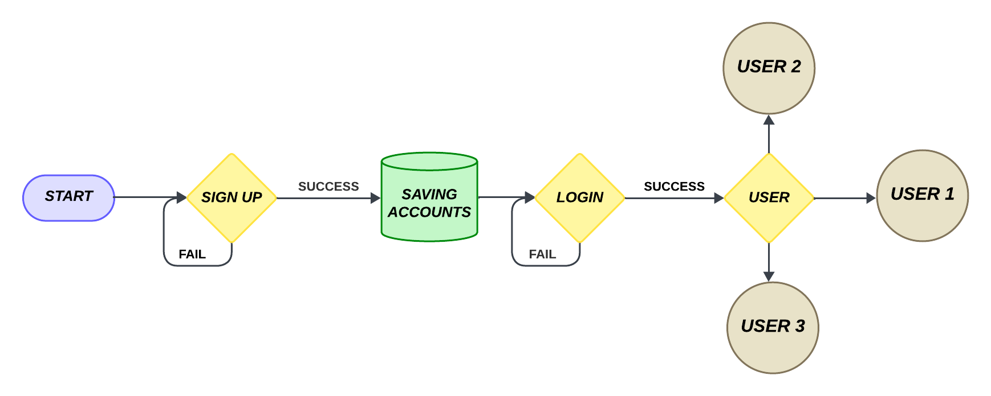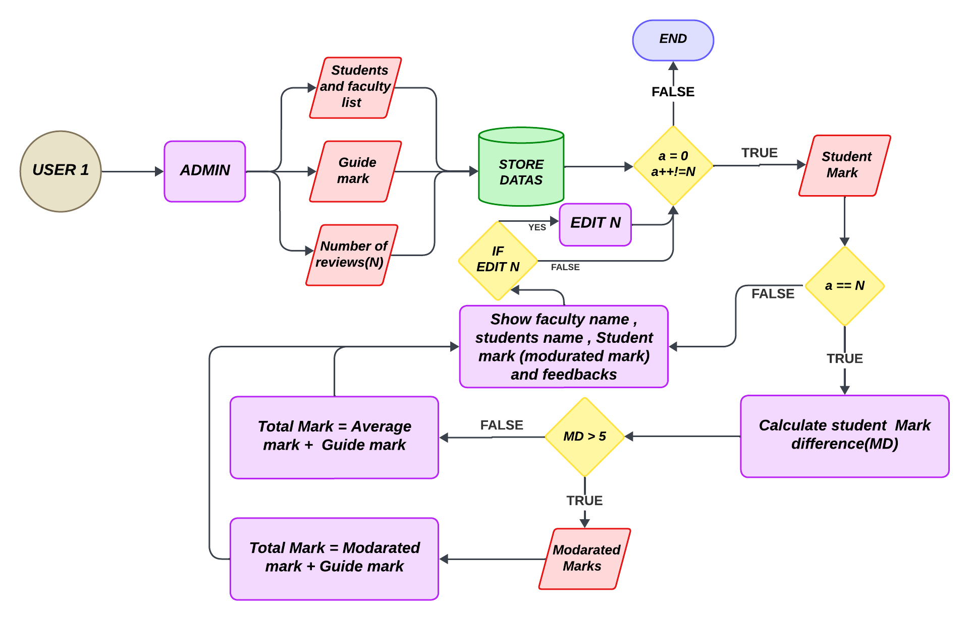

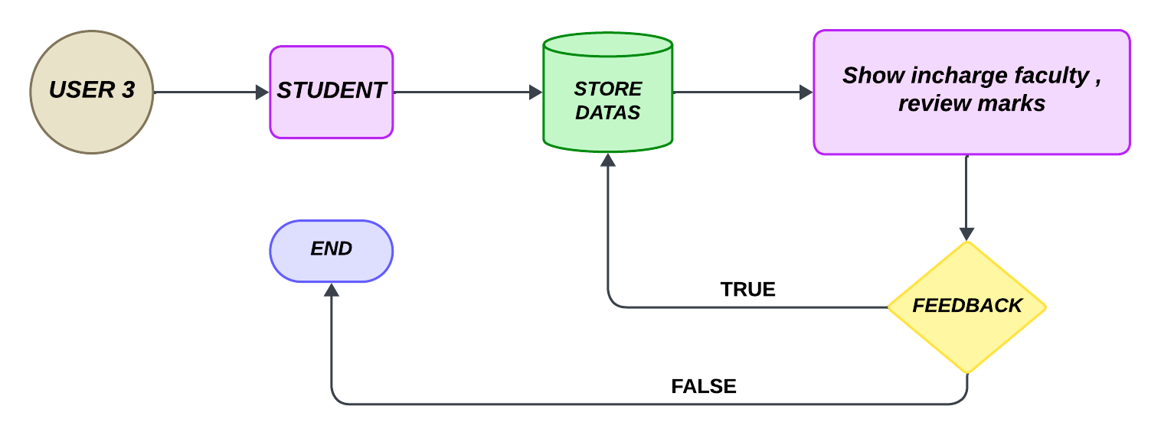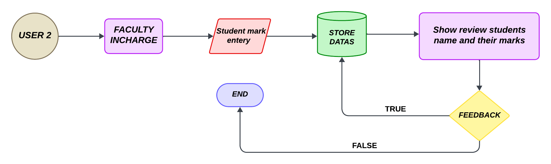

**MARK CALCULATION :**

Number of reviews :

2 terms of review :

PMC1 = Mark 1

PMC2 = Mark 2

3 terms of review :

PMC1 = Mark 1

PMC2 = Mark 2

PMC3 =Mark 3

Calculate the Difference mark(DM) :

DM = Max mark - Min mark

When DM > 5 :

Student mark = Moderated mark + Guide mark

When DM <= 5 :

Student mark = ( ( Sum of marks ) / Number of reviews ) + Guide mark

**CONCLUSION :**

This project builds a system for calculating individual project review marks and offering analytics (LAMP stack). Detailed documentation ensures clarity throughout development. Students can securely access their marks and contributing factors.