**Difference between % and px?**

**Absolute units**

The absolute units have fixed values, thus do not change their values until the user changes them manually. The**px**unit falls under the absolute category of sizing units in CSS. Although px is not good for responsiveness, it is still practiced where the elements do require fixed sizes on the screen. Moreover, the new user tends to use the **px** as the sizing unit as it is easy to handle and does not depend upon any other size unit or element.px yani msln humny kisi image ki height:100px;width:100px set ki tu ab hum different screens pr open kry page ko tu is image ki height:100px;width:100px hi rahy gi chhay screen ka size chota hoy a bara ho.Ab agr % ki missal lain tu msln humny image ki height:100%;width:100% li tu ab screen ka size jo ho ga usky according ye picture apny apko adjust kr la gi msln choti screen pr choti ho jay gi aur bari screen pr bari ho jay gi ye image ya agr div lia howa ha tu usky according kr la gi khud ko % ki waja sa.

**Relative units**

The other two **em** and **percentage** belong to the relative category of elements as they both change their behavior to manage responsiveness.

**em:**This unit refers to the font size of the parent/root element. It can also be used for width/height adjustment but the value of 1em would be 16px.

**percentage(%):**The percentage unit shows the relevancy with the parent element.  The value of **px** is fixed over the HTML document but the **em** and **%(percentage)** depends on the unit used by the parent element. The em majorly manipulates the font size of the HTML elements and the (%)percentage unit primarily refers to changing the height/width of an HTML element(according to the parent element).

For instance, if a parent element defines the **width** = “**10px**“. Now, this value would be taken as a reference to associate the width in **percentage**.

**Note:** CSS does offer various other relative units that include rem, VW(view port’s width ), and VWH(view port’s height) also belong to the relative category.

**JavaScript**

**Important Points**

* JavaScript is not a compiled language, but it is a translated language. The JavaScript Translator (embedded in the browser) is responsible for translating the JavaScript code for the web browser.
* **What is weekly typed language?**
* Strongly typed means, a variable will not be automatically converted from one type to another. Weakly typed is the opposite: Perl can use a string like "123" in a numeric context, by automatically converting it into the int 123 . A strongly typed language like python will not do this. JavaScript is a weakly typed language, where certain types are implicitly cast (depending on the operation).
* JavaScript is a **dynamic type language**, means you don't need to specify type of the variable because it is dynamically used by JavaScript engine. Strong typing means that variables do have a type and that the type matters when performing operations on a variable. Dynamic typing means that the type of the variable is determined only during runtime.Javascript is a weekly typed language. JavaScript is template based not class based. Here, we don't create class to get the object. But, we direct create objects.

#### **Declaring JavaScript global variable within function**

To declare JavaScript global variables inside function, you need to use **window object**.

Yani hum function ka andr bhi global variable bana skty hain aur function ka bahir bhi bana skty hain global variable lekin agr functions ka outside banana ha tu hamain window objection ki zarort nahi lekin agr kisi function ka andr hum global variable banana chahty hain tu humain window object ka sath us variable ko use krna ho ga. For example:

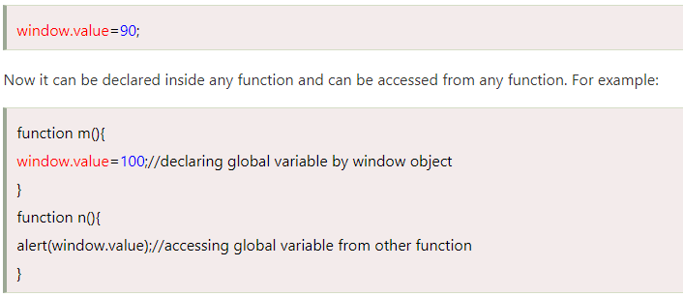

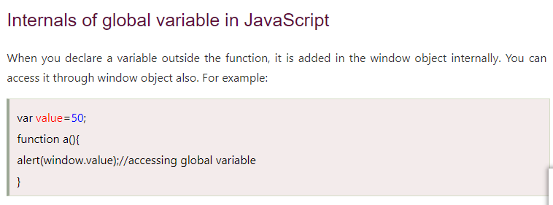

**Javascript Objects:**

There are 3 ways to create objects

1. By object literal
2. By creating instance of Object directly (using new keyword)
3. By using an object constructor (using new keyword)

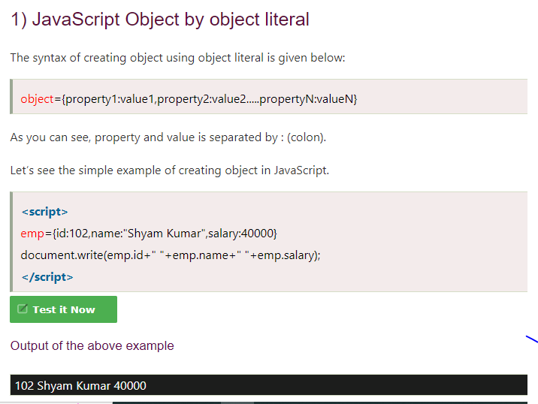

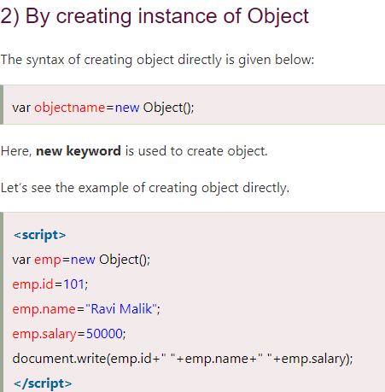

## **3) By using an Object constructor**

Here, you need to create function with arguments. Each argument value can be assigned in the current object by using this keyword.

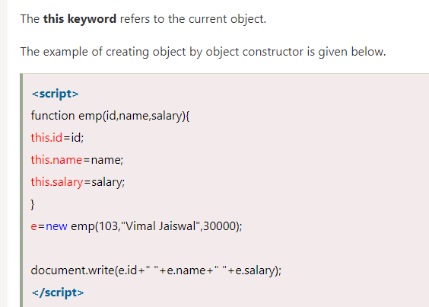

# **JavaScript Array**

**JavaScript array** is an object that represents a collection of similar type of elements.

There are 3 ways to construct array in JavaScript

1. By array literal
2. By creating instance of Array directly (using new keyword)
3. By using an Array constructor (using new keyword)

---------------------------------------------------------------------------------------------------------------------  
There are two ways to set interval in JavaScript: by setTimeout() or setInterval() method.

* setTimeout(()=> console.log("hek"),1000) ye function hr ek second ka bd call ho ga
* setInterval(()=> console.log("hek"),1000) ye function sirf ek dfa call ho ga wo bhi ek second ba

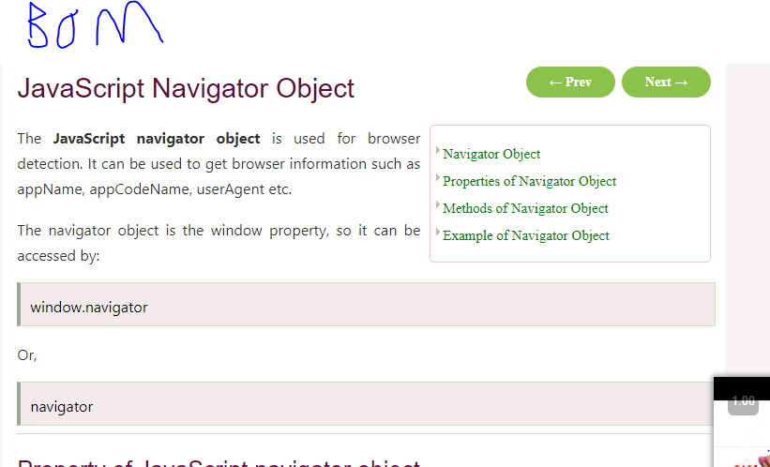

Msln agr hum dekhna chahty hain ka hamary browser ka nam kia ha uska version konsa ha kia is current browser ma javascript supported ha yan ahi etc tu ye tamam information janny ka liay hum Javascript Navigator BOM Object use krty hain.

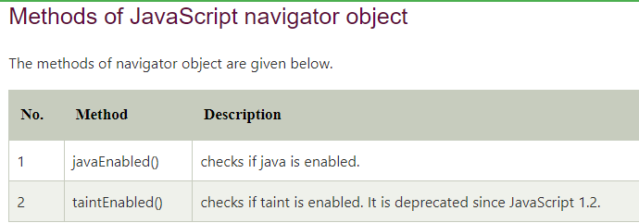

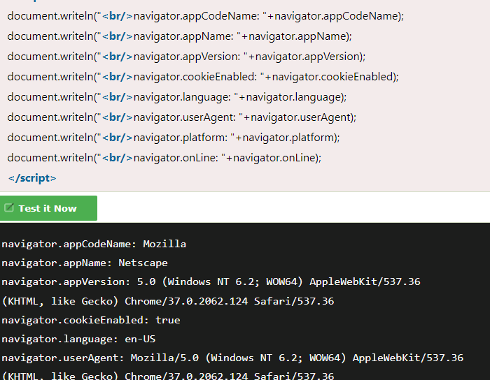

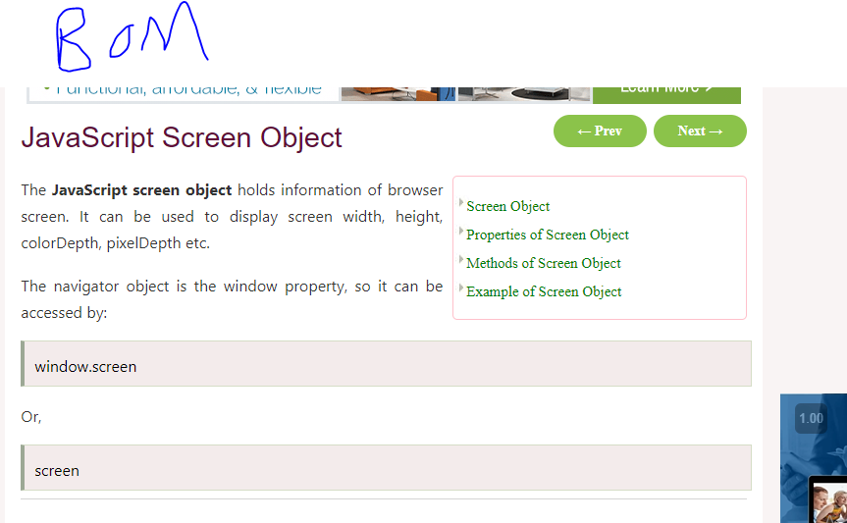

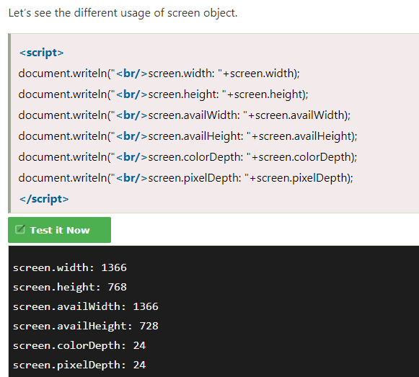

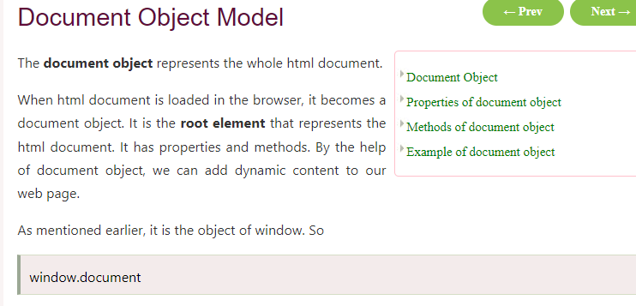

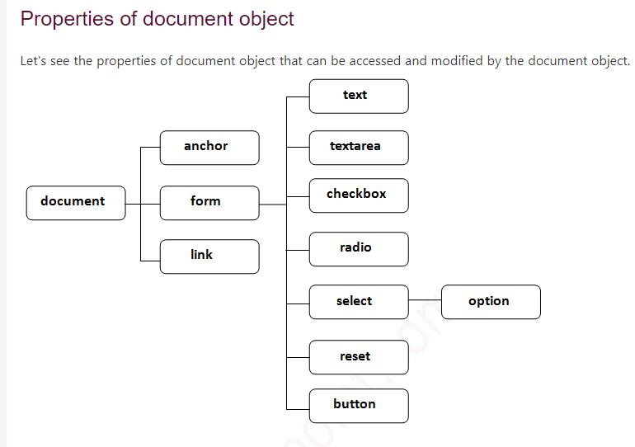

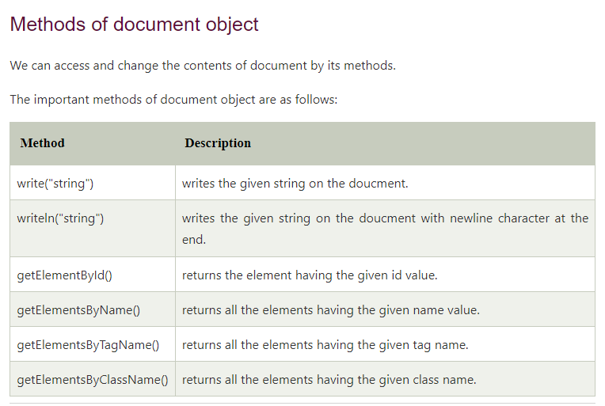

**document** is the root element that represents the html document.

**Get all Form Inputs**

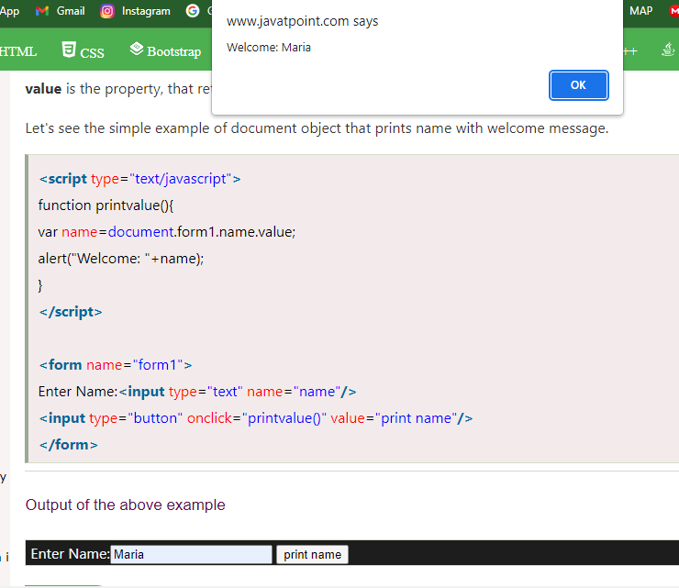

Figure 1Humny orm ki input li ha get ki ha

**Another Method**

