What is AXI:
- Stand for Advanced eXtensible Interface
- It is part of ARM's AMBA (Advanced Microcontroller Bus Architecture) family.

AXI Variants
AXI4-Stream
Completely different.
- No addresses.
- Only streaming data.
Example:
- Video
- Audio
- Network Packets
- AI Accelerator
AXI4-Lite
This is a simplified version.
Supports:
- Single read
- Single write
- No bursts
Perfect for:
- GPIO
- UART
- SPI
- Timers
- Control Registers

AXI4 (Full AXI)
This is the complete protocol.
Supports:
- Read
- Write
- Burst transfers
- Large data widths
- High performance
Typical use:
- CPU ↔ DDR
- DMA ↔ Memory
- GPU ↔ Memory

AXI Channels
There are five independent channels between an AXI master and slave. They are the:
- Read address channel
- Read data channel
- Write address channel
- Write data channel
- Write response channel

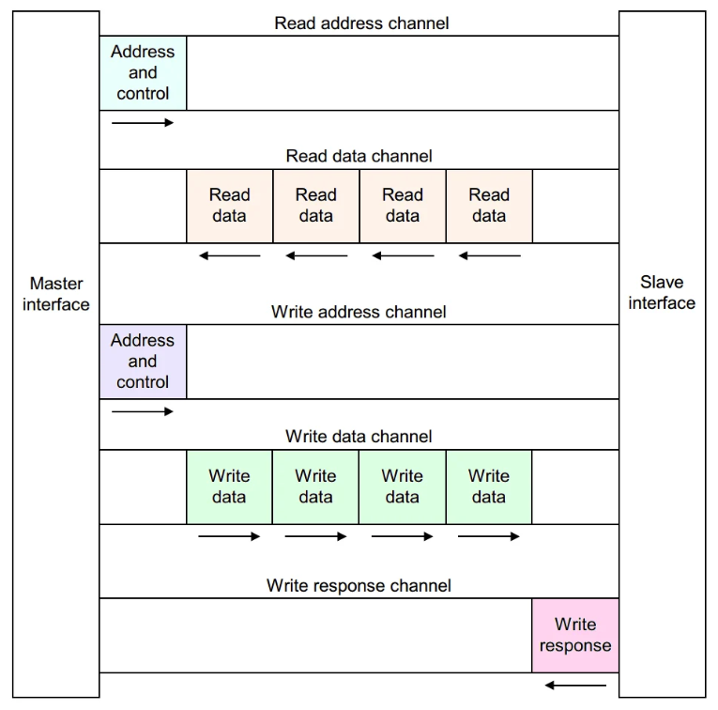

AXI Channels Signals
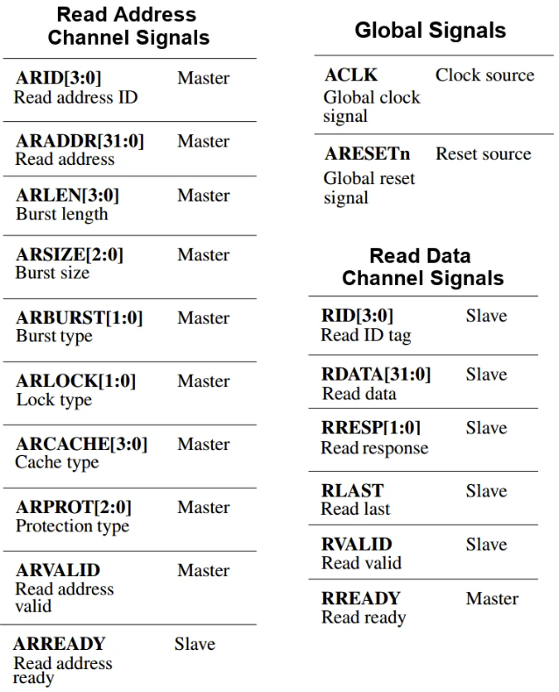
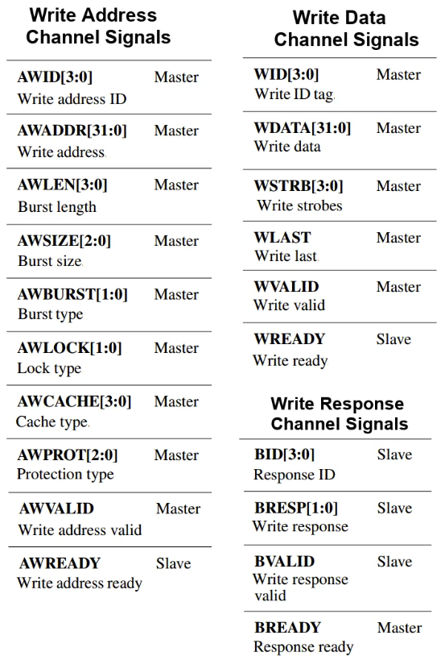




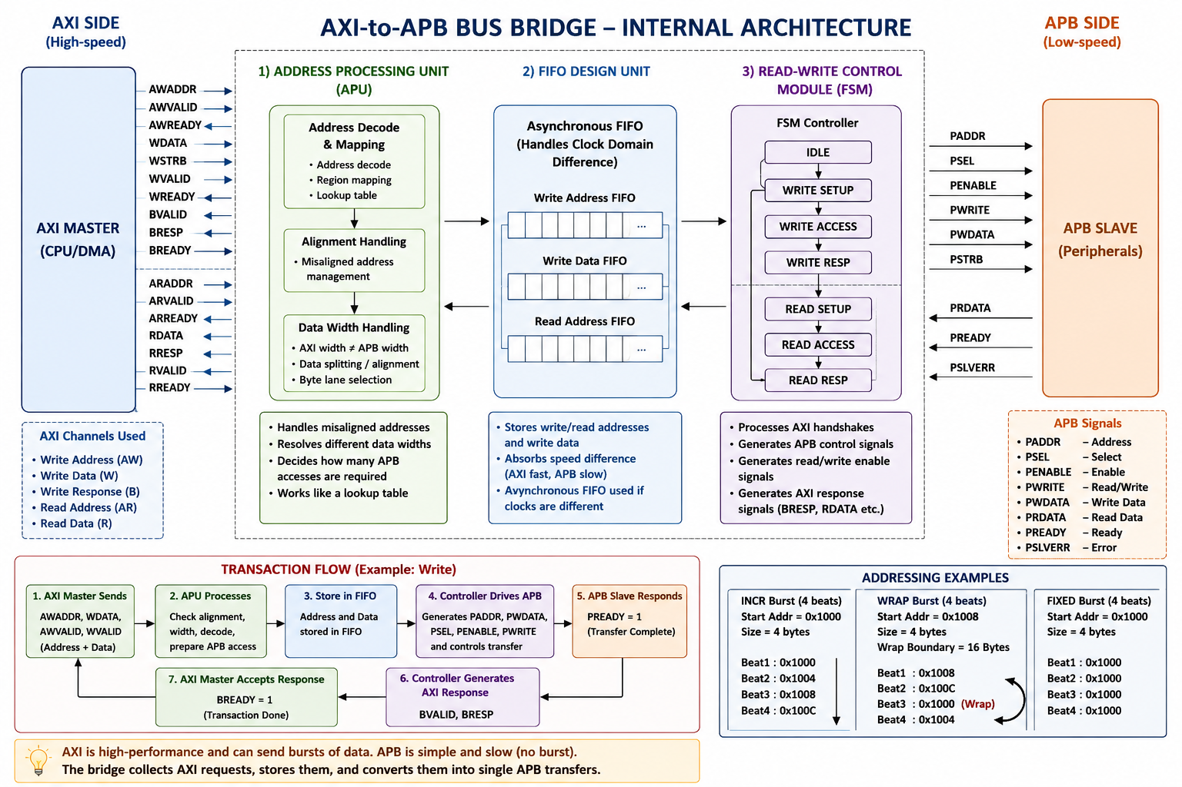

Burst operation:
In AXI channel, the number of data transfers in a single burst are called as beats.
A burst is a group of consecutive beats.
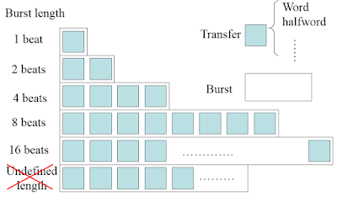
Burst Transfer Type:
- Fixed burst: In a fixed burst, the address remains the same for every transfer in the burst. This burst type is for repeated accesses to the same location such as when loading or emptying a peripheral FIFO.
- Incrementing burst: In an incrementing burst, the address for each transfer in the burst is an increment of the previous transfer address. The increment value depends on the size of the transfer. For example, the address for each transfer in a burst with a size of four bytes is the previous address plus four.
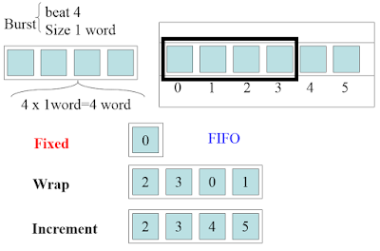
- Wrapping burst: A weapping burst is similar to an incrementing burst, in that the address for each transfer in the burst is an increment of the previous transfer address. However, in a wrapping burst the address wraps around to a lower address when a wrap boundary is reached. The wrap boundary is the size of each transfer in the burst multiplied by the total number of transfers in the burst. There are two restrictions for wrapping bursts: the start address must be aligned to the size of the transfer and the length of the burst must be 2, 4, 8, or 16.

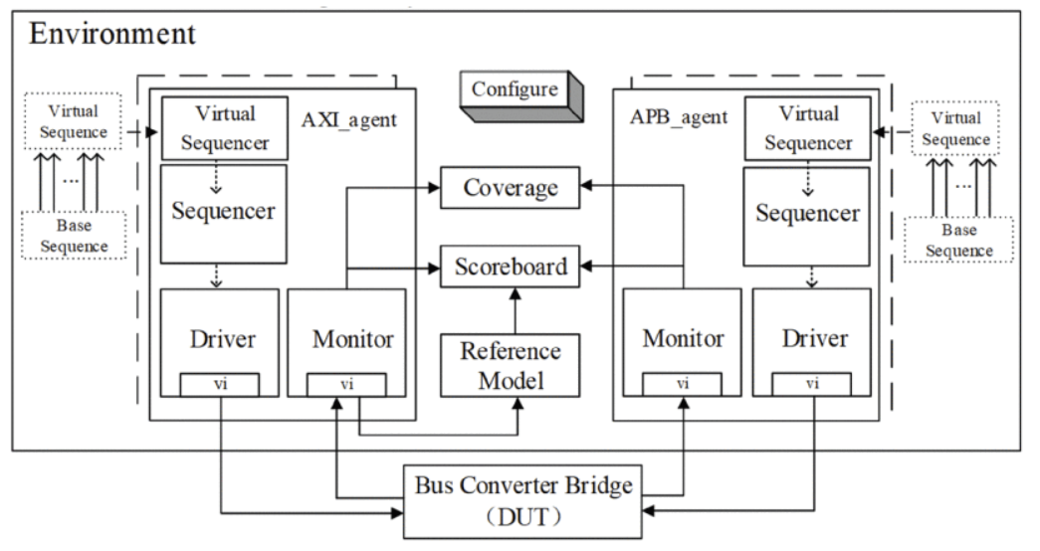

Test Plan
Test Name | AXI Sequence | APB Slave Behavior | What is Verified
Write Test | Single Write | Normal | AXI write → APB write
Read Test | Single Read | Return data | APB read → AXI read
Random Test | Random R/W | Normal | General functionality
Burst Test | Burst Write/Read | Normal | Burst conversion (Full AXI only)
Wait-State Test | Read/Write | Delayed PREADY | Bridge waits correctly
Error Test | Read/Write | PSLVERR=1 | Error propagation
Reset Test | Transactions after reset | Normal | Reset recovery
Stress Test | Thousands of random transactions | Random delays/errors | Robustness

