



Digital Design and Verification

LAB # 01
GCC Compiler, GNU Debugger and Data Types

NAME: MUHAMMAD HAMMAD
INSTRUCTOR: MRS. HIRA

Release: 1.1
Date: 24-Feb-2025
1

Task 1

Part 1-Compiler warnings
    - Compile your code
gcc pwd_checker.c test_pwd_checker.c -o pwd_checker

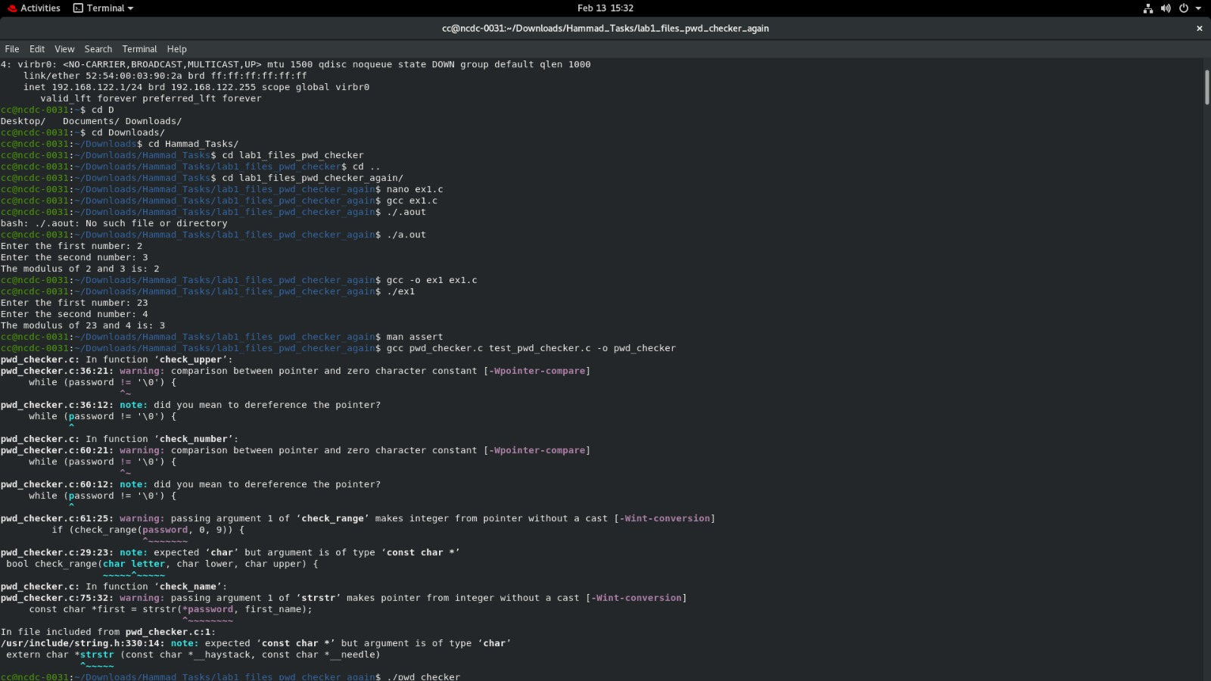

- 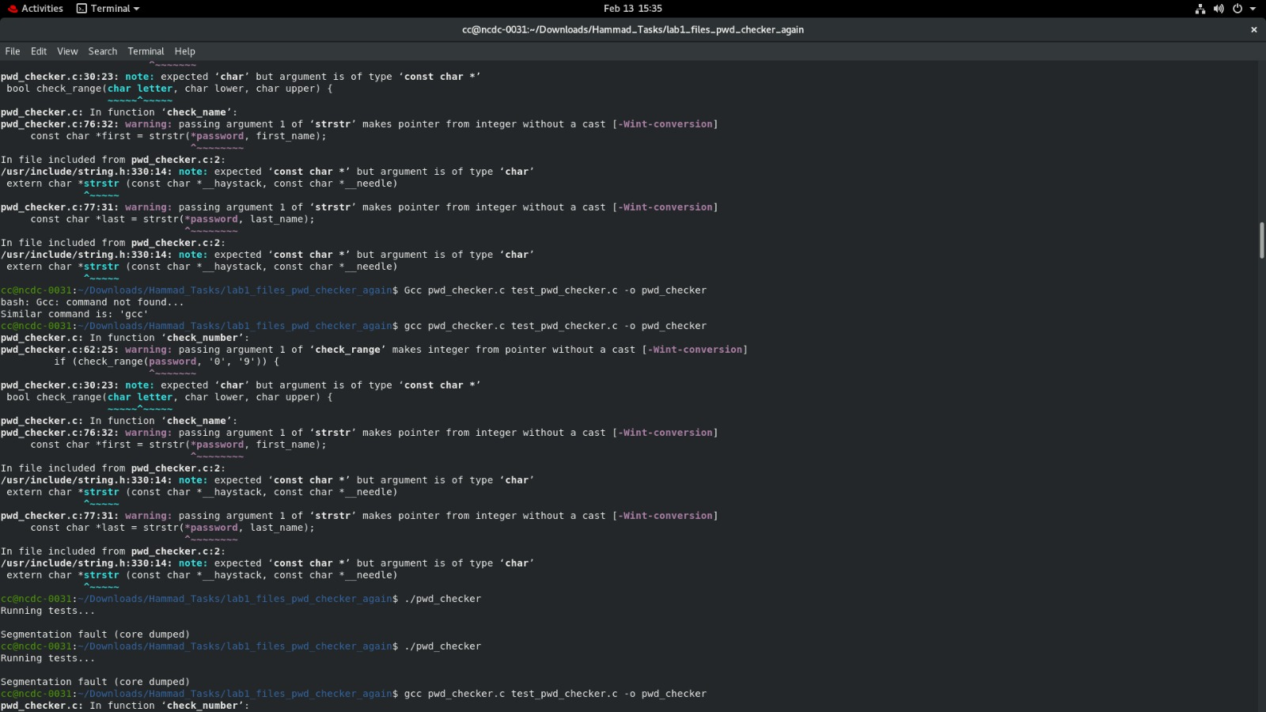After Compilation these errors occurred.

Part 2: Assert Statements
- Learn about how you can use assert statements to debug your code. Edit the code in pwd_checker according to the directions in this section.
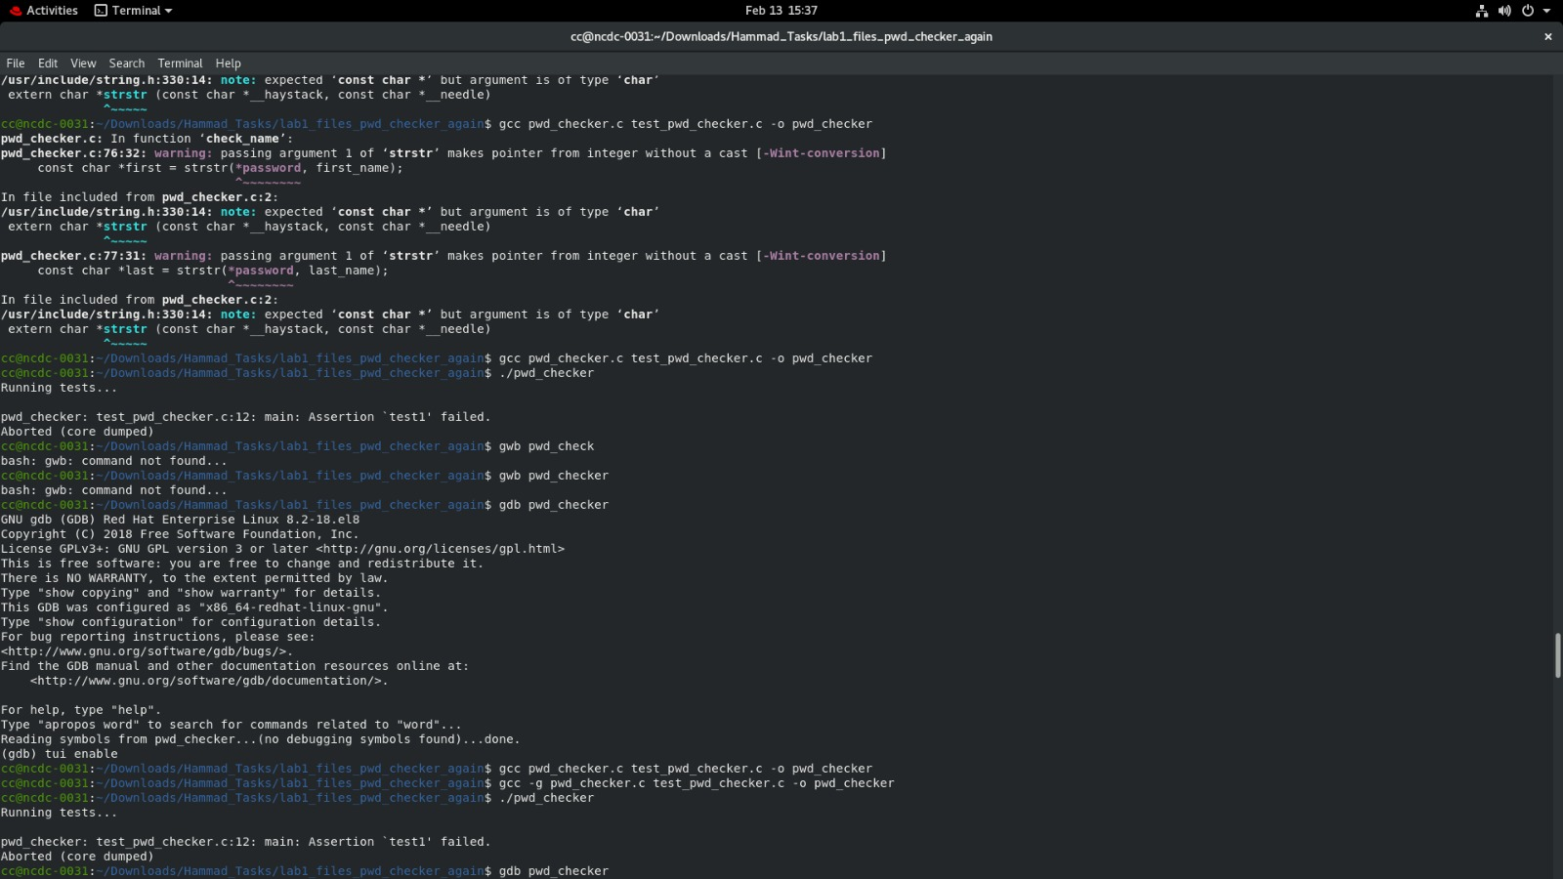
  - 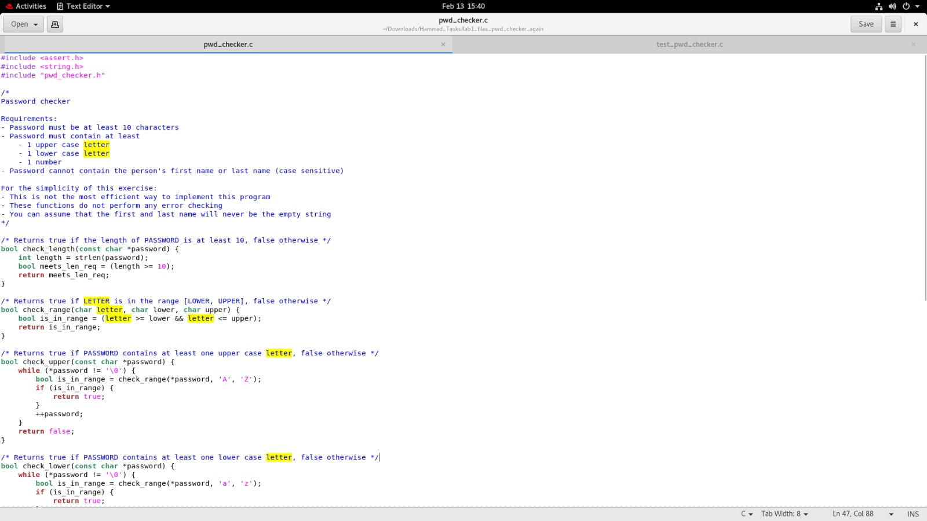Compile and run your code

The program says that Assertion ‘test1’ failed. However, we can see that qrtv?,mp!ltrA0b13rab4ham password fits all of the requirements. It looks like there is a bug in our code.

Part 3: Intro to GDB: start, step, next, finish, print, quit
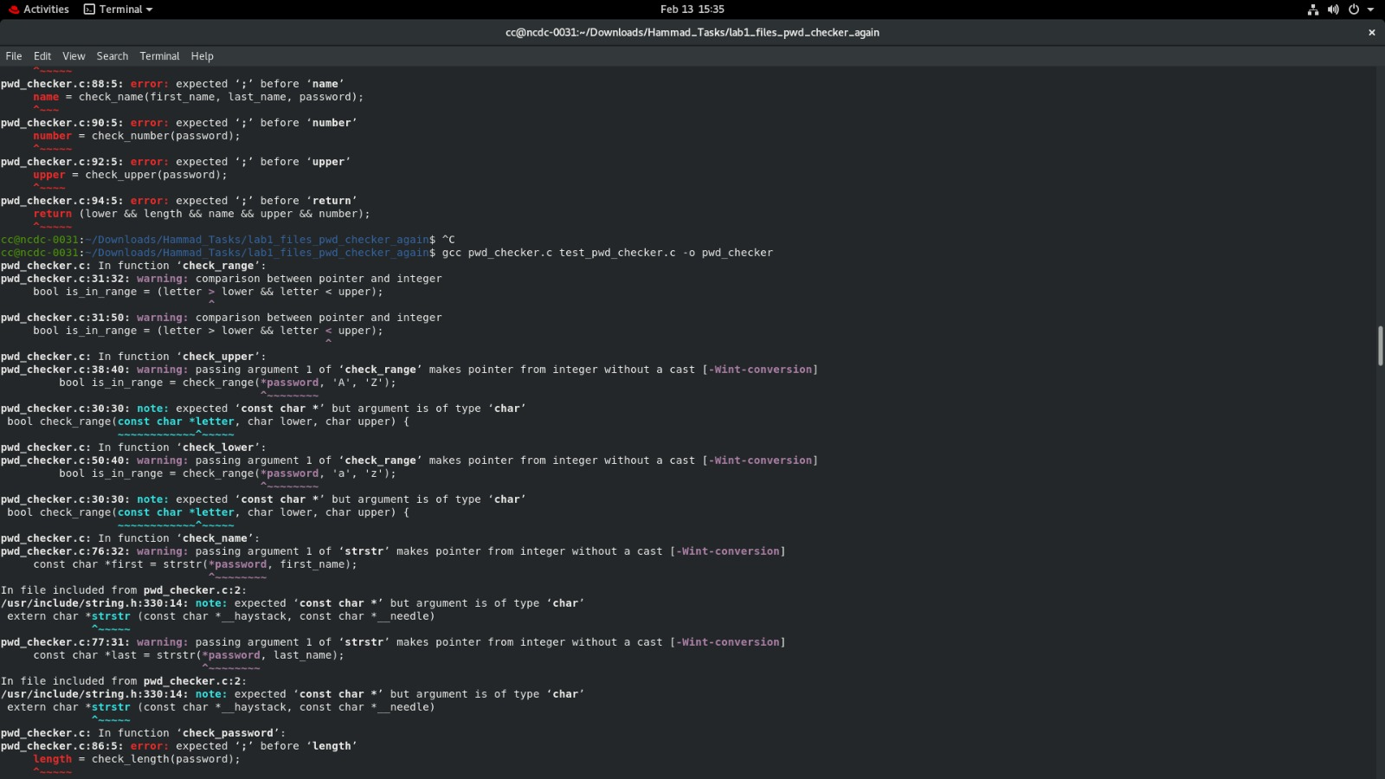



Length, Name & Password errors occurs.
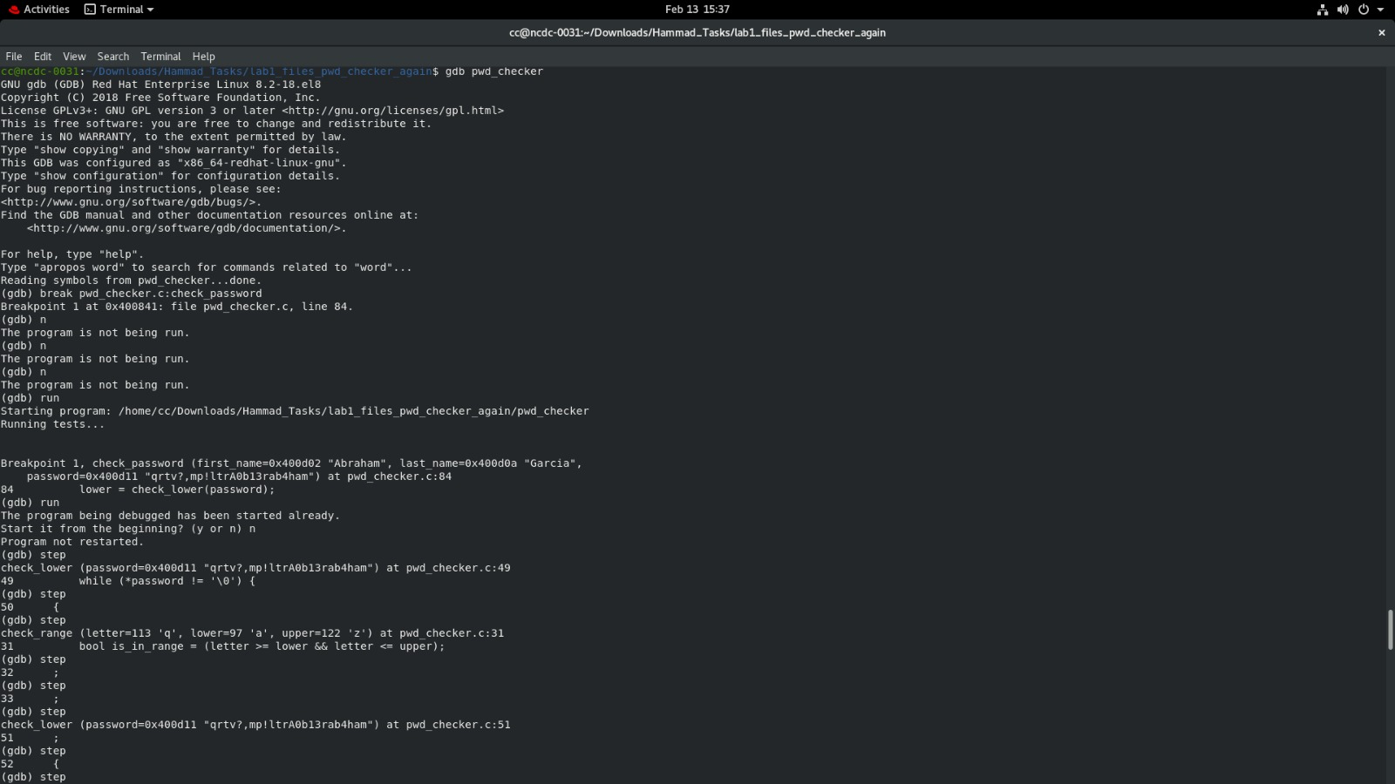

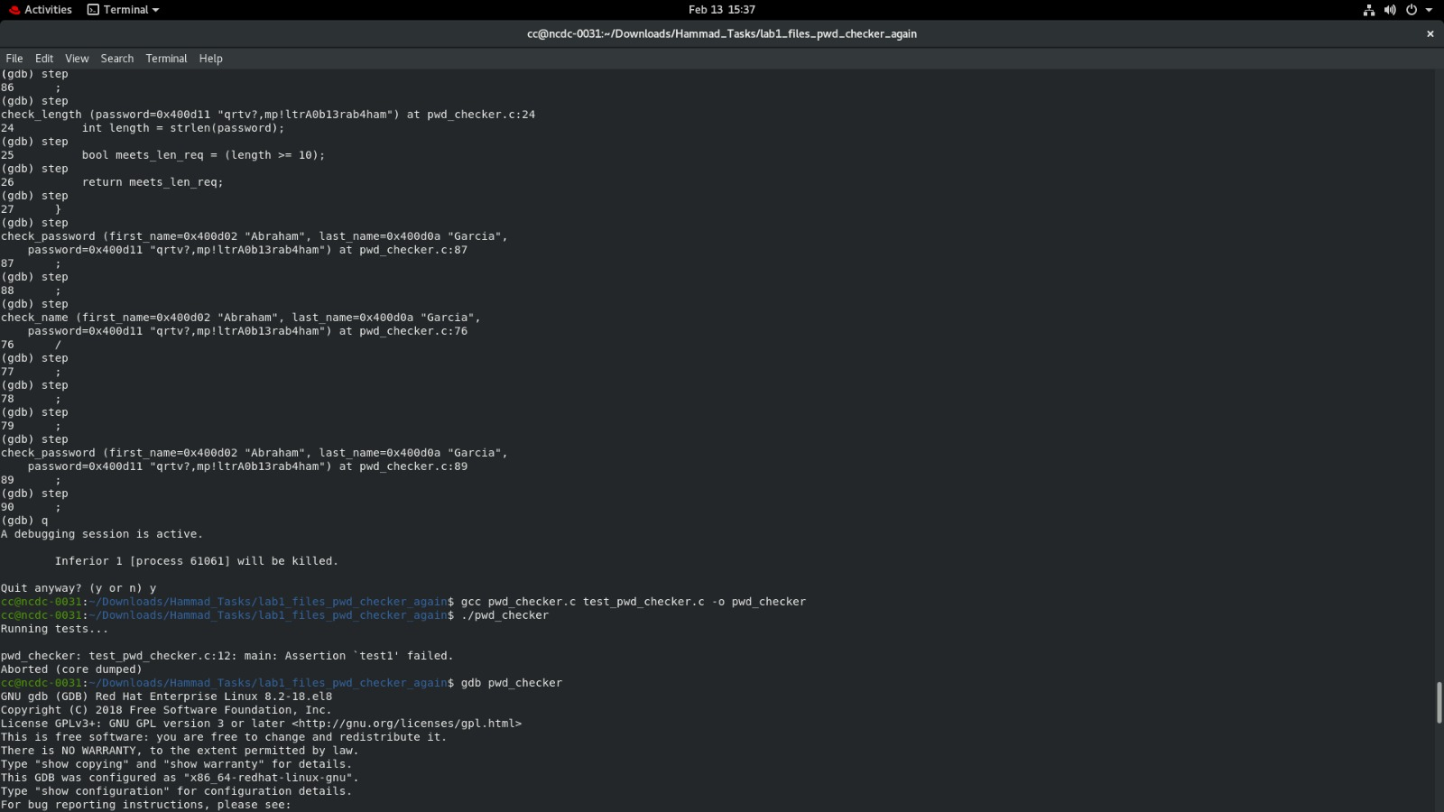
TUI Interface enabling and checking errors.
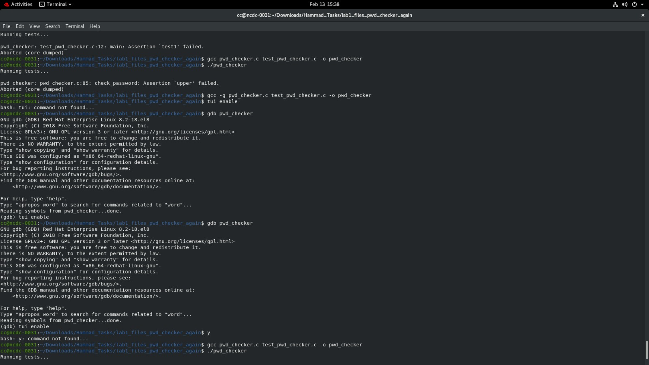


Part 4: GDB: break, conditional break, run, continue

Letter errors occurs due to uppercase and lowercase doesn’t inculde boundary character are not included. The password error occur due to the password is a pointer it is not defered and also the
It is taking 0 to 9 as numbers where these are characters.
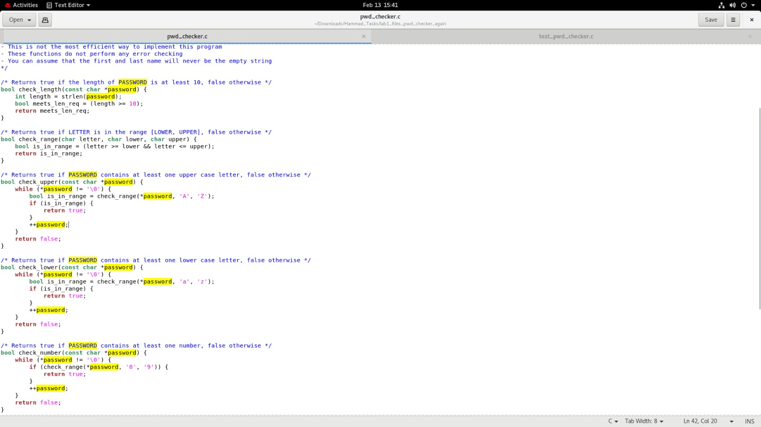

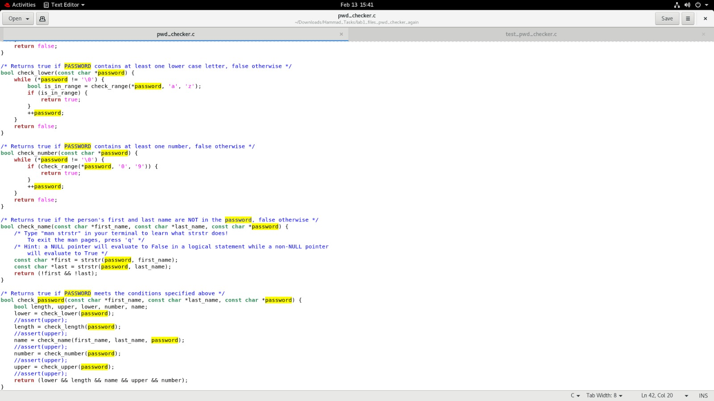

“Debug check_upper on your own using the commands you just learn.”

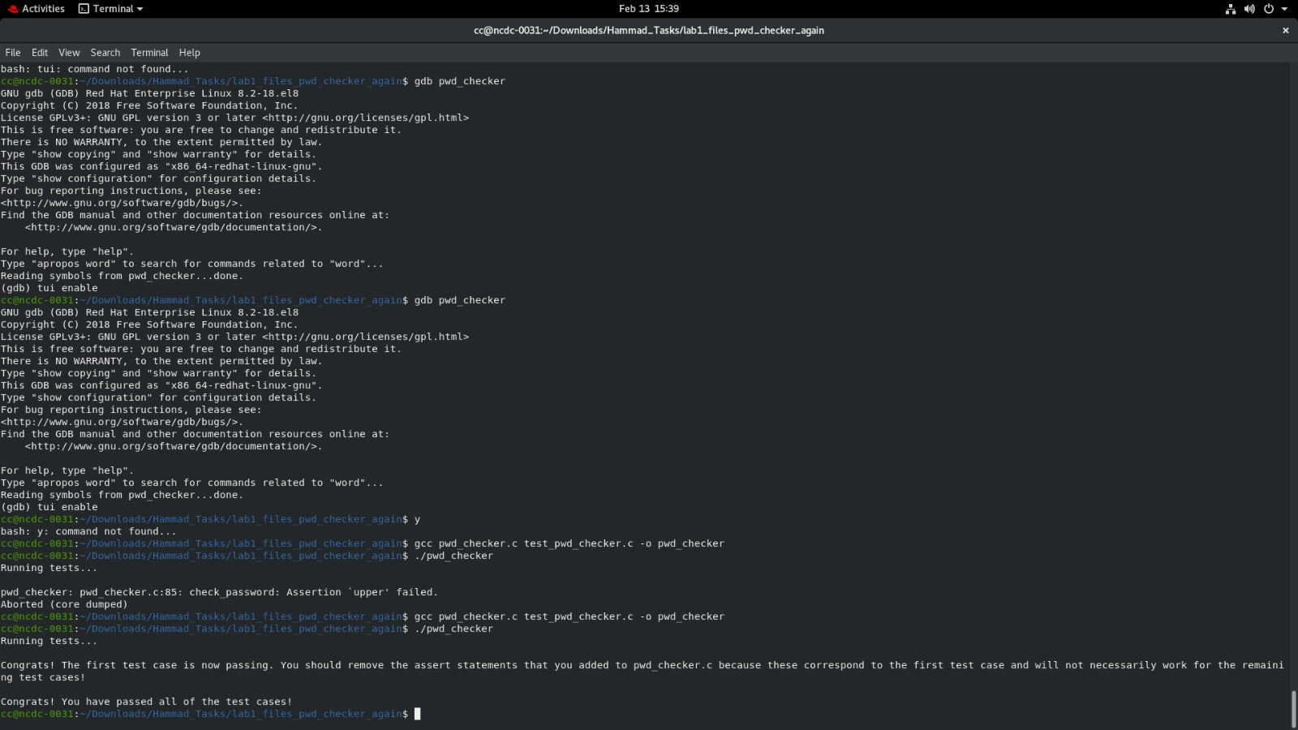

After correcting all the bugs, you should pass all the tests. It should display “Congrats!
you have passed all of the test cases!”

Task 2:
Let's do some real stuff with data types. What do you think is suitable for these variables? Try using data types with minimum storage requirements yet capturing a full range of values.

S.No. | Variable | Data Type
1. | Distance between home in Islamabad and Faisal Masjid in km | Float
2. | Your GPA | Float
3. | Your total credit hours | Unsigned Short
4. | Your Age in YY-MM-DD | String
5. | Petrol Price (PKR) | Float
6. | University Open/Close Status | Bool
7. | Origin of Universe in years | Unsigned Long Long
8. | Origin of human in years | Unsigned Int
9. | Current in Ampere | Float
10. | Voltage in Volts | Float
11. | Radius of earth in meters | Unsigned Int

Working with Characters
Let's work with characters. Characters are used for storing names.

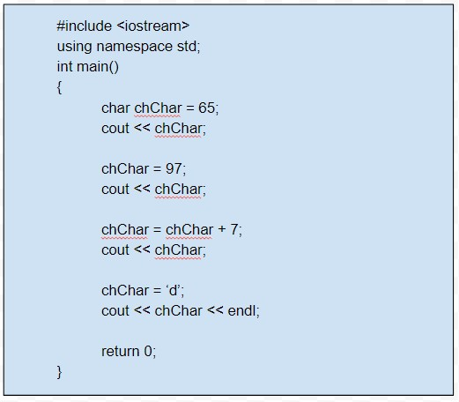

What will get printed? It will print “Aahd” . But how?

These are printing because of their ASCII characters and some are printed hard codedly.

Task 3:
Using char, print your name and CNIC. As in above example you are only allowed to store 1 character in the variable i.e. the last character of your name and likewise last digit of your CNIC. All other characters should be printed using numbers.

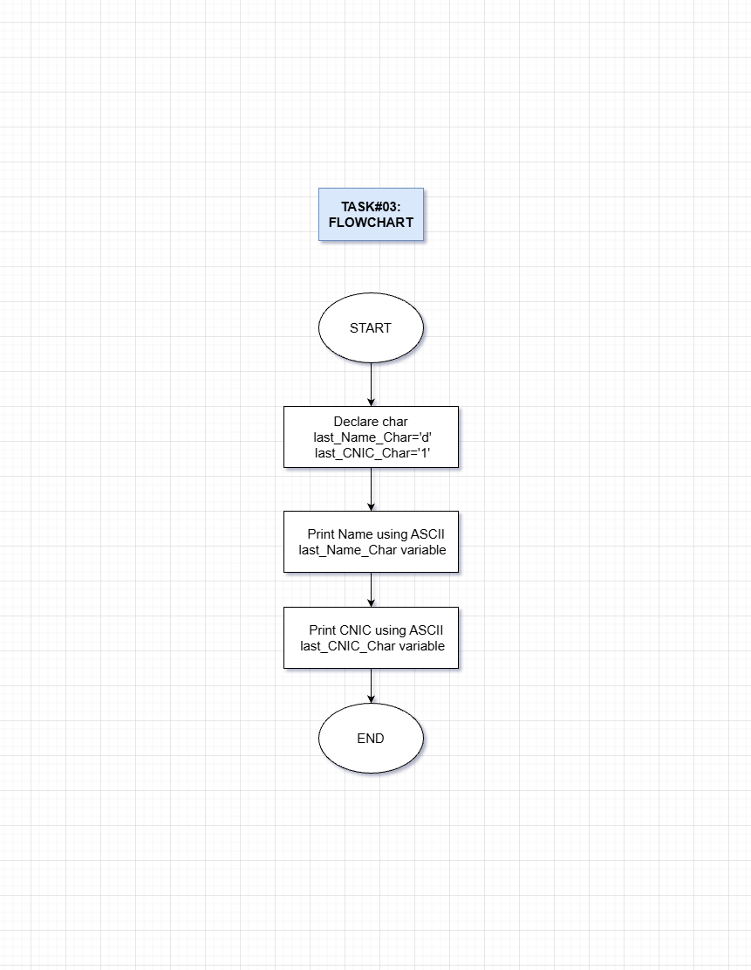

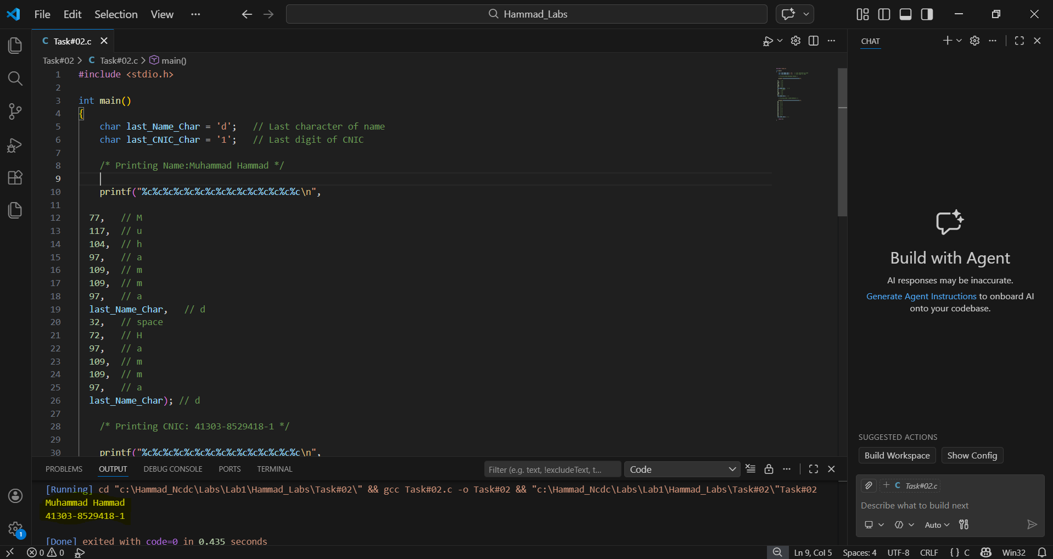
Code And Result:

Task 4:
Take input from the user about credit hours of your first semester courses along with the grade received in that course. Write a program to calculate the GPA at the end of your semester.

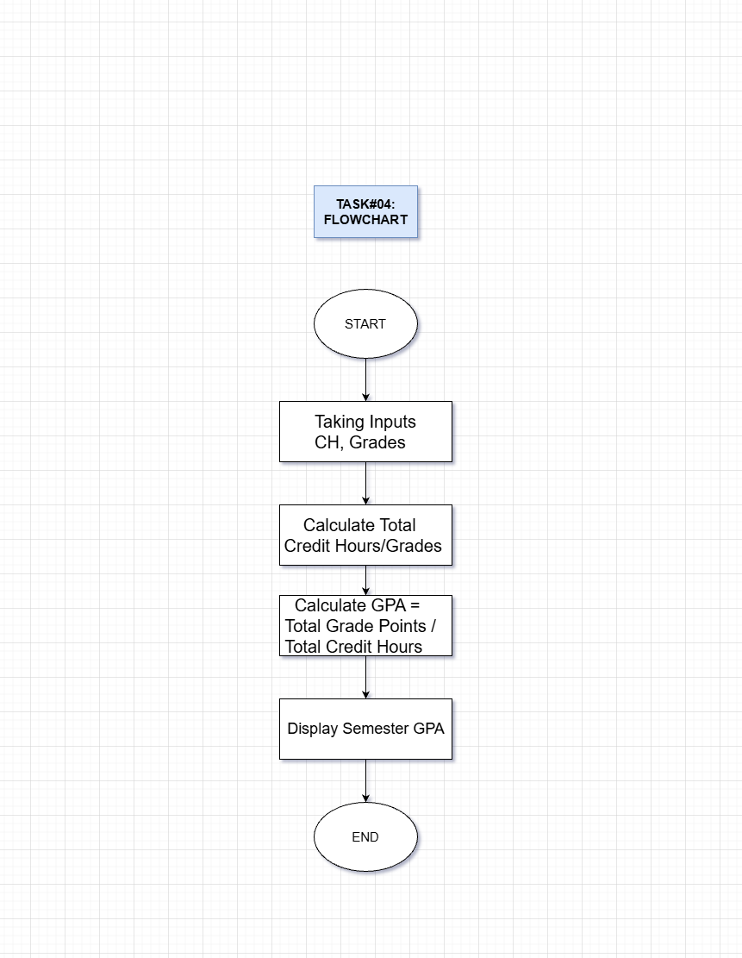
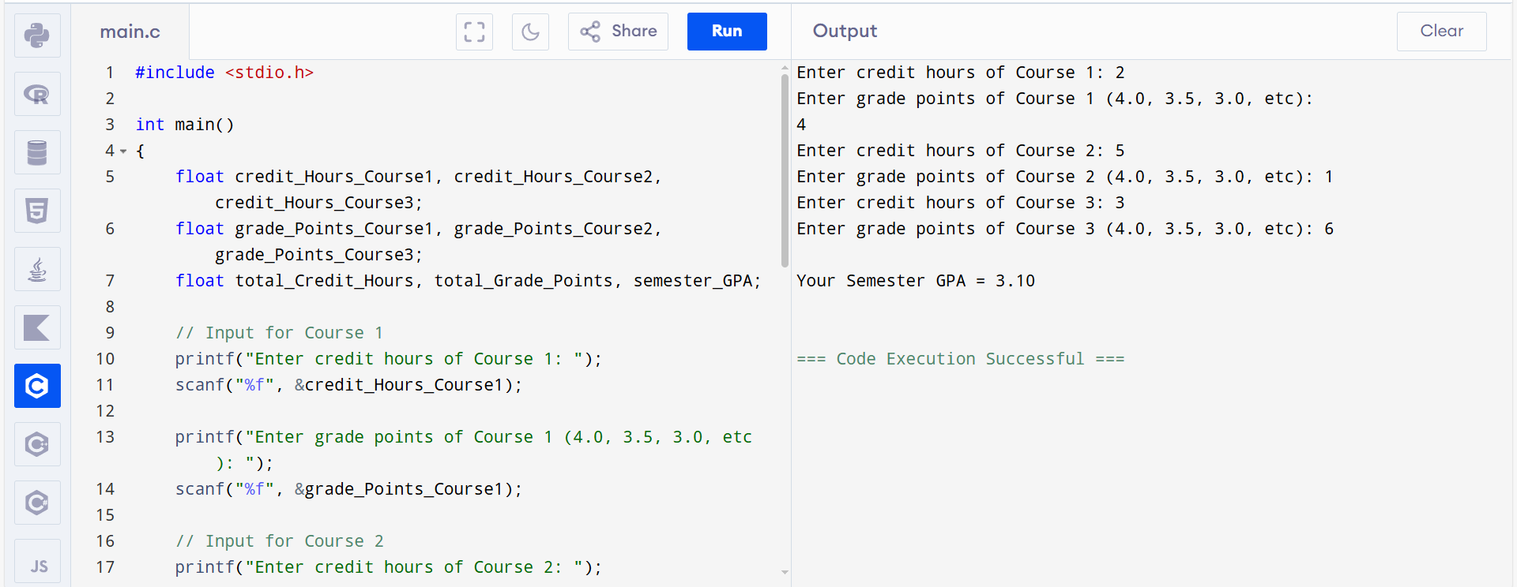

Linear Circuits Analysis
Kirchoff’s Law is one of the important tool in Linear Circuit Analysis which dictates that currents entering a particular node are equal to the currents exiting at that node. This law is usually used to calculate currents passing through the resistor or voltage across a resistor.

Task 5:
Consider the following circuit. You can take input from the user the value of V1, R1, R2 and R3.
Using Kirchoff’s Law, you need to find out i1, i2 and i3.
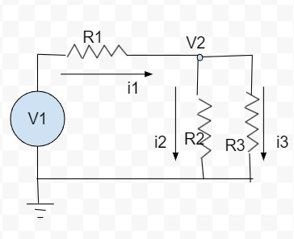
Hint: Kirchoff’s Law at Node V2 | i1 | = | i2 | + | i3
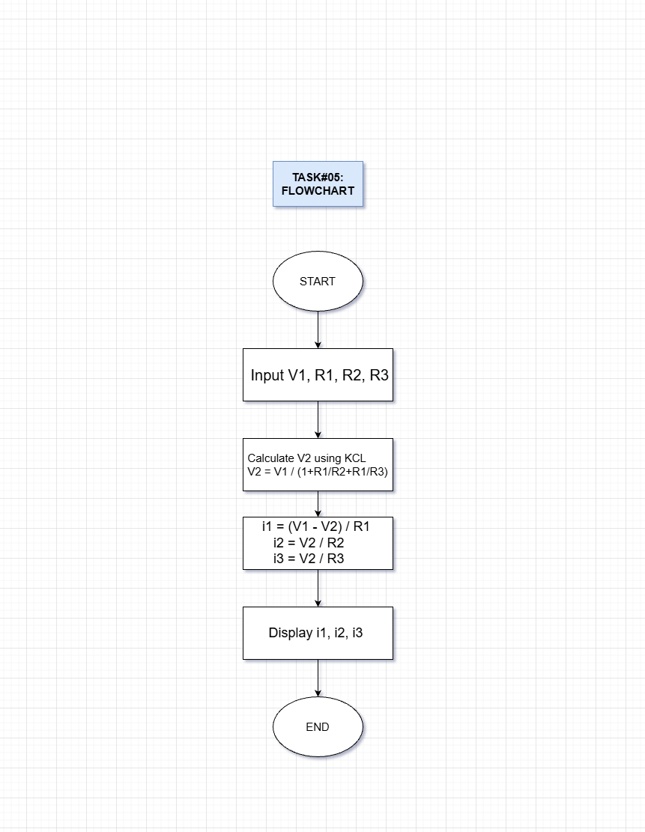

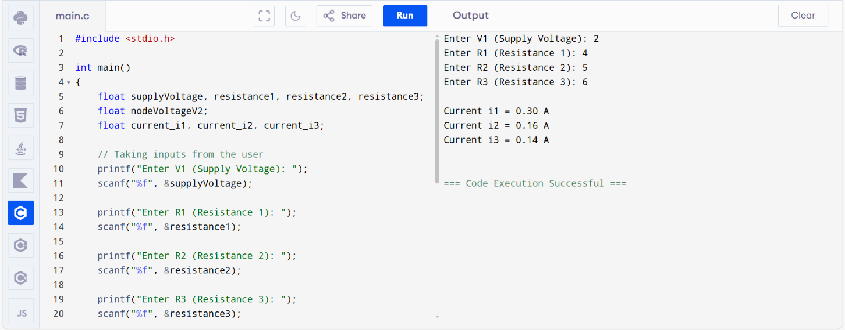
Calculus
The extrema points of a function are usually computed to figure out the maximum or minimum value of that function. Consider a quadratic function.
ax2 + bx + c = 0.

Task 6:
Take the coefficients of the above polynomial (a, b, c) from the user and figure out the extrema points.

